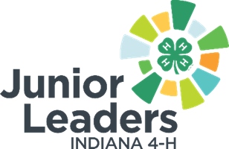

4-H Junior Leader President Role Description
Qualifications:
- Ability to speak well in front of others
- Demonstrates previous experience held in leadership positions
- Knowledge of Parliamentary Procedure
Skills:
- Organization and time management
- Positive attitude and team player
- Reliable
- Ability to lead your peers
- Ability to work well with adult advisors
Responsibilities:
- Exhibit good leadership qualities and serve as a role model to the members of 4-H.
- Work with Jr. Leaders and the adult advisor(s) to plan a fun and interesting program.
- A day or two ahead, check on arrangements for the meeting. See that everyone on the officer team is ready.
- Become familiar with business to be acted on at each meeting. This might include checking with committee chairs, other officers, and adult advisors. For a final check, adult advisors and the officers may have a huddle just before the meeting is called to order.
- Call the meeting to order on time and end on time. Be prompt and make the meeting fun.
- Speak clearly and loudly enough for all to hear.
- Use basic parliamentary procedure as a tool to conduct effective, orderly meetings.
- Call for a motion on any question that needs a decision. Encourage discussion to bring out the various points of view so that each individual can help make a decision. Encourage all members to take part in the meeting.
- Be impartial. You may cast the deciding vote in case of a tie.
- Ensure the election of officers.
What you will gain from this:
- Career readiness skills
- Public speaking skills
- Better understanding of Parliamentary Procedure
- Ability to problem solve
- Organizational and teamwork skills

