Changemakers- Teens as Teachers Presentation

Time: 1-2 hour

Supplies:
Markers
Writing Utensils

Handouts:
The Global Goals sheet
YES Grant Due March 15
Choose Your Cause sheet
Resources: (For a handout to be created)
https://www.un.org/sustainabledevelopment/youth/
https://in4h.org/grants/

Objectives:
- Youth will understand what it means to be a changemaker.
- Youth will have a start of an action plan to take back to their community for implementation towards their cause.
- Youth will understand financial opportunities to support their cause.

Lesson Plan:
Intro- 30 min
What is a changemaker?
"A changemaker is both a noun and a verb; it's someone you are and something you do."

Everyone in this room is a changemaker. By giving up a weekend to learn about leadership and programs you can take back to your community, you are making a difference.

When you think of a changemaker, who do you think of?
Make a list of the names of who they are saying on a flip chart sheet.

Our Logo for Changemakers highlights people in history that have made global change
One of them is Malala Yousafzai. Malala is a youth activist from Pakistan who fights for the right to education for women and girls. Malala became an activist at the age of 12 when she joined her father to advocate for education for girls, despite resistance from the Taliban. On October 9th 2012, Malala was attacked by the Taliban, a terrorist organization, on her way back from school. She suffered from a gunshot wound and was in critical condition. After the attack, Malala moved to the United Kingdom, where she continues to advocate for girls’ education through her book, movie and foundation. In addition to writing a blog for BBC Urdu under a pseudonym and being featured in a New York Times documentary, Malala travels all across Pakistan to speak about girls’ education rights at rallies and on television. She is the youngest person to have received a Nobel Peace Prize.

Global Goals
Overview Video of the Un Global Goals https://www.youtube.com/watch?v=RpqVmvMCmp0
Or https://www.youtube.com/watch?v=cBxN9E5f7pc&t=179s

Quiz for Global Goals https://www.ubs.com/global/en/ubs-society/togetherband/find-your-goal.html

(Handout: Template on working through your plan- Kathleen created)

Selecting Your Cause
Review the UN Global Goals- Select One to focus on

Part 2- 30 minutes
Why is this a worthy cause? - Research and Interviewing
Say: Is this cause a need in your community is, so what are specific needs?

- Explain that "Changemakers Slide Guide" is just that...a guide. We are providing it to help you collect your thoughts for your pitch, but you can copy, cut, paste, and edit (and be creative).
- Community mapping- create something
- Give time for them to work on filling out their Guide
- Regroup: Share what you put
PULL MORE STUFF FROM APRIL 28 SLIDE on interviewing part

Part 3- 30 minutes
How to Fund Your Cause
Ask, “How might you raise money if you need it to implement your project or donate to an organization you are passionate about?” Ideas (links are to examples):
- Grants: Different entities that have large amounts of money such as foundations, businesses, or government agencies and institutions, and that want to help solve problems all around the world, usually give out their money in the form of grants. Each donor has its own priorities, requests, and requirements for grants, and the process can sometimes be unpleasant and long. They usually consist of specific forms which you must fill in order to apply, but very often, it all comes down to your idea.
- Crowdfunding/Event fundraising: Crowdfunding is the act of raising small amounts of money from a large number of people online. You will be trying to convince a large number of people to support your idea, so you need to do quite creative in drawing the audience’s attention. You create an event which offers something interesting to your audience (such as a theatrical show, food event, or an art-selling exposition), and include a way to raise money, such as having a paid entrance fee, selling products for more than they cost to make, or just inviting people to donate without any requirements.
- Product selling: The product can be the solution itself (first aid kits or humane dog leashes) or he product or service can also be unrelated to your project (bake sale or 4-H projects you created in an auction)
- In-kind donations: Sometimes, you might not need actual money to implement your project, but you will need different kinds of materials or services for it, or want to donate to a local charity.
Activity: Put into break-out groups to do the first 6 prompts in green from the "My Solution into Action" slide: 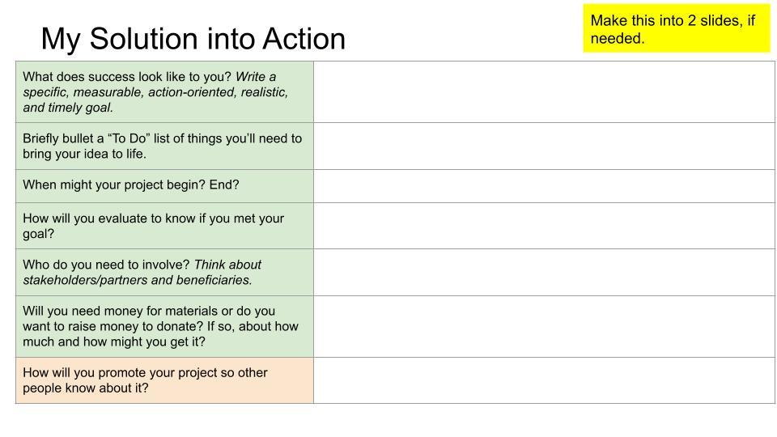https://docs.google.com/presentation/d/1jnDF53p_d9tgrs_HjMObNvnJosiMLfQ_7oL0CKx_u9g/edit?usp=sharing (I used a Hershey grant form to create the table.)
Discussion: Say, "Think about your research and interviews. What are the needs? Review your 'My Solution' slide where we brainstormed some ideas."
YES Grant
- What is a grant
- Application/Guidelines (handouts)
  - A group application must include at least two youth and two adults
  - Be sure to include your interview!
  - Short- and long-term goals
  - "Don't leave the committee with questions." Provide adequate details.
  - Continuation and completion of project
  - From Luke: Encourage team applications (can bring in youth who are not 4-H members, which is encouraged), can enter group/club name (Changemakers), want to see you in action (social media)
  - Offer to review and remind about deadline.
  - Question 2: Outline or describe the process your 4-H group went through to determine the concerns, needs, or problems existing in your community.
    - 182 words: I was part of a six-week program called The Changemakers to help me determine the needs and problems in my community. The program was led by Central Indiana 4-H educators. During the program, I connected my passion to both a cause and a United Nations Global Goal so that my local action could have global impact. I conducted research on the internet to find data in order to discover the root problem of the cause I was interested in. [Insert one data point.] I looked at maps of my county's resources to discover assets we already have and where there might be gaps. I learned about empathy and the importance of including the community, both stakeholders and beneficiaries, as I designed my community service project. I wrote and asked interview questions to help me better understand the community problem. [Insert who you interviewed and a brief summary.] With help from my fellow Changemakers, I interpreted my data in order to get to the root cause of my problem and brainstorm possible solutions, including the project I'm pitching as part of this grant.
  - 4-H entity to write check: Area 6 Youth ED Fund
  - Deadline: March 15th
- How to write a budget / what would go into a budget

Where do we go from here?

