Indiana 4-H & Indiana FFA

Career Development Events

Horse Evaluation CDE

Purpose
The purpose of the Horse and Pony CDE To learn principles of horse and pony selection and evaluation and to develop the ability to make sound decisions based on observations and to defend these decisions verbally. To learn to appraise horses and ponies visually as a part of a sound breeding and management program as well as a means of evaluation in horse shows and contests.

Objectives
The objectives of this Career Development Event are:
- Develop and exercise competitive spirit in a team atmosphere.
- Create a foundation for career choices by building an awareness of opportunities within the equine industry.
- Advance knowledge in equine science, selection, care and well-being, management and production of horses.
- Evaluate, make decisions and orally justify decisions on conformation traits and
performance of horses.

General Guidelines
- All youth must be active members of a county 4-H program or FFA chapter in good standing in order to compete.
- A team listed as an FFA team must be made up entirely of actively enrolled FFA members from the same FFA Chapter.
- Junior FFA teams must be made up of members who originate from the school where they would normally attend and be Junior FFA members in the 5th- 8th grade.
- Senior FFA teams must be made up of members who originate from the same FFA chapter and be enrolled in 5th to 12th grades.
- A team listed as a 4‐H team must be made up entirely of actively enrolled 4‐H members.
- A school-based junior or senior 4-H team must include participants enrolled at the same school. Online learning schools cannot participate as a school-based 4-H team.
- A community club-based junior or senior 4-H team must include participants enrolled in the same 4-H club.
- A county-based junior or senior 4-H team must include participants enrolled in the same 4-H county.
- Any 4-H team and coach must be approved by their county 4-H Youth Development Educator.

Event Rules
- All contestants must be registered by the deadline via 4-H Online or the Indiana FFA Portal.
- All contestants are to enter the contest with a clean notebook and no notes or handouts other than what may be provided by the contest coordinator. The group leader is to take away from contestants any notes or handouts in their possession.
- No cell phones, smartwatches, or other electronic devices are to be with the youth unless it is a medical device and has been reported to the contest coordinator.
- Each contestant will be allowed a maximum of 15 minutes for each non-reasons class and 17 minutes on reasons classes.
- Each contestant will be allowed a maximum of two minutes to give oral reasons.
- Youth will fill out a scantron for their placings.
- Fifty points will constitute a perfect score on a placing class and on a set of oral reasons.
- Group Leaders. A group leader shall be in charge of each group to move the contestants, to assist in supervising the class, to see that the classes are properly exhibited, and to answer any questions, which may not pertain to the actual placing of the classes under consideration.

Tiebreakers
- Individual rank - If two or more contestants have the same total points score, it will be broken by total reasons score.
- Team rank - If two or more teams have a combined total points score that is the same, the tie will be broken by a combined total reasons score.
- If still tied for either Individual and/or team rank, the contestant or team having the highest placing score in the class(es) with the lowest total cuts, will be listed first.
- If still tied, the contestant or team with the highest total placing score (adding together the placing scores on reasons classes) on reasons classes, will be listed first.
- If still tied, the contestant or team with the highest single class reason score will be listed first.
- Ties for individuals and teams in the oral reasons category will be broken such that the contestant or team with the lower total placing score (adding together the placing scores on reasons classes) on reasons classes, will be listed first.
- If all of the above fail, duplicate awards shall be given.

Event Format.
Halter Classes (4 Classes-200 Points)
- Contestants shall judge at least four halter classes - consisting of both English and Western breeds plus there will be 3-5 performance classes.
- All halter classes will be judged on confirmation, correctness of type for the breed and way of going. All halter horses will be considered sound unless otherwise announced.
- Halter classes may be selected from any of the following:

  - Appaloosa
  - Arabian
  - Draft Horses
  - Haflinger
  - Miniature Horses
  - Morgan
  - Paint
  - Palomino
  - Ponies
  - Quarter Horses
  - Saddlebred
  - Thoroughbreds (Hunter Type)
  - Walking Horses

Performance Classes (2-3 Classes)
- Performance classes will be selected from those described in the official handbook published by the Indiana 4-H Horse and Pony program.
- Performance horses should be judged on manners, way of going and responses to the cues and aids of the rider.
- Performance classed will be judged as they are in regard to soundness.

Oral Reasons (4 Sets—200 Points)
- Prior to the beginning of the contest, contestants will be told which classes are reasons classes; or to treat all classes as reasons classes with the announcement of which classes will be made after classes have been completed, and the officials have determined the most appropriate reasons classes.
- Oral reasons will be given on at least two halter classes and two performance classes for all Senior contestants. Juniors will give two sets of reasons.
- Contestants will be held in a waiting room to prepare their oral reasons. No reference materials will be allowed in the waiting room for the Senior 4-H or FFA divisions.
- Junior division contestants may have references in the waiting room.
- All contestants are expected to work quietly in the waiting room. Excessive noise, or disruption, as determined by the room moderator(s) will result in disqualification of the contestant from the contest.
- The reasons will be given orally before the judge or judges in a private room.
- Judges will reflect the use of notes in scoring for youth who read from notebooks.

Total Scoring
- All Classes are 50 Points Each/Total # of Classes will determine total possible points.
- Reason Scores- 50 Points Each Max- Seniors give 4 sets for total of 200 points; Juniors give two sets for total of 100 points
- The lowest scoring team member on a team of 4 is the drop score.

References
This list of references is not intended to be all-inclusive. Other sources may be utilized, and teachers are encouraged to make use of the very best instructional materials available. The following list contains references that may prove helpful during event preparation.

- Indiana 4-H Horse and Pony Handbook (4-H 661)
- AQHA Performance Class rules — Use the current rules available as a free PDF at https://www.aqha.com/aqha-rulebook
- USEF Performance Class rules — Use the current rules available as a a free PDF at https://www.usef.org/compete/resources-forms/rules-regulations/rulebook
- AQHA Forms and Resources, https://www.aqha.com/forms-an-resources
Scoresheets for pattern classes (Horsemanship, Showmanship & Hunt Seat Equitation), Trail, Ranch Riding, Ranch Trail, Reining and Western Riding).
- National Horse Judging Team Coaches Association (NHJTCA) offers a free study guide for the Equine Management and Evaluation Certification, download/view the National Horse Judging Team Coaches Association Equine Study Guide. National Horse Judging Team. Coaches’ Association also offers DVD’s, www.nhjtca.org

- ICEV also offers a course at https://www.icevonline.com/equine-management
- CEV Videos on horse judging, https://store.icevonline.com/

- American Quarter Horse Association, Amarillo Texas — Video References,
- https://www.aqha.com/-/educational-judging-videos. Additional video packages are at https://showing.aqhuniversity.com/pages/judge-home
- AQH University provides excellent video resources and tutorials on new classes starting in 2024. Many resources for youth are offered free once an account is set up by an adult.
- Heird, James C. and The American Quarter Horse Association, Competitive Horse Judging. First Edition. The American Quarter Horse Association, 1990.
- https://equinehusbandry.ces.ncsu.edu/wp-content/uploads/2015/02/AQHA-Competitive-Horse-Judging.pdf
- American Paint Horse Association, Fort Worth Texas-Judging References,- Judging
- References for horse judging and care. Team package is available for $150 for 1 instructor and 25 students for 1 year of access. https://www.horseiq.com/
- Evans, J. Warren, Borton, Anthony, Hintz, Harold F., and Van Vleck, L. Dale, The HORSE, current edition. W. H. Freeman and Company, 41 Madison Avenue, New York, NY 10010 ISBN 0-7167-1811-1
- The American Youth Horse Council, https://www.ayhc.com/
- Equine Science Curriculum – a special project from the National Council for Agricultural Education, https://www.ffa.org/thecouncil/resources
- Tack Identification: Horses and Tack, Howard Ensminger, http://teskeys.com select Tack
- Oklahoma State University horse breeds http://www.ansi.okstate.edu/breeds/horses/
- University of Kentucky Agripedia website, search horse judging http://www2.ca.uky.edu/
- Texas A&M AgriLife Learn Online Horse Judging Course, https://animalscience.tamu.edu/livestock-species/equine/online-judging/
- Black Hawk Horse Judging Manual available for purchase, http://bookstore-
- east.bhc.edu/
- Official Judging Guide from each of the various breed associations and audiovisuals

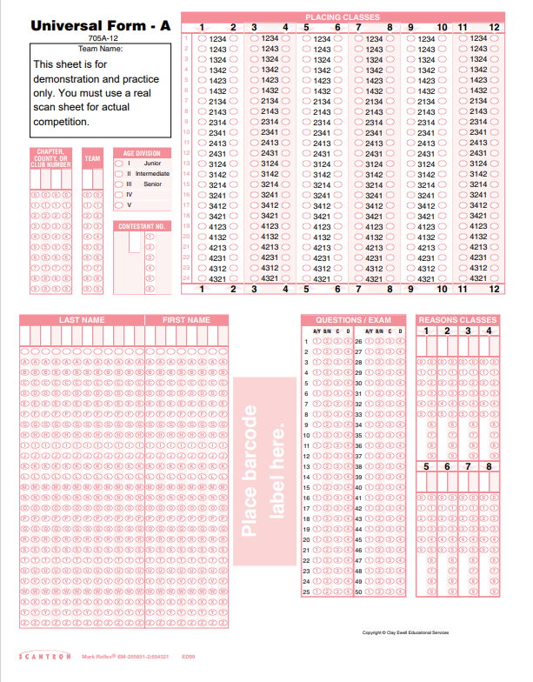

Scantron Example

