
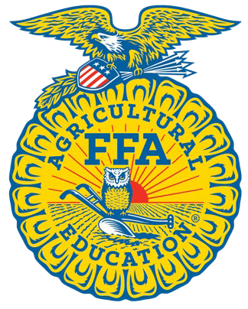


INDIANA 4-H & INDIANA FFA

Career Development Events

Livestock Skillathon

Purpose
The purpose of the Livestock Skillathon CDE is to provide a competitive, yet friendly, environment for youth to develop their knowledge of animal science and livestock management practices, and to gain and improve their production and life skills through hands-on learning.
Objectives
Students will be able to:
- Demonstrate the understanding and practical application and the principles of Animal Sciences related to the beef, sheep, swine, and meat goats project areas.
- Identify common breeds of livestock, feedstuffs, retail meat cuts, and equipment
- Demonstrate knowledge and skills related to the proper care and handling related to animal health care.
- Demonstrate knowledge related to all aspects of the livestock industry.
- Demonstrate knowledge and skills of livestock and meat evaluation.
Event Format
  - Regional Contest Components (All Individual Activities)
    - Identification of breeds, equipment, feedstuffs, retail meat cuts
    - Industry Quiz
    - Quality Assurance Exam
  - Regional Contest Scoring/Advancement
    - Identification- Total Possible Points:
      - Breed: 5 points per question
      - Equipment: 5 points per question
      - Feedstuffs: 5 points per question
      - Retail Meat: 5 points per question (Juniors: 4 points per question)
    - Industry Quiz: 2 points per question
      - Juniors-20 questions; Senior- 25 questions
    - Quality Assurance Quiz: 2 points per question
      - Juniors-10 questions; Senior- 20 questions
    - Total points for Junior Individuals: 260; Seniors Individuals: 290
    - Total points possible for Junior team: 780; Senior team= 870
    - Team Score is composed of top three scores per team
    - Advancement to State
      - Top 8 Senior Teams
      - Top 5 Junior Teams
      - If a regional contest included both 4-H and FFA teams, but both divisions were not represented by the teams qualifying for the state contest, the regional chairperson may add an additional state qualifying team to represent the missing division.

2026 State Contest
    - Each of the six regions will qualify the following teams to the state contest:
      - Senior- 8 teams
      - Junior- 5 teams

2

State Contest Components
    - Individual Components
      - Identification of breeds, equipment, feedstuffs, retail meat cuts
      - Industry Quiz
      - Quality Assurance Exam
      - Hay Judging
      - Wool Judging
      - Retail Meat Judging
    - Team Components
      - Quality Assurance
      - Animal Evaluation
      - Marketing and Performance

State Contest Scoring
    - INDIVIDUAL ACTIVITIES
    - Identification- Total Possible Points:
      - Breed: 5 points per question
        - JR: Breed Only
        - SR: Breed 3 pts & Description 2 pts
      - Equipment: 5 points per question
      - Feedstuffs: 5 points per question
        - JR: Feed ID
        - SR: Feed ID 3 pts & Classification 2 pts
      - Retail Meat
        - Junior: 4 Points (Species: 1pt; Primal 1pt; Retail 2pts)
        - Senior: 5 Points (Species: 1pt; Primal 1pt; Retail 2 pts; Cookery 1pt)
    - Industry Quiz: 2 points per question - 25 questions
    - Quality Assurance Quiz: 2 points per question
      - Juniors-10 questions; Senior- 20 questions
    - Hay Judging- Class of 4 samples with data and scenario (50 points)
    - Wool Judging- Class of 4 fleece samples with scenario (50 points)
    - Retail Meat Judging
      - 2 Species represented
      - Classes of 4 cuts (Ex. Ribeye steaks, Lamb Loin Chops, Pork Loin Chops)
      - Each class 50 points
      - Questions- 5 questions per class; 2 points per questions

TEAM ACTIVITIES
    - Quality Assurance Exam
      - Seniors- 25 questions; 2 points per question (50 points)
      - Juniors- 15 questions; 2 points per question (30 points)
    - Animal Breeding Class
      - Keep/Cull Class with Data and Scenario (50 points)
      - Questions- 2 points per question (10 points)
    - Marketing and Performance
      - Placing class with performance data (NOT EPDs) with a scenario (50 points)
    - Marketing and Performance youth are allowed to use a calculator. Bring your own calculator. NO programmable calculators or cell phones allowed!

Total Points Possible
    - Individual: Senior: 510 Points; Junior: 480 Points
    - Team: Senior: 160 Points; Junior: 140 Points
    - Total Team Score: Top 3 individuals on the team plus the team activities

Tiebreakers
    - Industry Quiz; Quality Assurance Quiz; Retail Meat ID

Scantron Example-Front Side
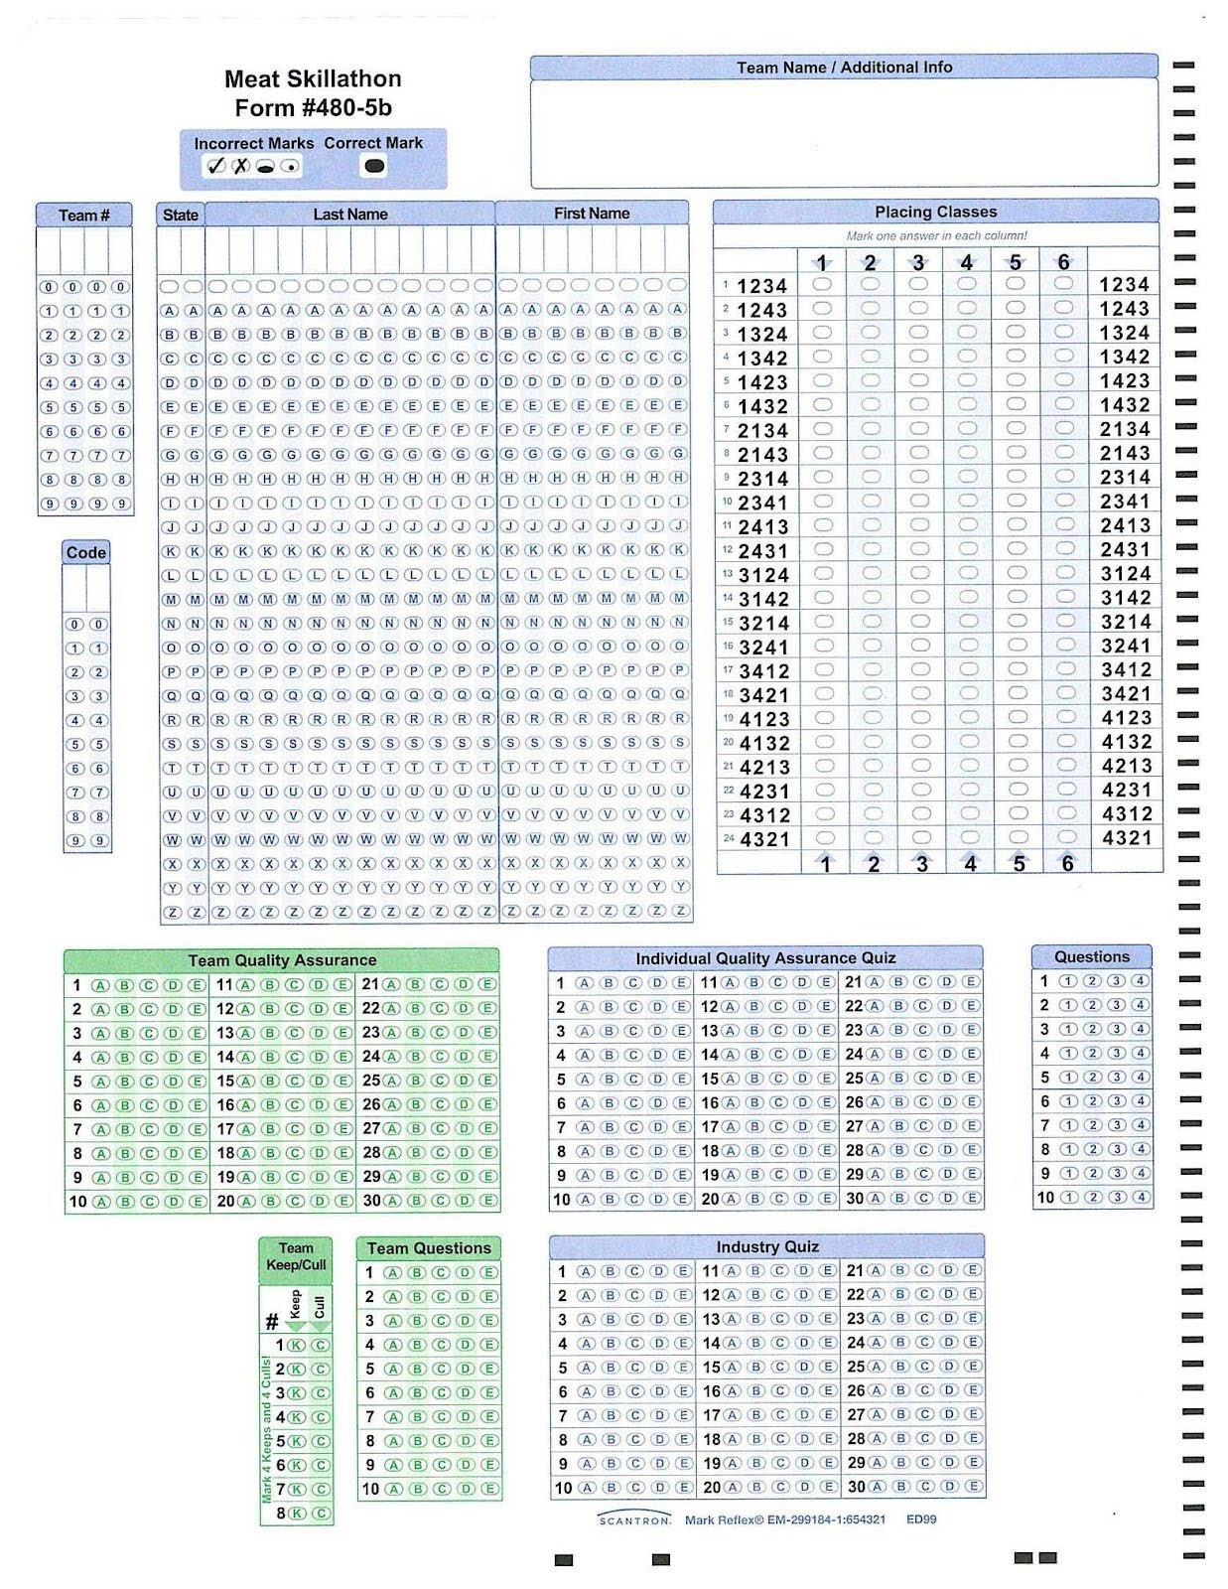

Scantron Example-Back Side
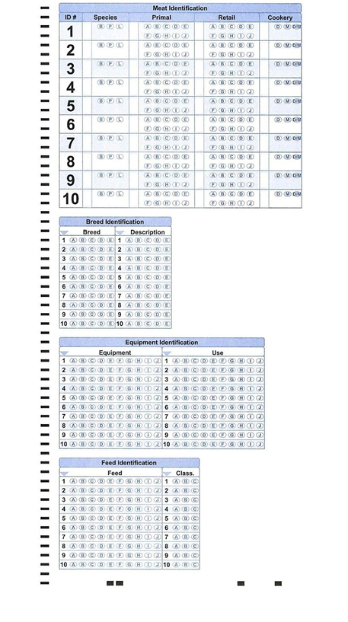

5

IDENTIFICATION LISTS

6

LIVESTOCK BREEDS
Beef
Angus | British breed with highest number of registrations in the US. Noted for mothering ability and carcass marbling
Belted Galloway | - Polled, black with white “belt” on barrel • Large size • Originated in Scotland • Easy Calving • Disease resistant • Adaptable
Brahman | Bos Indicus breed is known for heat and insect tolerance.
Brangus | Developed in the US, made up of 3/8 Brahman and 5/8 Angus. Bred for heat tolerance of Brahman and maternal and carcass traits of Angus.
Charolais | High growth breed originally from France known for muscle and cutability.
Chianina | Developed in Italy. Known for size and growth, referred to as the tallest breed of cattle.
Gelbvieh | Developed in Germany, originally considered a dual-purpose breed. Has good carcass cutability  and relatively early puberty.
Hereford | Can be horned or polled. Hardy British breed which in recent years combined polled and  horned associations.
Limousin | Developed in France with moderate growth rate and frame size and high carcass cutability.
Maine-  Anjou | Developed in France by crossing the Durham and the Mancelle breeds. Has good muscling.
Red Angus | From Scotland. Considered maternal with good terminal-related performance.
Red Poll | Originally developed as a dual-purpose breed in England that would possess moderate size,  would fatten quickly and also produce a good milk supply.
Salers | Found in ancient cave drawings dated 7,000 years ago in France. Considered to be one of the oldest and most genetically pure of all of the European breeds.
Santa Gertrudis | Developed in Texas by crossing the Brahman (3/8) and Shorthorn (5/8) breeds. Became first official breed developed in the US. Known for heat tolerance and maternal.
Shorthorn | Originated in England, with three distinct color patterns, considered a maternal breed.
Simmental | Originally developed in Switzerland for meat, milk and draft. Now noted for high growth rate, milking ability, and carcass cutability.
Texas Longhorn | Due to its natural selection and adaptation, this breed is considered to be a survival of the fittest breed. Known for being hardy, aggressive and adaptable.

7

Sheep
Cheviot | Small sized meat breed noted for its hardiness from Scotland
Columbia | Large frame US breed, developed from Lincolns and Rambouillets
Corriedale | Large frame wool breed developed from crossing Lincoln or Leicester rams on Merino ewes
Dorper | Primarily a mutton sheep, this breed was developed in South Africa and is one of the most fertile of sheep breeds.
Dorset | English, white face, meat breed known for out of season breeding
Finn sheep | Lighter muscled breed from Finland noted for being prolific

Hampshire | Large framed, English, meat breed with black face and wool cap
Katahdin | A hair sheep breed developed in the United States.
Lincoln | Although not a popular breed in the US, this breed is unique because the fleece of is carried in heavy locks that are often twisted into a spiral near the end
Montadale | Breed developed from Columbia and Cheviot cross noted for high quality carcasses and excellent wool
Merino | Very fine fleece breed with heavy wool production from Spain
Oxford | This breed originated as the result of crossing Cotswold and Hampshire and produces the heaviest fleece of any of the Down breeds.
Rambouillet | Wool breed developed in France and Germany from Merino breed
Shropshire | Breed originating in England known as one of the heaviest wool producers among the medium wool breeds
Southdown | This breed is early maturing with good lambing ability and average milk production. They excel in a crossbreeding program in their ability to produce meaty lamb carcasses at light weights and hot-house lambs.
Suffolk | Large framed, black faced breed known for high growth rate and carcass cutability from England
Tunis | This is a medium sized meat type breed that is also known for their disease resistance and their ability to remain productive on marginal land.

8

Swine
Berkshire | Originally from England noted for pork quality, tenderness and marbling.
Chester White | Known as a maternal breed with high conception rates, developed in PA.
Duroc | Noted for high growth rate, durability and leanness, developed in New Jersey and New York.
Hampshire | Terminal sire breed with unique color patterns that is noted for muscle and cutability.
Hereford | Dual purpose breed, red with white markings on head and lower body.
Landrace | Noted for large litters and large droopy ears, generally refined in bone.
Meishan | Black with wrinkled skin, long droopy ears • Small to medium size • Originates in China • Introduced to the US in 1989 • Slow growth rate • Early maturity • Large amount of back fat •
Pietrain | Noted for extreme muscle volume and shape, with a high propensity for stress which is related to pork quality concerns.
Poland China | Lean, heavy muscled, black breed with six white points and droopy ears from Ohio.
Spot | Black and white, developed in US, noted for rapid growth and as aggressive breeders
Tamworth | Red, rugged, active breed known as a lean type of hog with long neck, snout and leg.
Yorkshire | Has erect ears, known as the “mother breed”.
Goat
American Cashmere | Varied in color, horned • Small to medium size • Originates in Australia/ New Zealand • Introduced to US during the 1980s • Tolerant • Independent • Primarily used for fiber and cashmere production • 60% of the world’s supply of cashmere is produced in China
Angora | The most valuable characteristic of this breed as compared to other goats is the value of the mohair that is clipped
Boer | A prominent strong head with brown eyes and a gentle appearance. Nose with a gentle curve, wide nostrils, and well-formed mouth with well-opposed jaws. Body should be boldly three dimensional: long, deep, wide
Kiko | Known for hardiness and ability to achieve substantial weight gains when under natural conditions without supplementary feeding. Large framed, generally white with a coat that ranges from slick in summer to flowing hair when run in mountain country in winter.
Pygmy | Originally exported from Africa to zoos in Sweden and Germany where they were on display as exotic animals.
Tennessee Wooden Leg | Myotonic, their muscles become extremely stiff when they are frightened. This hereditary condition makes the goat very muscular.

9

Livestock Equipment List
Ammonia Sensor | Antiseptic  Applicator | Balling Gun | Beef Cattle Frame Stick
Beef Halter | Breeding Catheter | Cattle Clippers | Cattle AI Gun
Cauterizing Tail Docker | Curry Comb | Dehorner | Disposable Syringe
Drench Gun | Ear Notchers | Ear Tag Pliers | Elastrator
Electric Fence  Tester | Electronic ID Tag | Emasculator | Ewe Spoon
Foot Rot Shears | Forage Probe | Freeze Branding Iron | Heat Detection Patch
Heat or Hot Iron  Brand | Hog Snare | Hoof Block or  Cowslips | Hoof Chisel
Hoof Trimmer | Intravenous Set | Knife Steel | Lamb Boot
Lambe Tube  Feeder | Nasal Canula | Needle Teeth  Clippers | Nipple Waterer
Nitrogen Tank | Nose Lead | Pig Obstetrical Forceps | Pig Resuscitator
Pistol Grip Syringe | Prolapse Ring  Retainer | Ralgro Implant Gun | Ram Marking Harness
Rumen Magnet | Scalpel | Scotch Comb | Shearer’s Screwdriver
Sheep Shears | Squeeze Chute | Swine Breeding Spirette | Tattoo Pliers
Test Tube | Transfer Needle | Vacutainer | Wool Card

10

Livestock Skillathon Feedstuffs Classifications
Energy
Whole Shelled Corn | 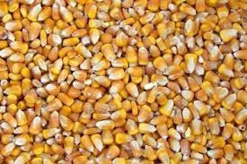
Cracked Corn | 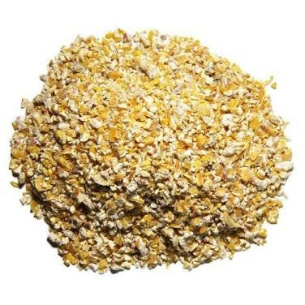
Steam Flaked Corn | 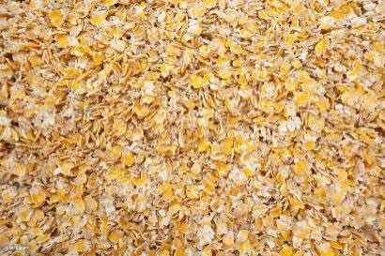
Soybean Hulls | 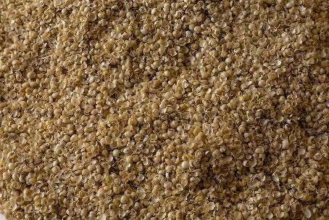
Whole Grain Wheat | 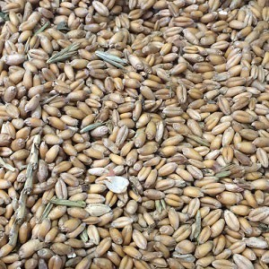

11

Wheat Middlings | 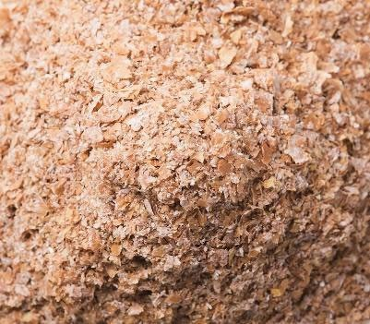
Whole Grain Barley | 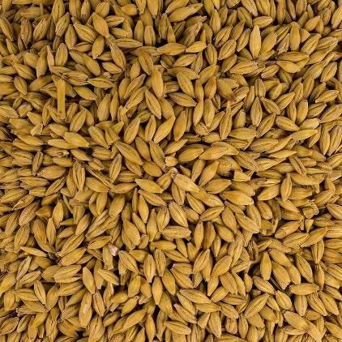
Cottonseed Hulls | 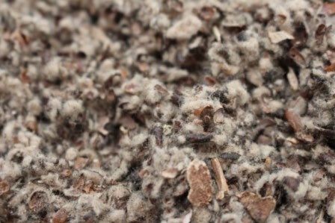
Whole Oats | 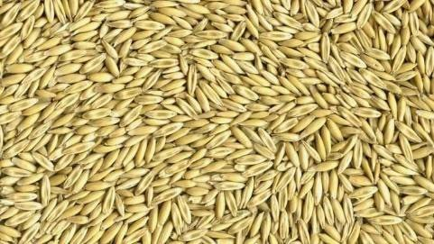
Rolled Oats | 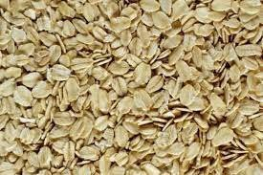

12

Dried Sugar Beet Pulp | 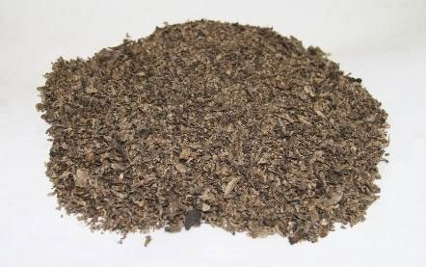
Dried Whey | 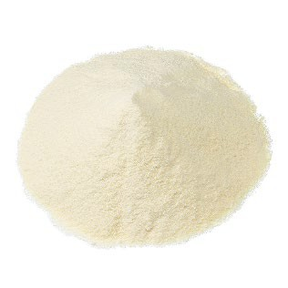
Dry Molasses | 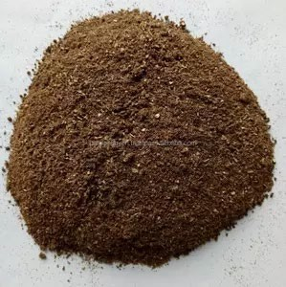
Protein
Urea | 
Corn Gluten Feed Pellets | 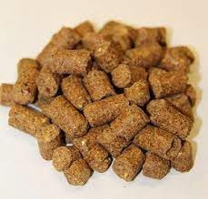

13

Corn Gluten Meal | 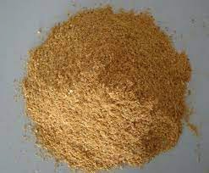
Distiller’s Grain | 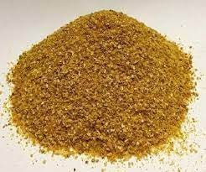
Whole Soybeans | 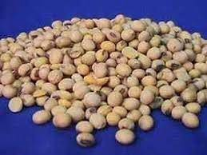
Soybean Meal | 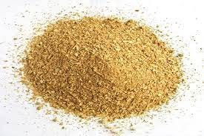
Cottonseed Meal | 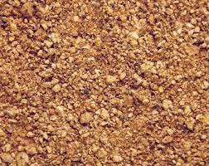

14

Fish Meal | 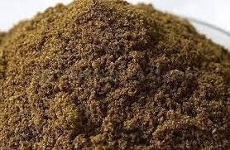
Blood Meal | 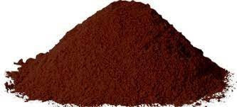
Dehydrated Alfalfa Meal Pellets | 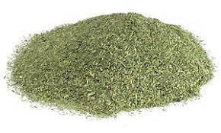
Mineral
Dicalcium Phosphate | 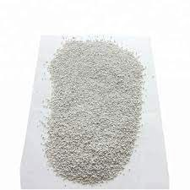
Ground Limestone | 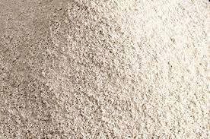

15

Trace Mineral Salt | 
White Salt | 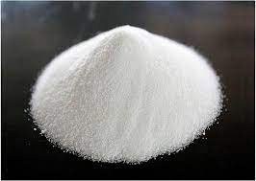

16

Retail Meat ID List

Species Primal Retail Cookery

Beef | Brisket | Corned | Moist
Beef | Brisket | Flat Half, Bnls | Moist
Beef | Brisket | Whole, Bnls | Moist
Beef | Chuck | 7-Bone Pot-roast | Moist
Beef | Chuck | Arm Pot-Roast | Moist
Beef | Chuck | Arm Pot-Roast, Bnls | Moist
Beef | Chuck | Blade Roast | Moist
Beef | Chuck | Eye Roast, Bnls | Dry/Moist
Beef | Chuck | Eye Steak, Bnls | Dry
Beef | Chuck | Mock Tender Roast | Moist
Beef | Chuck | Mock Tender Steak | Moist
Beef | Chuck | Petite Tender | Dry
Beef | Chuck | Shoulder Pot Roast (Bnls) | Dry/Moist
Beef | Chuck | Top Blade Steak (Flat Iron) | Dry
Beef | Flank | Flank Steak | Dry/Moist
Beef | Loin | Porterhouse Steak | Dry
Beef | Loin | T-bone Steak | Dry
Beef | Loin | Tenderloin Roast | Dry
Beef | Loin | Tenderloin Steak | Dry
Beef | Loin | Top Loin Steak | Dry
Beef | Loin | Top Loin Steak (Bnls) | Dry
Beef | Loin | Top Sirloin Cap Steak Bnls | Dry
Beef | Loin | Top Sirloin Cap Steak Bnls Cap Off | Dry
Beef | Loin | Top Sirloin Steak, Bnls | Dry
Beef | Loin | Tri Tip Roast | Dry
Beef | Plate | Short Ribs | Moist
Beef | Plate | Skirt Steak, Bnls | Dry/Moist
Beef | Rib | Rib Roast | Dry
Beef | Rib | Ribeye Roast, Bnls | Dry
Beef | Rib | Ribeye Steak, Bnls | Dry
Beef | Rib | Ribeye Steak Lip-On | Dry

17

Beef | Round | Bottom Round Roast | Dry/Moist
Beef | Round | Botton Round Rump Roast | Dry/Moist
Beef | Round | Bottom Round Steak | Moist
Beef | Round | Eye Round Roast | Dry/Moist
Beef | Round | Eye Round Steak | Dry/Moist
Beef | Round | Round Steak | Dry/Moist
Beef | Round | Round Steak, Bnls | Dry/Moist
Beef | Round | Tip Roast - Cap Off | Dry/Moist
Beef | Round | Tip Steak- Cap Off | Dry
Beef | Round | Top Round Roast | Dry
Beef | Round | Top Round Steak | Dry
Beef | Various | Cube Steak | Dry/Moist
Beef | Various | Beef for Stew | Moist
Beef | Various | Ground Beef | Dry
Beef | Variety | Heart | Dry/Moist
Beef | Variety | Kidney | Dry/Moist
Beef | Variety | Liver | Dry/Moist
Beef | Variety | Oxtail | Moist
Beef | Variety | Tongue | Dry/Moist
Pork | Ham/Leg | Pork Fresh Ham Center Slice | Dry/Moist
Pork | Ham/Leg | Pork Fresh ham Rump Portion | Dry/Moist
Pork | Ham/Leg | Pork Fresh ham Shank Portion | Dry/Moist
Pork | Ham/Leg | Smoked Ham, Bnls | Dry
Pork | Ham/Leg | Smoked Ham, Center Slice | Dry
Pork | Ham/Leg | Smoked Ham, Rump Portion | Dry
Pork | Ham/Leg | Smoked Ham, Shank Portion | Dry
Pork | Ham/Leg | Tip Roast, Bnls | Dry
Pork | Ham/Leg | Top Roast, Bnls | Dry
Pork | Loin | Back Ribs | Dry/Moist
Pork | Loin | Blade Chops | Dry/Moist
Pork | Loin | Blade Chops, Bnls | Dry/Moist
Pork | Loin | Blade Roast | Dry/Moist
Pork | Loin | Butterflied Chops Bnls | Dry

18

Pork | Loin | Center Loin Roast | Dry
Pork | Loin | Center Rib Roast | Dry
Pork | Loin | Loin Chops | Dry
Pork | Loin | Rib Chops | Dry
Pork | Loin | Sirloin Chops | Dry
Pork | Loin | Sirloin Cutlets | Dry
Pork | Loin | Sirloin Roast | Dry
Pork | Loin | Smoked Pork Loin Chop | Dry
Pork | Loin | Smoked Pork Loin Rib Chop | Dry
Pork | Loin | Tenderloin, Whole | Dry
Pork | Loin | Top Loin Chops | Dry
Pork | Loin | Top Loin Chops, Bnls | Dry
Pork | Loin | Top Loin Roast, Bnls | Dry
Pork | Shoulder | Arm Picnic, Whole | Dry/Moist
Pork | Shoulder | Arm Roast | Dry/Moist
Pork | Shoulder | Arm Steak | Dry/Moist
Pork | Shoulder | Blade Boston Roast | Dry/Moist
Pork | Shoulder | Blade Steak | Dry/Moist
Pork | Shoulder | Smoked Picnic, Whole | Dry/Moist
Pork | Side | Slab Bacon | Dry
Pork | Side | Sliced Bacon | Dry
Pork | Side/Belly | Fresh Side | Moist
Pork | Spareribs | Pork Spareribs | Dry/Moist
Pork | Various | Ground Pork | Dry
Pork | Various | Hock | Moist
Pork | Various | Pork Cubed steak | Dry/Moist
Pork | Various | Pork Sausage Links | Dry
Pork | Various | Sausage | Dry
Pork | Various | Smoked Pork Hock | Moist
Pork | Various | Country Style Ribs | Dry/Moist
Lamb | Breast | Ribs (Denver Style) | Dry/Moist
Lamb | Leg | American Style Roast | Dry
Lamb | Leg | Center Slice | Dry

19

Lamb | Leg | Frenched Style Roast | Dry
Lamb | Leg | Leg Roast, Bnls | Dry
Lamb | Leg | Sirloin Chops | Dry
Lamb | Leg | Sirloin Half | Dry
Lamb | Loin | Loin Chops | Dry
Lamb | Loin | Loin Roast | Dry
Lamb | Rib | Rib Chops | Dry
Lamb | Rib | Rib Chops Frenched | Dry
Lamb | Rib | Rib Roast | Dry
Lamb | Rib | Rib Roast, Frenched | Dry
Lamb | Shoulder | Arm Chops | Dry/Moist
Lamb | Shoulder | Blade Chops | Dry/Moist
Lamb | Shoulder | Square Cut | Dry/Moist
Lamb | Various | Shank | Moist
Beef | Variety | Heart | Dry/Moist
Lamb | Variety | Heart | Dry/Moist
Pork | Variety | Heart | Dry/Moist
Beef | Variety | Kidney | Dry/Moist
Lamb | Variety | Kidney | Dry/Moist
Pork | Variety | Kidney | Dry/Moist
Beef | Variety | Liver | Dry/Moist
Lamb | Variety | Liver | Dry/Moist
Pork | Variety | Liver | Dry/Moist
Beef | Variety | Oxtail | Moist
Beef | Variety | Tongue | Dry/Moist
Lamb | Variety | Tongue | Dry/Moist
Pork | Variety | Tongue | Dry/Moist
Beef | Variety | Tripe | Moist

20

Reference Material

21

Animal Science Course Standards

Domain Animal Husbandry and Welfare
Core Standard: Students demonstrate management techniques that ensure animal welfare and analyze procedures to ensure animal safety while maintaining safe animal products.
- AS-2.2 Analyze and document animal welfare procedures used to ensure safety and maintain low stress when moving and restraining animals.
- AS-2.3 Analyze and document animal husbandry practices and their impact on animal welfare.
- AS-2.4 Utilize tools, technology and equipment to perform animal husbandry and welfare tasks.
- AS-2.5 Analyze consumer concerns with animal production practices relative to human health.

Domain Animal Nutrition
Core Standard: Students analyze the nutritional needs of animals and evaluate feed rations for effectiveness.
- AS-3.1 Differentiate between nutritional requirements of animals in different growth stages and production systems (e.g., growth, maintenance, gestation, natural, organic, etc.).
- AS-3.2 Correlate a species’ nutritional needs to feedstuffs that could meet those needs.
- AS- 3.3 Determine the relative nutritional value of feedstuffs by evaluating their general quality and condition.
- AS-3.4 Appraise the adequacy of feed rations using data from the analysis of feedstuffs, animal requirements and performance.
- AS-3.5 Compare and contrast methods that utilize feed additives and growth promotants with production practices that do not, (e.g., organic versus conventional production methods).
- AS-3.6 Utilize tools and equipment to perform animal nutrition tasks.
- AS-3.7 Analyze and apply information from a feed label and feeding directions to feed animals.

Domain Animal Reproduction
Core Standard: Students evaluate animals for reproduction readiness and soundness and apply scientific principles to breeding programs.
- AS-4.1 Analyze the functions of major organs in the male and female reproductive systems.
- AS-4.2 Assess and describe factors that lead to reproductive maturity.
- AS-4.3 Evaluate reproductive problems that occur in animals.
- AS-4.4 Compare and contrast the use of genetically superior animals in the production of animals and animal products.
- AS-4.5 Demonstrate how to determine probability trait inheritance in animals.
- AS-4.6 Analyze how DNA analysis can detect genetic defects in breeding stock
- AS- 4.7 Analyze the care needs for breeding stock in each stage of growth.
- AS-4.9 Develop an understanding of artificial insemination, embryo transfer, and cloning.
- AS-4.10 Analyze the processes of major reproductive management practices, including estrous synchronization, superovulation, flushing and embryo transfer.
- AS-4.11 Compare and contrast quantitative breeding value differences between genetically superior animals and animals of average genetic value.

Domain Anatomy and Physiology
Core Standard: Classify animals according to taxonomic classification systems and use (e.g., agricultural, companion, etc.).
- AS-6.1 Explain how animals are classified using a taxonomic classification system.
- AS-6.2 Appraise and evaluate the economic value of animals for various applications in the agriculture industry.
- AS-6.3 Analyze the visual characteristics of an animal or animal product and select correct classification terminology when referring to companion and production animals.
Core Standard: Apply principles of comparative anatomy and physiology to uses within various animal systems.
- AS-7.1 Analyze the functions of each animal cell structure.

22

- AS-7.3 Compare and contrast animal cells, tissues, organs, body system types and functions among animal species.
Core Standard: Select and train animals for specific purposes and maximum performance based on anatomy and physiology.
- AS-8.1 Compare and contrast desirable anatomical and physiological characteristics of animals within and between species.
- AS-8.2 Compare and contrast procedures to sustainably and efficiently develop an animal to reach its highest performance potential with respect to its anatomical and physiological characteristics.
- AS-8.3 Evaluate and select products from animals based on industry standards.

Domain Animal Health and Safety
Core Standard: Students design programs to prevent animal diseases, parasites and other disorders and analyze biosecurity measures utilized to ensure animal welfare.
- AS-9.1 Describe and demonstrate the proper use and function of specific tools and technology related to animal health management.
- AS-9.2 Perform simple health-check evaluations on animals and practice basic emergency response procedures related to animals.
- AS-9.3 Identify and describe common illnesses and disorders of animals based on symptoms and problems caused by wounds, diseases, parasites and physiological disorders.
- AS-9.4 Research and analyze data to evaluate preventive measures for controlling and limiting the spread of diseases, parasites and disorders among animals.
- AS-9.5 Assess the safety and effectiveness of facilities and equipment used for surgical and nonsurgical veterinary treatments and procedures.
- AS-9.6 Analyze procedures at the local, state and national levels to ensure biosecurity of the animal industry.
- AS-9.7 Analyze the health risk of different zoonotic diseases to humans and identify prevention methods.

Students should be knowledgeable about all areas of the livestock industry.
- Industry Exam:
  - Health- types of diseases, methods of treatment, signs of disease, normal vital signs
  - Digestive Systems and Nutrition- Nutrient classes and functions, similarities and differences between various digestive systems found in livestock
  - Anatomy and Physiology- functions of each body system; major parts of each system
  - Breeding and Reproduction- knowledge of gestation, parturition, signs of estrus, dystocia, etc.
  - Genetics- understand terms like homozygous, heterosis, determining probability of traits and their heritability
  - Meats- major cuts of each species, common characteristics of each type of meat; carcass terms
  - Marketing- how livestock are marketed; prime times for the sale of livestock; common terms
  - Breeds- common characteristics; maternal vs terminal
- Quality Assurance Exam
  - Reading Drug Labels- able to pull key information from the label
  - Calculating Dosage of Medications
  - Selection of Proper Drug for Scenario
  - Common conversions
  - Knowledge of Proper Methods of Injection
  - Understanding of withdrawal times

23

