Indiana 4-H & Indiana FFA

Career Development Events

Poultry and Eggs CDE

Purpose
The purpose of the Poultry and Eggs CDE simulates learning activities related to production and management, processing, marketing, food safety, and poultry product quality.

Objectives
The objectives of this Career Development Event are:
- Make accurate observations and logical decisions.
- Discuss and justify decisions (orally and written).
- Communicate industry and product terminology.
- Identify USDA standards of product quality.
- Identify consumer acceptance criteria of products.
- Recognize the economic importance of value-added products.
- Collaborate with others to analyze industry scenarios.
- Demonstrate the use of appropriate information technology in the poultry industry.
Specifically, participants will
- Evaluate and place live meat-type chickens and orally defend the selection.
- Evaluate and place live egg-type hens and orally defend the selection.
- Evaluate, grade and place ready-to-cook carcasses of chickens or turkeys and orally defend the placing.
- Evaluate and grade ready-to-cook carcasses and parts of chickens and turkeys.
- Evaluate and grade individual shell eggs for interior quality.
- Evaluate and grade individual shell eggs for exterior quality and indicate factors governing the grading.
- Evaluate pre-cooked or par-cooked further processed poultry meat products and indicate factors governing the evaluation.
- Identify poultry carcass parts.

General Guidelines
- All youth must be active members of a county 4-H program or FFA chapter in good standing in order to compete.
- A team listed as an FFA team must be made up entirely of actively enrolled FFA members from the same FFA Chapter.
- Junior FFA teams must be made up of members who originate from the school where they would normally attend and be Junior FFA members in the 5th- 8th grade.
- Senior FFA teams must be made up of members who originate from the same FFA chapter and be enrolled in 5th to 12th grades.
- A team listed as a 4‐H team must be made up entirely of actively enrolled 4‐H members.
- A school-based junior or senior 4-H team must include participants enrolled at the same school. Online learning schools cannot participate as a school-based 4-H team.
- A community club-based junior or senior 4-H team must include participants enrolled in the same 4-H club.
- A county-based junior or senior 4-H team must include participants enrolled in the same 4-H county.
- Any 4-H team and coach must be approved by their county 4-H Youth Development Educator.

Event Rules
- All contestants must be registered by the deadline via 4-H Online or the Indiana FFA Portal.
- All contestants are to enter the contest with a clean notebook and no notes or handouts other than what may be provided by the contest coordinator. The group leader is to take away from contestants any notes or handouts in their possession.
- No cell phones, smartwatches, or other electronic devices are to be with the youth unless it is a medical device and has been reported to the contest coordinator.
- Each contestant will be allowed a minimum of 10 minutes for each class
- Each contestant will be allowed a maximum of two minutes to give oral reasons.
- Youth will fill out a scantron for their placings.
- Fifty points will constitute a perfect score on a placing class and on a set of oral reasons.
- Group Leaders. A group leader shall be in charge of each group to move the contestants, to assist in supervising the class, to see that the classes are properly exhibited, and to answer any questions, which may not pertain to the actual placing of the classes under consideration.

Tiebreakers
- For all individual awards, ties will be broken first by the highest individual score in class 1, then class 2, etc., until the tie is broken.
- Ties for team awards will be broken by the alternate’s score.

Event Format.
Past Production (200 Total Points)
- Two placing classes of white leghorn or leghorn type hens (50 points each)
- Total cuts per class not to exceed 15 points.
- Two sets of oral reasons (50 points each)
  - Seniors Only

Market Poultry (300 Total Points)
- Class of Dressed Broilers (2-6 lbs) (50 Points) Graded A, B, C, or No Grade Cuts of 1-2-2
- Class of Dressed Ducks or Dressed Turkey (6-16 lbs) (50 Points) Graded A, B, C, or No Grade Cuts of 1-2-2
- Boneless Further Processed Poultry Meat Products
  - 2 points for each defect (present or absent) for each plate of product = 10 points per plate (100 Points)
- Parts Identification (50 Points)
  - 10 Parts- 5 Points each
  - List of parts found in National 4-H Poultry Judging Manual
- Parts Grading (50 Points)
  - Graded A, B, C, or No Grade. Cuts 1-2-2
  - All parts will be from same size birds. 10 Parts

Market Eggs (200 Total Points)
- Exterior Egg Grading (50 Points Per Class)
  - Graded A, B, or Dirty. Cuts 2-3
  - 10 Eggs per class
- Egg Candling (50 Points Per Class)
  - Graded AA, A, B, or Loss. Cuts 1-3
  - 10 Eggs per class
- Broken Out Eggs (50 Points Per Class)
  - Graded AA, A, B, or Loss. Cuts 1-3
  - 10 Eggs per class
  - This will be the final class of the day.

Total Scoring
- Juniors: 600 Points/ Individual Team: 1800 Points
- Seniors: 700 Points/ Individual Team: 2100 Points

References
This list of references is not intended to be all-inclusive. Other sources may be utilized, and teachers are encouraged to make use of the very best instructional materials available. The following list contains references that may prove helpful during event preparation.

- University of Kentucky- https://national4hpoultry.ca.uky.edu/poultry-judging-manual
Poultry Picture Series, USDA Agricultural Marketing Service, https://www.ams.usda.gov/book/poultry-picture-series
- Poultry-Grading Manual —Agriculture Handbook Number 31 (latest USDA edition). Agricultural Marketing Service, United States Department of Agriculture. https://www.ams.usda.gov/sites/default/files/PoultryGradingManual.pdf
- Egg-Grading Manual —Agriculture Handbook Number 75 (latest USDA edition),
- Agricultural Marketing Service, United States Department Agriculture.
https://www.ams.usda.gov/sites/default/files/media/Egg%20Grading%20Manual.pdf
- Past CDE materials and other resources are available on FFA.org
- One Less Thing—Poultry Judging Handbook Lessons, https://www.onelessthing.net/collections/poultry
- Poultry Science Manual for National FFA Career Development Events 7th Edition (2017)
- Instructional Material Services. Available from Instructional Materials Service (IMS), Texas A&M University, 2588 TAMUS, College Station, Texas 77843-2588 (Phone: 979-845-6601; FAX: 979-845-6608; https://agrilifelearn.tamu.edu/s/product/poultry-science-manual-for-career-developments-7th-edition/01t4x000002dEvPAAU

Scantron Example-Front

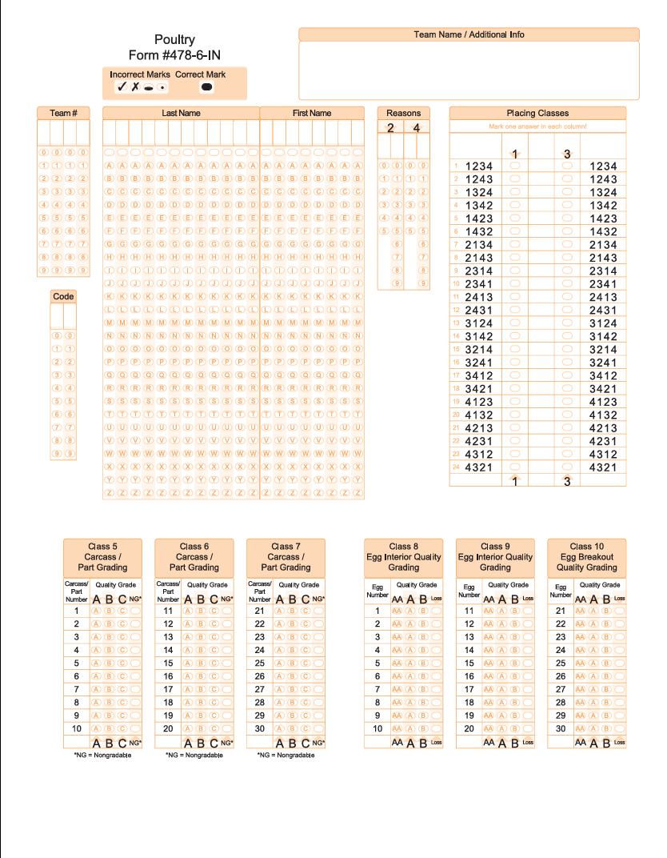

Scantron Example-Back
