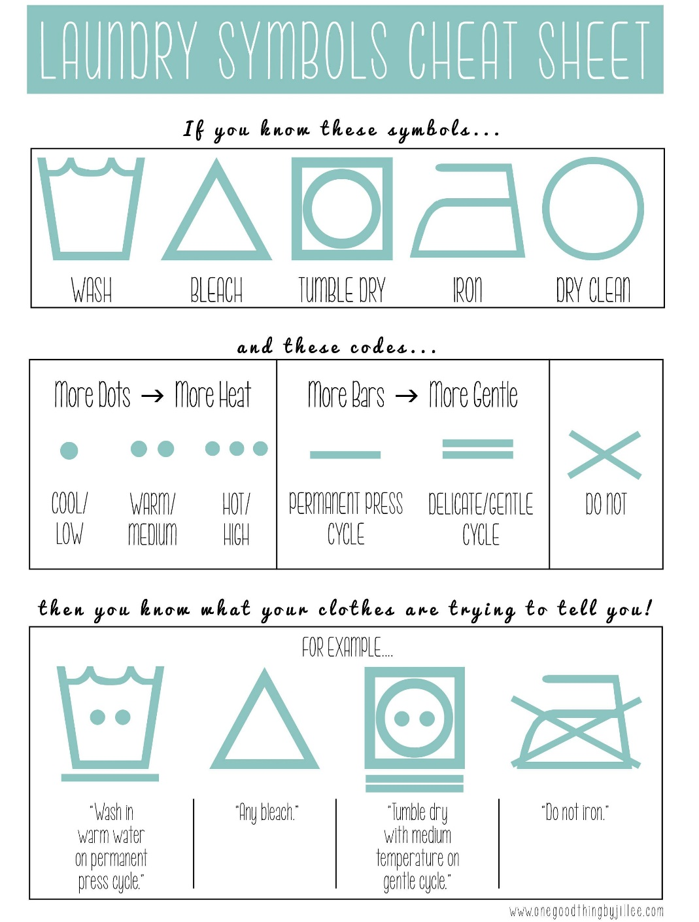
Here's a cool cheat sheet from http://onegoodthingbyjillee.com/.

