Name:

Logbook Blueprint

Model i Habits and Actions

Stay Curious, Learn from Failure, Uncover

What is an invention?
An invention is something new that enables us to solve a problem or do something better or easier.

Purpose of the Logbook Blueprint
The purpose of the Logbook Blueprint is to tell the entire story of your invention, beginning, middle and end. You will record every step you take in making your invention, including what you did, why you did it and how you did it. You will make note of what worked and what didn’t work. The Logbook Blueprint is an important part of the invention process and should be a complete and accurate record of the ideas, plans and steps used to create the invention. This record will help you make decisions as you work through your invention journey. Logbooks can be used by students to prove they came up with the idea and invention. Oftentimes, they are used as part of the patenting process.

How to use the Logbook Blueprint
The Logbook Blueprint is like a diary or journal that is continuously added to as you work on your invention. Follow the steps of the invention process and fill out the various pages as you work on them. When you are done with a page, print your name and the date at the bottom. If you need extra space for any section, add your own paper as needed. Once you are done, put the pages in the order in which you did them, and staple them to make a complete Invention Logbook. This logbook will also be used as part of the final presentation and needs to be complete.

You can also use lined paper or any notebooks as a logbook. Use the subject headings and questions on pages 6-7 to guide the creation of your logbook.

The name of the invention:

The problem it solves:

Logbook Blueprint

Statement of Originality

I promise that the ideas in this Invention Log are my own. (If a team, all should complete.)

Inventor Name(s):

Signature(s):

Date:
Grade:
School:

Originality
If you plan to compete in Invention Convention, it is very important that your solution is original and does not already exist or is substantially different from any other invention. These are great places to research to find out if your idea already exists:
- Libraries (ask a librarian for advice on where to look)
- The internet (e.g., www.google.com, www.bing.com)
- Stores (e.g., www.amazon.com, www.bestbuy.com, www.walmart.com, www.target.com)
- Books about your topic(s) (look up at www.bn.com or www.amazon.com)
- Trade- or industry-specific publications (each industry has topical magazines and websites)
- United States Patent and Trademark Office (visit www.uspto.gov to search for patents and trademarks)
- Domain registrars (e.g, www.GoDaddy.com to see if your product name dot.com is taken)

Invention Process Overview

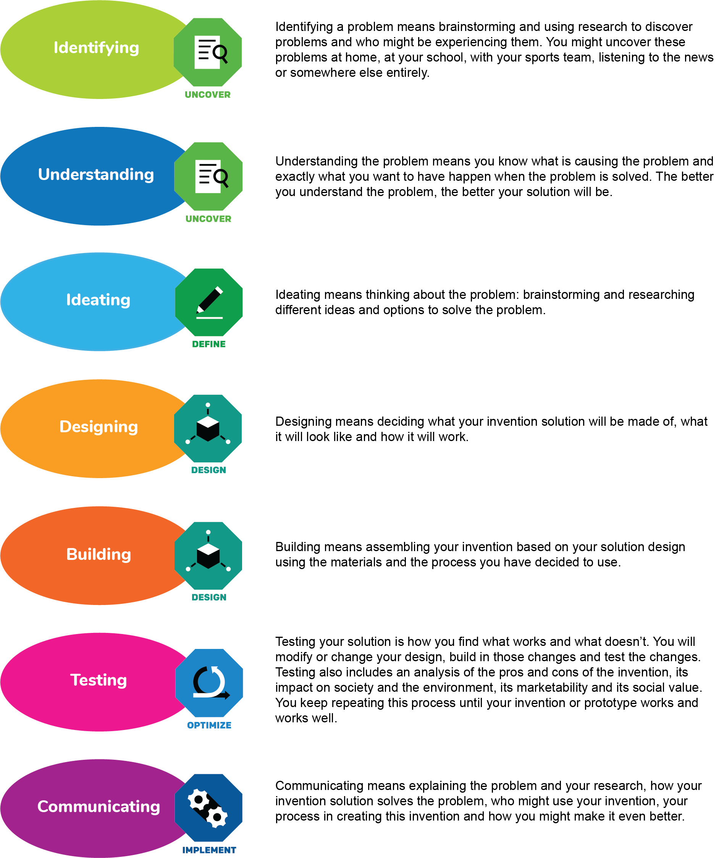

Terms to Explore

These are terms related to inventing. Some are used in this Logbook Blueprint and some may be terms that you will want to use to describe your process. Please read over the terms before you get started.

Advertise – the act or practice of calling public attention to one's product, service, need, etc., especially by paid announcements in newspapers and magazines, over radio or television, in social media, on billboards, etc.

Brainstorm – to produce an idea or way of solving a problem by holding a spontaneous group discussion or individual thinking session.

Data collection – the process of gathering and measuring information of different variables in a systematic way that helps one to answer research questions, test hypotheses and evaluate outcomes.

Design – to plan and make decisions about something that is being built or created. To create the plans, drawings, etc., that show how something will be made.

Durable – able to withstand wear, pressure or damage.

Engineer – people who invent, design, analyze, build and test machines, systems, structures and materials to fulfill objectives and requirements while considering the limitations imposed by practicality, regulation, safety and cost.

Entrepreneur – a person who organizes and operates a business or businesses, taking on greater than normal financial risks in order to do so.

Experiment – a scientific procedure undertaken to make a discovery, test a hypothesis or demonstrate a fact.

Hypothesis – a proposed explanation using previous knowledge but made on the basis of limited evidence; a starting point for further investigation.

Improvements – the act or process of making something better; the quality of being better than before.

Interview – a formal discussion to establish needs or requirements; a report or reproduction of information is obtained.

Inventor – a person who invented a particular process or device or who invents things as an occupation.

Invest – to put (money) to use, by purchase or expenditure, in something offering potential profitable returns.

Market – to advertise and offer a product for sale; to present something in a particular way and make people want to buy the product.

Marketable – able or fit to be sold or marketed; meets enough market needs to be able to be sold.

Operational – in or ready for use.

Terms to Explore

Patent – a government authority or license conferring a right or title for a set period, especially the sole right to exclude others from making, using or selling an invention.

Perseverance – continued effort to do or achieve something despite difficulties, failure or opposition.

Pitch – promotion by means of an argument and demonstration; a short verbal dialogue that tells the story and benefits of a product.

Problem – a matter regarded as unwelcome or harmful and needing to be dealt with and overcome.

Product – something that is made or grown to be sold or used.

Profit – money that is made in a business, through investing, etc., after all costs and expenses are paid; a financial gain.

Profitable – yielding advantageous returns or results; yielding a financial profit or gain.

Prototype – an original or first model of something from which other forms are copied or developed; an early version of a product that helps the inventor consider different options for design before finalizing a go-to-market design.

Publication – the act or process of producing or printing a book, magazine, newspaper, etc., and making it available to the public.

Research – the study of materials and sources in order to establish facts and reach new conclusions.

Seek – to search for something or someone; ask for help to achieve something.

Solution – something that is done to deal with a problem; something that solves a problem.

Source – the point or place which something starts; a place, person, or thing from which something originates.

Substantially – to a great or significant extent.

Test – a procedure intended to establish the quality, performance, or reliability of something, especially before it is taken into widespread use.

Testimonial – a written or spoken statement in which you say that you used a product or service and liked it.

The Steps You Will Take - Overview

As you work on your invention, follow these steps and check them off as you complete them. Don’t write your ideas here — use the appropriate space in the following pages to complete each of the sections.

IF YOU ARE CREATING YOUR OWN LOGBOOK, WRITE THESE SUBJECT HEADINGS AND THE QUESTIONS AT THE TOP OF EACH PAGE TO GUIDE YOUR JOURNEY.

Invention Step: Identifying and Understanding — Model i: Uncover
- Begin brainstorming possible problems or needs that you might be interested in solving. Try using SCAMPER to inspire your brainstorming.
- What problem are you trying to solve?
- Research the problem you are trying to solve to gain understanding and perspective.
- Interview at least three people to gain understanding of the problem.
- After completing your research, clarify the problem you are trying to solve and restate it.

Invention Step: Ideating — Model i: Define
- What are some possible solutions? Brainstorm as many as you can.
- Which one did you choose to do?
- Has this solution been done before?

Invention Step: Designing — Model i: Design
- Make a model (drawing) of the invention.
- What problems might you encounter with this design?
- How will you fix those problems?
- Revise your design and draw a new model that you think will work.
- What parts and materials will you need to make the invention?
- Where will you get those parts and materials?
- What additional skills will you need to make the invention?
- Who can help you do those activities?
- Considering the materials and skills you need, do you need to revise your design? Draw a new model.

The Steps You Will Take - Overview

Invention Step: Building — Model i: Design
- Get the parts and materials and build the invention. Get any help you need to build it.

Invention Steps: Testing — Model i: Optimize
- Create a testing plan to collect observations and data on your prototype.
- Test and evaluate the invention.
- Identify any problems with the invention.
- Repeat Invention Step: Designing to fix any problems.
- Repeat Invention Step: Testing. Continue designing and testing until you have reached your goal.

Invention Step: Communicating — Model i: Implement
- Name the invention.
- Plan and create the Invention Display Board.
- Practice what you will say about your invention. For help in preparing your pitch, use SCAMPER Part 3 and Pitch Practice Core Activities.
- Be proud of what you have done!!!!

Invention Step: Identifying and Understanding – Model i: Uncover

- Begin brainstorming possible problems or needs that you might be interested in solving. What are some common problems you encounter throughout your day? What are some common problems your family and friends encounter throughout their day? Is there something in your neighborhood or community that could be made better? Ask others, too. Use SCAMPER to inspire your ideas.

- What problem are you trying to solve? The more specific you are in describing the problem, the better your solution will be. How did you come up with the problem?

- To gain understanding and perspective, research the problem you are trying to solve. Example questions: What are the causes of this problem? Who and what is impacted by the problem? When did people begin to discover that this is a problem? Has anyone tried to fix it? If you need more space, use lined paper and add it to these pages.

- Interview at least three people to gain understanding of the problem. Ask them to share their experiences with this problem. How have they tried to fix it themselves? What might help improve this problem for them, specifically?

- After completing your research, clarify the problem you are trying to solve and restate it.

- What is the result you are trying to achieve? The more specific you are in describing the result you want, the better your solution will be.

Invention Step: Ideating – Model i: Define

- What are some possible solutions? Brainstorm as many as you can. Don’t stop to think whether it is possible (you’ll do that later). For now, let your imagination run. Even silly ideas can inspire real solutions.

- Which one did you choose to pursue? How did you decide which solution to try?

- Has this solution been done before? If it exists, how is your approach different and better? What research did you do to see if this invention had been done before? Who did you talk to? Where did you look? What website did you search? You should show four pieces of evidence of different types of research — talking with experts, searching the internet, interviewing friends and family as to how useful this would be, etc.
Where I looked to see if my idea is new:
A.
B.
C.
D.

Document any similar inventions you find. Include how yours is different.

Teacher Signature – REQUIRED FOR ALL PARTICIPANTS
Teacher's Name: (Printed)
Teacher's Signature:
Teacher's Signature: |  | Date:
I approve of the solution/invention my student has chosen to pursue and agree that it not only meets the guidelines shown on the Restrictions and Requirements page but is also safe.

- Draw a model (sketch or drawing) of the invention you are thinking about building. Label all of the important parts and features. Explain how the invention will work. If you need more space, use another blank page.

Invention Step: Designing – Model i: Design

- What problems or issues might you encounter with this design? Who did you talk to about this design (another student, parent, teacher, etc.)? What were their comments about your design?

- How can you fix those problems or address those issues?

- Revise your design and draw a new model that you think will work.

- What parts, materials and tools will you need to make the invention, and how much will they cost?

- Where will you get those parts and materials?

- What additional skills or abilities will you need to make the invention?

- Who can help you build the invention?

- Considering the materials and skills you need; do you need to revise your design? Draw a new model.

Invention Step: Building – Model i: Design

- Get the parts and materials and build the invention (ask your helpers, if needed). Don't forget to take notes on this process, too. What is working and what had to change?

Invention Step: Testing – Model i: Optimize

- Create a testing plan to collect observations and data on your prototype. How will you know if your invention works?

- Test and evaluate the invention. How did you test the invention?

- Identify any problems with the invention. What will you change to make it better?

- Repeat Invention Step: Designing to fix any problems. Add additional sheets of paper as needed.

- Repeat Invention Step: Testing. Continue DESIGNING and TESTING until you have reached your goal. Add additional sheets of paper as needed.

Invention Step: Communicating – Model i: Implement

- Naming your invention is important. What words describe your invention?

- What is the function of your invention? How will it solve the problem? How will it help others? (This might be referred to as marketing.)

- How is your invention different from others that may already be on the market? If it is similar, what did you do to make it better? How is it different?

- Who is your target audience? Who would use your invention?

- Some creative, attention-getting techniques you can use:

- Alliteration (using the same first letters or sounds): Kit Kat
- Rhyming: Light Bright
- Alternative spelling: Sno Bal
- Using numbers in the name: Super Clean 3000
- Describing the function of the invention: Hydro-Blast

Based on this analysis, what are some good names for your invention?

- Which name do you like best and why?

For help in designing your display board, use the Communicating — Designing My Display Board lesson plan.

For help in creating and practicing your pitch, use the Communicating — Pitch Practice lesson plan.

