

3D Design Curriculum

Sam McCollum

**This is a basic outline of what I did for my 3d Printing SPARK Club. I had access to 10 Laptops and 4 3D Printers. You will not have the time to complete any of the prototypes during the classes. You will be able to start the Race Cars at the end of the first day and have them ready for youth on the second day. Make sure youth understand that this is not instant gratification. You will need to give yourself a week if you are using your own printers to print everything that youth create during the second day.**

**Day 1**

Introduction

1. What is 3D design and prototyping?
   1. Take a digital file and create and actual product.
      1. Turns consumers into creators!
   2. How do they work.
      1. 3D printers take the model that you downloaded or created and slices them up into layers. Then, layer by layer lays down plastic to create your model. The possibilities are only limited by your imagination!
   3. Why is it important?
      1. People can make anything at any time! 3D Printing can eliminate the need for storing and stocking items. Things can be customized based on the customer needs!
   4. What can you print? – Just bout anything!
   5. What kind of jobs use 3D design and prototyping?
2. What will we be covering?
   1. Using the measuring on TinkerCAD
      1. How to use calipers
         1. 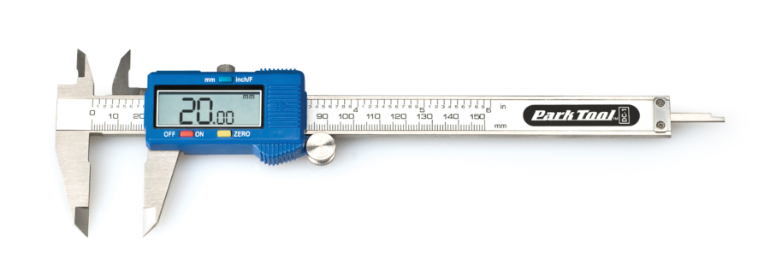Use a digital Caliper on a tube or pipe

Depth Measurement

External Measurement Measurement

Internal Measurement

* + - 1. Can measure objects to the exact millimeter and can be transferred over to Tinkercad.
    1. The numbers in the TnkerCAD program are very important. These numbers will allow participants to get exact sizes, shapes and distances. TinkerCAD uses millimeters in every measurement that it displays so get youth used to it.
  1. Learning how to use TinkerCAD
     1. Create an account that youth can access. TinkerCAD is a great way to save projects on the cloud. This will make it easier for you to print just using the export process.
     2. Basic Shape Use and basic scaling and movement for TinkerCAD
        1. 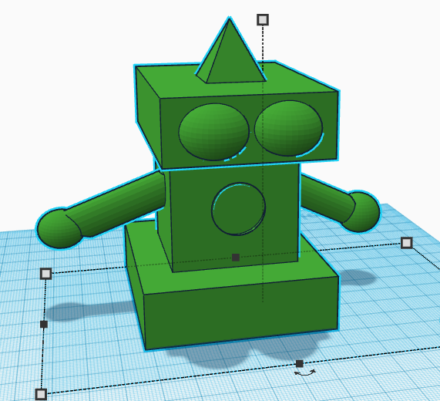Moving/rotating images
        2. Shaping
        3. Creating holes
     3. Create a basic robot using cubes, spheres and cylinders.
        1. This will allow youth to get used to modifying shapes.
        2. You will not print these robots
     4. Create a car with movable parts.
        1. The body, axels and wheels will need to be printed separately.
        2. Copy and paste the created items to make sure all the sizes are accurate.
        3. Axel holes in the base will need to be 2mm bigger than the axels to allow them to pass through and be able to spin.
        4. 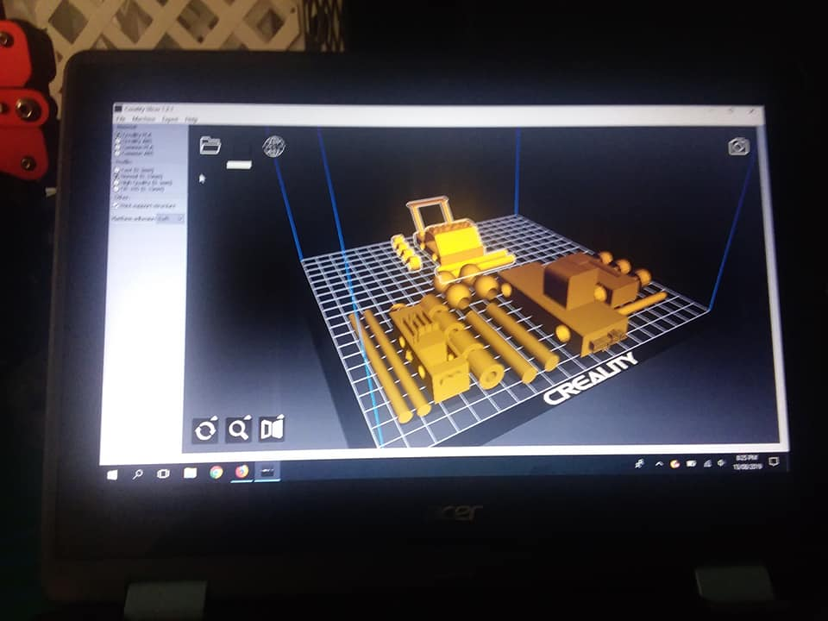Wheels will need to fit snugly on the axels. The wheel holes need to be 1mm bigger than the axels. You may make it larger to make sure it fits.
        5. Make sure all holes and axels are perfect circles in the program. Ovals and squares do not spin.
        6. To make sure pieces stay together use a 3D Printing pen like a glue gun.

**Day 2**

1. Design
   1. Go over the importance of sketching out a design before making a 3D model
      1. Why?
         1. Sometimes just winging it can be fun. What if you were tasked to create something for someone? Judging on the amount of time it takes to print an item, do you have time and material to do it over and over?
   2. Task: you will all be broken up into teams and given a Need to complete for me before the end of this session. You will have to brainstorm what you need to do to fill this need, design it and then 3D print it. Once it is printed you will then be asked to present the need and the process you took to fulfill it.
2. Printing
   1. Printing will most likely not be finished by the end of this session. You will be able to receive the items at our office once completed.
3. Needs
   1. Puzzle – Crate a puzzle with 3 fitting pieces minimum
   2. Charity Group – We run a donation program that supplies plates and utensils to families overseas. We need a prototype plate spoon and fork that fits into smaller packages to cut back on shipping costs
   3. Teacher – Explore the seven wonders of the ancient world:

* Great Pyramid of Giza
* Hanging Gardens of Babylon
* Statue of Zeus at Olympia
* Temple of Artemis at Ephesus
* Mausoleum at Halicarnassus
* Colossus of Rhodes
* Lighthouse of Alexandria

Or explore the [New7Wonders of World](https://en.wikipedia.org/wiki/New7Wonders_of_the_World):

* Great Wall of China
* Petra
* Christ the Redeemer
* Machu Picchu
* Chichen Itza
* Colosseum
* Taj Mahal
* Great Pyramid of Giza
  1. Toy – Create Mr. potato head pieces that can fit into the base.
  2. Fashion – Create a wearable object
  3. Engineering – Design gears that lock together and move
  4. Caliper use – Design an exact replica of an item.
  5. Vehicle – Create a car that is powered by balloons
  6. Space – Design a container that we can use in space
  7. Create a sign using braille for the 4-H Office
  8. Create two functional tools that can tighten and loosen bolts.
  9. Choose any need in your household or community. Make a prototype, sketch it and design it.

1. Present
   1. Each team will be given 3 minutes to present the item that they created.
   2. Please inform us of the Need that you chose, the challenge of it and why you chose it.