4-H Eco-Lab: Exploring STEM through the Environment
2024 Youth Staff Pre-Conference
Davis Purdue Agricultural Center

Table of Contents
Environmental Monitoring with Sensors
Water Quality Sensors with Snap Circuits
Erosion Control & Experimental Design
Stream Geomorphology & Restoration
Introduction to Watersheds
Stream Geomorphology: Math in Action
Stream Restoration & Engineering Design
Wetlands
What is a wetland? – Frayer Model
Wetland Restoration: Modeling Wetlands as Sponges
Wetland Detectives
Technical Communication: Design Informational Signage for Visitors to this Wetland
Constructed Wetland Engineering
Follow-Up Environmental Resources
Reading List

Teaching STEM Concepts in an Ecological Science and Engineering Context
This workshop covers activities that equip students with knowledge and skills in scientific inquiry, experimental design, mathematics, technology, and engineering design and are situated in an authentic ecological science and engineering context. Situated learning helps students see how these STEM skills can be applied to monitor, evaluate, protect, manage, and restore ecosystems, providing opportunities for students to practice transfer of learning. These demonstrations of the long-range utility can increase students’ motivation to learn.
Some modules are designed with a place-based educational approach, providing opportunities for students to engage with local ecosystems through field visits and research. Place-based education (PBE) leverages the surrounding community and environment into curricula, which helps students develop a strong sense of place and community engagement.

Environmental Monitoring with Sensors
Activities:
- Water Quality Sensors with Snap Circuits
- Experimental Design & Erosion Control
- IoT & the Environment

Water Quality Sensors with Snap Circuits

Background
Expected Duration: 1 hour
Learning Objectives:
- To recognize how sensors can measure environmental properties and processes indirectly through relationships with electrical properties
- To understand that electrical resistance is opposition to the flow of current
- To explain how voltage, current, and resistance relate

Materials
- At least 2 Snap Circuits kits
- AA batteries
- Water samples
  - Create water samples with table salt for conductivity and cocoa powder/soil for turbidity and label them as coming from different local sources (e.g., stormwater pond, river, agricultural ditch)
  - Collect water samples from a variety of local sources (i.e., tap water, lake/stream, stormwater control measure)
- Clear plastic bottles or cups
- Flashlights

Discussion of Lesson
Many environmental properties and processes are difficult or expensive to measure directly. Scientists and engineers use sensors to indirectly characterize these properties and processes based on different electrical and optical properties. Calibrations are mathematical relationships that represent how environmental properties relate to electrical measurements from sensors. Calibrations are developed from a subset of samples with properties characterized by more direct methods, such as mass-based approaches.
The conductivity and turbidity sensors built with Snap Circuits demonstrate Ohm’s Law. Ohm’s Law describes the relationship between voltage, current, and resistance in a simple electrical circuit, stating that the current flowing through a conductor is directly proportional to the voltage across it. Mathematically, Ohm’s Law is expressed by the following equation.
$$V=IR$$

When analyzing these circuits, the following form of the equation will help students understand how changes in resistance due to changes in conductivity and turbidity will impact current (i.e., inversely proportional).
$$I= \frac{V}{R}$$

Station 1: Conductivity/Salinity Sensors
Scientists and engineers can measure differences in resistance to characterize certain environmental properties. Resistance is the opposition to the flow of charge through a material. Conductivity is the inverse of resistance. Dissolved salts and other inorganic chemicals conduct electrical current, so measuring the conductivity of a water sample provides insight into concentrations of salts and other inorganic chemicals.

Before the activity, create water samples with different salinity with table salt (no added salt, some added salt, considerable added salt) or procure samples from various water sources that span a range of conductivity. Label the samples with numbers or letters. Create a key with the sample source or conductivity level that students can review after sorting samples.
- Student teams of 2-4 should:
  - Work through Project 494 to understand how resistance is measured.
  - Work through Project 197 to build a conductivity sensor.
  - Test the conductivity sensor with water samples and order the samples from least to most salt content.
  - Additional challenge: modify your circuit from Project 197 to provide a more quantitative output for conductivity by using the analog meter.

Station 2: Turbidity Sensors
Suspended solids, which include sediment, algae, and other particulate pollutants, can impact the clarity of water bodies. Engineers and scientists use turbidity, a measure of the amount of light scattered by particulate pollutants, to gauge the concentration of suspended solids. Resistance in photoresistors depends on light intensity, so resistance should change with turbidity if a light source is present.

Before the activity, create water samples with different turbidity with soil or cocoa powder (clear water, moderate clarity, low clarity) or procure samples from various water sources that span a range of turbidity. Label the samples with numbers or letters and create a key with the sample source or turbidity level that students can review after sorting samples.
- Student teams of 2-4 should:
  - Work through Project 326 to build a light-intensity sensor.
  - Hold the water sample over the photoresistor. Shine a flashlight through the water sample toward the photoresistor. The meter should move based on the amount of light that is transmitted through the water sample.
  - Work through Project 486 to investigate if the circuit can be optimized to provide measurements with higher precision (i.e., greater movement in the meter for smaller changes in light intensity).
Potential Assessment Questions:
- How do scientists and engineers use electrical properties to characterize environmental phenomena? Use examples in your explanation.
- At a fixed voltage, how does current change as resistance increases? As resistance decreases?
- Which sample had the highest conductivity? The lowest? Was this what you expected?
- What factors might contribute to higher conductivity in water samples?
- What factors might contribute to higher turbidity in water samples?
- How might conductivity and turbidity measurements help assess water quality conditions?
- What are some limitations of using these simple conductivity and turbidity sensors? How could these measurements be more reliable?

Student Data Tables
Conductivity Station:
- Measure the conductivity with the sensor built via Project 197. Classify the sample as having low, medium, or high conductivity, and record these observations in the Relative Conductivity Level column in the data table. Alternatively, modify your circuit to get a more quantitative reading.
- Rank the samples by conductivity level based on your measurements with the Snap Circuits sensor, with the lowest conductivity being a rank of 1. Record results in the table below in the Predicted Rank column.
Sample/Source | Relative Conductivity Level | Predicted Rank

Turbidity Station:
- Measure the turbidity with the sensor built via Project 326. Classify the sample as having low, medium, or high turbidity, and record these observations in the Relative Conductivity Level column in the data table. Remember more light passing through the sample means lower turbidity.
- Rank the samples by turbidity level based on your measurements with the Snap Circuits sensor and visual assessment, with the lowest turbidity being a rank of 1. Record results in the table below in the Predicted Rank column.
Sample/Source | Relative Turbidity Level | Predicted Rank

Optional Extension
Borrow a multiparameter water quality sonde that measures conductivity (e.g., Illinois-Indiana Sea Grant Limno Loan program) or purchase an inexpensive conductivity sensor (e.g., at-home drinking water sensors). Collect measurements with the Snap Circuits sensors and the calibrated water quality sonde. Ask students about the limitations of using the tone in Project 197 to assess the conductivity levels. Students should identify that a more quantitative output will be easier to interpret and recognize how the water quality sensors have already linked the sensor outputs to conductivity levels via calibration.
Student Guide for Optional Extension
Conductivity Station: You will use your Snap Circuits conductivity sensor to compare and rank the electrical conductivity of different water samples. Then, you will use a calibrated sensor to measure conductivity.
Procedure:
- Build the conductivity sensor circuit from Project 197.
- Measure the conductivity with the sensor built via Project 197. Classify the sample as having low, medium, or high conductivity, and record these observations in the Relative Conductivity Level column in the data table. Alternatively, modify your circuit to get a more quantitative reading.
- Rank the samples by conductivity level based on your measurements with the Snap Circuits sensor, with the lowest conductivity being a rank of 1. Record results in the table below in the Predicted Rank column.
- Measure conductivity with the calibrated sensor. Record readings in the data table.
- Rank the conductivity levels of samples based on the quantitative outputs, and place these rankings in the Measured Rank column. Contrast the predicted and measured ranks.
Sample/Source | Relative Conductivity Level | Predicted Rank | Sensor Reading | Measured Rank

Supplemental Information

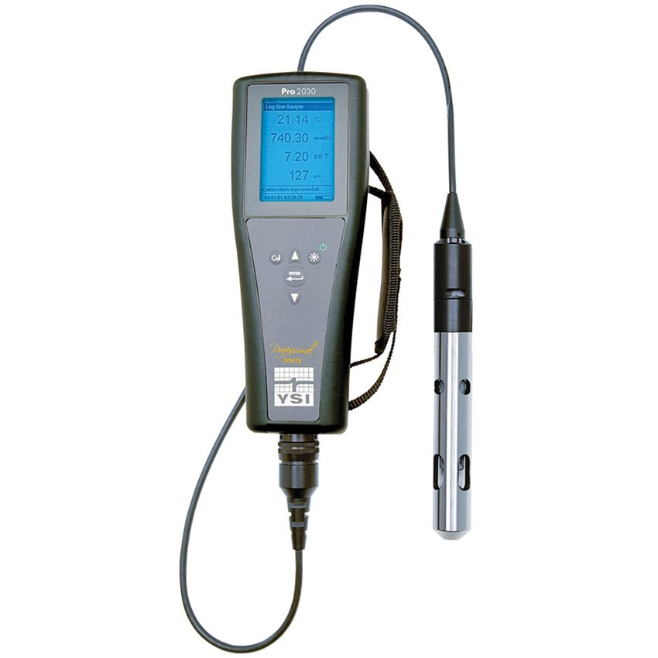
Figure 1: Multiparameter water quality sonde, which can measure conductivity (Image Credit: YSI)

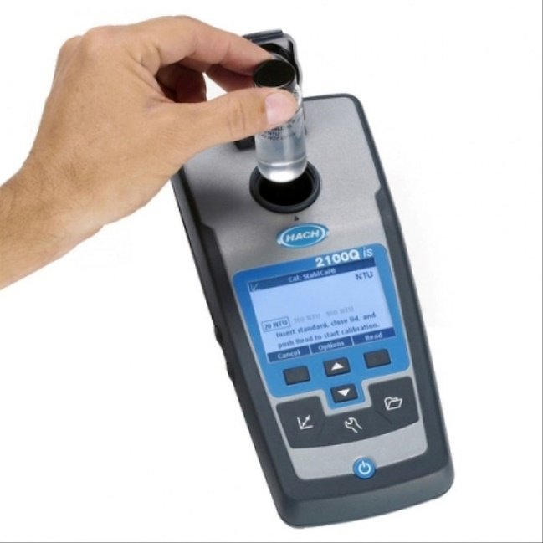
Figure 2: Portable turbidity meter, which measures light that passes through a water sample (Image Credit: Hach Company)

References
- Elenco Electronics, Inc. Electronic Snap Circuits (Experiments 1- 101) Manual
- Elenco Electronics, Inc. Electronic Snap Circuits (Experiments 102-305) Manual
- Elenco Electronics, Inc. Electronic Snap Circuits (Experiments 306-511) Manual

Experimenting with Erosion Control

Background
Expected Duration: 1-2 hours
Learning Objectives
- Identify and explain environmental factors that impact erosion
- Formulate a testable hypothesis about erosion control practices
- Identify and control variables in an experiment
- Design a controlled experiment to test erosion control practices
- Collect, analyze, and interpret data from an experiment
- Draw conclusions from an experiment to inform land management practices

Materials
- Plastic bottles (e.g., 2-liter bottles, disposable water bottles) with one side cut off, leaving the neck of the bottle intact (See Figure 1) [3-9 per group]
- Water
- Cups to capture runoff – these can made from the bases of water bottles or other materials on hand (optional: string/twine to hang these cups from the neck of the bottles)
- Soil
- Water cans or spray bottles to simulate rainfall
- Blocks or books to control slope
- Various materials to model land cover (e.g., fabric/geotextiles, mulch, moss, sod, straw, model vegetation)
- Various materials to build erosion control practices (i.e., gravel/rocks, fabric/geotextiles for silt fences, straw and mesh for wattles, sticks)
- Turbidity sensors (e.g., build from Snap Circuits or borrow sensors from conservation agencies/organizations)
- Experimental design and data collection sheets
- Stopwatches or timers
- Measuring cups, graduated cylinders, or other equipment to measure volumes

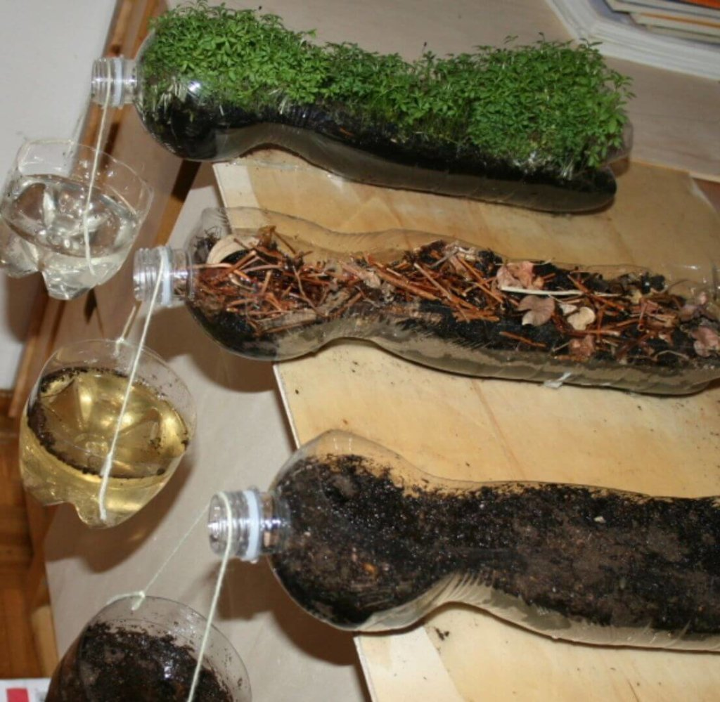
Figure 1: Plastic bottles configured to support erosion control experiment (Image Source: Orlando Science Center)

Discussion of Lesson

Excess soil erosion is a significant environmental quality challenge that impacts agriculture, water quality, and ecosystem health. Erosion is the geological process by which soil or rock is removed and transported from one location to another by wind or water. While erosion is natural, human activities can significantly accelerate this process. Excess erosion can negatively impact plant growth, as nutrient-enriched topsoil is transported to other ecosystems. Excess erosion negatively impacts water bodies, as entrained sediments reduce water clarity, and deposited sediments can damage benthic habitats.

The Revised Universal Soil Loss Equation (RUSLE) provides a framework for land managers to consider the environmental and management factors affecting soil erosion and estimate soil loss. RUSLE includes the impacts of climate, soil properties, slope, and management practice and is represented by the following equation.

A = R * K * LS * C * P
Where:
A: Estimated average soil loss in tons per acre per year
R: Rainfall-runoff erosivity factor
K: Soil erodibility factor
LS: Slope length and steepness factor
C: Cover-management factor
P: Support practice factor
RUSLE focuses on sheet and rill erosion but does not account for gully erosion or mass-wasting events. By understanding and applying RUSLE, land managers and conservationists can better assess erosion risks and implement effective conservation measures to protect soil resources and water quality.
Some of the factors in RUSLE can be modified by management, while other variables are relatively fixed for a specific site. Each variable is described below.
Rainfall-runoff erosivity factor (R): This factor represents the erosive potential of climate at the site you are evaluating. R is determined based on historical weather data.
Slope erodibility factor (K): This factor represents erosive potential based on soil properties. K values were determined empirically. K is primarily driven by soil texture, organic matter content, structure, and permeability.
Slope length and steepness factor (LS): This factor represents the impacts of slope length, slope, and landform shape on erosion.
Cover-management factor (C): This factor represents the impact of land use and land cover on soil erosion. Ground cover, canopy, tillage practices, roots, and soil organic matter impact the cover-management factor.
Support practice factor (P): This represents the impacts of conservation practices, such as terracing, contouring, silt fences, and sediment basins.

Adapting to Your Audience
Recommendations for adjusting to younger audiences: Focus on land cover and how this impacts turbidity
Recommendations for adjusting to older audiences: Focus on the RUSLE model where climate, soil type, and topography are fixed and how potential soil loss will shift with cover management and supporting practices. Lean into robust experimental design.
Procedure
- Preparation
- Divide the class into small research teams.
- Introduce erosion, RUSLE, and the scenario to the class.
- Optional: Use the Model My Watershed – Runoff Simulation to understand the impact of land cover.
- Distribute the materials to each group.
- Discuss how ecologists and ecological engineers cannot always conduct experiments at field or landscape scales, so they might scale down to use smaller experimental units. We will be using plastic bottles today to model conditions in the farmers’ fields.
- Setting Up the Experiment (30 minutes)
- Students fill the bottom half of the bottles with soil, creating a sloped surface with the soil or using books or blocks to prop up one side of the bottle.
- Students should research erosion control practices.
- Students should select cover materials and/or erosion control measures (e.g., wattles, check dams, or silt fences) to construct and test based on the available supplies.
- Students should add the treatments to experimental units (i.e., cut bottles). If enough bottles are available, encourage students to prepare replicates.
- Conducting the Experiment (10 minutes)
    - Students should place a collection cup at the end of each bottle.
    - Emphasize the importance of keeping all factors concept, except for the tested factor of the experiment.
    - Students should pour a set amount of water over the soil surface across a set time using a stopwatch or timer (i.e., control precipitation depth and intensity).
    - Students should collect runoff in the collection cup.
- Data Collection (15 minutes)
    - Students should use the turbidity sensor to measure the clarity of the runoff for each treatment.
    - Students should record the volume of water collected for each treatment and the time it took for the water to stop flowing from each experimental unit, organizing their data into tables.
    - Students should note any visual observations about soil movement or water flow patterns.
- Analysis and Discussion (20 minutes)
    - Students should compare the turbidity readings from different treatments (When replicates are included, this activity provides an opportunity to introduce summary statistics for central tendency and spread. For more advanced students, potentially introduce one-factor and two-factor ANOVA as a parametric statistical test to evaluate the results).
    - Students should create appropriate visualizations to present the collected data. Students could sketch these visualizations or use software to make these visualizations.
    - Students should determine which treatments most effectively limit erosion and why.
    - Students should consider how and why the volume and time taken for runoff to stop varied between treatments.
- Conclusions and Recommendations (30 minutes)
    - Organize a mini-conference where groups their experimental designs and findings to other teams. Encourage constructive peer feedback on experimental methods and conclusions.
    - Summarize the findings as a group.
    - Collectively prepare a paragraph on recommendations for the farmer in the scenario. Support these recommendations with data.
    - Discuss how similar experiments might be used in environmental management decisions (i.e., selecting vegetation types for wetland restoration).

Student Handout
Key Definitions for Experimental Design:
Factors/Independent Variable: a variable in an experiment that is changed or manipulated by the research (e.g., type of land cover may be the factor for an experiment on erosion control)
Controlled Variables: factors in an experiment that are kept constant to ensure that they do not influence the results
Levels: the different values or conditions being tested for a particular factor (e.g., when the type of land cover is the factor of an erosion control experiment, levels might be bare soil, forest, or tall grasses)
Treatment: a combination of levels of different factors that are applied to experimental units (e.g., When slope and land cover are both factors, treatments might include 1) 5% slope with forest and 2) 5% slope with bare soil, 3) 2% slope with forest). When only one factor is tested, treatments and levels are the same (e.g., when the type of land cover is the factor of an erosion control experiment, levels and treatments are both bare soil, forest, or tall grasses).
Dependent Variable: factor in an experiment that is measured or observed to see how it responds to changes in the independent variable
Control: a group in an experiment that does receive the treatment(s) being tested and is used as a baseline for comparison
Scenario:
A farmer reached out to her local Purdue Extension office about testing different erosion control methods to reduce erosion outside of the growing season, thereby reducing negative water quality impacts of her operation and maintaining better soil health to support better yields.
To best simulate conditions on her farm, the farmer provided soil from her fields and determined that the average slope of the fields is 2%. You found mean precipitation depth and intensity (i.e., depth per unit time) for storms based on local precipitation records.
Research:
Research erosion control practices, including cover management. Summarize your findings below. Determine what practices you will test.
________________________________________________________________________________________________________________________________________________________________________________________________________________________________________________________________________________________________________________________________________________________________________________________________________________________________________________________________________________________________________________________________________________________________________________________________________________________________________________
Experimental Design:
Identify the factor(s), levels, and treatments for the experiment.
Factor(s): ____________________________________________________________________
Levels: ______________________________________________________________________
Treatments: ___________________________________________________________________
______________________________________________________________________________
Control Treatment: ______________________________________________________________
What are the controlled variables?
Precipitation depth, precipitation intensity, slope, soil type
____________________________________________________________________________________________________________________________________________________________
What are your dependent variables? How will you measure these?
Runoff volume – use a measuring cup or graduated cylinder to measure total runoff volume
Turbidity of runoff – use turbidity sensors to measure turbidity
Time for runoff to stop – use a stopwatch/timer to measure the time until runoff stops [longer retention time is generally associated with enhanced water quality benefits]
____________________________________________________________________________________________________________________________________________________________
____________________________________________________________________________________________________________________________________________________________
____________________________________________________________________________________________________________________________________________________________
Write out a step-by-step procedure, also known as a standard operating procedure or SOP, for your experiment. You will share this SOP with a researcher in another region, who is interested in assessing the effectiveness of erosion control practices with their soils and topography.

______________________________________________________________________________
______________________________________________________________________________
______________________________________________________________________________
______________________________________________________________________________
______________________________________________________________________________
______________________________________________________________________________
______________________________________________________________________________
______________________________________________________________________________
______________________________________________________________________________
______________________________________________________________________________
______________________________________________________________________________
Data Collection:
Create a table to record your results.

Data Analysis:
Create a visualization to share your results.

Summarize your results.
____________________________________________________________________________________________________________________________________________________________________________________________________________________________________________________________________________________________________________________________________________________________________________________________________________________________________________________________________________________
Conclusions:
What are the limitations of your experiment?
____________________________________________________________________________________________________________________________________________________________________________________________________________________________________________________________________________________________________________________________________________________________________________________________________________________________________________________________________________________
What recommendations do you have for the farmer? Support with your data.
____________________________________________________________________________________________________________________________________________________________________________________________________________________________________________________________________________________________________________________________________________________________________________________________________________________________________________________________________________________

Supplemental Information

Reference Activities
Soil Science Experiment – How to Demonstrate Soil Erosion – Orlando Science Center. Retrieved from https://www.osc.org/soil-science-experiment-how-to-demonstrate-soil-erosion/

Supporting Resources
Teaching Resources - Erosion. U.S. National Park Service. Retrieved from https://www.nps.gov/subjects/erosion/teaching-resources-erosion.htm
- Erosion and Us Video - Black Canyon in Gunnison National Park
- Buffalo Caves and Karst activity – Buffalo National River
- Floodwaters in the Desert Lab Activity – Death Valley National Park
- A Day at Sand Beach – Acadia National Park
- Freeing the Elwha (River Flows and Sediment Movement) – Olympic National Park
- The Work of Water Activity – Glacier National Park
- Beaches in Motion – Coastal Vulnerability Activity – Cape Cod National Seashore

Stream Geomorphology & Restoration
Activities:
- Introduction to Watersheds
  - A Crumpled Watershed Model
  - Geospatial Tools for Learning about My Watershed
- Stream Geomorphology: Math in Action
- Stream Restoration & Engineering Design

Introduction to Watersheds
This module includes two activities:
- Defining watersheds with A Crumpled Watershed Model activity from the University of Nebraska Extension
- Geospatial Tools for Learning about My Watershed
Materials:
A Crumpled Watershed Model
- 2 sheets of paper (8.5” x 11” inches)
- Spray bottle with water
- Non-permanent markers that will run when sprayed with water, ideally blue, brown, green, and red to represent drainage and different land uses.
- Tray to catch water
Geospatial Tools for Learning about My Watershed
- Computers or tablets
- Internet access
Procedure:
A Crumpled Watershed Model
See the lesson plan from the University of Nebraska Extension.
Potential extension: Use the River Runner app to explore where water will flow from any spot in the contiguous United States.
Geospatial Tools for Learning about My Watershed
Work as a group to determine what you might want to know about your watershed ahead of your field visit.
Students can gather data on their watersheds using a variety of software and other research tools ahead of their field visit. As watershed represent areas, rather than single points, retrieving and processing geospatial data provides critical insights for watershed management. Geospatial data are data that include information related to locations on the Earth’s surface.

Watershed Research Guide
My Watershed’s Unique ID – Hydrologic Unit Codes (HUC)
Hydrologic Unit Code (HUC) is a hierarchical watershed classification system created by the United States Geological Survey (USGS) that assigns numeric codes to watersheds. The USGS split the United States into successively smaller hydrologic units. These individual units are determined by topography, representing different drainage areas. HUC ranges from 2 to 12 digits in length, with 12 digits representing the smallest drainage area (Table 1 & Figure 1). The HUC provides a unique ID for your watershed. This ID can help with watershed research, as sub-watershed names often repeat between larger watersheds.
Name | Level | Digits
Region | 1 | 2
Subregion | 2 | 4
Basin | 3 | 6
Subbassin | 4 | 8
Watershed | 5 | 10
Subwatershed | 6 | 12
Table 1: Levels for the HUC system

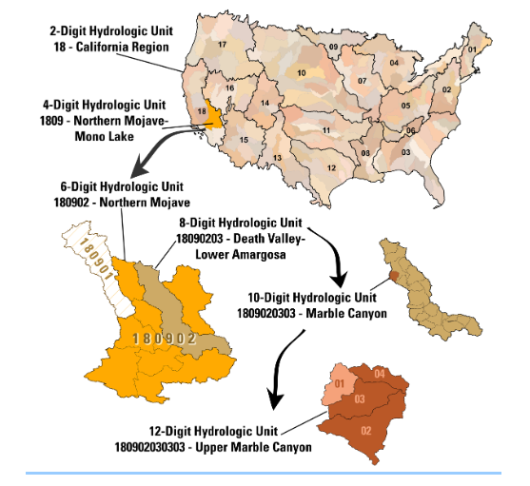
Figure 1: Hierarchical HUC System (Image Source: USGS)
Find the HUC for your watershed
For sites across the United States, use the USGS National Map Viewer, which includes the most current Watershed Boundary Dataset. To explore this data, you can also download the Watershed Boundary Dataset or National Hydrography Dataset (HUC8 is the first 8 digits of the reachcode) products from the USGS.
For sites with Indiana, use IDEM’s Indiana HUC Finder.
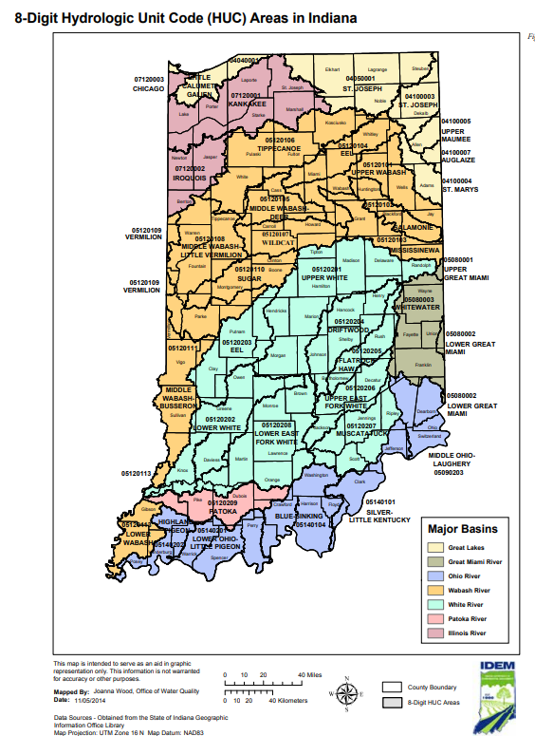
Figure 2: 8-Digit HUC Map for Indiana (Image Source: Indiana Department of Environmental Management)
Accessing and Analyzing Geospatial Data on Watersheds
Beginner tools:
- Model My Watershed – best for beginners to delineate and review data on their watershed.
- EPA’s How’s My Waterway? – accessible interface to summarize water quality data for HUC10 watersheds, including water monitoring locations and associated data, permitted discharges, conditions of water bodies, and plans for ecosystem restoration.
- IndianaMap – the web-based interface of ArcGIS, exclusively for Indiana. View the data in the IndianaMap Viewer. No login is required unless you want to save data between sessions.
  - Relevant data types
    - Aerial imagery
    - Land use/land cover (current and historic) – National Land Cover Dataset, USFWS mapped wetlands
    - Soils/Geology – STATSGO, SSURGO
    - Topography/Digital Elevation Models
    - Hydrography/Flow Lines
    - Floodplain Extent
    - Pollution Point Sources (CAFOs, Permitted Discharges, Brownfields)
- Google Earth – view aerial imagery of your stream and the surrounding landscape.
- Web Soil Survey – an online platform to retrieve soil data for different areas of interest. Soil characteristics are not necessarily confirmed by field mapping.
More advanced tools:
- StreamStats – easy to use this tool but difficult to interpret the outputs. Users select a point along a waterway using the web-based application to delineate drainage areas and provide basin characteristics, geomorphology predictions based on regional curves, and flow statistics.
- Time of Travel Beta – model the impact of a spill near your stream site on downstream ecosystems. This tool provides a visualization of how downstream ecosystems are impacted by pollution events upstream.
- More General Geographic Information Systems (not just for watershed analyses)
  - Software/Interfaces
    - ArcGIS – Purdue has licenses for ArcMap, ArcGIS Pro, and ArcGIS Online. ArcGIS Online has a free option, but the functionality is limited.
    - QGIS – open-source geospatial analysis software
    - Google Earth Engine – open-source geospatial analysis software, most coding-intensive platform
  - Relevant data types
    - Aerial imagery
    - Land use/land cover (current and historic) – National Land Cover Dataset, USFWS mapped wetlands
    - Soils/Geology – STATSGO, SSURGO
    - Topography/Digital Elevation Models
    - Hydrography/Flow Lines
    - Floodplain Extent
    - Pollution Point Sources (CAFOs, Permitted Discharges, Brownfields)
- USGS Current Water Data for the Nation – daily streamflow conditions at gauged locations throughout the United States. Some sites also have water quality data. Data are often not available for smaller watersheds.
Reflection Questions for Watershed Explorations:
- How might current watershed conditions be impacting stream health?
- What stream characteristics do you anticipate during the field visit?
- What challenges should watershed managers be focused on?
- If pollutants enter streams in this watershed, what other areas will be potentially affected by that pollution?

Additional Reading
- What is a Hydrologic Unit Code? – SDSU Extension
- A Day in the Life of A Drop – EPA’s WaterSense

Stream Geomorphology: Math in Action
Overview: Students will assess stream geomorphology to practice mathematical and statistical concepts in an applied context. This stream assessment is an opportunity to leverage local ecosystems for environmental education.
Assessment of stream geomorphology typically involves surveying equipment, but the following outline only requires surveying tape and a telescoping rod. A regular tape measure and PVC pipe with measurements will also suffice. Select a shallow, wadable stream with banks that permit easy entry and exit. Ensure that there are enough adult chaperones to manage the group.
Background information: Streams and rivers are conduits for water and sediment. Stream geomorphology (e.g., fluvial geomorphology) is the study of how streams and rivers are shaped, including in response to human-caused and natural disturbances. Stream variables that interact to determine the physical form of the channel include:
- Discharge, or the volume of water per unit of time.
- Sediment supply
- Sediment size
- Channel width
- Channel depth
- Water velocity
- Slope
- Roughness of channel materials
The geology, topography, soils, climate, and land use in the watershed impact these variables that drive the physical form of channels.
Assessing the physical form of streams provides critical information for scientists and engineers. Understanding channel geometry is also essential for understanding stream discharge and sediment transport. The assessment helps them identify sources of impairment that can be addressed through stream restoration. Healthy streams should 1.) have a balance of sediment aggradation and erosion, maintaining a somewhat stable form over time, 2.) support flows that spill out onto the floodplain at a recurrence interval of at most every 1.5 to 2 years, and 3.) supports habitats with different stream depth, width, velocity, and substrate throughout the channel.
Characterizing the geomorphology of less impaired streams in the region can provide critical insights into how to design a stream restoration for a nearby degraded stream. This approach of aiming to restore streams to have geomorphic characteristics like those in more pristine streams in the region is known as Natural Channel Design. Scientists and engineers often focus on the bankfull level when assessing stream geomorphology for projects using Natural Channel Design. In pristine streams, the bankfull level is the top of the bank. In entrenched streams that have been degraded from excessive erosion, the bankfull level is often below the top of the bank. These entrenched streams are often found in developed areas and watersheds with intensive agriculture. The following stream geomorphic characterization will be based on bankfull levels.
Additional background reading:
Geomorphology: Fluvial Geomorphology. (n.d.). Minnesota Department of Natural Resources. Retrieved September 15, 2024, from https://www.dnr.state.mn.us/whaf/5-component/fluvial_geo.html
Doll, B.A., Grabow, G.L., Hall, K.R., Harman, W.A., Jennings, G.D., Wise, D.E. (2003). Stream restoration: A Natural channel design handbook. North Carolina Stream Restoration Institute and North Carolina Sea Grant. Retrieved from https://bae.ncsu.edu/wp-content/uploads/2017/07/sr_guidebook.pdf
Featured mathematical and statistical concepts:
Select from the following concepts based on the age group that you are working with:
- Datum//frame of reference for taking measurements
  - Maximum stream depth taken with respect to bankfull elevation
  - Bankfull width taken with respect to bankfull elevation
  - Flood-prone estimated with respect to bankfull elevation
- Slope
  - Definition of slope with stream slope
  - Conversion of slope to a dimensionless ratio
- Ratios
  - Width-to-depth ratio
  - Entrenchment ratio
  - Sinuosity
- Conversion of units
  - Feet-to-miles or miles-to-feet conversion for stream slope
- Dimensional analysis
  - Velocity measurements with orange floats
  - Mean bankfull depth from the cross-sectional area and bankfull width
  - Hydraulic radius from the cross-sectional area and wetted perimeter
- Definitions of area and perimeter
  - Calculate and contrast bankfull cross-sectional area and wetted perimeter
- Area calculations
  - Area of trapezoids by estimating cross-sectional area
  - Area of a rectangle by estimating cross-sectional area
  - Area of a rectangle by estimating mean bankfull depth
  - Area of a rectangle by estimating wetted perimeter
- Summary statistics
  - Measures of central tendency by estimating velocity with orange floats
  - Measures of spread by estimating velocity with orange floats
  - Measure of central tendency by estimating mean depth with channel approximated as a rectangle
- Functions
  - Bankfull shear stress
  - Bankfull discharge via Manning’s Equation
- Reference tables and diagrams
  - Reference table for Manning’s n
  - Using the Shield’s diagram to find sediment competence from shear stress
- Models
  - Contrast measured dimensions to model outputs from regional curves
- Numerical integration
  - Estimating area under a curve with the Trapezoidal Rule

Stream Assessment Data Sheet
Date: _______________________________________
Time: _______________________________________
Team Members: _____________________________________________________
Stream Name: ___________________________________
HUC12: ________________________________________
Location: _______________________________________
- Select a representative cross-section for the stream.
- Identify the bankfull elevation.
Bankfull indicators include 1.) abrupt breaks in slope (indicating a transition from steeper banks to the flatter floodplain surface), 2.) shifts in vegetation, such as surfaces that are bare or have more water-tolerant vegetation to surface with hardier perennial vegetation, 3.) shift in texture of and organic matter content of sediment, 4.) water stains on vegetation or rocks.
The bankfull elevation will serve as the vertical datum, or the reference point used to determine the elevation or depth of all other points. Stake the surveying tape at the bankfull elevation from bank to bank. Orient the surveying tape so that the origin for your lateral measurements is the left bank. The left bank is defined by looking downstream.
Bankfull indicators in this stream: __________________________________________________
______________________________________________________________________________
______________________________________________________________________________
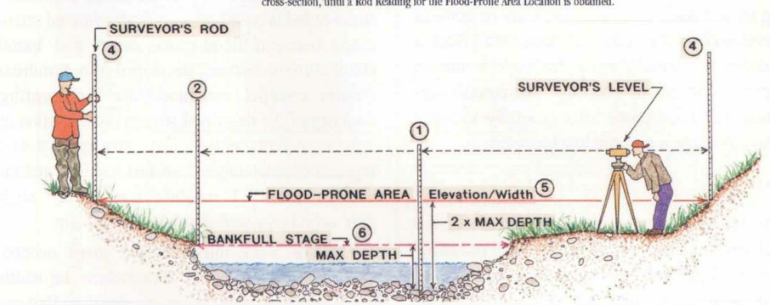
Source: Stream Restoration: A Natural Channel Design Handbook (Doll et al., 2003)

- Measure the bankfull stream width.
Measure the width of the stream at the bankfull elevation.
Width: ___________________________
- Measure the maximum stream depth.
Maximum stream depth is measured at the thalweg, or the lowest point in the stream cross-section, from the streambed to the bankfull elevation.
Maximum Depth: ______________________________
- Characterize the bankfull cross-sectional geometry.
Measure depth at multiple points in the cross-section, either at specific intervals or where there are noticeable changes in geometry. Create a table for each measurement point, width, and depth. Leave space for three additional columns.

Create a sketch of the stream cross-section based on the collected data.

- Estimate flood-prone width.
Floodplain width for natural channel design is designated as the floodplain width at the elevation of twice the maximum depth of the channel. Use the telescoping rod to mark the flood-prone elevation (i.e., bankfull elevation + maximum bankfull depth). Then, use the surveying tape to walk away from the channel in either direction until reaching where the floodplain surface intersects with the flood-prone elevation. The flood-prone width is the distance between these points of intersection on either side of the stream.
The flood-prone in flat landscapes might be pretty large and need to be measured with a topographic map or digital elevation model.
Flood-prone width: ___________________________
Source: Stream Restoration: A Natural Channel Design Handbook (Doll et al., 2003)
- Estimate the stream velocity.
Velocity is the rate at which an object changes position. Velocity is a vector quantity. In streams, velocity is defined as perpendicular to the stream cross-section. The magnitude of average velocity is represented as the displacement divided by the change in time.
$$\overline{v}=\frac{∆x}{∆t}$$
Measure a length of the stream with the survey tape in the direction of flow (i.e., longitudinal). Add an orange or other float to the stream at the upstream end of the survey tape and measure how long it takes for the orange float to reach the end of the survey tape. Repeat this measurement two more times.
Distance traveled: _______________________
Trial 1 - Time Taken: _____________________
Trial 2 – Time Taken: _____________________
Trial 3 – Time Taken: _____________________
What are the units of velocity? Why?
____________________________________________________________________________________________________________________________________________________________
- Conduct a tracer experiment.
Add milk as a tracer to the stream. If turbidity sensors are available, record turbidity measurements over time. Alternatively, collect samples at certain times, and measure turbidity later in the lab. If possible, take concurrent measurements at multiple points in the stream.
Make qualitative observations about transient storage zones. __________________________________________________________________________________________________________________________________________________________________________________________________________________________________________________________________________________________________________________________________________________________________________________________________________________________________________________________________________________________________________________________________________________________________________________________________________________________________________________________________________________________________________________________________________________________________________________________________________________________________________________________________________________________

- Sketch a longitudinal profile.
Sketch key features along a representative length of stream (i.e., reach). Extend the survey tape in the direction of flow along the reach. Use the survey tape to determine the station at the start of each riffle, run, pool, and glide to develop a longitudinal profile of the stream.

- Describe the sediment in the streambed, especially the sediment size.
____________________________________________________________________________________________________________________________________________________________________________________________________________________________________________________________________________________________________________________________________________________________________________________________________________________________________________________________________________________
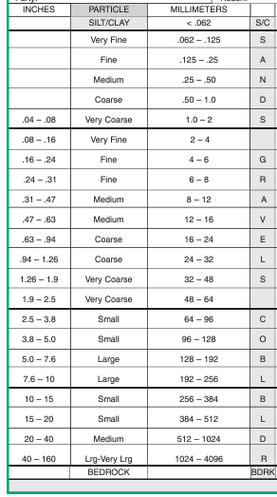
Source: Stream Restoration: A Natural Channel Design Handbook (Doll et al., 2003)
- Describe the conditions of the banks, including vegetation coverage and sediment texture.
______________________________________________________________________________________________________________________________________________________________________________________________________________________________________________________________________________________________________________________________________________________________________________________________________ ______________________________________________________________________________
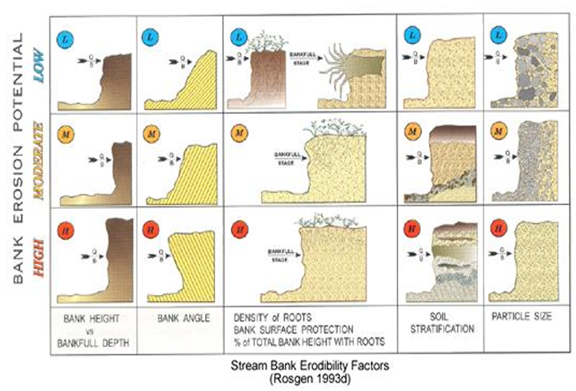
- Characterize the water quality.
What do you notice about the water in the stream? Include any water quality measurements in the box below. ________________________________________________________________________________________________________________________________________________________________________________________________________________________________________________________________________________________________________________________________________________________________________________________________________________________________________________________________________________________________________________________________________________________________________________________________________________________________________________

Water quality measurements:

Back in the Lab [Advanced]
- Estimate bankfull cross-sectional area using the Trapezoidal Rule.
Apply the Trapezoidal Rule, which approximates the area under a curve as a series of trapezoids. The area between each set of points is represented as a trapezoid. Revise your table above to include the height of the trapezoid, which is the lateral distance between each observation. Revise your table above to include the mean depth between each successive point [$\frac{b_{1}+b_{2}}{2}$]. Calculate the area of each trapezoid. Record the area of each trapezoid in the table.
Area of a Trapezoid: $A=\frac{b_{1}+b_{2}}{2}$h
where h = height of trapezoid and b₁ and b₂ are the bases of the trapezoid.
Find the sum of the areas of the trapezoids to estimate bankfull cross-sectional area.
Bankfull Area:__________________________________________________________________
How can we get a more accurate measurement of the bankfull cross-sectional area?
____________________________________________________________________________________________________________________________________________________________
- Calculate the mean bankfull depth.
Calculate the mean bankfull depth by dividing the stream cross-sectional area by the stream width.
Mean stream width: ________________________
- Calculate the entrenchment ratio.
The entrenchment ratio is flood-prone width divided by the bankfull width.
Entrenchment ratio: ___________________________
Use the Rosgen Classification of Natural Rivers below. Classify the entrenchment ratio.
Entrenchment ratio classification: _____________________
- Calculate the bankfull width-to-depth ratio.
The bankfull width-to-depth ratio is bankfull width divided by the mean bankfull depth.
Bankfull width-to-depth ratio: ___________________________
Use the Rosgen Classification of Natural Rivers below. Classify the width-to-depth ratio.
Width-to-depth ratio classification: ________________________

- Approximate the wetted perimeter.
Wetted perimeter is the length along the banks and streambeds that touches water during bankfull flows. The wetted perimeter can be approximated with the following equation:
$${WP}_{bkf}=W_{bkf}+2d_{bkf}$$
Where ${WP}_{bkf} is the bankfull wetted perimeter$
$W_{bkf} is the bankfull width$
$d_{bkf}$ is the mean bankfull depth
Wetted perimeter: ___________________________
Based on the formula above, what shape is the channel approximated as?
____________________________________________________________________________
- Calculate the hydraulic radius.
Calculate the hydraulic radius by dividing the bankfull area by the bankfull wetted perimeter.
Hydraulic radius: ________________________________
Based on the calculation, what are the units for the hydraulic radius?
____________________________________________________________________________________________________________________________________________________________
- Calculate channel sinuosity.
Sinuosity is the ratio of stream length to valley length. Valley and stream length can be estimated using hydrography datasets, aerial imagery, or surveying.
Valley length: 2381 feet
Stream length: 2423 feet
Sinuosity: __________________
Use the Rosgen Classification of Natural Rivers below. Classify the sinuosity.
Sinuosity classification: _____________________

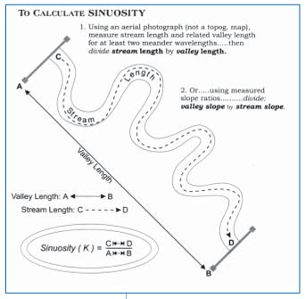
Source: Stream Restoration: A Natural Channel Design Handbook (Doll et al., 2003)

- Convert slope.
Slope is the ratio of rise to run. In the case of streams, the rise is the elevation change of the streambed, and the run is the stream length.
Based on Stream Stats, the channel slope is 17.2 ft/mi. Represent channel slope as a dimensionless ratio [1 mile = 5280 feet].
Slope: __________________
- Contrast channel geometry to regional curves.
Regional curves are models developed from streams assessed in a region. These models provide an estimate of bankfull geometry based on drainage area.
We used the Central Till Plain Region curve via Stream Stats to estimate bankfull geometry for Elkhorn Creek. This model estimated the following parameters based on the delineated drainage area:
- Bankfull width: 40.9 feet
- Bankfull depth: 2.37 feet
- Bankfull area: 96.3 ft²
How does the measured geometry compare to the predicted geometry?
__________________________________________________________________________________________________________________________________________________________________________________________________________________________________________

Why do the model outputs differ from the field measurements?
____________________________________________________________________________________________________________________________________________________________
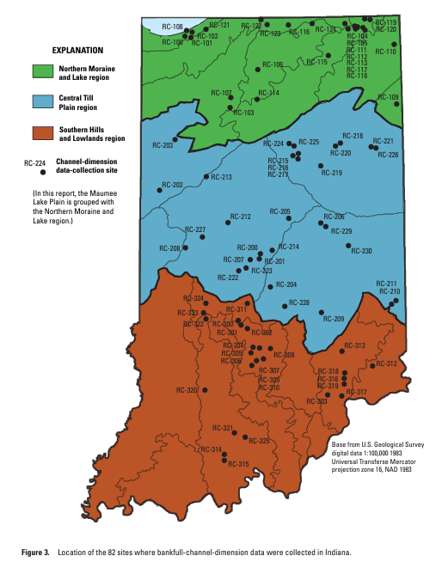
Source: Regional Bankfull-Channel Dimensions of Non-Urban Wadeable Streams in Indiana (Robinson, 2013)
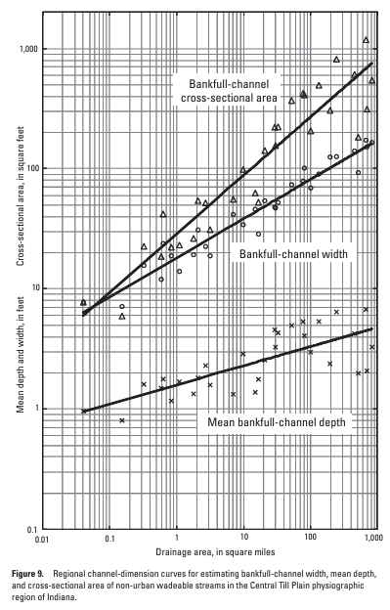
Source: Regional Bankfull-Channel Dimensions of Non-Urban Wadeable Streams in Indiana (Robinson, 2013)

- Calculate summary statistics for velocity.
Calculate the mean and standard deviation for the trials of velocity measurements.
Mean Velocity: ___________________________
Standard Deviation of Velocity: __________________________

- Ensure sediment-transport competence.
Sediment competence is the maximum size of sediment that a stream can transport under a given discharge. Shear stress is the force applied across a cross-sectional area that can suspend and move sediment particles and is calculated as follows:
$$τ=γRs$$
Where τ is shear stress (lb/ft²)
γ is the density of water (62.4 lb/ft³)
R is the hydraulic radius at bankfull stage (ft)
s is the average stream slope (ft/ft)
Shear stress at bankfull stage: _________________ lb/ft²
Engineers relate shear stress to the diameter of sediment that can be suspended and transported using the Shield’s relationship. Use the Shield’s diagram below to estimate the maximum sediment diameter that can be suspended and transported during bankfull flows.
Grain diameter: ______________________mm
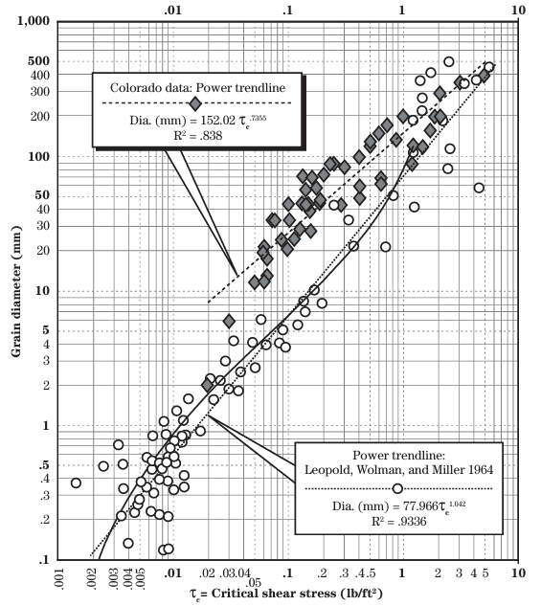
Source: Part 654 Stream Restoration Design National Engineering Handbook (Chapter 11 Rosgen Geomorphic Design)

- Estimate bankfull stream discharge based on Manning’s Equation.
Some streams have gauges that measure discharge. Manning’s Equation, which was developed empirically, estimates bankfull discharge with the following formula:
$Q_{bkf}[cms or m^{3}/s]=\frac{1}{n}A_{bkf}R^{\frac{2}{3}}S^{\frac{1}{2}}$ [in metric units]
$Q_{bkf}[cfs or {ft}^{3}/s]=\frac{1.49}{n}A_{bkf}R^{\frac{2}{3}}S^{\frac{1}{2}}$ [in U.S. Customary Units]
Where $Q_{bkf} is the bankfull discharge$
n is the Manning’s coefficient (review description of the streambed to inform the selection of a representative Manning’s n from the table below)
$A_{bkf} is the bankfull area$
$R is the hydraulic radius$
S is the slope of the stream (as a unitless ratio)
Modeled discharge: _________________ cfs or ft³/s

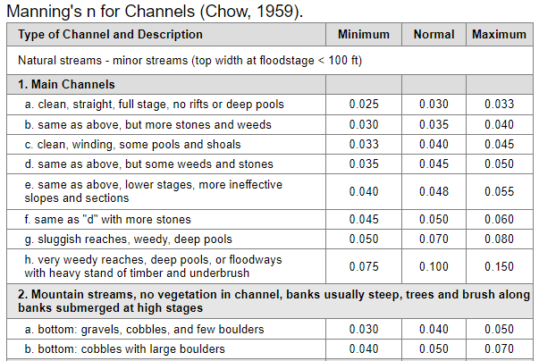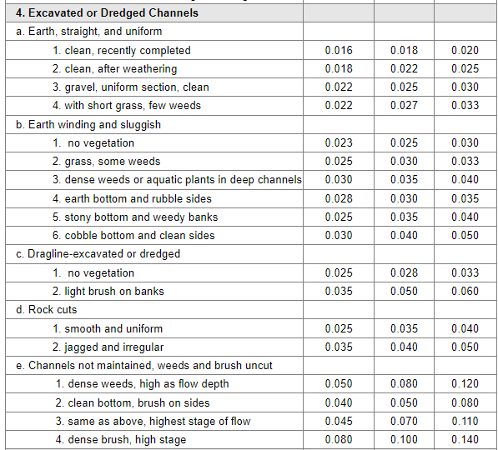

- Use the information above to classify the stream site based on Rosgen’s Classification of Natural Rivers.
Stream type: _______________________

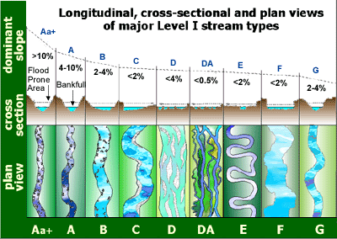
Image Source: Wildland Hydrology

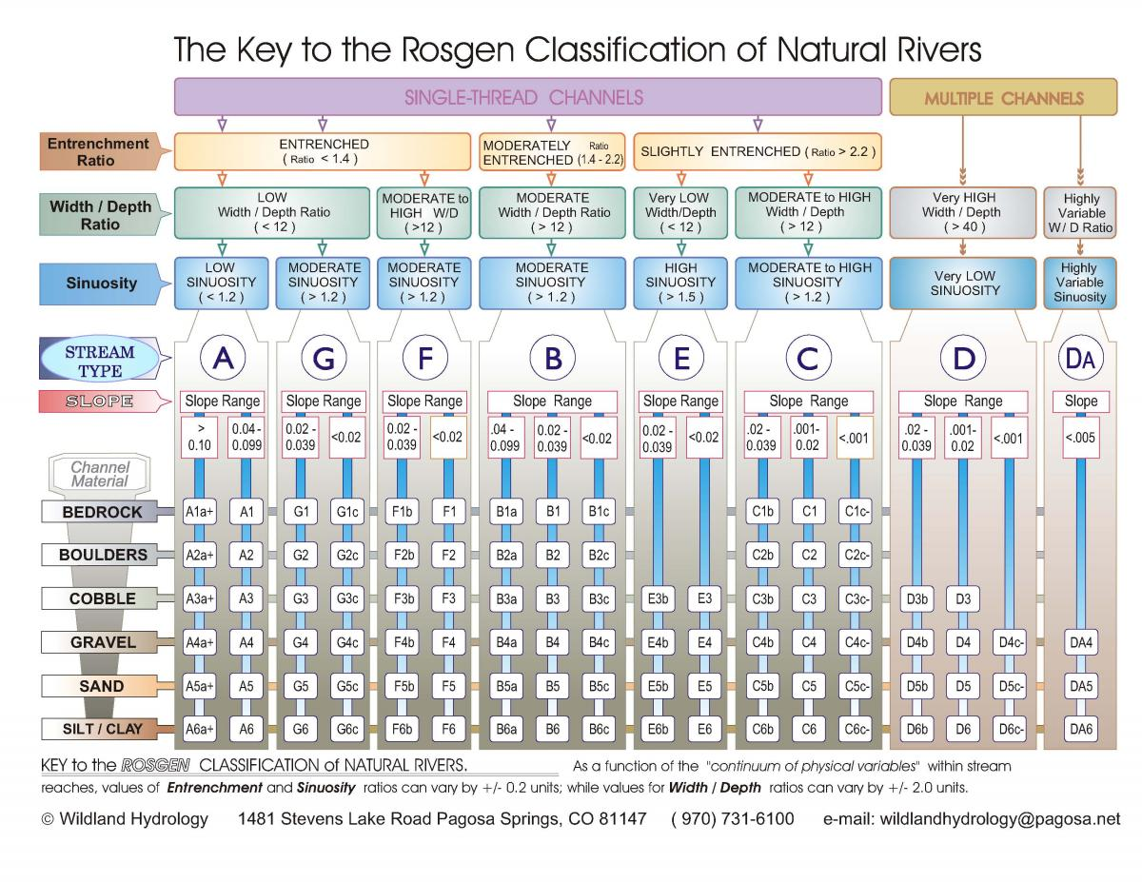
Back in the Lab [Junior]
- Estimate the mean bankfull depth.
Calculate the mean of depth measurements collected in the field.
Mean bankfull depth: ________________________
- Estimate bankfull cross-sectional area by approximating the channel as a rectangle.
Assume the channel is a rectangle. Use the mean bankfull depth and bankfull width to estimate the cross-sectional bankfull area.
Bankfull Area:__________________________________________________________________
- Calculate the entrenchment ratio.
The entrenchment ratio is flood-prone width divided by the bankfull width.
Entrenchment ratio: ___________________________
Use the Rosgen Classification of Natural Rivers below. Classify the entrenchment ratio.
Entrenchment ratio classification: _____________________
- Calculate the bankfull width-to-depth ratio.
The bankfull width-to-depth ratio is bankfull width divided by the mean bankfull depth.
Bankfull width-to-depth ratio: ___________________________
- Wetted Perimeter
Wetted perimeter is the length along the banks and streambeds that touches water during bankfull flows. The wetted perimeter can be estimated with the following equation:
$${WP}_{bkf}=W_{bkf}+2d_{bkf} where$$
Where ${WP}_{bkf} is the bankfull wetted perimeter$
$W_{bkf} is the bankfull width$
$d_{bkf}$ is the mean bankfull depth
Wetted perimeter: ___________________________
- Hydraulic Radius
Calculate the hydraulic radius by dividing the bankfull area by the bankfull wetted perimeter.
Hydraulic Radius: ________________________________
Based on the calculation, what are the units for hydraulic radius?
____________________________________________________________________________________________________________________________________________________________

- Sinuosity
Sinuosity is the ratio of stream length to valley length. Valley and stream length can be estimated by hydrography datasets, aerial imagery, or surveying.
Valley length: 2381 feet
Stream length: 2423 feet
Sinuosity: __________________
Source: Stream Restoration: A Natural Channel Design Handbook (Doll et al., 2003)
- Convert slope.
Slope is the ratio of rise to run. In the case of streams, the rise is the elevation change of the streambed, and the run is the stream length.
Based on Stream Stats, the channel slope is 17.2 ft/mi. Represent channel slope as a dimensionless ratio [1 mile = 5280 feet].
Slope: __________________
- Calculate summary statistics for velocity
Calculate the mean velocity for the trials of velocity measurements.
Mean velocity: ___________________________

- Use the information above to classify the stream site based on Rosgen’s Classification of Natural Rivers.
Stream type: ___________________________________

Image Source: Wildland Hydrology

Potential Extensions:
- Create a spreadsheet to collect inputs from the field visit and calculate all other parameters.
- Create an interface to help scientists and engineers more easily input their data [i.e., Air Table, Google Form, or mobile application].
- Conduct a stream habitat assessment.
- Rate stream banks based on the Bank Erodibility Hazard Index (BEHI) rating guide.

Follow-Up Resources for Outdoor Stream Explorations:
- Water Quality Monitoring with Hoosier Riverwatch
  - Can check out water quality monitoring kits once training is complete
  - Find upcoming workshops
- Limno Loan Program with Illinois-Indiana Sea Grant
  - Can check out water quality monitoring kits once the training is complete
  - Consider other loanable kits from Illinois-Indiana Sea Grant

References
Doll, B.A., Grabow, G.L., Hall, K.R., Harman, W.A., Jennings, G.D., Wise, D.E. (2003). Stream restoration: A Natural channel design handbook. North Carolina Stream Restoration Institute and North Carolina Sea Grant. Retrieved from https://bae.ncsu.edu/wp-content/uploads/2017/07/sr_guidebook.pdf
Geomorphology: Fluvial Geomorphology. (n.d.). Minnesota Department of Natural Resources. Retrieved September 15, 2024, from https://www.dnr.state.mn.us/whaf/5-component/fluvial_geo.html
Robinson, B.A. (2013.). Regional bankfull-channel dimensions of non-urban wadeable streams in Indiana. (Scientific Investigations Report 2013-5078). U.S. Geological Survey. Retrieved from https://pubs.usgs.gov/sir/2013/5078/pdf/sir2013-5078.pdf

Stream Restoration & Engineering Design
Learning Objectives:
- Analyze field observations and measurements to identify goals for a project.
- Apply engineering design principles to develop a solution that addresses a specified problem.
  - Evaluate and select appropriate design approaches to address identified goals.
  - Develop initial design ideas that align with project goals.
  - Build, test, and improve the selected design.
  - Communicate the specified problem, iterations, and final design to stakeholders.
Materials:
- Stream model (to test designs)
  - Build a low-cost stream table (Example)
  - Build smaller stream models with available materials (e.g., paint trays)
- Sand, pea gravel, and gravel (to represent stream sediment of different sizes)
- Sticks (to model brush and tree trunks)
- 3-D printers, printer filament, devices to use 3-D design software (to model structures) [alternatives to 3-D printing: modeling clay, LEGOs]
- Model riparian and aquatic vegetation (i.e., trees, shrubs, grasses, moss) [alternatives: have students construct their own model vegetation from craft supplies or design and 3-D print model vegetation]
- Tubing (to model culverts and other drainage infrastructure)

Pre-Work
Visit a local stream or river, making sure to identify potential impairments. Use the stream data collection sheet provided in the previous module or other stream data collection sheets, such as from Hoosier RiverWatch.

Module 1: Introduction to Stream Restoration
Stream restoration are active interventions to repair degraded streams, aiming to improve stream ecosystem services. Stream restoration projects may design streams to look more like pristine streams in the region. Other stream restoration designs include features that may not be typical of streams in the region or features that are not found in streams naturally, such as culverts and bioengineered banks, to meet design goals based on the current watershed conditions.
Introduce stream restoration with the case study of Muddy Creek in Edgewater, Maryland via video or book (ISBN-10: 1493866788).
Career Connections: Ecological Engineers, Civil Engineers, Environmental and Natural Resources Engineers, Fluvial Geomorphologists, Ecologists
Module 2: Define the Problem & Select an Approach
Funds are available to restore Elkhorn Creek. Review observations from the field visit and findings from researching the site to identify impairments and determine restoration goals. Examples of impairments include bank erosion, disconnection from the floodplain, impaired water quality, or inadequate fish passage.
- Select 1-2 design approaches to address your impairment based on the identified goals (circle intended approaches).
  - Reshape the stream channel
  - Restore the riparian buffer zone
  - Stabilize the stream banks
  - Install in-stream structures
  - Install fish passage solutions or structures to deter invasive species
- Write a design brief (3-4 sentences), outlining the current problems with the stream, restoration goals, chosen approaches, and preliminary design ideas.
Module 3: Research Potential Solutions & Select a Design
- Research design ideas based on the selected approach.
- Select a design and justify this choice.

Module 4: Design & Prototype
- Develop a detailed design, either drawing by hand or with computer software. The design should include dimensions and materials.
- Construct a physical prototype based on the design plans:
  - Stream Channel Design: build a model stream channel in a container with sand or other materials.
  - In-Stream Structure/Fish Passage Solutions: build in-stream structures for the model stream
Module 5: Test
- Test the prototype by simulating design conditions. Examples include rainfall simulation on a riparian buffer or pumping water through a stream change to evaluate channel design or in-stream structures.
- Collect data. This data may be more qualitative, such as noting excessive erosion or channeling. Students will propose how they might evaluate the stream with better equipment/more resources.
- Analyze results from testing. Assess if prototypes are meeting design goals.
Module 6: Iterate
- Based on the testing results, modify the design to improve outcomes and meet specified goals and criteria.
- Test the new design.
Module 7: Communicate
- Prepare final presentations with the rationale for selecting that solution, design process, final design, and any iterations. The instructor can select the format for the presentation (see below).
- Present the project to the group, supporting this discussion with the prototype.

Presentation Ideas:
- Pecha Kucha presentation: uses 10 or 20 slides displayed for 20 seconds each. The slides should have very few words, ideally just containing one or more images.
- Elevator pitch: use a concise verbal pitch, supported by referencing the physical prototype.
- Storyboard: design a storyboard with sketches, diagrams, and photos to narrate the design process and resulting design visually.
- Design process infographic: summarize each stage of the engineering design process with an infographic, using icons, flowcharts, and concise text.
- Make research-style posters and host a mini-conference.

Reflection and Assessment:
- What did you learn about stream restoration techniques?
- Reflect on the engineering design process. How did the engineering process help you understand the challenge with this stream and develop an effective solution?

Student Worksheet
Stream Restoration Design
Scenario: Funds are available for restoration. Review observations from the field visit and findings from researching the site to identify impairments and determine goals for the restoration. Examples include bank erosion, disconnection from the floodplain, impaired water quality, or inadequate fish passage.
Define the Problem & Select an Approach
Name of the local stream or river visited: _____________________________
List 3 potential impairments you observed:
a. ___________________________________________________________
b. ___________________________________________________________
c. ___________________________________________________________
After learning about Muddy Creek, list two key lessons you learned about stream restoration:
a. ___________________________________________________________
b. ___________________________________________________________
Based on your field visit observations, what are the main goals for restoration? (Check all that apply)
[ ] Reduce bank erosion
[ ] Reduce streambed erosion
[ ] Reduce excessive sediment deposition
[ ] Reconnect stream to floodplain
[ ] Improve water quality
[ ] Enhance fish passage
[ ] Prevent the passage of invasive species
[ ] Enhance aquatic habitat
[ ] Enhance riparian habitat
[ ] Other: ____________________________________________________
Which 1-2 design approaches have you selected? (Circle your choices)
a. Reshape the stream channel
b. Restore the riparian buffer zone
c. Stabilize the stream banks
d. Install in-stream structures
e. Install fish passage solutions or structures to deter invasive species
Write a design brief (3-4 sentences), outlining the current problems with the stream, restoration goals, chosen approaches, and preliminary design ideas.
___________________________________________________________________
___________________________________________________________________
___________________________________________________________________
___________________________________________________________________
___________________________________________________________________
___________________________________________________________________
___________________________________________________________________
___________________________________________________________________
___________________________________________________________________
___________________________________________________________________
___________________________________________________________________

Research Potential Solutions & Select A Design
Research design options for the restoration design approach(es) that you selected.
___________________________________________________________________
___________________________________________________________________
___________________________________________________________________
___________________________________________________________________
___________________________________________________________________
___________________________________________________________________
___________________________________________________________________
List 3 key design ideas from your research:
a. ___________________________________________________________
b. ___________________________________________________________
c. ___________________________________________________________
Select a design. Why did you select this design?
___________________________________________________________________
___________________________________________________________________
___________________________________________________________________
___________________________________________________________________
___________________________________________________________________
___________________________________________________________________
___________________________________________________________________
______________________________________________________________________________________________________________________________________

Design & Prototype
Sketch your detailed design here (including dimensions and materials):

Describe how you will represent this design with a physical prototype.
___________________________________________________________________
___________________________________________________________________
___________________________________________________________________
___________________________________________________________________
___________________________________________________________________

Test
How will you test your prototype?
___________________________________________________________________
___________________________________________________________________
___________________________________________________________________
___________________________________________________________________
___________________________________________________________________
What types of data will you collect during testing?
___________________________________________________________________
___________________________________________________________________
___________________________________________________________________
___________________________________________________________________
How would you evaluate the success of the stream restoration with better equipment/resources?
___________________________________________________________________
___________________________________________________________________
___________________________________________________________________
___________________________________________________________________
___________________________________________________________________
___________________________________________________________________
___________________________________________________________________
Conduct the test. Describe and analyze results from testing.
___________________________________________________________________
___________________________________________________________________
___________________________________________________________________
___________________________________________________________________
___________________________________________________________________
___________________________________________________________________
___________________________________________________________________
Iterate
Based on your test results, how will you modify your design?
___________________________________________________________________
___________________________________________________________________
___________________________________________________________________
___________________________________________________________________
___________________________________________________________________
___________________________________________________________________
___________________________________________________________________
If time permits, build and test the revised design. Record your results.
___________________________________________________________________
___________________________________________________________________
___________________________________________________________________
___________________________________________________________________
___________________________________________________________________
Communicate
Outline your presentation.
Current stream impairments: __________________________________________
Solution & rationale for solution: _______________________________________
______________________________________________________________________________________________________________________________________
Design process: _____________________________________________________
______________________________________________________________________________________________________________________________________
Iterations: _________________________________________________________
___________________________________________________________________
Final design: ________________________________________________________
___________________________________________________________________

Wetlands
Activities:
- What is a wetland? – Frayer Model
- Wetland Restoration: Modeling Wetlands as Sponges
- Wetland Detectives
- Technical Communication: Design Informational Signage for Visitors to this Wetland
- Constructed Wetland Engineering

What is a Wetland? – Frayer Model
Students will use the Frayer Model to increase their understanding of wetlands.
Learning Objectives:
- Describe a wetland, including key features and differences from other types of ecosystems.
- Determine if examples meet technical criteria
Materials:
- Frayer Model template (one per student or student group)
- Reference materials on wetlands or devices with Internet access
Activity:
- Introduce the Frayer Model (5 minutes)
Explain that students will use a graphic organizer called the Frayer Model to better understand wetlands.
- Center: word being defined ‘wetlands’
- Top left: definition
- Top right: key characteristics
- Bottom left: examples
- Bottom right: non-examples
- Guided Practice
To help the class fill out the Frayer Model, provide an initial definition for wetlands. The definition of wetlands shifts slightly by discipline. The Environmental Protection Agency (EPA) and the U.S. Army Corps of Engineers (USACE) define wetlands as “areas that are inundated or saturated by surface or ground water at a frequency and duration sufficient to support, and that under normal circumstances do support, a prevalence of vegetation typically adapted for life in saturated soil conditions.” The EPA also provides a more plain-language definition of wetlands as “areas where the frequent and prolonged presence of water at or near the soil surface drives the natural system meaning the kind of soils that form, the plants that grow and the fish and/or wildlife communities that use the habitat.”

- Small Group Work
Ask students to work in groups to suggest characteristics of wetlands for top right corner, examples for the bottom left corner, and non-examples for the bottom right corner.
- Discussion
Bring the group back together to share and discuss their examples and non-examples. Summarize this discussion by creating a unified Frayer Model for the entire group.
Potential Extensions:
- For older students, use one Frayer model to explore wetlands in a scientific context. Use a second Frayer model to examine the definition of wetlands in the United States through a legal context. Contrast the definitions, characteristics, examples, and non-examples to highlight wetland types not protected by law but that still have ecological significance.
- Research different types of wetlands (i.e., fen, bog, marsh, or swamp) and develop a Frayer Model for each wetland type.

Definition | Characteristics  Wetland
Examples | Non-Examples
Frayer Model


Modeling Wetlands as Sponges

Learning Objectives: 1) To recognize how wetlands prevent excess runoff and associated pollutants from entering waterways 2) To use a model to represent ecosystem functions and interactions 3) To design an experiment to assess the impact of landscape properties on ecosystem processes [Part 4]

Related Indiana Academic Standards:
- Develop a model using an example to describe ways the geosphere, biosphere, hydrosphere, and/or atmosphere interact [5-ESS2-1]
- Evaluate competing design solutions for maintaining biodiversity and ecosystem services [MS-LS2-5]

Time to complete activity: 1-2 hour

Skill level: Grades 5-7

Setting: 4-H Club Meetings, School and After-School Classroom Visits

Potential Careers: Ecological engineer, water resources engineer, environmental scientist, natural resource manager, environmental engineer, city planner

Potential Majors: Environmental and natural resource engineering, environmental and ecological engineering, natural resource and environmental science, sustainable food and farming systems, landscape architecture

Materials:
- Long, rectangular pan (e.g., paint trays already have a slope and pool; disposable aluminum pans also work)
- Modeling clay or playdough
- Sponges
- Clean water
- Watering can, spray bottle, or plastic jug/bottle with pin holes to simulate rainfall (Figure 1)
- Potting soil or cocoa powder to represent topsoil
- Container to measure volumes (e.g., graduated cylinder, kitchen measuring cups)

Potential materials for Part 4:
- Tin foil or plastic wrap
- Play sand
- Leaves, grass clippings, twigs to represent vegetation
- Moss or green felt

Background:
- Wetlands are ecosystems where there is standing water or where groundwater is near the soil surface for all or part of the year (e.g., your feet will usually sink into the ground where groundwater is shallow).
- Wetlands also contain hydrophytic plants, which are plants that tolerate wet soil or flooding better than most plants. Examples of hydrophytic plants in Indiana include broad leaf cattails, duck potato, and rice cutgrass.
- Marshes, bogs, fens, and swamps are examples of different types of wetlands.
- Wetlands are often found between upland areas, which include farms, cities, and forest, and bodies of water, such as lakes, rivers, and streams. These transitional might be referred to as ecotones.
- Wetlands provide critical ecosystem services for societies, including reducing damaging floods and improving water quality. Wetlands must be preserved to maintain these ecosystem benefits.
- In some cases, wetlands have been destroyed or damaged by human activities, such as being drained to develop land or to farm. Wetland restoration involved rehabilitating degraded wetlands or reconstructing wetlands where they were present historically. Created/constructed wetlands are wetlands that are built in areas where wetlands did not historically exist or are a different type of wetland than present in the past at a site.

Method:
Preparation ahead of the activity:
- Create a hill with the modeling clay on one side of the pan to represent a watershed that drains to a water body. The hill should grade downward from the edge of the pan toward the center of the pan.
- Add a shallow layer of clean water to the other side of the pan to represent a water body, such as lake, river, or ocean.

Activity:
Part 1: Wetlands Capture Water to Prevent Floods
- Introduce the concept of runoff - Runoff is water that flows across the land, because the capacity of the soil to store water is exceeded by the amount or intensity (i.e. rate of rainfall) of rainfall. We want to reduce runoff, because runoff carries pollutants to rivers and streams. Reducing runoff also helps prevent flooding and protects streambanks.
- Start a discussion – What is a wetland? What do wetlands provide for the environment and society?
- Introduce sponges as a model for wetlands: Wetlands soils are porous like sponges, which allows wetlands to store water in spaces between soil particles. Large pollutants can get trapped in these pores, which prevents these pollutants from entering waterways.
- Explain how the modeling clay represents an upland landscape, which may include farms, cities/towns, construction zone, forests, prairies, etc.
- Add sponges to the transition between the water body and clay landscape. Try to prevent flow from bypassing the sponges.
- Sprinkle/spray clean water on the clay landscape to simulate a rainstorm. Make sure to pour enough that water runs down the hill, rather than being fully absorbed by the clay. The sponge should capture and store some of the runoff, limiting the volume that reaches the water body.
- To make the activity more quantitative, you can measure the water level (i.e. stage) in the lake before and after the rainstorm with a ruler or tape measure.
- Ask students what they observe. The students should notice that sponges swell with the stored water.

Part 2: Removal of Wetlands from the Landscape
- Ask students to predict what will happen if the sponges are removed.
- Repeat the simulated storm with clean water but without the wetland sponges in place. Try to pour the same amount of water at the same rate. Runoff should flow more quickly into the water body. The water level in the lake should rise higher for the same volume of rainfall as compared with the simulation with the sponges in place.
- Ask students to explain the differences between the simulation with and without the sponge.

Part 3: Wetlands Filter Pollutants*
- Squeeze out or replace the sponges. Add sponges back to the landscape model.
- Ask students what pollutants might be transported from the landscape by runoff. (Examples: road salt, sediment from farms and construction sites, fertilizer, oil from roads)
- Spread a thin layer of loose soil/cocoa powder and colored sugar over the clay landscape model. Ask students to predict what will happen when it rains.
- Repeat the simulated storm with the clean water. The sponge should catch some of the soil particles.
- Remove the sponges. Refresh the layer of pollutants across the landscape. Replace the water in your model lake/river/stream with clean water.
- Repeat the rainfall simulation. Almost all soil should end up in the model lake/stream/river.
- Asks students about what happens when the wetlands are present versus removed. How do wetlands improve water quality?
*You can combine Part 3 with Parts 1 & 2 by adding topsoil to each simulation. The separation of pollutants in Part 3 helps to highlight water quality treatment functions of wetlands.

Part 4: Experimenting with Landscape Features (Optional Extension)
- Have students brainstorm how engineers and scientists might reduce runoff and prevent pollution from reaching riparian wetlands waterways in the first place (Example: conservation practices and reduction of impermeable surfaces) or what landscape properties might influence runoff (Examples: slope, soil type, land use). Work in small groups or as a class
- Ask each group to students to formulate a hypothesis about the relationship between different watershed properties and runoff (Example: We predict that there will be more runoff from a landscape with 50% impermeable surface than a landscape with no impermeable surface).
- Provide students will materials to build different watershed models and then have students test their hypotheses.
- Assess the differences between models by measuring the change in water level on the other side of the pan before and after the simulated storm of a fixed volume with a ruler or tape measure.
  - Impact of different land use on runoff:
    - Permeable landscapes: Forests and prairies support more infiltration and less runoff – represent this with a layer of moss or green felt over the modeling clay
    - Impermeable landscapes: Pavement, concrete, and roofs increase runoff volume due to impeded infiltration – represent with tin foil or plastic wrap over modeling clay, which will prevent infiltration into modeling clay
  - Impact of soil type on runoff:
    - Coarse-textured soils: Sand has higher infiltration rates – replace modeling clay with play sand
    - Fine-textured soils: Fine-textured soils, such as those with high clay content, will have slower infiltration rates – represent with the original model
  - Impact of slope on runoff:
    - Steep slopes limit infiltration and increase the likelihood of severe erosion – create a steep slope with the modeling clay
    - Shallow slopes provide more time for infiltration – create a shallow slope with the modeling clay (extra step: add shallow depressions in the modeling clay where water can be temporarily stored)
  - Impact of vegetation:
    - Vegetated slope: Vegetation reduces runoff velocity, which promotes infiltration and limits erosion – use leaves, grass clippings, twigs, etc to model the presence of vegetation on the slope
    - Unvegetated slope: Bare soil is more susceptible to erosion – Clay is very cohesive, so you can add a thin layer of potting soil or cocoa powder on top of your watershed model to better demonstrate erosion

Modification for Use with EnviroScape® Ecological Restoration Model
- Instead of using a paint tray or aluminum pan, you can use the EnviroScape® Ecological Restoration Model, which should include all the materials needed for this activity (check if consumables in the kit need to be replenished). EnviroScape® Ecological Restoration Model is also available for check-out from the State Office.
  - Set-up the model based on guidance and photos in the primary manual that is included with the kit, but do not include the wetlands yet (Figure 2). If scheduling permits, you will want to do this before students arrive.
  - Before each precipitation event, you can add cocoa powder or potting soil to zones of the model where there is bare soil (dark brown zones and construction zone) to highlight how wetlands capture sediment.
  - Place empty plastics cups in the water tray beneath the main plug and other holes in the model to capture water.
  - Simulate a precipitation event with the spray bottles. Once the water has drained, show the captured water to students. Ask students what they observe and to predict what will happen when wetlands are added to the landscapes.
  - The EnviroScape kit includes sponges of different sizes. Add sponges to wetland zones on the model, except for the floodplain under the marina.
  - Repeat the simulation of precipitation with the wetlands in place. Less water volume and cleaner water should end up in the cups. Asks students about what happens when the wetlands are present versus removed from the landscape. How do wetlands improve environmental quality?
- Modifying Part 4 for the EnviroScape®
  - To test the impact of vegetation, use the green felt strips to represent restoration of ecosystems with native vegetation (i.e. replacing a gray impermeable pieces on parking lot/buildings or marina with prairie or wetlands).
  - To test the impact of slope, modeling clay could be added to landscape model. Some modeling clay is included in the EnviroScape® kit.

Reflection Questions:
- If wetlands are destroyed and replaced with pavement, what might happen when there is a severe storm?
- Why do we want to limit erosion and transport of soil into our waterways?

Supplemental Information:
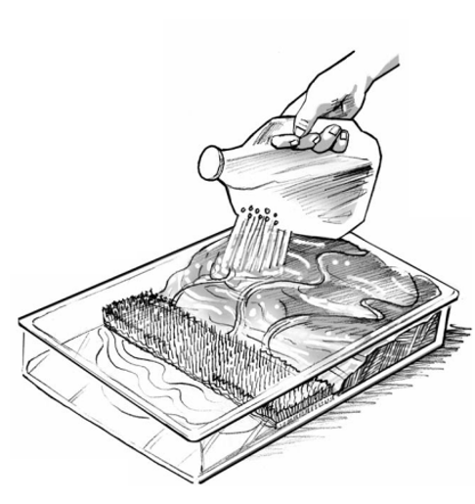
Figure 1: Example of wetland in a pan (Source: California Coastal Commission)
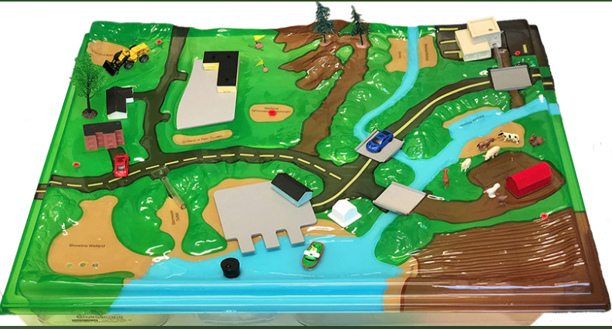
Figure 2: EnviroScape® set-up before wetland addition (Source: JT&A, Inc.)

Vocabulary:
Wetlands – ecosystems with ponded water or water just below the ground surface that

Runoff – water that flows across the land, rather than being absorbed into soil

Sediment – soil that ends up in runoff or body of water

References:
Adapted from Mykut, J. (n.d.). Wetlands in a Pan. Penn State College of Agricultural Sciences. https://ecosystems.psu.edu/outreach/youth/sftrc/lesson-plans/water/6-8/wetland

Environmental Concern Inc. and The Watercourse (1995). Wow! The Wonders of Wetlands. St. Michaels, Md., & Bozeman, Mont.: Environmental Concerns Inc. and The Watercourse.

Wetland Detectives
Build students’ scientific observation and documentation skills through a visit to a local wetland. Students will act as detectives looking for proof that an ecosystem is a wetland. Detectives will also try to map the extent of the wetland (i.e., perform a wetland delineation).
Learning Objectives:
- Learn the characteristics of a wetland
- Build scientific observation and documentation skills
Materials:
- Waterproof gridded field notebooks
- Clipboards
- Flagging tape
- Printed simple wetland map template (i.e., aerial imagery or topographic map)
- Printed Detective Data Sheets
- Printed Wetland Clues Guide (at least 1 per team)
- Optional: water quality sensors, water quality testing strips or kits, handheld GPS units, smartphone or tablet, soil probe or trowel, plant identification guide, regional field guides
Preparation:
- Select a nearby wetland that is safe and accessible for youth.
- Ensure that you have enough chaperones to supervise youth in the wetland.
- Print out aerial imagery of the wetland if possible. Aerial imagery will not work well for forested wetlands. If aerial imagery is unavailable, print gridded paper on which students can draw a map.
Recommended Pre-Work: What is a Wetland? – Frayer Model activity
Activity:
Detective Briefing (10 minutes):
Explain that youth will be Wetland Detectives who must gather clues to prove that the ecosystem they visit is a wetland. Wetland detectives can use the Wetland Clues Guide, which contains wetland indicators related to wetland hydrology, hydrophytic vegetation, hydric soils, and water control structures, to aid their investigation. More advanced students can also try to map the wetland extent (i.e., the boundary of the wetland). The boundary represents the transition from wetland hydrology to drier conditions, hydrophytic vegetation to less water-tolerant vegetation, and hydric soils to soils that are more well-drained. This boundary demarcates the wetlands from upland conditions.
Divide the students into small groups (i.e., detective teams). Students should record data on their wetland data sheets and provided maps.
The Wetland Clues Guide is adapted from the Regional Supplements to the U.S. Army Corps of Engineers Wetland Delineation Manual. The student’s wetland data sheet is adapted from the U.S. Army Corp of Engineers Wetland Determination Data Form for the Midwest Region.
If possible, provide printed regional field guides to aid with identification of vegetation and wildlife, and teach students to use image recognition tools, such as iNaturalist or Google Lens. Explain how these image recognition models are trained and the importance of verifying these observations.

Detective Data Sheet
Attention, Wetland Detectives! Your mission is to determine if this site is a wetland. If it is a wetland, uncover the outer boundary of a wetland. Use your keen scientific observation skills to collect and map evidence.
Project/Site: _________________________________ Sampling Date: __________________
City/County: ____________________ State: ________
Investigation Team: ___________________________________________________________
Water Presence Clues
Look for clues that this site has wetland hydrology for at least part of the year.
Primary Clues (minimum of one is required, check all that apply)
[ ] Standing or flowing water | [ ] Algal mat or crust – active or dried
[ ] Shallow groundwater or saturation | [ ] Iron deposits
[ ] Water marks | [ ] Water-stained leaves
[ ] Sediment deposits | [ ] Aquatic animals
[ ] Drift deposits | [ ] Hydrogen sulfide (H₂S) odor
The wetland may not be currently flooded or have shallow groundwater. Look for secondary clues that hint that there is wetland hydrology during other parts of the year.
Secondary Clues (if you did not find a primary clue, a minimum of two secondary clues are required, check all that apply)
[ ] Cracks on the soil surface | [ ] Crayfish burrows
[ ] Drainage patterns | [ ] Stunted or stressed plants
[ ] Orange along roots
Sketch the Extent of Water and Saturation.
Note any signs of water. Standing water is often in the center of the wetland, not near the boundary. If soils feel soft or soggy under your feet, groundwater is likely close to the soil surface. Sketch a map of the extent of standing water in your field notebook or on your wetland map. Map where soil becomes firm under your feet, indicating that the groundwater is not shallow or the soil is not saturated.
Soil Secrets
Hydric soils are soils with characteristics typically formed because of the persistent wet conditions present in wetlands.
Characteristics of Hydric Soils (check all that are observed).
[ ] Organic soils | [ ] Thin layer of muck
[ ] Black soil surface | [ ] Light gray soil with orange streaks
[ ] Thick, dark soil surface | [ ] Light gray soil
[ ] Hydrogen sulfide (H₂S) odor
Vegetation Vigilance
Is floating vegetation present? Yes [ ] No [ ]
Is underwater vegetation present? Yes [ ] No [ ]

Hydrophytic vegetation thrives under flooded or saturated conditions that are found in wetlands. These plants often have adaptations that help them thrive in these conditions, distinguishing them from those in drier upland ecosystems.
Wetland Plant Adaptions (check all that are observed)
[ ] Pneumatophores | [ ] Buttress roots
[ ] Aerenchmya | [ ] Waxy coatings on leaves and stems
[ ] Shallow roots
Describe vegetation in the wetland. Include sketches of some vegetation below.
________________________________________________________________________________________________________________________________________________________________________________________________________________________________________________________________________________________________________________________

Use field guides, identification keys, or image recognition tools to identify some of the plants in the wetland. Identified wetland species:
- ____________________________________________
- ____________________________________________
- ____________________________________________
- ____________________________________________
- ____________________________________________
Are there clusters of different vegetation types? Add vegetation communities to your sketch of the wetland via shading or patterns. Include a legend (i.e., key) that links the shading or patterns to different vegetation types. Note any shifts in vegetation type and density. These shifts may indicate the transition between the wetland and upland ecosystems.

Topographic Tells
Wetlands tend to be in certain spots in the landscape where groundwater and surface water drain. Analyzing the position of this site within the landscape provides more evidence.
Potential Topographic Positions of Wetlands (check all that are observed).
[ ] Along a river or stream | [ ] Along a pond, lake, or ocean
[ ] At the bottom of a hill or slope | [ ] In flat areas
[ ] At a low point or bowl-shaped area in the landscape
If you have a contour map, look for the following clues (check all that are observed).
[ ] Closely spaced contours that abruptly become more widely spaced, indicating a transition from a steep slope to a flat area | [ ] Widely spaced contours beside bodies of water, suggesting flat valleys or floodplains
[ ] Circular or oval contours, which indicate a depression

Animal Evidence
Note presence of water-loving animals (e.g., frogs, waterfowl, turtles) and aquatic animals (i.e., fish, mussels). Use field guides or image recognition tools to identify wildlife.
________________________________________________________________________________________________________________________________________________________________________________________________________________________________________________________________________________________________________________________
Suspicious Structures
Engineers may alter drainage patterns to restore or create the necessary wetland hydrologic conditions. Wetland creation or restoration may involve changing the topography of the site by excavating or filling different areas. Engineers may also design certain structures that change water levels by limiting flow out of the ecosystem.
Water control structures to support wetland hydrology (check all that are observed).
[ ] Flashboard risers | [ ] Sluice gate
[ ] Dam/Weir Structure | [ ] Earthen dam or berm
[ ] Riser | [ ] Ditch plug

Cracking the Case
Compile your evidence to determine if this site is a wetland and, if it is a wetland, to map the wetland boundary in your field notebook or on your printed map. Write a brief on your decision. Support your conclusion with the following information:
- Water Presence Clue
- Soil Secrets
- Vegetation Vigilance
- Topographic Tells
- Animal Evidence
- Suspicious Structures
______________________________________________________________________________________________________________________________________________________________________________________________________________________________________________________________________________________________________________________________________________________________________________________________________________________________________________________________________________________________________________________________________________________________________________________________________________________________________________________________________________________________________________________________________________________________________________________________________________________________________________________________________________________________________________________________________________________________________________________________________________________________________________________________________________________________________________________________________________________________________________________________________________________________________________________________________________________________________________________________________________________________________________________________________________________________________________________________________________________________________________________________________________________________________________________________________________________________________________________________________________________________________________________________________________________________________________________________________________________________________________________________________________________________________________________________________________________________________________________________________________________________
Congratulations, Wetland Detective! You’ve solved the case.

Wetland Clues Guide
Water Presence Clue  Standing or flowing water | 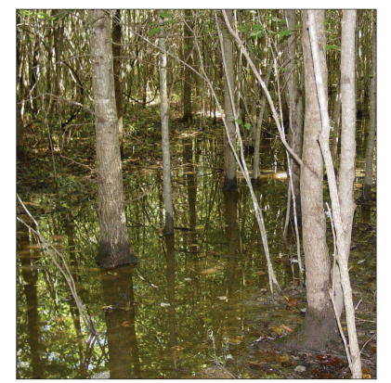
Water Presence Clue  Shallow groundwater or saturation  If soils feel soft or soggy under your feet, groundwater is likely close to the soil surface. Saturated soils may glisten in the sunlight due to high water content. | 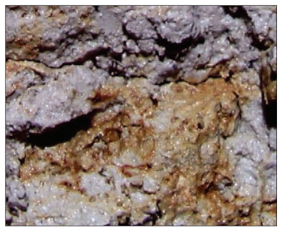
Water Presence Clue  Water marks  Dark stains on trees and other vegetation that are indicators of past floods or high-water levels | 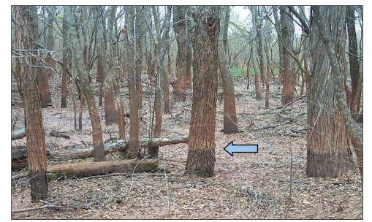
Water Presence Clue  Sediment deposits  Sediment might be left behind on trees and other vegetation after past floods. Piles of deposited silt or sand may be on the soil surface. | 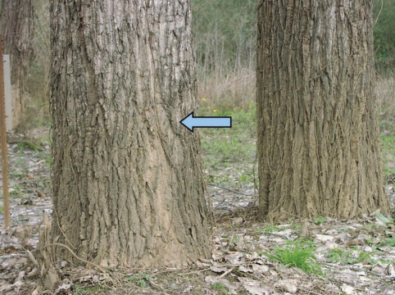
Water Presence Clue  Drift deposit  Piles of debris (e.g., branches, stems, and leaves) left behind after a flood. These deposits are often against trees or other fixed objects. | 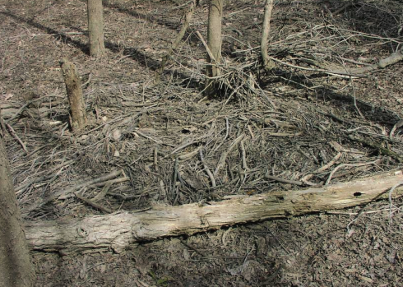
Water Presence Clue  Algal mat or crust [active]  Algal growth indicates sustained wet conditions | 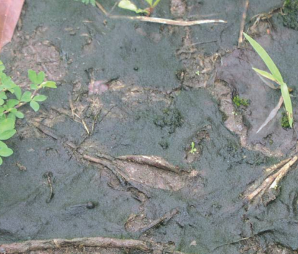
Water Presence Clue  Algal mat or crust [dried]  Algal growth indicates sustained wet conditions | 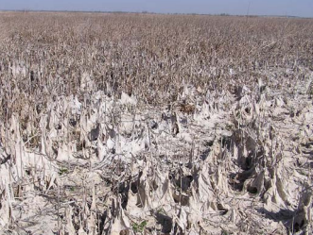
Water Presence Clue  Iron deposits  Orange streaks when iron in groundwater is exposed to air | 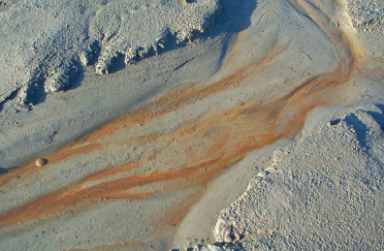
Water Presence Clue  Water-stained leaves | 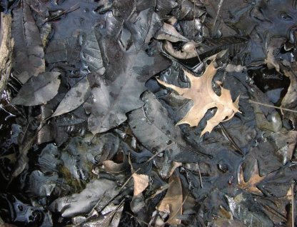
Water Presence Clue  Aquatic animals  Look for aquatic animals or evidence of their presence. Examples include fish, frogs, and frogs. | 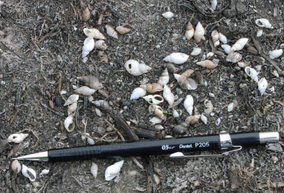
Water Presence Clue  Hydrogen sulfide (H₂S) odor | Gas that smells like rotten eggs when you disturb soils in the wetland
Water Presence Clue  Cracks on the soil surface  These cracks indicate that the soil was wet and has now dried. | 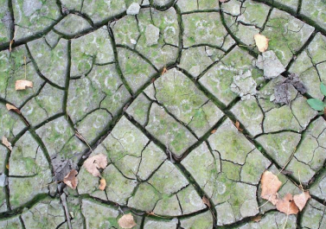
Water Presence Clue  Drainage patterns  Grasses and shrubs bent over in the direction of water flow from past floods. | 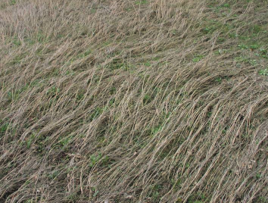
Water Presence Clue  Drainage patterns  Limited leaves and woody debris may indicate where water flowed during flooding events. | 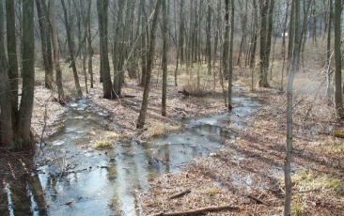
Water Presence Clue  Orange along roots  Orange along roots indicates soils were quite wet, but roots provided oxygen to the soil. | 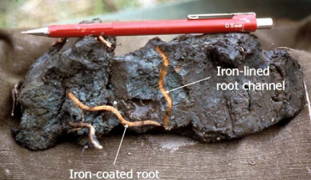
Water Presence Clue  Orange along roots  Orange along roots indicates soils were quite wet, but roots provided oxygen to the soil. | 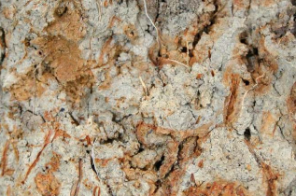
Water Presence Clue  Crawfish burrows | 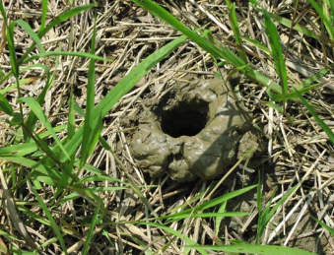
Water Presence Clue  Stunted or stressed plants | 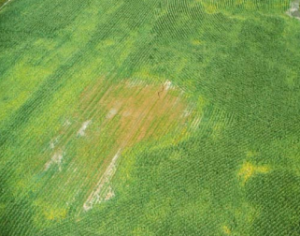

Soil Secrets  Organic Soils  Organic soils have more organic carbon than other soil types.These soils are a deep, rich brown or black color. If you look closely, you might see small pieces of leaves, twigs, and other plant materials, or the soil might be more like a sticky chocolate cake mix. | 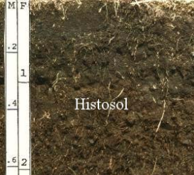
Soil Secrets  Black Soil Surface  Top layer of soil is enriched is organic and dark black. | 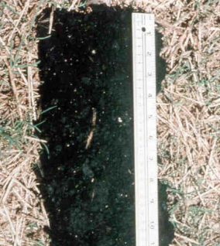
Soil Secrets  Thick, Dark Soil Surface  Not all wetlands have organic soils. Wetlands tend to have more organic carbon than drier soils in other ecosystems, so the top layers are a deep, rich brown or black color. | 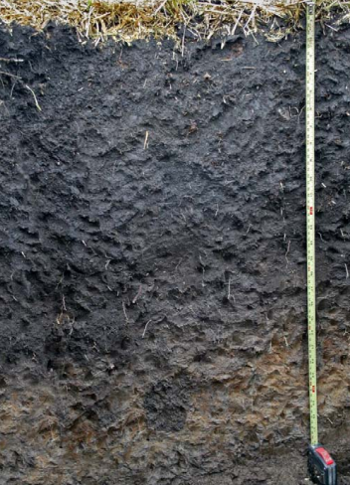
Soil Secrets  Hydrogen sulfide (H₂S) odor | Gas that smells like rotten eggs when you disturb soils in the wetland
Soil Secrets  Thin layer of muck  Muck is dark and somewhat sticky soil material. Nearly all plant material is so decomposed that you cannot pick it out. | 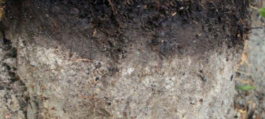
Soil Secrets  Light gray soil with orange streaks  Light gray soil is where iron has been lost due to prolonged wet conditions. Orange streaks are zones where iron has moved to and become oxidized again. | 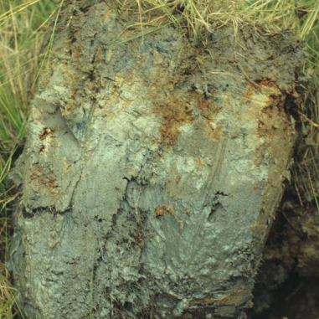
Soil Secrets  Light gray soil with orange streaks  Light gray is where iron has been lost due to prolonged wet conditions. Orange streaks are zones where iron has moved to and become oxidized again. | 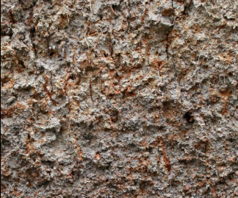
Soil Secrets  Light gray soil  Light gray is where iron has been lost due to prolonged wet conditions. | 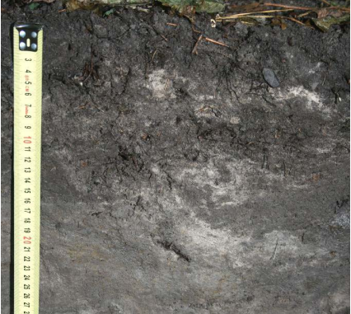

Vegetation Vigilance  Pneumatophores  Roots that grow above the soil surface. | 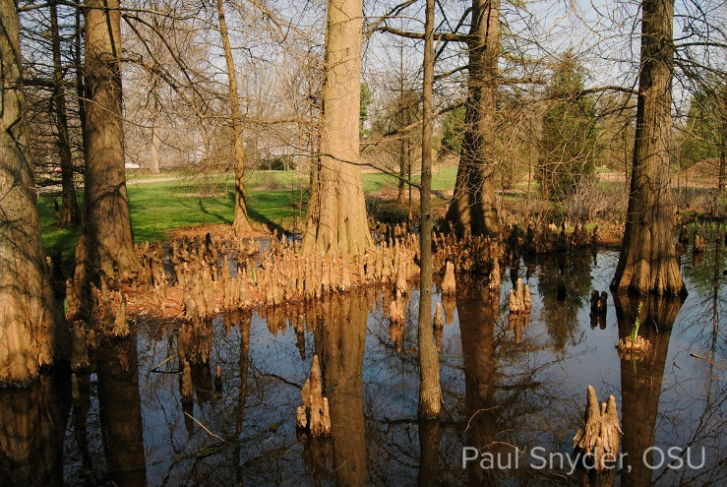  Image Source: Paul Snyder, Ohio State University
Vegetation Vigilance  Aerenchyma  Large air pockets in the stems of some wetland plants. | 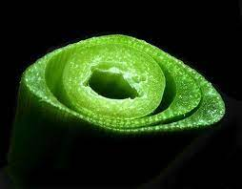  Image Source: NRCS
Vegetation Vigilance  Shallow roots  Roots of wetland plants tend to grow along the soil surface. | 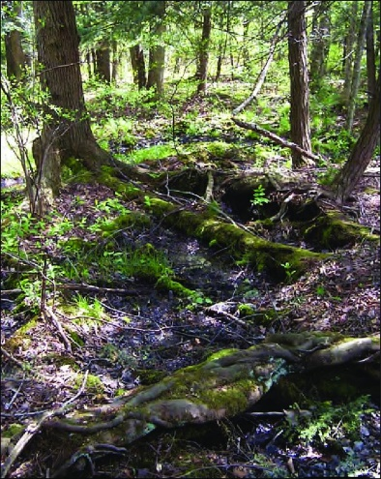
Vegetation Vigilance  Buttress roots  Wide roots that extend from the base of a tree to support it, stabilizing the tree in flowing water | 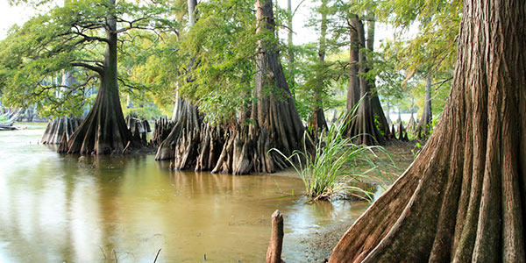  Image Source: National Wildlife Federation
Vegetation Vigilance  Waxy coatings on leaves and stems | 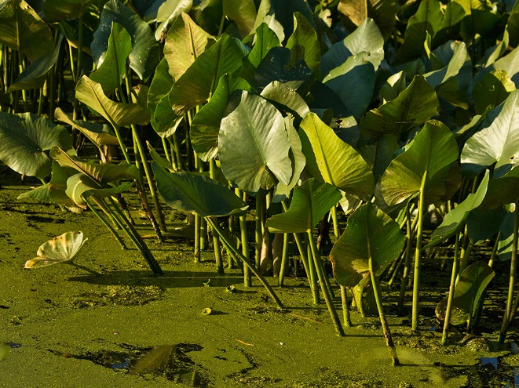  Image Source: Rutgers University

Suspicious Structures  Flashboard riser | 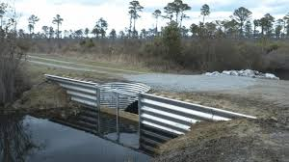  Image Source: Wurster et al., 2016 (USFWS)
Suspicious Structures  Dam/Weir Structure | 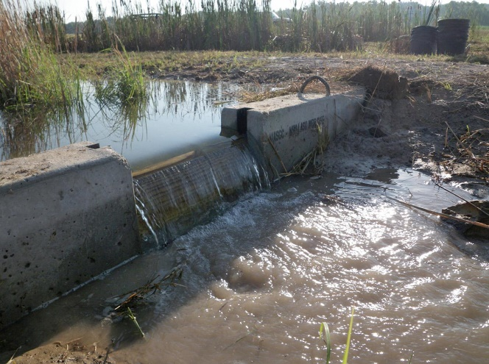  Image Source: Mississippi State University Extension
Suspicious Structures  Riser | 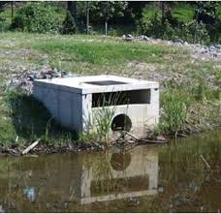  Image Source: Clemson University
Suspicious Structures  Sluice gate | 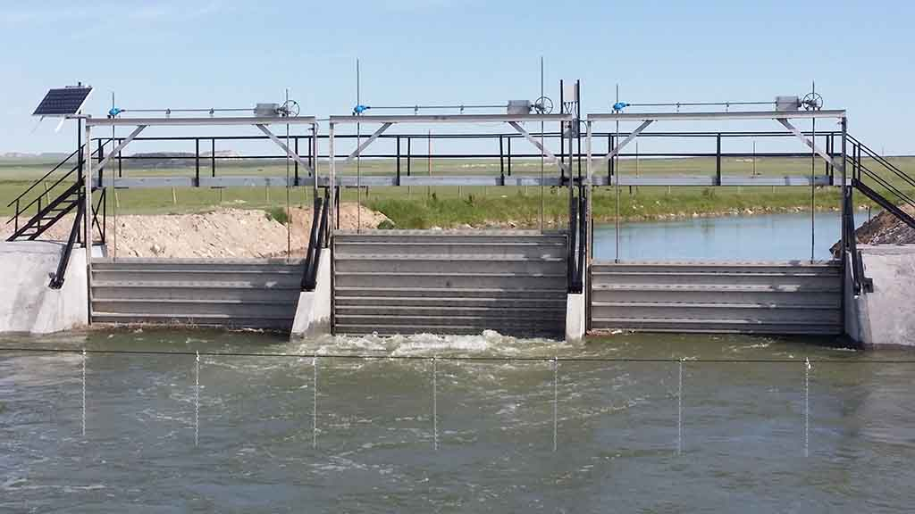  Image Source: Water Technologies
Suspicious Structures  Earthen dam or berm | 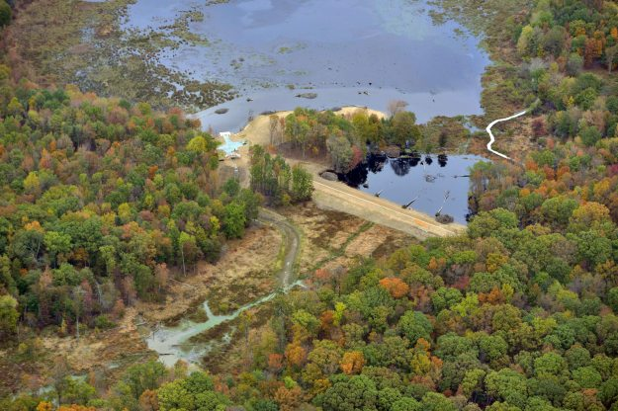  Image Source: Fairfax County Park Authority
Suspicious Structures  Ditch plug | 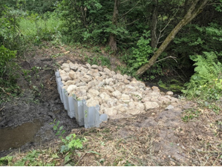  Image Source: Anoka Conservation District

Want to Know More About This Wetland?
Wetland detectives can look for more clues about the wetland before or after the visit using aerial imagery and other geospatial data.
See the previous lesson in the Stream Geomorphology & Restoration section on sources of and access to geospatial data.
- Look at aerial images of the wetland from different dates. Clues that this site is a wetland include:
  - Inundation or flooding on aerial images
  - Dark soils on the aerial images suggest that soil is saturated and has high organic carbon content
- Review topography maps
- Review soil maps, such as via Web Soil Survey.
Additional Reading:
Wetland Indicators: A Guide to Wetland Formation, Identification, Delineation, Classification, and Mapping [Second Edition] by Ralph W. Tiner

Technical Communication: Design Informational Signage for Visitors to this Wetland
Learning Objectives:
- Synthesize environmental data
- Understand the ecological value of wetlands
- Practice technical communication skills by translating environmental data to be accessible to general audiences
Materials:
- Digital Posters
  - Laptops/computers to design digital posters
  - Digital design software (i.e., Canva, PowerPoint, Adobe products)
  - Photos from the field, if available
- Physical Posters
  - Paper or posterboard
  - Markers, paints, glue, tape, etc.
  - Printed photos from the field, if available
Pre-Work:
Visit a local wetland and complete the Wetland Detectives activity. Student teams will need observational data collected at the wetland to inform the educational signage.
Evaluation Criteria:
- Accuracy of technical information on wetlands
- Clarity of messaging
- Visual appeal and organization
- Relevance to the audience

Student Guide
Create informative and engaging signage to educate visitors to this wetland. This sign should help visitors understand the ecological value of this wetland. Use data collected during your wetland detective investigation to inform your design.
Data Review
Review the data and observations collected during your wetland detective work. Summarize key features of the wetland. Link these features to the ecosystem services wetlands provide (i.e., flood reduction, water treatment, habitat provision, carbon sequestration).
Audience Analysis
Consider typical visitors. What will be most interesting to them about the wetland?
___________________________________________________________________
___________________________________________________________________
___________________________________________________________________
___________________________________________________________________
___________________________________________________________________
Key Messages
Develop 3-5 main points about the wetland’s ecosystem services and associated features. Consider the importance of the wetland to society.
- _____________________________________________________________
- _____________________________________________________________
- _____________________________________________________________
- _____________________________________________________________
- _____________________________________________________________

Visual Design
Sketch a layout for your sign. Include
- An attention-grabbing title
- Easy-to-read key points
- Visual appeal (i.e., drawings, data visualizations, photos)
- A map of the wetland

Call to Action
Encourage visitors to protect the wetland with a call to action, such as
- “Stay on marked trails to prevent erosion.”
- “Report sightings of invasive species to ___________.”
Feedback & Iterate
Get feedback on your draft signage from peers. Revise your design.
Presentation
Present your sign to the group, explaining design choices and how the sign relates to your observations about the wetland.

Potential Extensions:
Interactive Elements: Add an interactive element to your sign design, such as a checklist to spot wetland wildlife or vegetation. You might consider adding moveable pieces to the sign or tactile experience.

Constructed Wetland Engineering
Constructed wetlands are designed to use many of the same ecological processes that natural wetlands use to improve water quality but look different than wetlands found in nature and are built in places where wetlands may not be likely to form naturally. Constructed wetlands often treat wastewater or stormwater.
Students will select one or more of the following scenarios and apply the engineering design process and their understanding of wetlands to design a solution.
Learning Objectives:
- Analyze the characteristics and functions of ecosystems to inform ecological engineering design
- Apply engineering design principles to develop a nature-based solution that addresses a specified problem.
  - Evaluate and select appropriate design approaches to address identified goals and meet design criteria.
  - Develop and refine a design that aligns with project goals and meets design criteria.
  - Communicate the specified problem, iterations, and final design to stakeholders.
Scenario 1:
Background Information:
Floating treatment wetlands are floating, porous mats with wetland plants that can be added to lakes, stormwater ponds, shorelines, and other bodies of water. These floating treatment wetlands can improve water quality, reduce erosion, provide habitat, and enhance visual appeal.

Problem: 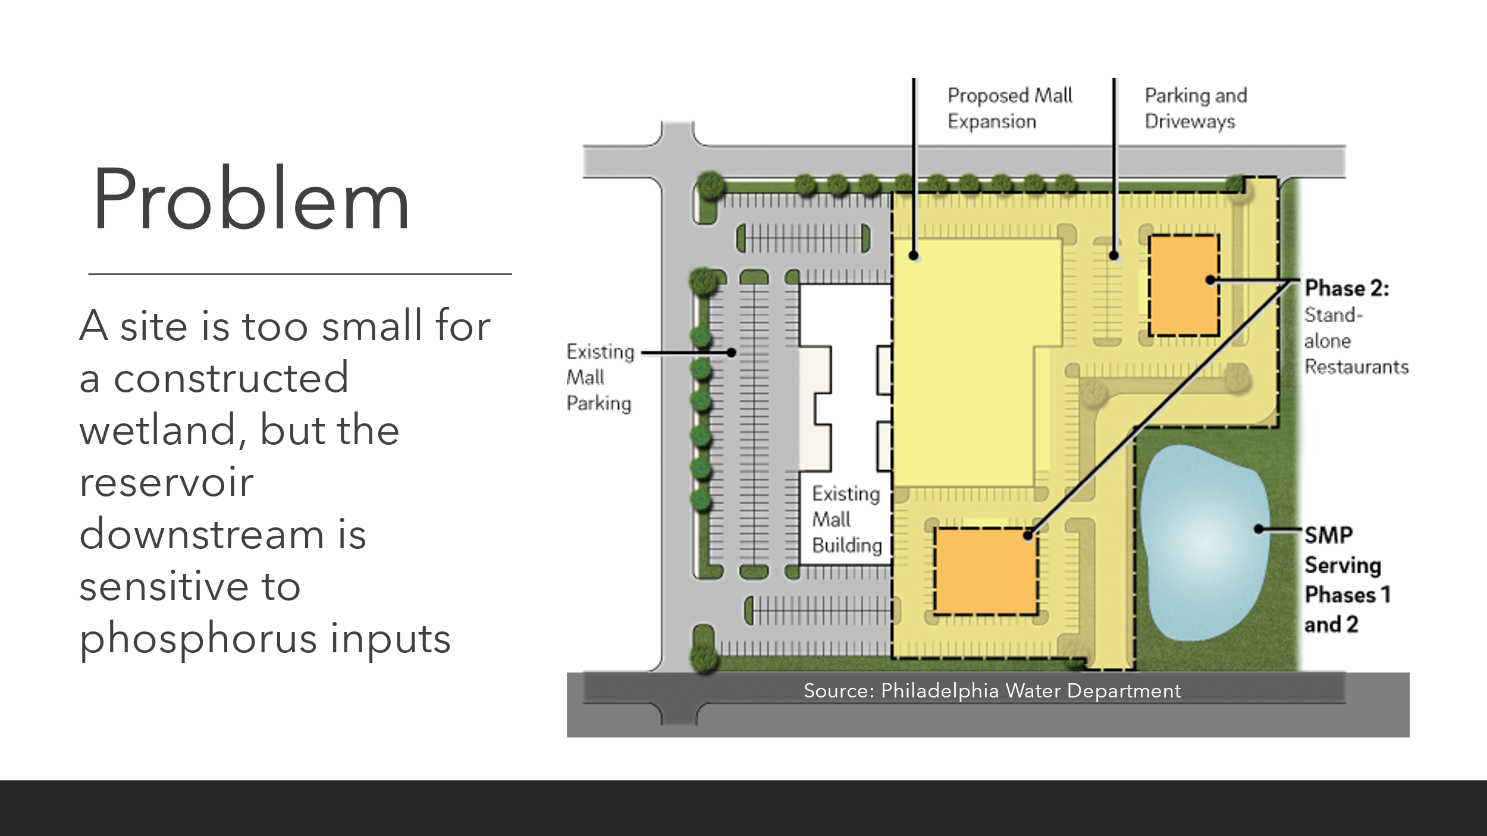
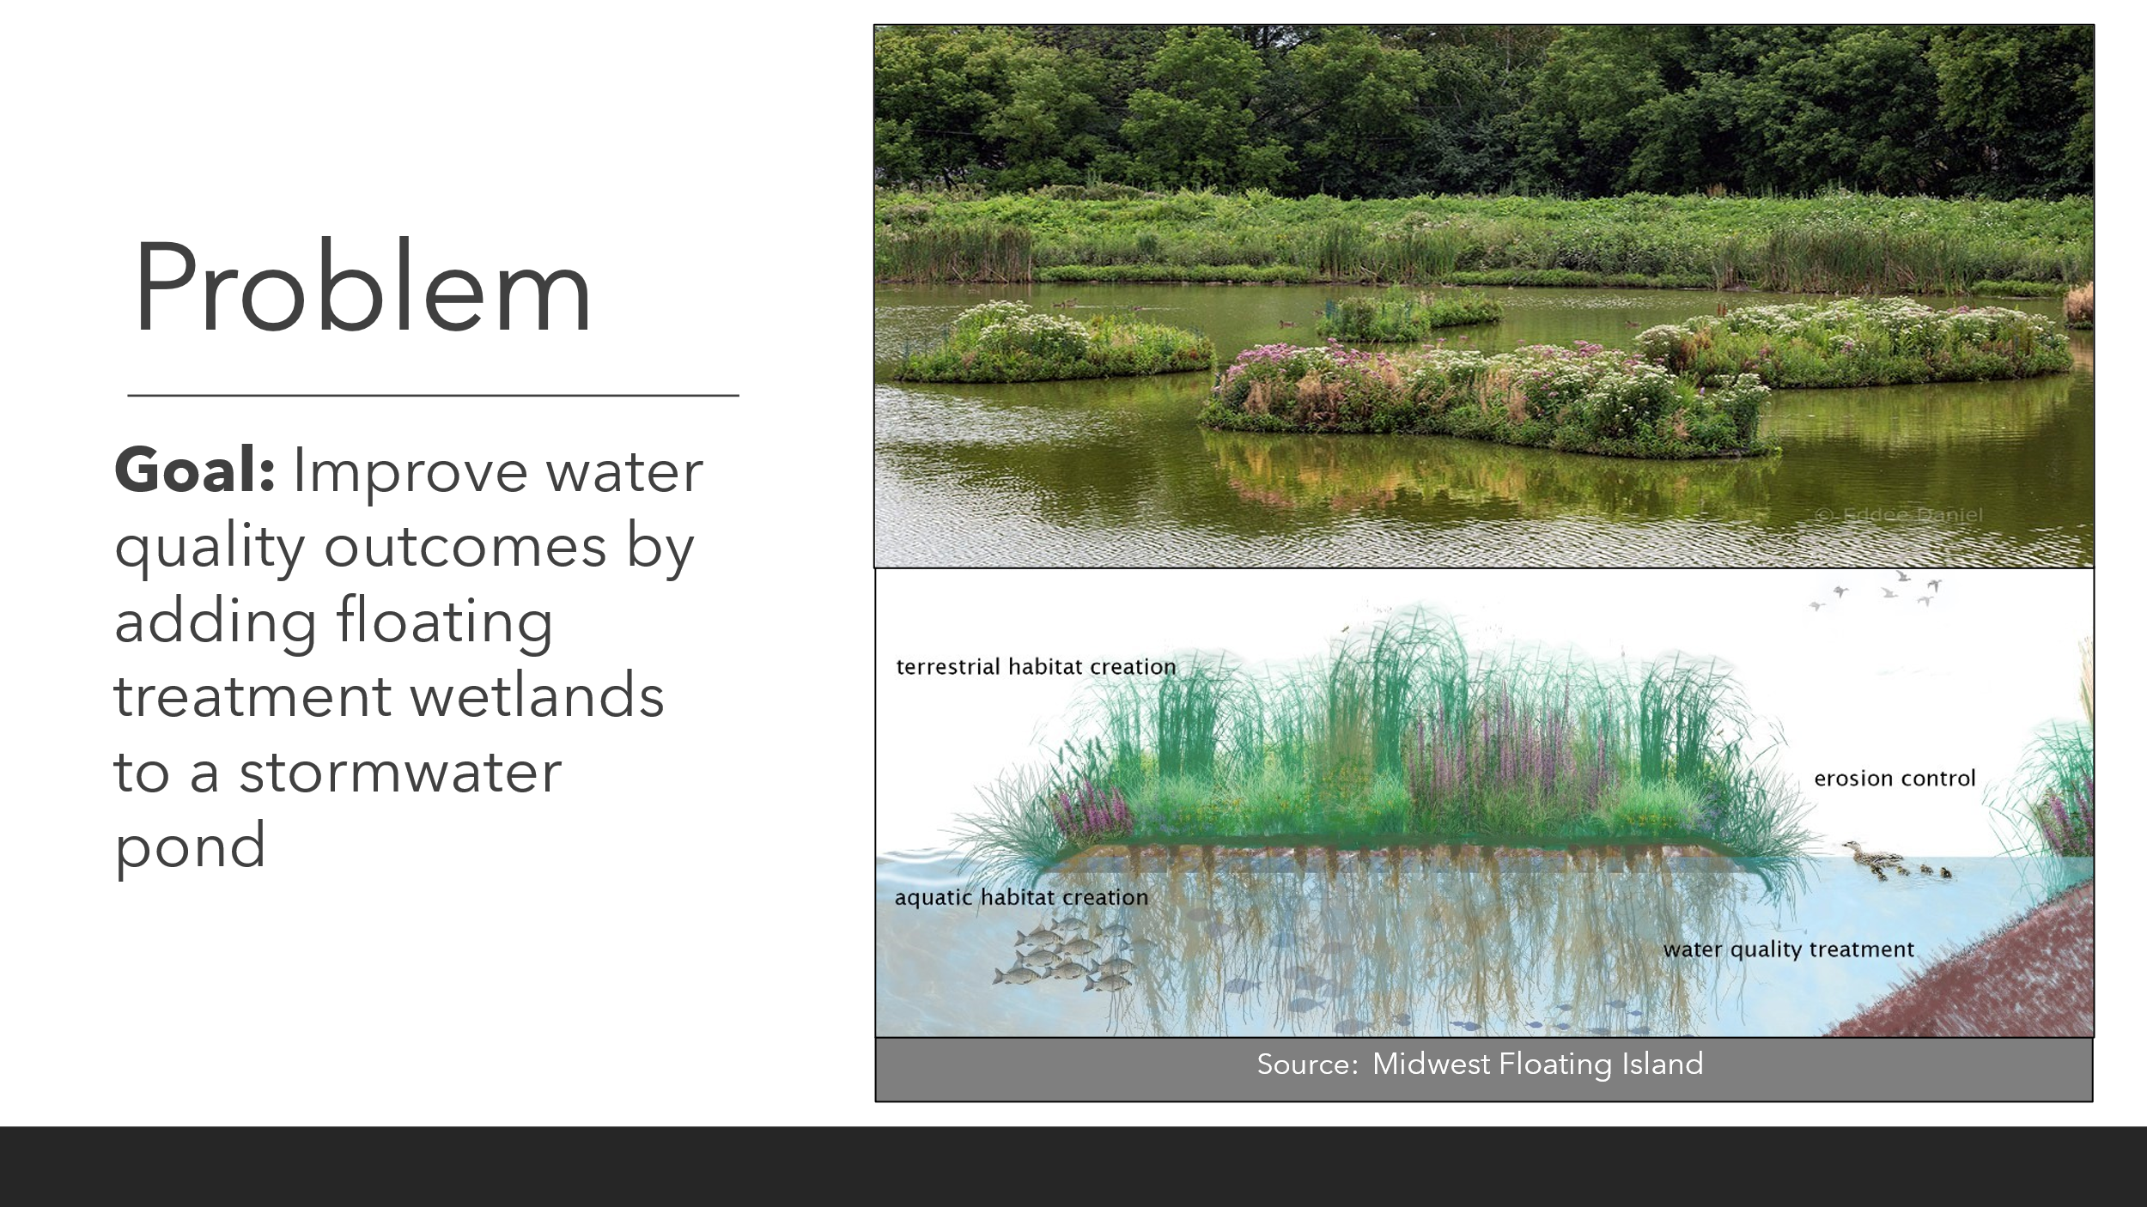
Design Criteria:
- Plants
  - Must thrive in full sun
  - Must thrive under flooded conditions
- Floating mat
  - Must be porous to promote growth of biological films
- Anchor
  - Must be anchored to the bottom of the pond
Key Design Choices:
- Plant selection
- Material and structure of floating mat
- Type of anchor
- Configuration in the pond
Scenario 2:
Background Information:
A vertical flow wetland (VF wetland) uses wetland plants and layered filter media, such as soil or gravel, to treat wastewater. Wastewater is added to the surface and then moves downward through media layers to an outlet pipe at the base.
Problem:
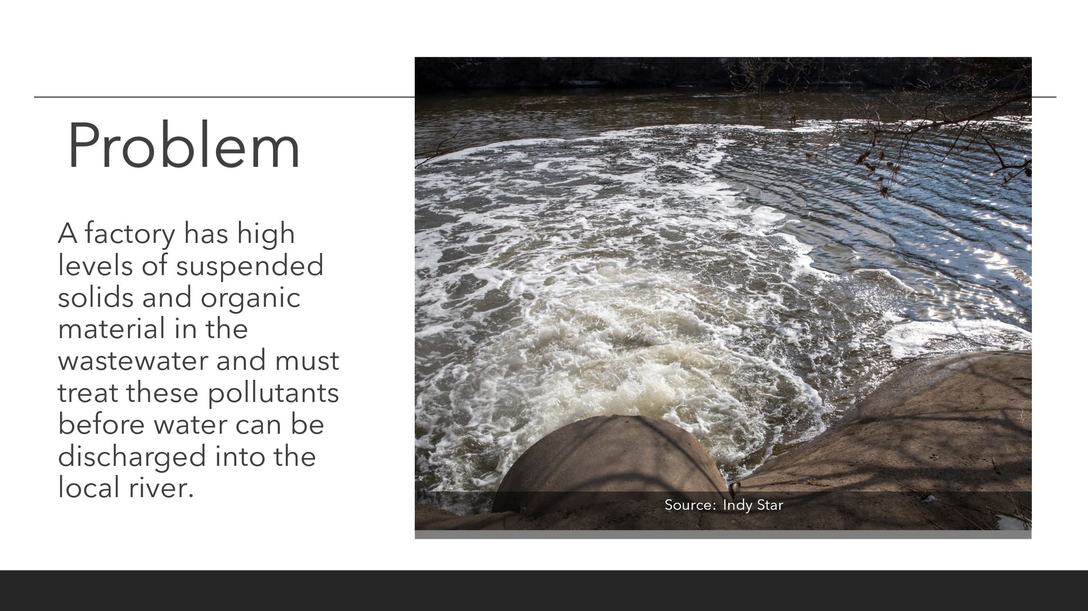
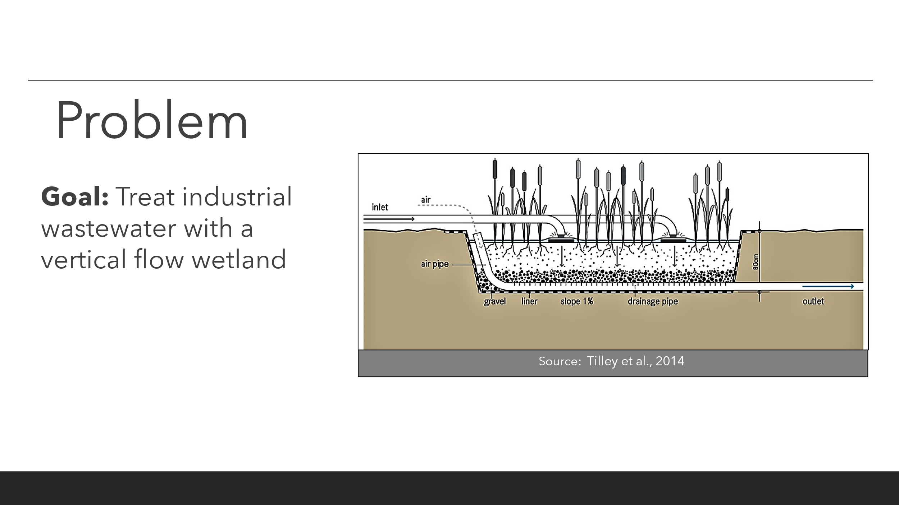
Design Criteria:
- Plants
  - Must thrive under elevated organic and solids loading
- Hydrology
  - Flow must enter at the soil surface, flow vertically through media layers, and exit via an outflow below the wetland
Key Design Choices:
- Plant selection
- Media – materials, layer width, and layer order
- Hydraulics
Scenario 3:
Background Information:
A free water surface wetland is a constructed wetland where water flows over the surface from an inlet to an outlet, typically inundating soils continuously. Free water surface wetlands are planted with wetland vegetation and may be contained by impermeable liner or berms.

Problem:
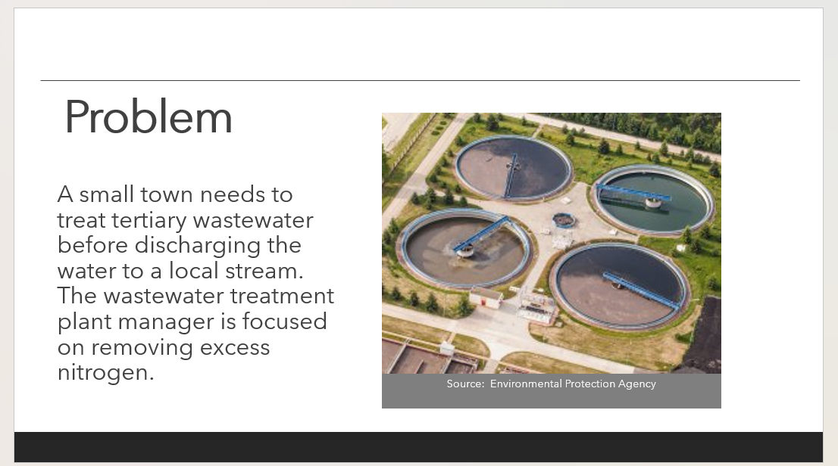
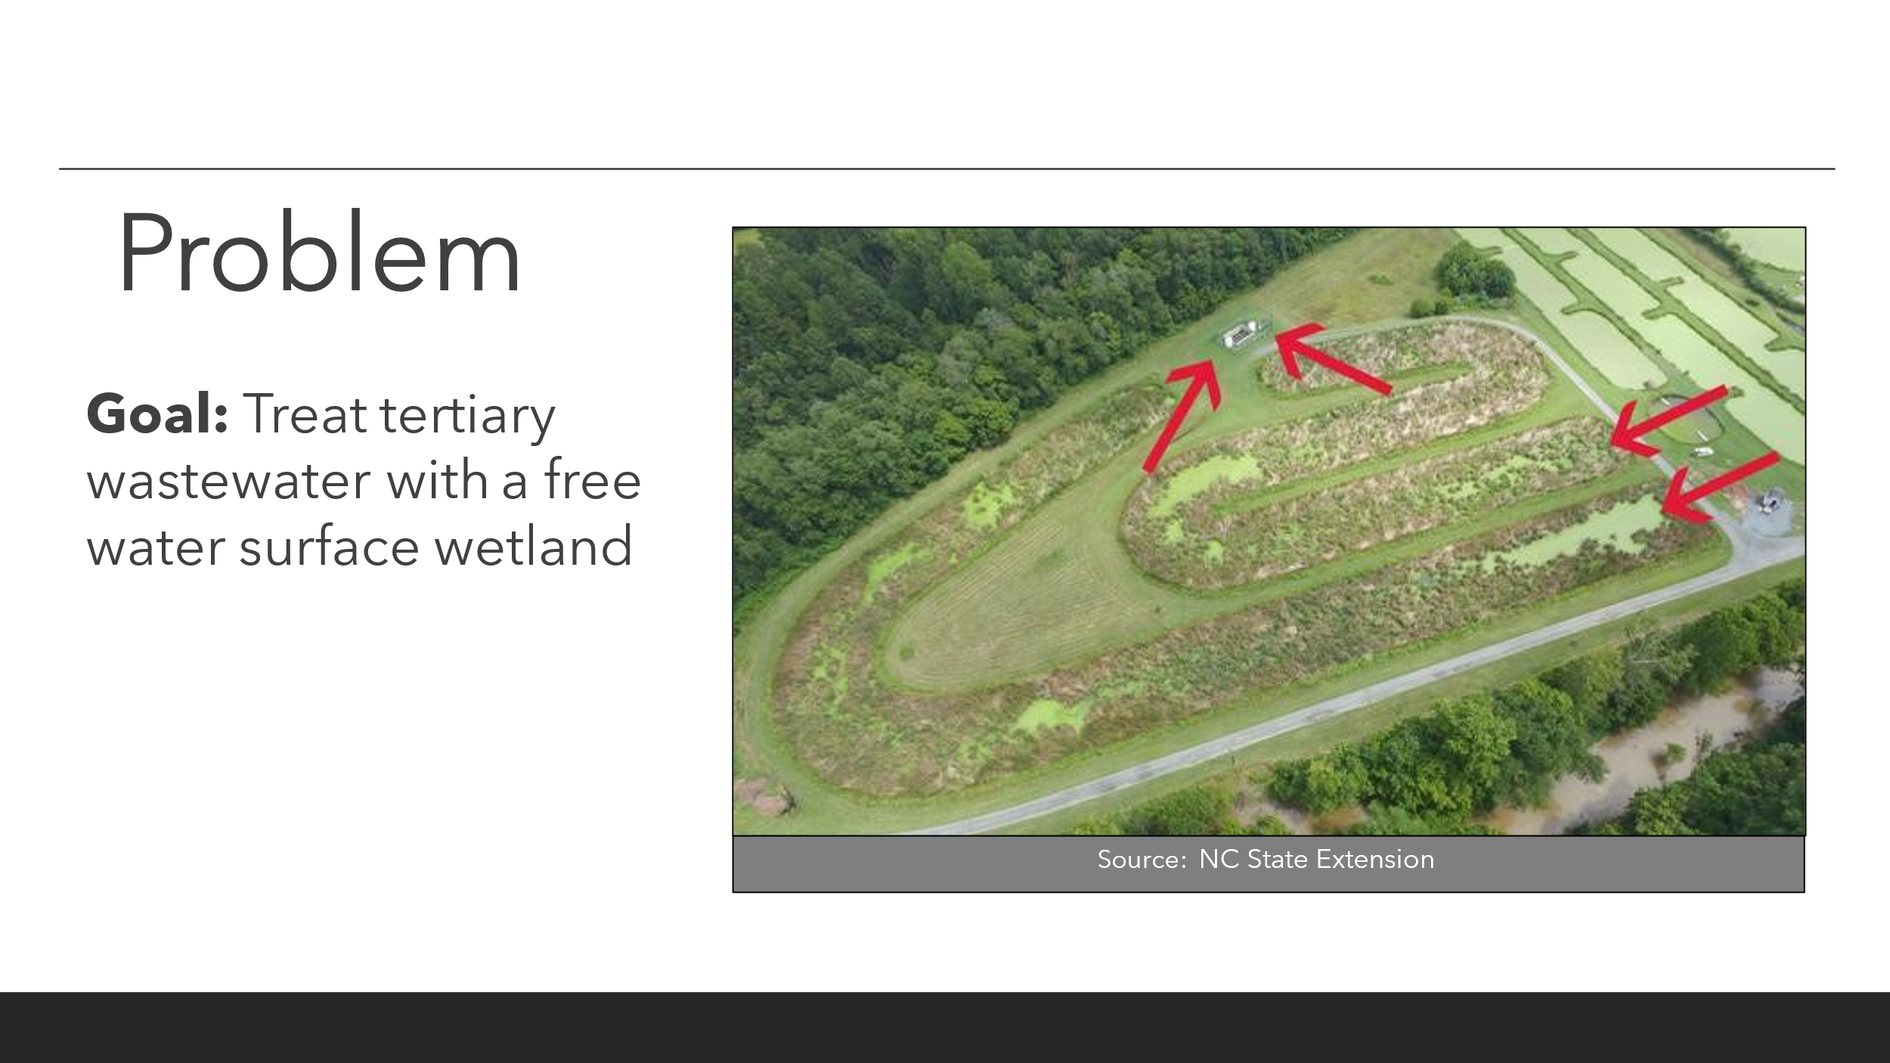
Design Criteria:
- Plants
  - Must thrive under flooded conditions
  - Should be associated with high nitrogen treatment
- Hydrology
- Flow must enter and exit at or above the soil surface
Key Design Choices:
- Length and shape
- Plant selection
- Plant management (i.e., harvest, perennial vegetation)
Scenario 4:
Background Information:
A subsurface flow (SSF) wetland is a constructed wetland that maintains the water level below the surface of filter media, such as gravel and sand. SSF wetlands are further classified as vertical flow (VF), horizontal flow (HF), or hydrid systems. SSF wetlands minimize contact between pollutants and oxygen. The lack of standing water can also be important to address safety concerns, such as fostering mosquito habitat.
Problem: 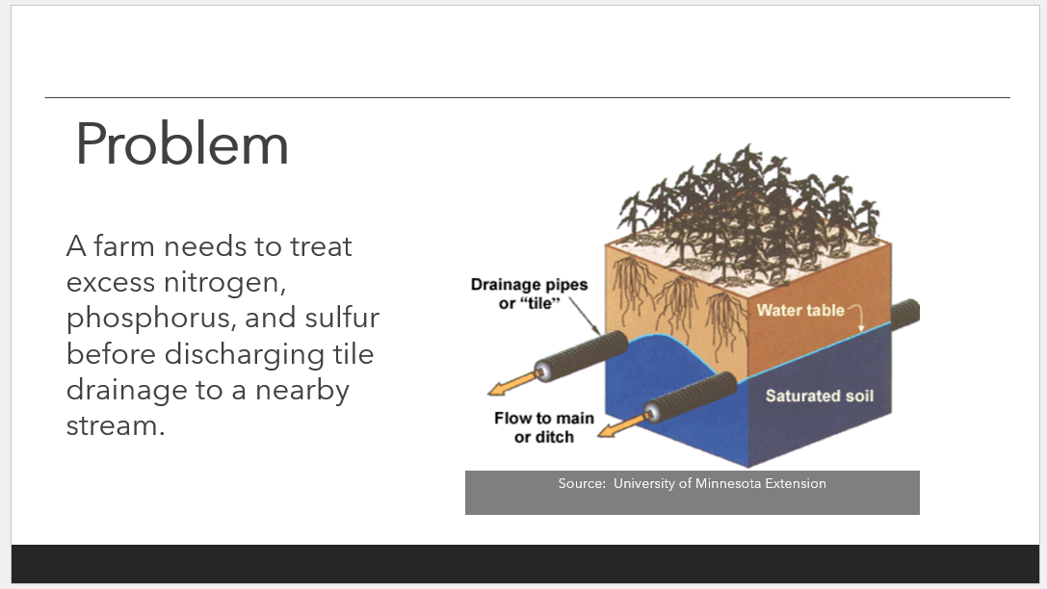
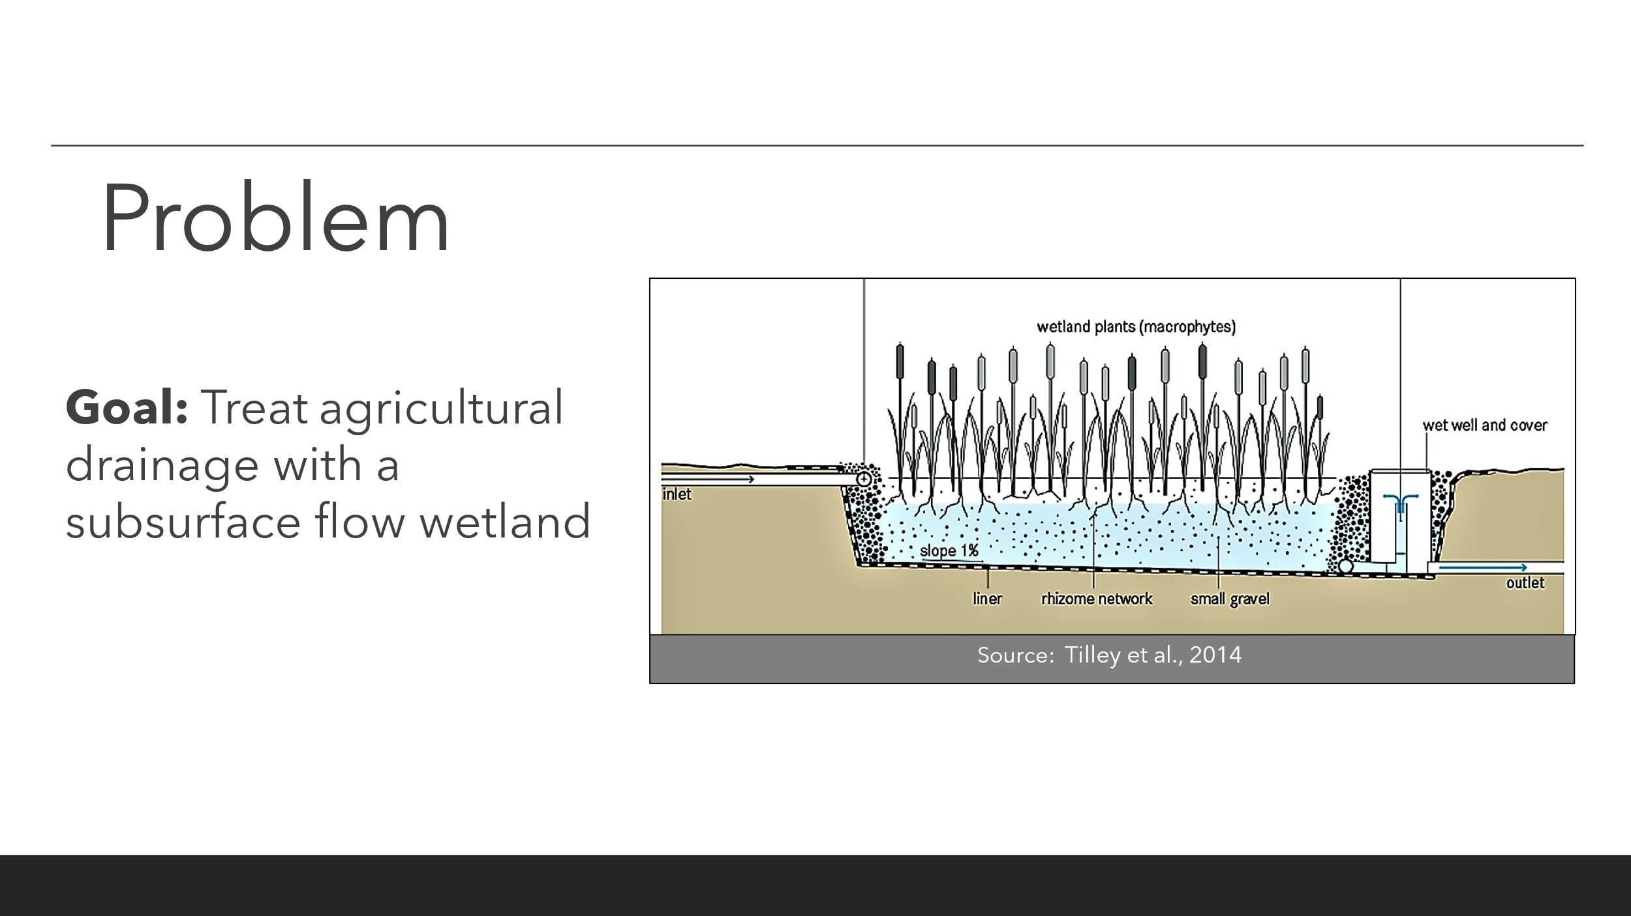
Design Criteria:
- Plants
  - Must thrive under saturated conditions
  - Should be associated with high nutrient treatment
- Hydrology
- Water must stay below the wetland surface
Key Design Choices:
- Direction of flow
- Hydraulics
- Plant selection
- Media – materials, layer width, layer order
Scenario 5:
Background Information:
A stormwater wetland is a constructed wetland that stores stormwater to mitigate downstream flooding and erosion and treats pollutants in runoff. As compared to stormwater wet ponds, stormwater wetlands have shallower water and higher coverage of vegetation. Stormwater wetlands often have a forebay, which is a small pool or basin that captures sediment by dissipating energy to prevent wetlands from filling in with excess sediment.
Problem: 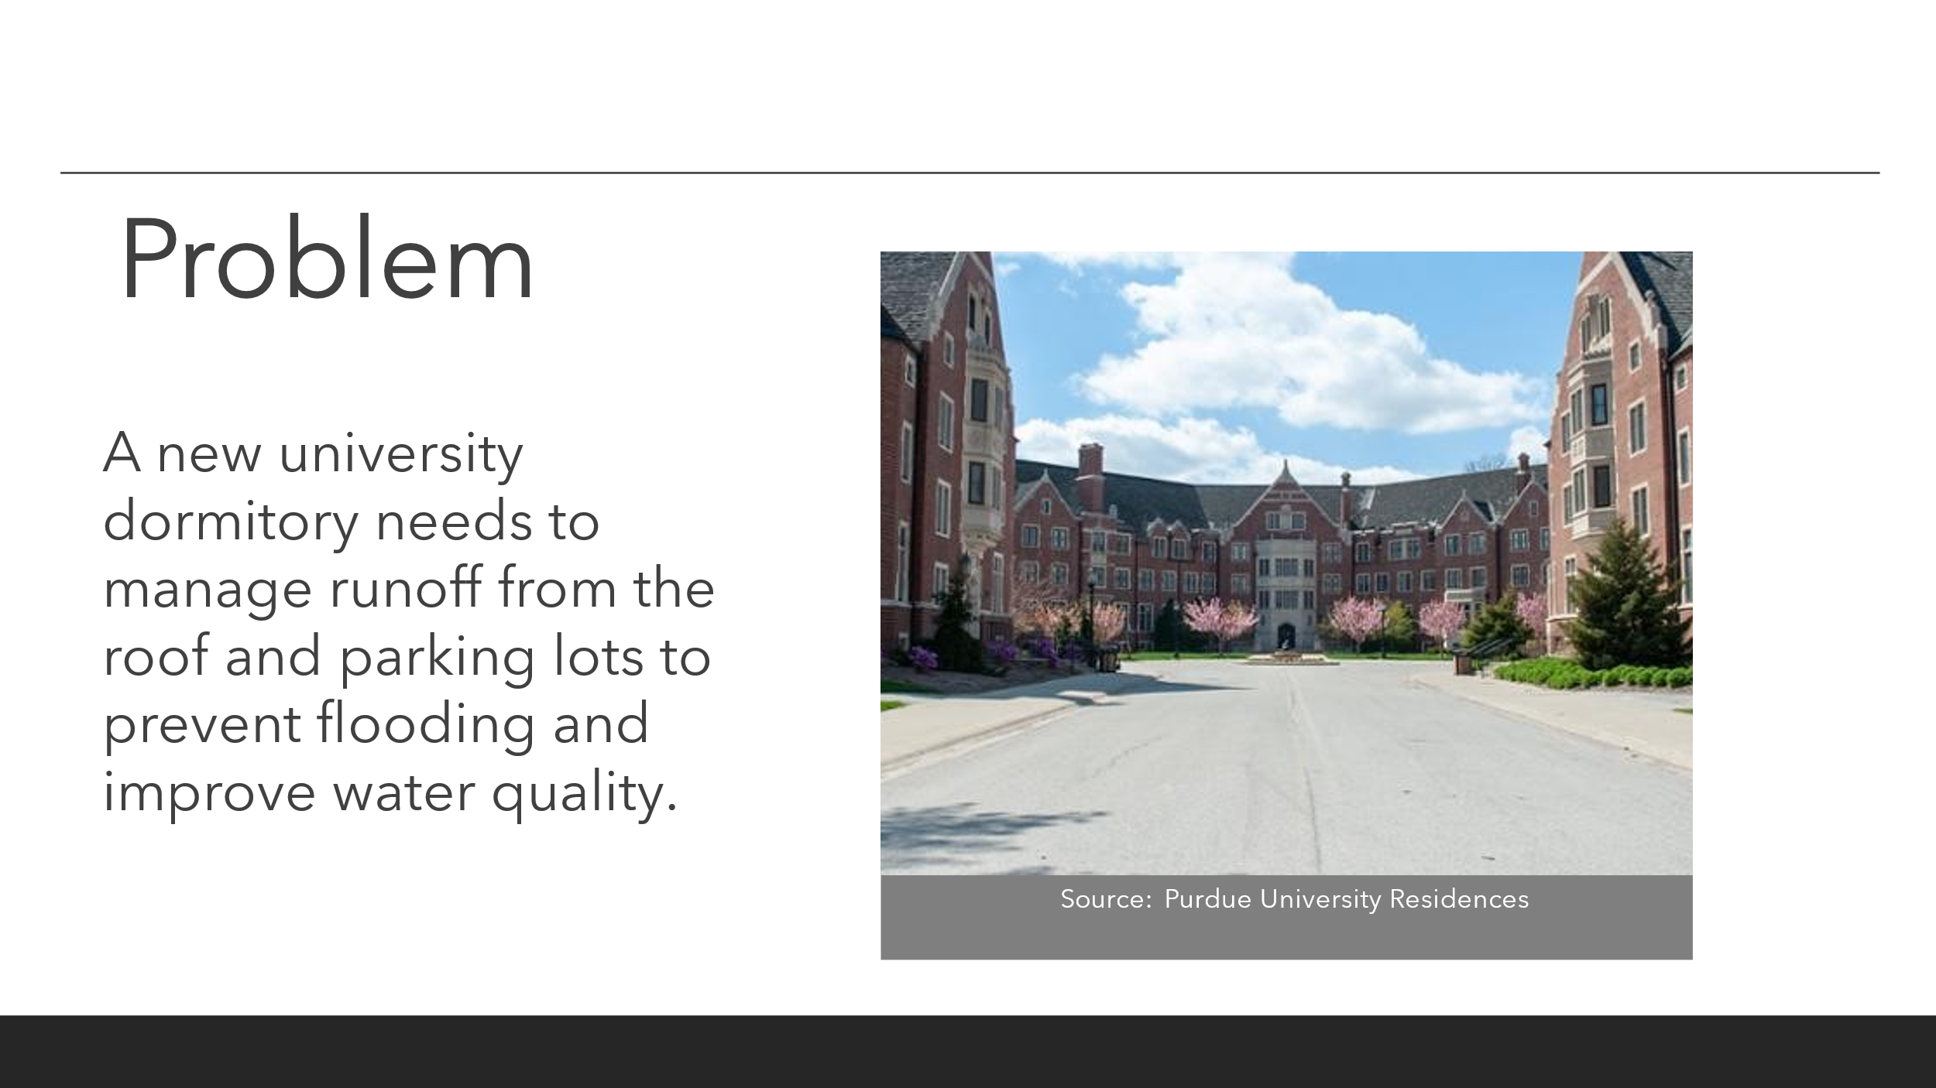
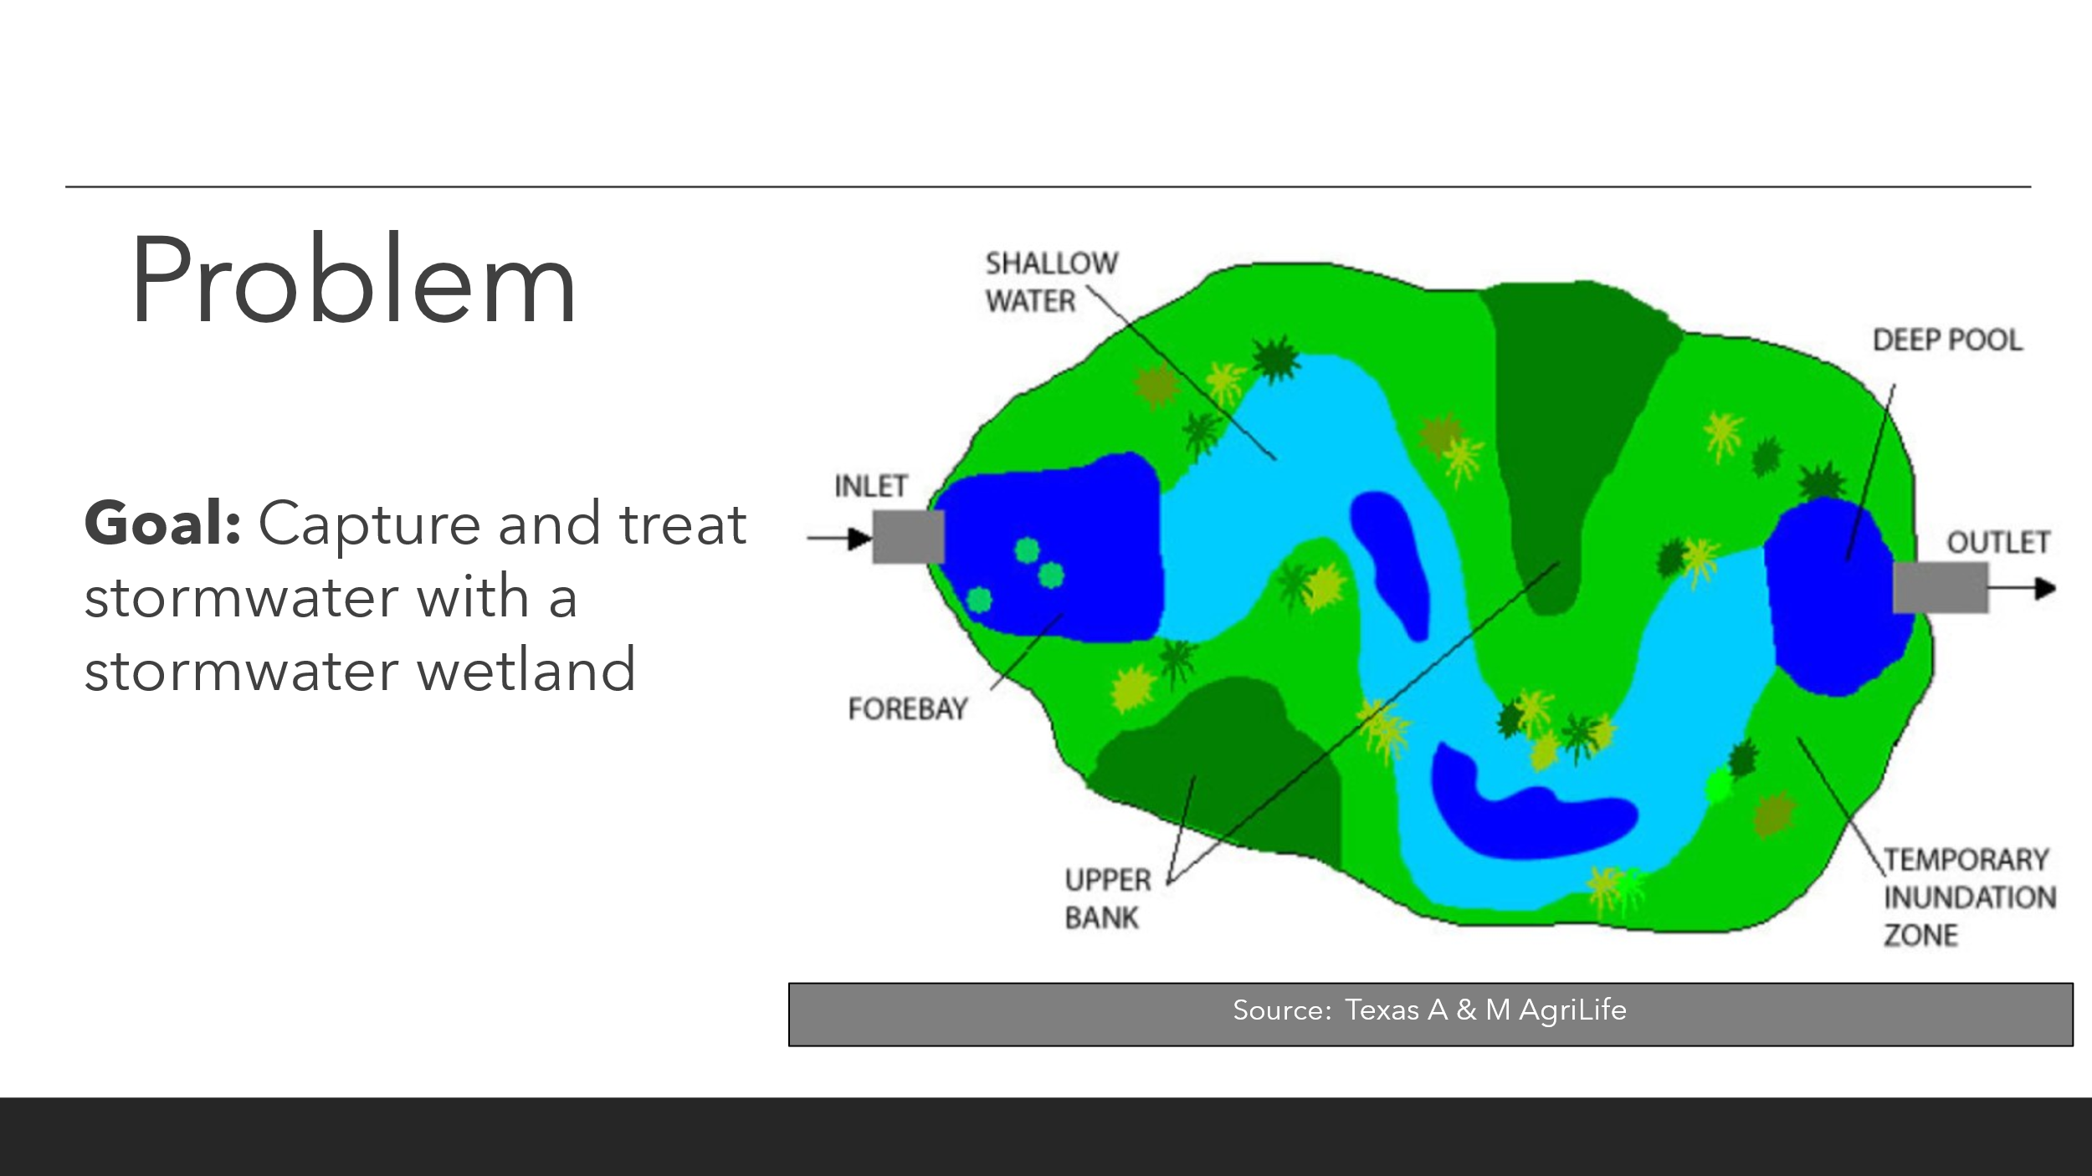

Design Criteria:
- Plants
  - Must thrive under fluctuating dry and flooded conditions
- Hydrology
- Hold large amounts of water
- Forebay
- Capture excess sediment before it enters the wetland with a forebay
- Aesthetics
  - Be visually appealing for a high-traffic residential area
Key Design Choices:
- Balance of pools, shallow water, shallow land, and bank
- Plant selection

Reading List:
Wetlands
- About Habitats: Wetlands by Cathryn Sill (ISBN-10: 1561456896)
- Over and Under the Wetland by Kate Messner (ISBN-10: 1797210874)
- America’s Wetlands: Guide to Plants and Animals by Marianne Wallace (ISBN-10: 1555914845)
Streams:
- Brooke Meets a Stream Doctor: Featuring Dr. Watt R. Shedd by Alexandra McLaughlin (Penn State Extension)
- About Habitats: Rivers and Streams by Cathryn Sill (ISBN-10: 1682633942)
- Creekfinding: A Story by Jacqueline Briggs Martin (ISBN-10: 0816698023)
Other Recommendations:
- The Living Landscape: Discovering the Critical Zone by Eric Parrish and Suzanne Anderson (Institute for Arctic and Alpine Research)
- Over and Under the Pond by Kate Messner (ISBN-10: 1452145423)

