# Virtual Groundwater Contamination Simulation

## A Resource from the Purdue University College of Science

### Background – For the Teacher

* Target age group: middle and high school
* Duration: 45 minutes – 1 hour
* Setting: school visits, club meetings
* Indiana Academic Standards:
  + Construct a scientific explanation based on evidence for how the uneven distributions of Earth's mineral, energy, and groundwater resources are the result of past and current geoscience processes [MS-ESS3-1]
  + Apply scientific principles to design a method for monitoring and minimizing a human impact on the environment [MS-ESS3-3]
  + Design, evaluate, and refine a solution for reducing the impacts of human activities on the environment and biodiversity [HS-ENV4-2]
* Potential College Majors: Civil Engineering, Environmental and Natural Resource Engineering, Environmental Geosciences, Natural Resources and Environmental Science, Environmental and Ecological Engineering, Geology, Soil and Water Science
* Potential Careers: Hydrologist, geologist, civil engineer, water resources engineer, environmental scientist, environmental engineer

### Materials

* Access to the [Virtual Lab: Groundwater Contamination Simulation Lab 1](https://www.purdue.edu/science/K12/LabPages/groundwaterLab1.html)
* Copies of the [Groundwater Contamination Simulation Lab 1](https://docs.google.com/document/d/1mB_d5-cKZNLB9ISVNwts3qml-8w7C4TD-vS-4PWpIVM/edit?usp=sharing)
* Projector/screen to display the groundwater model (Figure 1) and videos showing contamination extent
* Recommended: Computers/laptops for students to explore virtual lab resources

### Discussion of Lesson

Groundwater is a valuable natural resource. Drinking water and irrigation supplies often come from groundwater, so preventing contamination of groundwater with pollutants is crucial. When groundwater is contaminated, engineers and scientists may use models to predict where contaminants end up. These models can guide efforts to extract and treat groundwater contaminants. See additional notes for facilitators in Supplemental Information for more technical information.

### Activity

1. Introduce the importance of groundwater as a natural resource.
2. Allow students to work through Prior Knowledge section and Questions 1-2 of the Groundwater Contamination Lab section in teams.
3. Show the contamination simulations to allow students to see if their hypotheses were supported or refuted (Question 3).
4. Have students work in teams to identify causes and consequences of different types of pollution.
5. Facilitate a follow-up discussion: What can we do at or nearthe Earth’s surface to prevent groundwater contamination?

### Vocabulary

Groundwater – water that flows and is stored below the Earth’s surface

Groundwater wells – boreholes that allow us to monitor groundwater levels and collect water samples for further analysis

### References

[Purdue University College of Science HS/MS Learning Experiences](https://www.purdue.edu/science/K12/LabPages/teachingscience.html)

### Supplemental Information

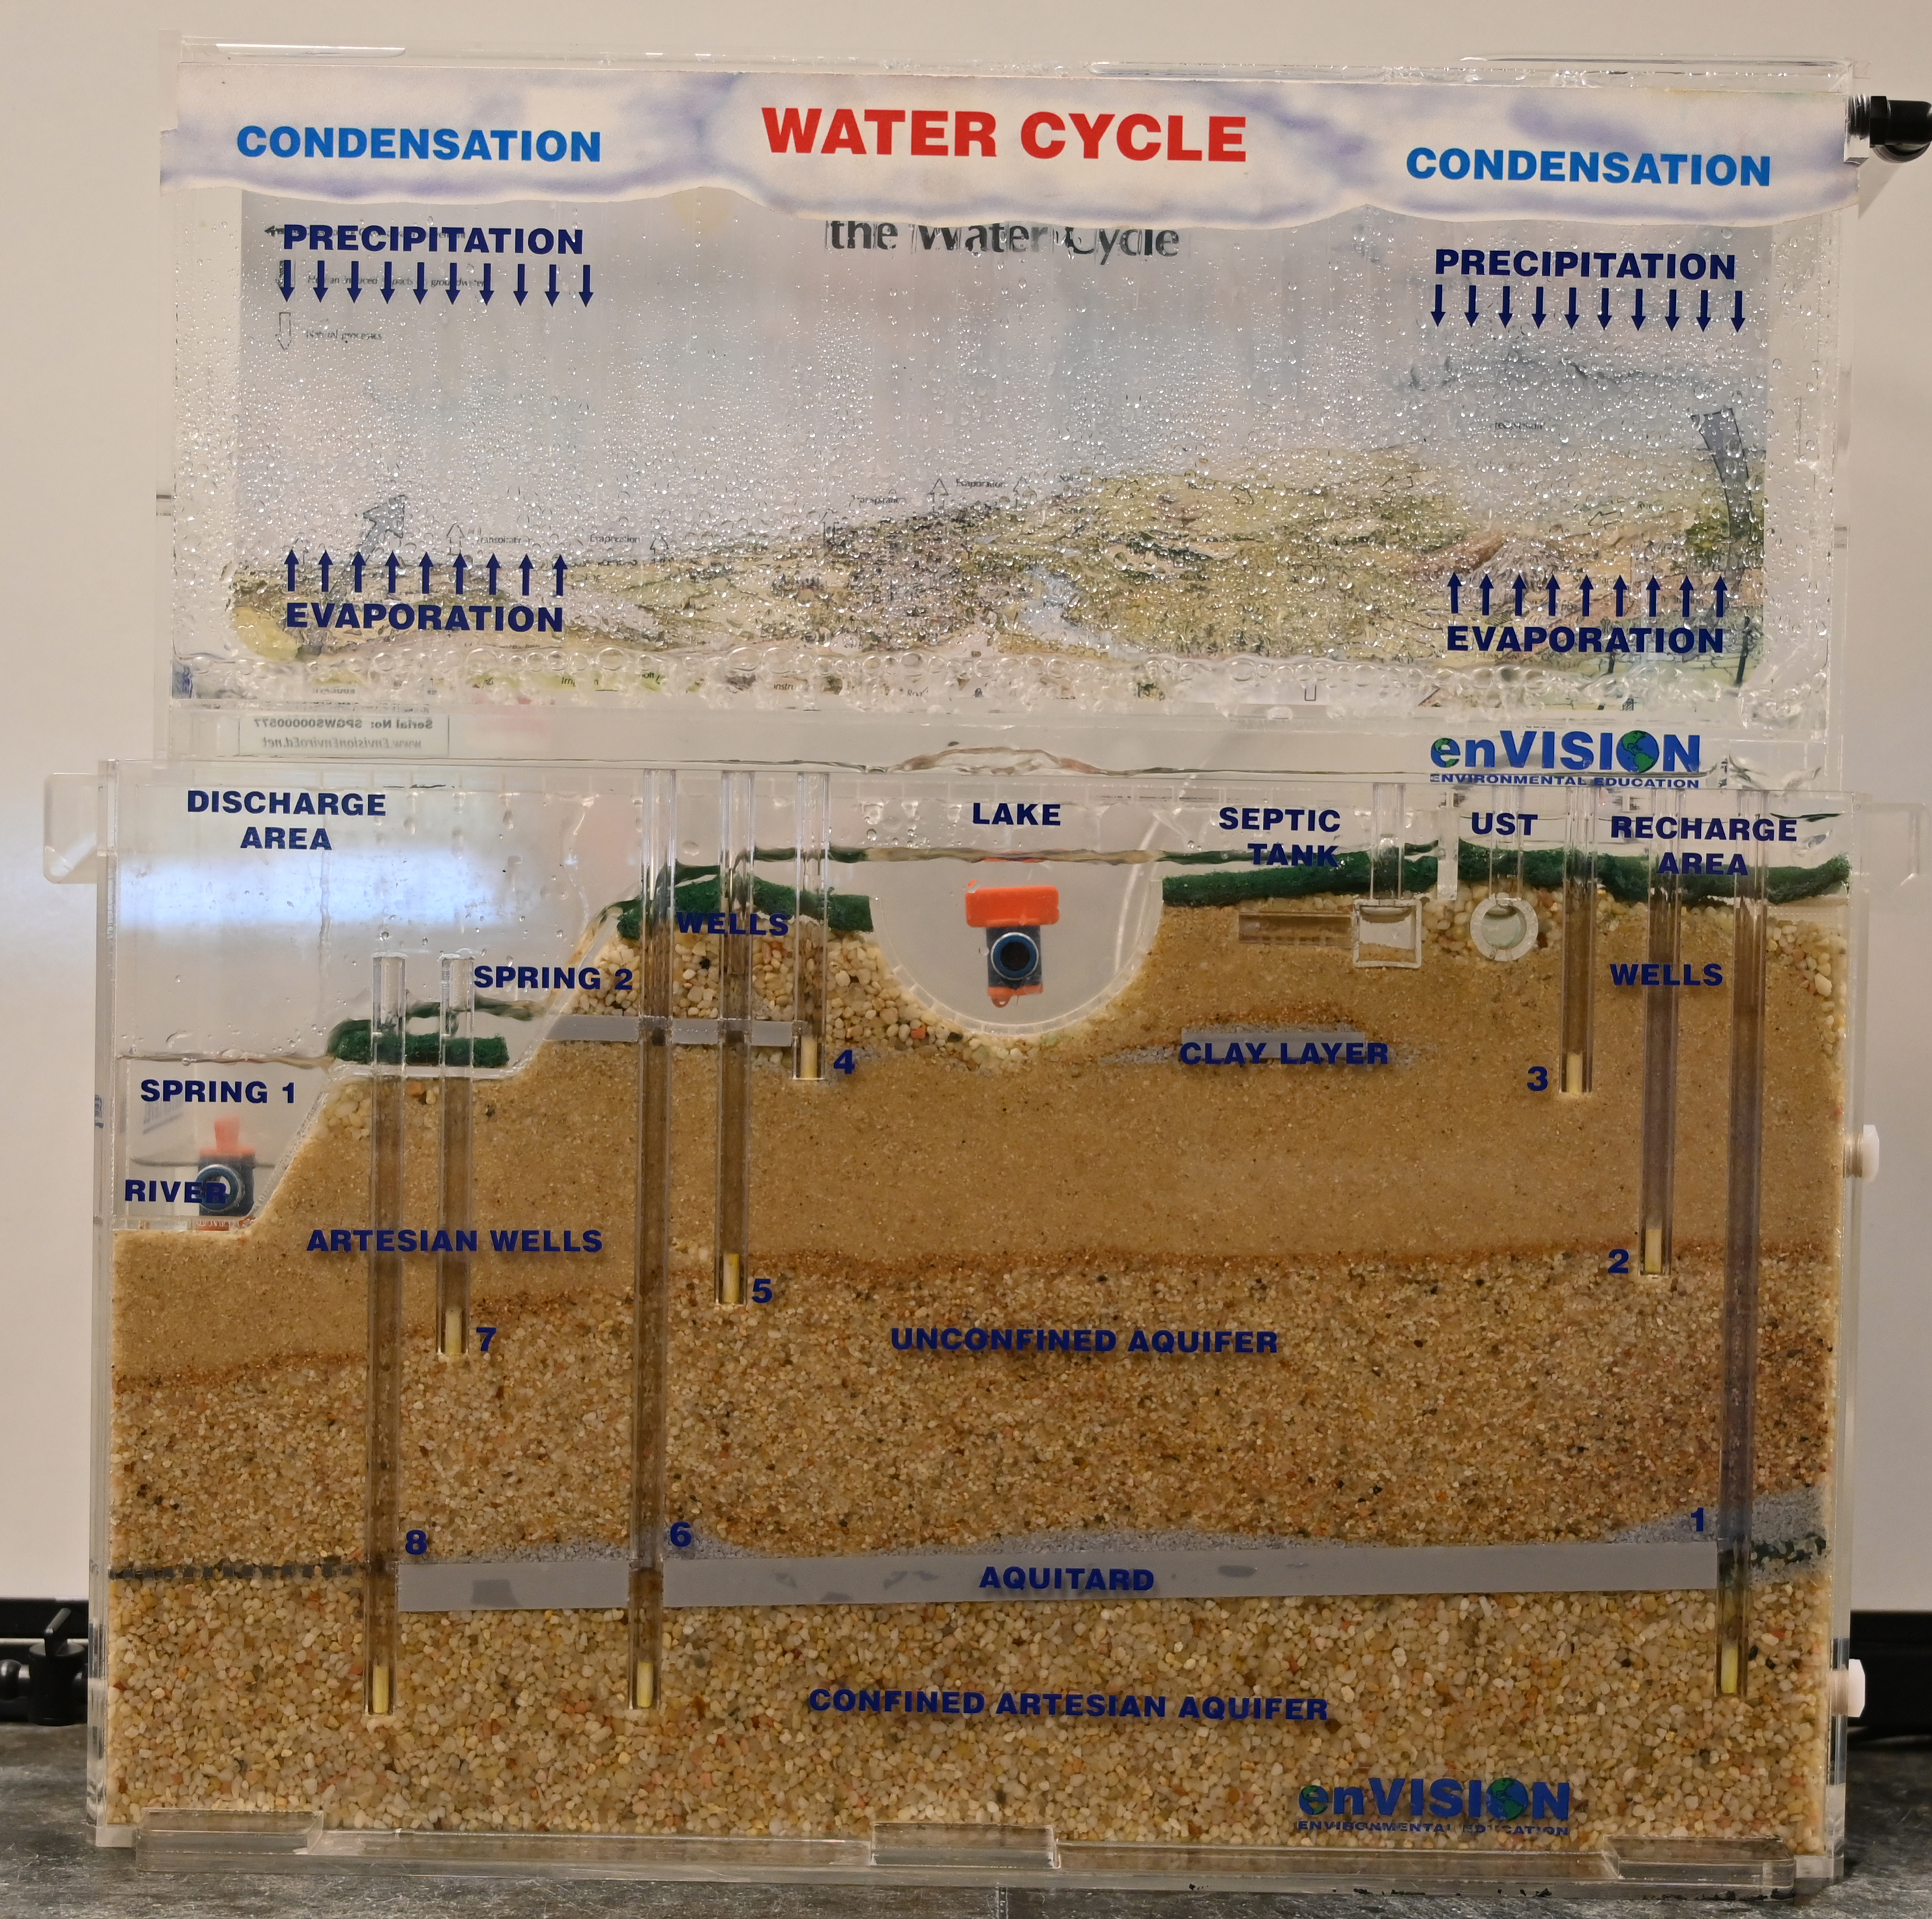

Figure 1: Model of groundwater and surface water connections

Additional notes for facilitators:

1. Groundwater eventually flows into rivers, lakes, or the ocean.
2. Direction and travel time of groundwater are primarily controlled by topography and soil/geologic properties.
3. Unconfined aquifers are at atmospheric pressure, because there is not a confining layer (i.e. aquitard) that is between the aquifer and the Earth’s surface. Aquitards are soils or geologic features through which water can not easily flow, such as compacted layers of clay or cemented deposits. Confined aquifers are contained within or below aquitards and are not at atmosphere pressure.
4. Springs are areas where groundwater flows on the soil surface and become surface water. Recharge areas are zones where surface water infiltrates into the soil to become groundwater.
5. “UST” in the model is an underground storage tank. USTs often store petroleum products or other chemicals. USTs often begin to leak as they age. This leakage may contaminate groundwater.
6. Septic tanks are used to store and treat wastewater in rural areas. If septic systems are undersized or not properly maintained, bacteria and nutrients (e.g. nitrogen) may enter into groundwater supplies.