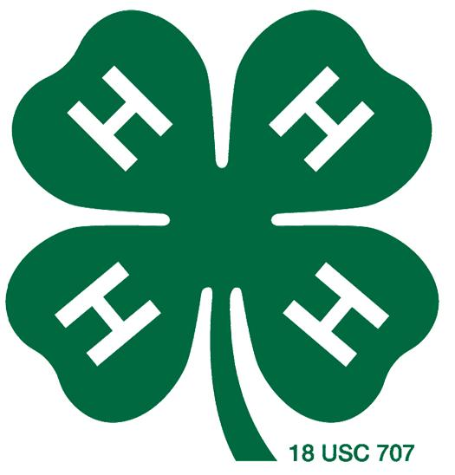

Science Experiment:

Crystal Names

Project: Arts & Crafts

***Supplies:***

Pipe cleaners

Fishing line {twine or yarn will work too}

Pencils or wooden skewers

Scissors

Glasses or plastic container {one for each color}

A container large enough to hold your name {if doing your name as a single piece written in cursive}

Borax

Food Coloring {optional, if you want colored letters you can dye the borax solution or use colored pipe cleaners}

Liquid measuring cup

Tablespoon

Heat Safe Mixing Bowl

**Time:** 15-20 minutes for the experiment; let dry overnight

**What to Do:**

1. Using white pipe cleaners, form the letters of your name. Older youth can form their name in cursive. The pipe cleaner letter should fit inside the container without touching any sides.
2. Heat a large pot of water on the stove or heat water in a microwave.
3. Add 3 cups of almost boiling water to the jar.
4. Add 9 Tbsp Borax to the jar and mix until dissolved.
5. Next, add several drops of food coloring to the jar.
6. Place the wooden skewer across the top of the jar.
7. Use fishing line to suspend each letter a few inches from wooden skewer.
8. Let the containers sit overnight. In the morning, the crystal names are finished.

Variations: Try different shapes and colors. Try adding beads. This is a great experiment for snowflake ornaments.

Science Behind It: When borax is dissolved in water a suspension is created.  A suspension is a mixture that has solid particles (the borax) that are large enough for sedimentation (settling out). As the borax begins to settle, it starts to crystalize on all the surfaces it comes in contact with – including the pipe cleaner letters.  As the borax continues to settle out, it builds crystals on top of other borax crystals creating a thick layer.

Source: <http://www.playdoughtoplato.com/kids-science-crystal-names/#_a5y_p=3154354>

**Reflect:**

1. What happened in this experiment?
2. Why do you think this happened?
3. If you did this activity again, how would you change it?
4. What other things could you crystallize?

**Apply:**

1. Where do we see similar crystals throughout our world?
2. How do these crystals differ from the crystals in the experiment?
3. How are these crystals similar to the crystals in the experiment?