Recovery System

Getting Astronauts from space is hard. In the past, NASA has relied on water landings called splashdowns to get astronaut crews back from space safely. Your mission is to design, build, and test a crew exploration vehicle or CEV to safely return astronauts to Earth. Your CEV will need to land in water, float, and keep water out. You will test your small-scale model by dropping it into a home water source like a plastic tub, sink, or bathtub. Don't let your crew drown!
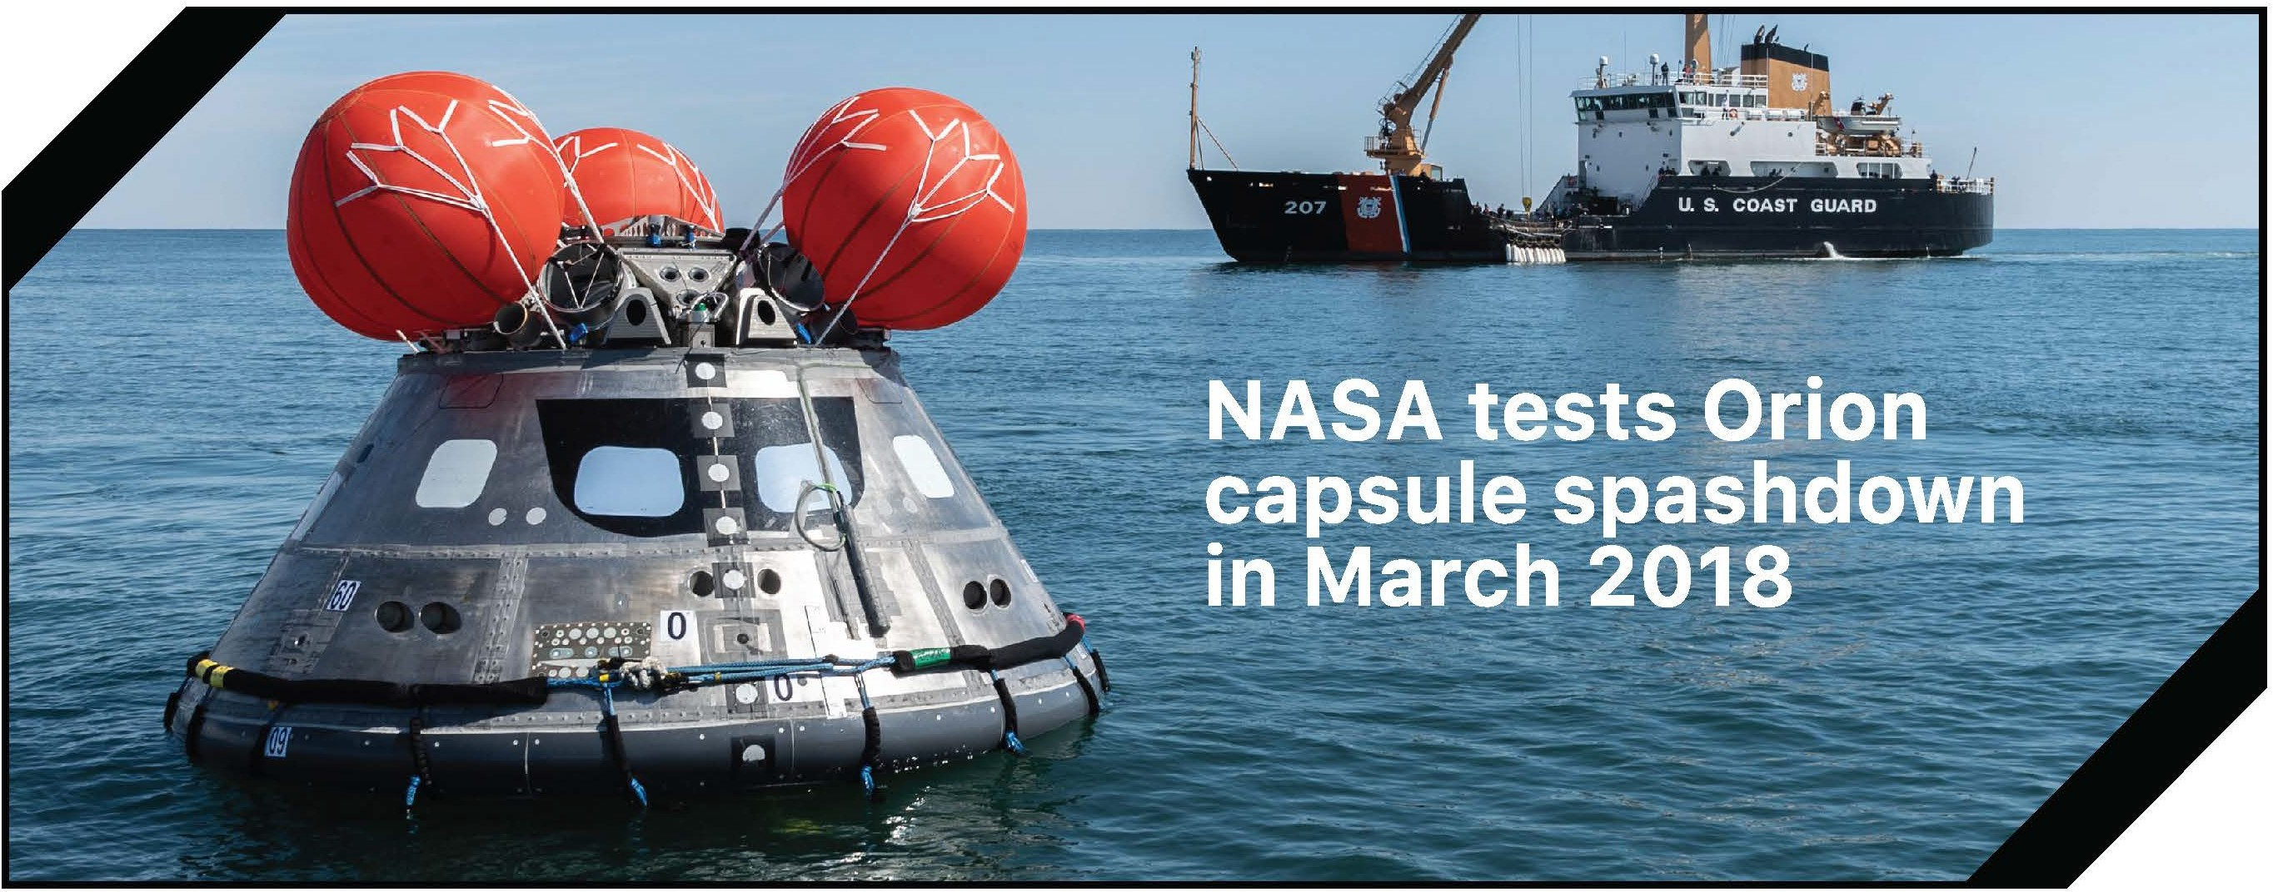

WE CHALLENGE YOU TO
Design, build, and test a crew exploration vehicle that will safely land and float on water

AND LEARN ABOUT
- Gravity
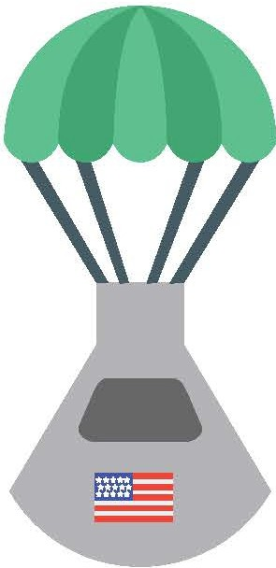
- Buoyancy
- Deacceleration
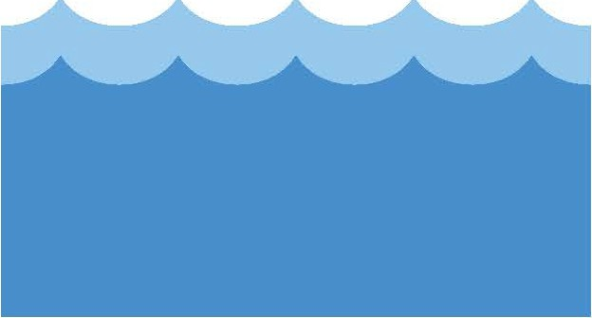

FURTHER EXPLORATION

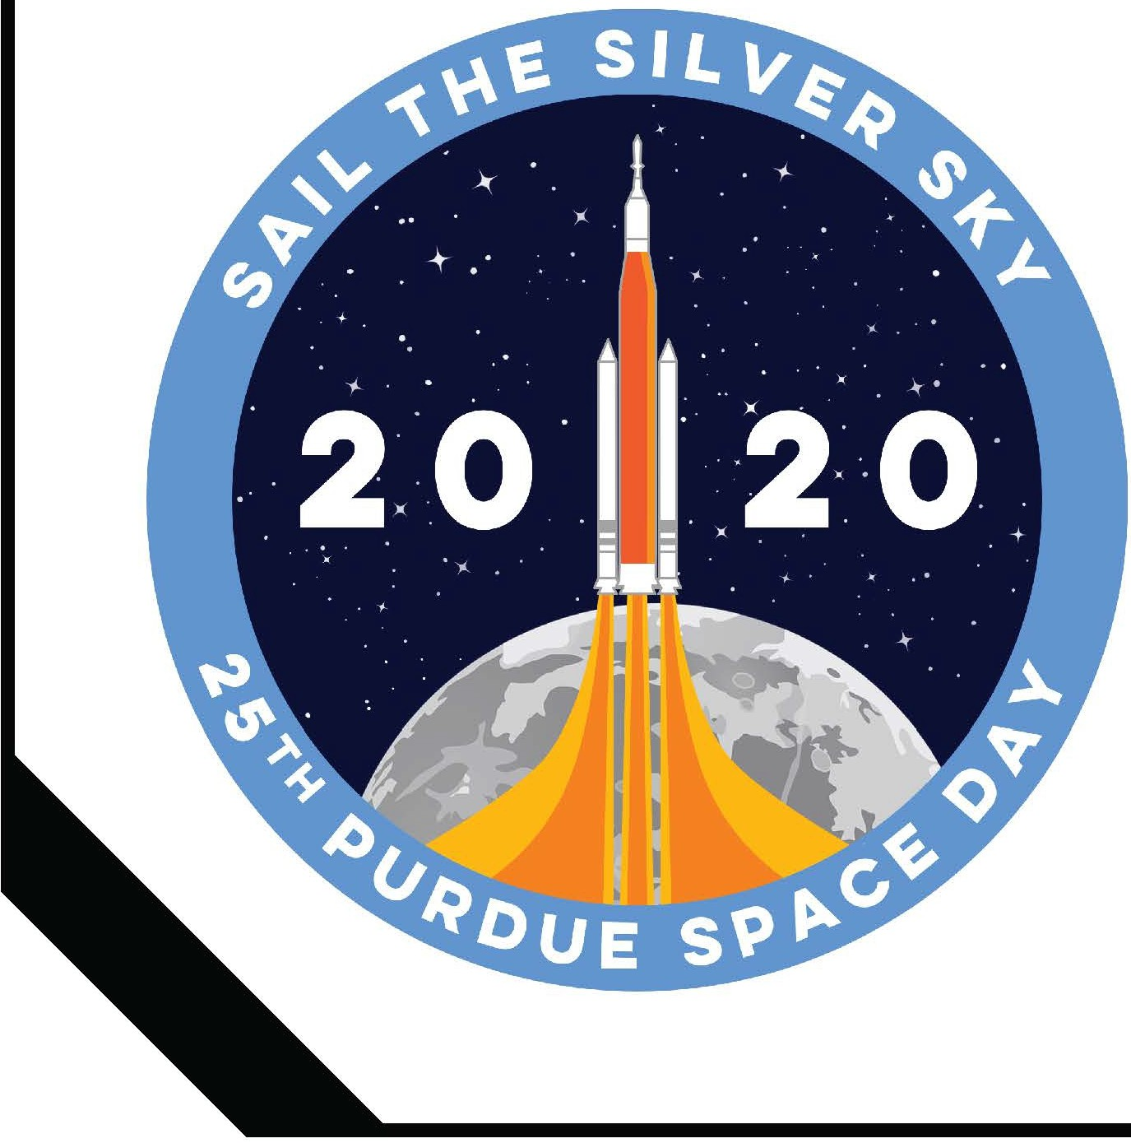

MATERIALS
  - Water tub source ***
•Towels***
  - Plastic wrap (optional) ***
  - Grocery bags (optional) ***
  - Foam cup
  - Cardboard (shipping box)
  - Straws
  - Foam sheet
  - String
  - Plastic sandwich bags
  - Astronaut cutout

*** Materials found at home

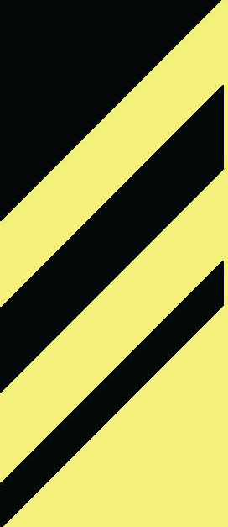
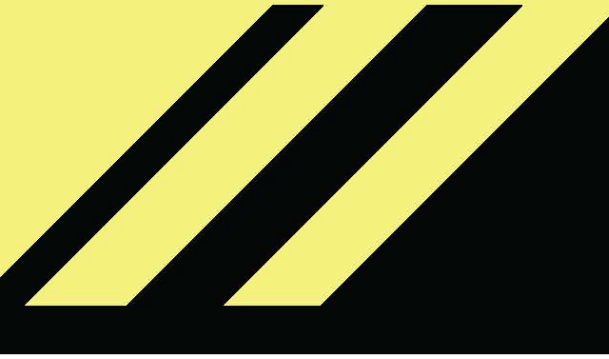
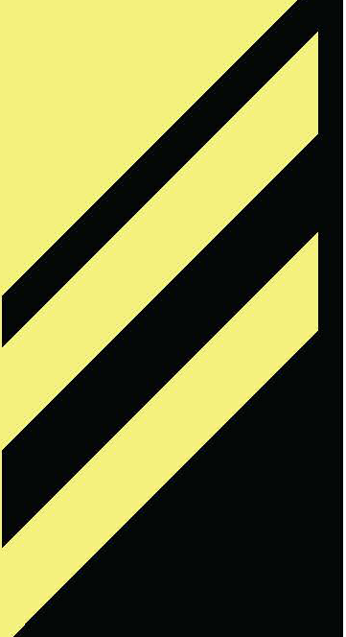
Orion Exploration Flight Test 11 https://youtu.be/PZITbVuUgX0 Orion Model Vertical Splash Test I https://youtu.be/aulKLSxVLW4 Orion Space Capsule Drop Test Part 21 https://youtu.be/joYucwl0i4Q

PURDUE SPACE DAY 2020 I SAIL THE SILVER SKY

DESIGN & BUILD
- Use your imagination to design a CEV to safely land in the water that will stay upright and float
  - How will your CEV protect the astronaut during a water landing?
  - What happens if your CEV lands upside down? How will it flip over so it is upright?
  - How will your CEV float?
  - Do you need a parachute to slow down your CEV's descent?
- Sketch your design
- Build your CEV using the materials provided or using other materials available at home

SAFETY TIPS

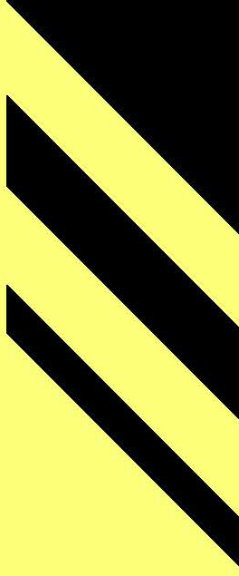
- Be careful with scissors!
- Make sure to clean up spilled water to avoid slipping!

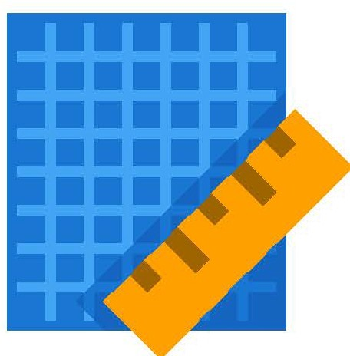

TEST
- Fill a bucket, sink, or bathtub with water

- Drop your CEV into the water basin from a height of about 3 feet and let it float for 30 seconds
- Remove your CEV and dry it with a towel. Check to see if your astronaut is still try and the hatch can still open
- Evaluate your design and, if necessary, change one thing on your CEV and test again to see if the change improved
the performance of your CEV

TIPS
- You may want to take a slow-motion video to observe what happens as the CEV lands

DISCUSS
- Why would NASA prefer to land in water rather than on land?
- If you added a parachute, did it affect your CEV's ability to float and remain upright?
•
- Did the hatch remain closed during landing? Could you open it to let the astronaut out?
- Did the inside of the CEV remain dry?

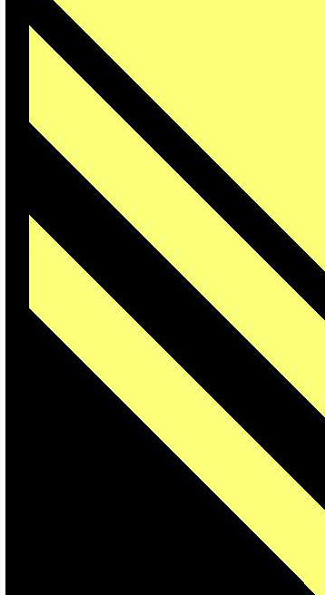
PURDUE SPACE DAY 2020 I SAIL THE SILVER SKY

