Launch Stack

NASA's Constellation program for the next generation of space rockets includes a heavy lift launcher called the Ares V. Ares V will carry heavy payloads into orbit, such as very large scientific satellites, space station replacement modules and supplies, and Earth departure stages that will propel human spacecraft to the Moon and Mars. Raising heavy payloads to orbit is challenging. Rockets require powerful engines and massive amounts of propellants. NASA's Ares V will be able to accomplish the job. It will be one of the largest and most powerful rockets ever built.

Ares V

WE CHALLENGE YOU TO
Design, build, and test a balloon-powered rocket that will launch the greatest payload possible

AND LEARN ABOUT
- Newton's 1st Law
- Newton's 3rd Law
- Forces
- Propulsion

MATERIALS
  - Scissors ***
  - Tape***
  - Two chairs for fishing line ***
  - Binder clip or clothes pin (optional) ***
  - 2 balloons
  - Fishing line
(see Activity 2.1)
  - 3 oz paper cup
  - 20 paperclips
  - Straw
  - Activity cards

*** Materials found at home

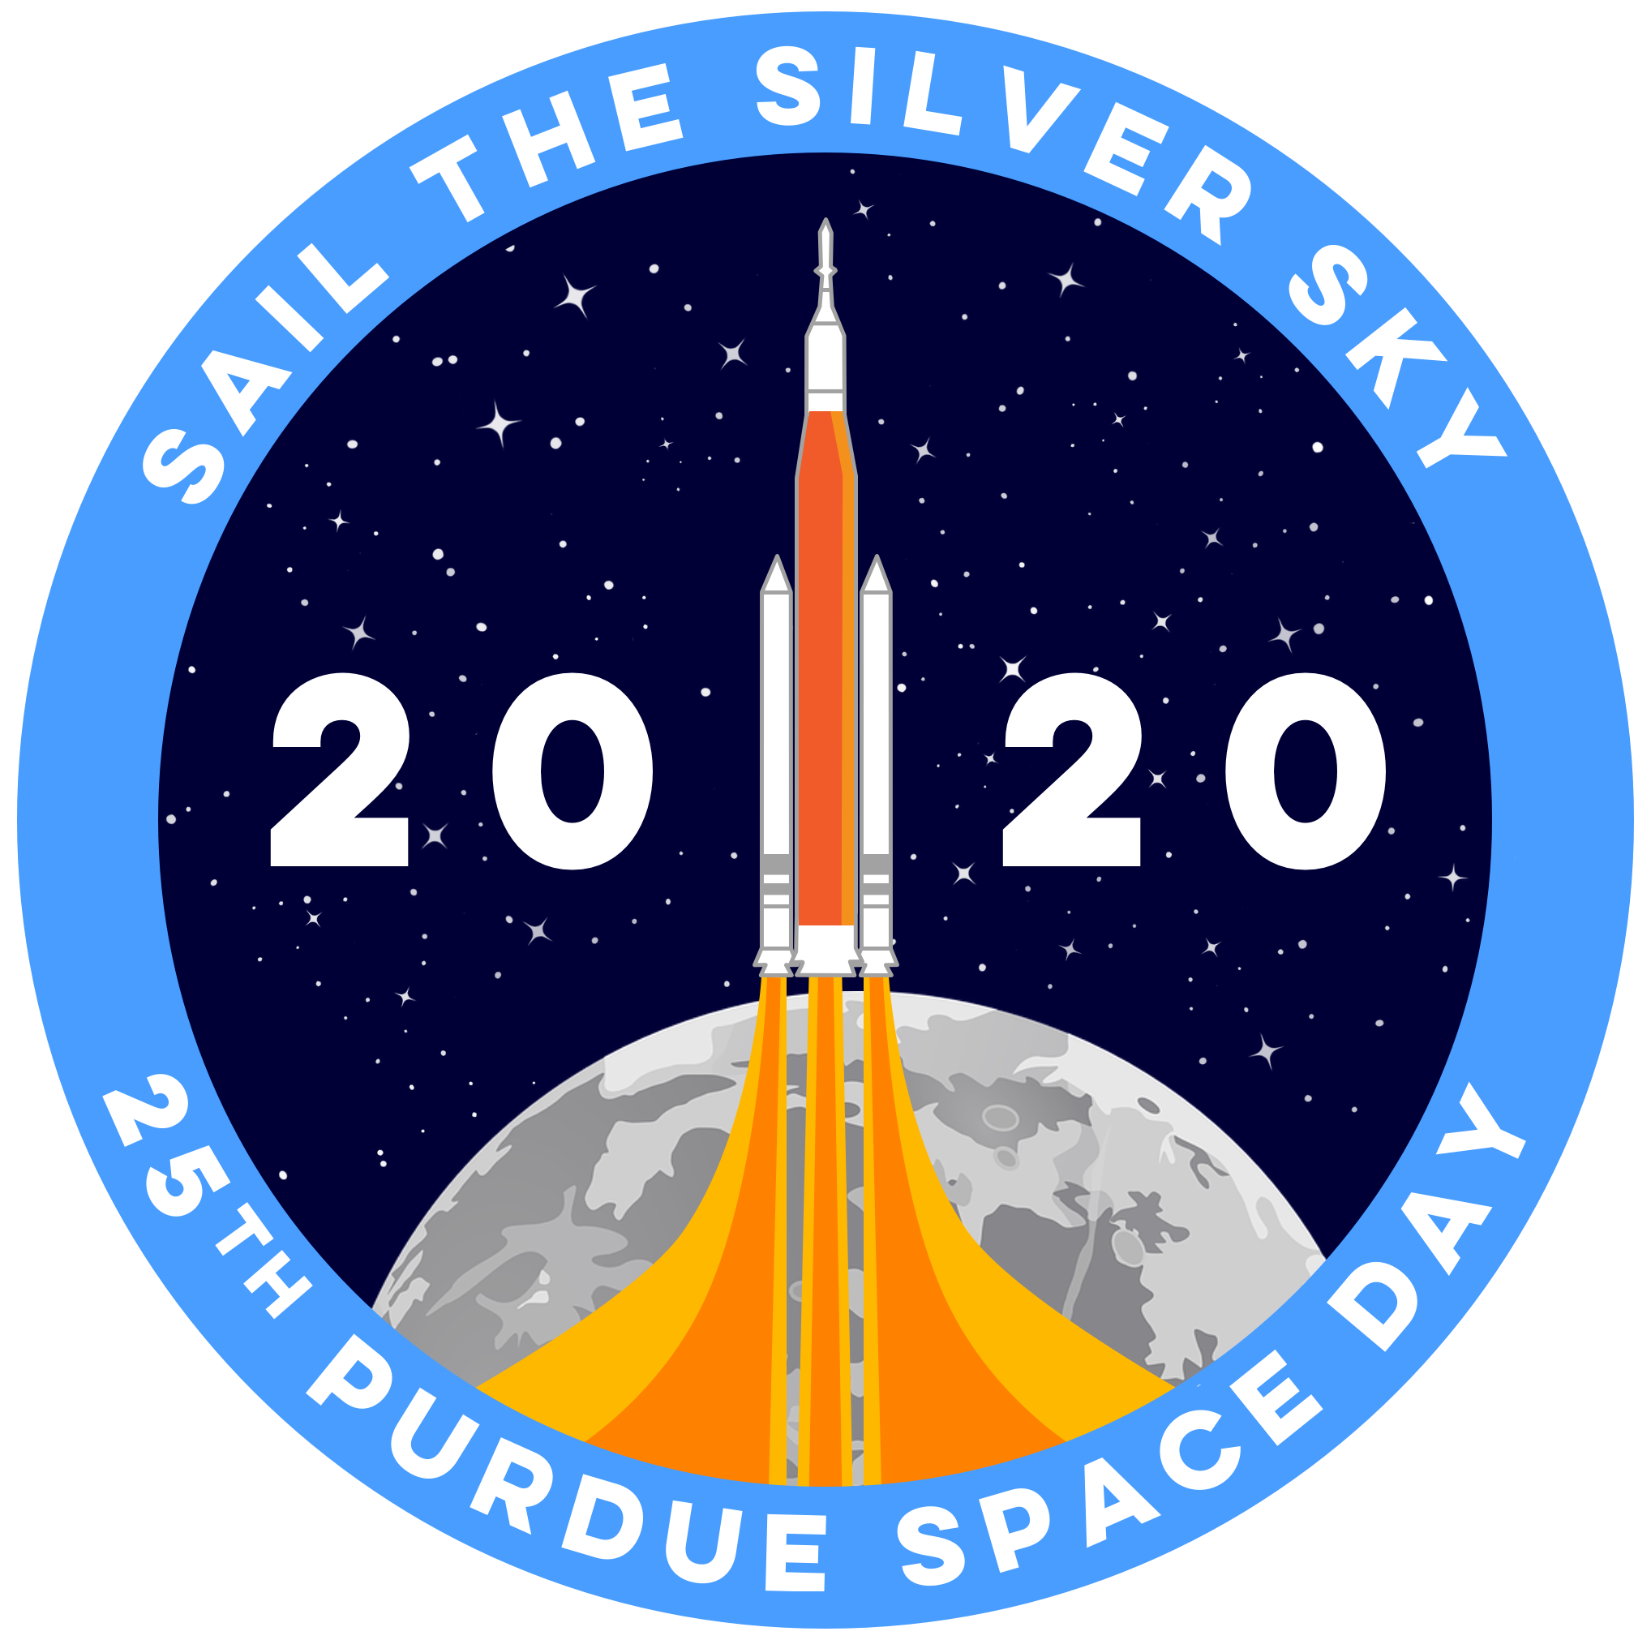
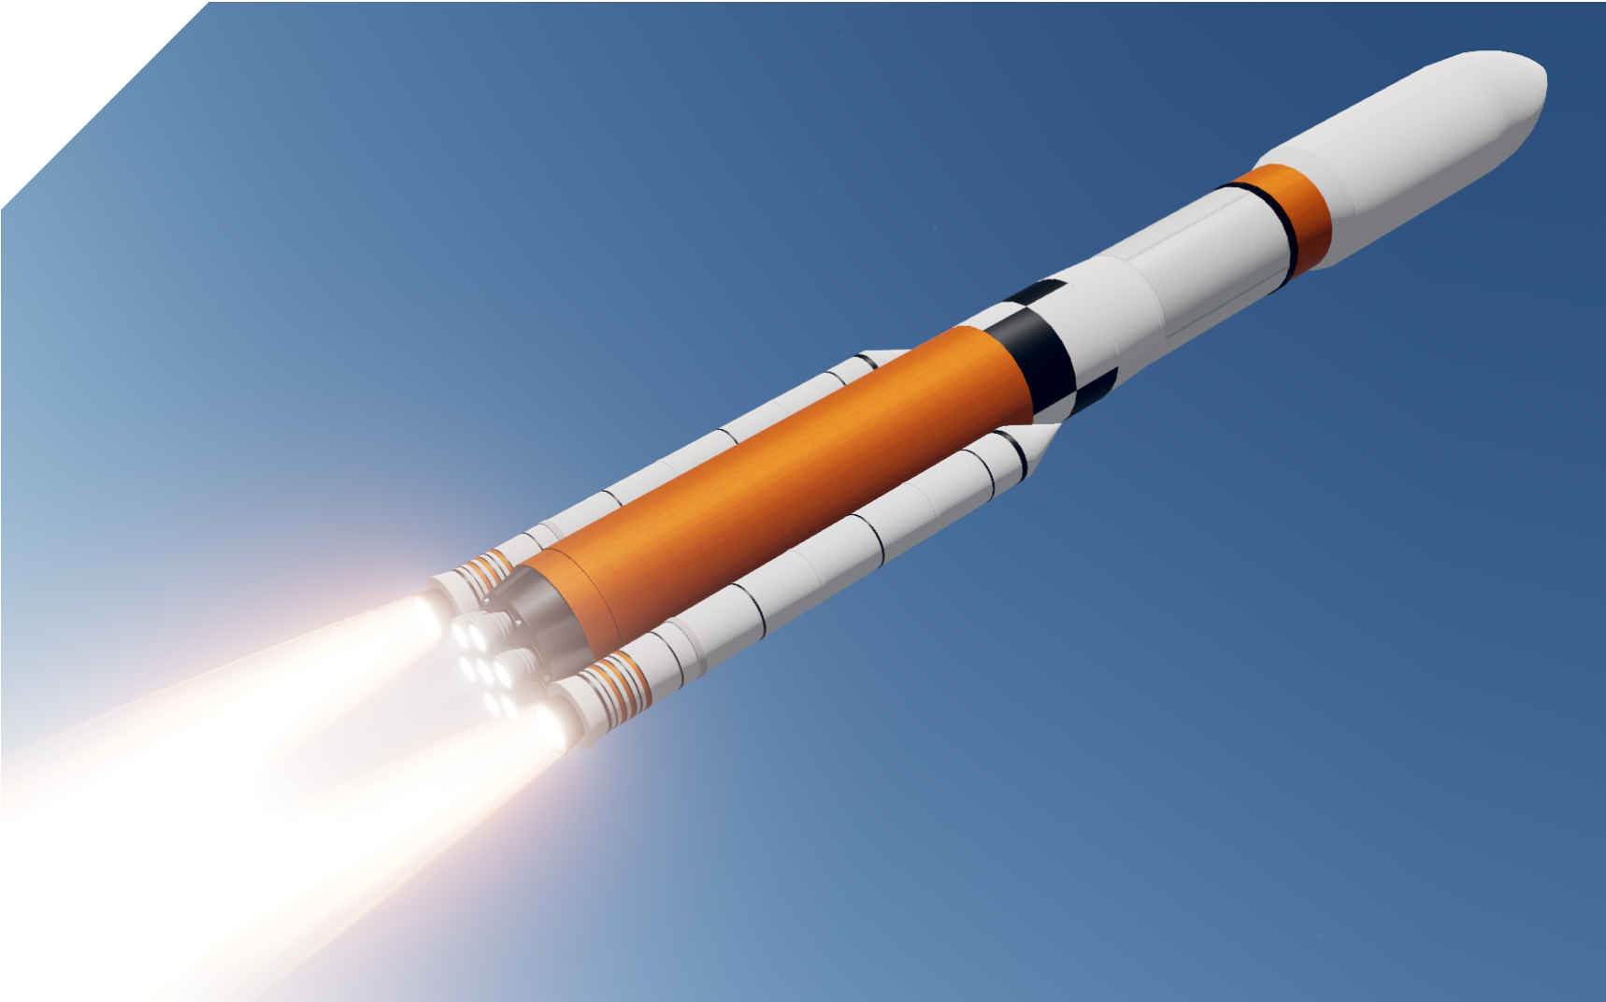




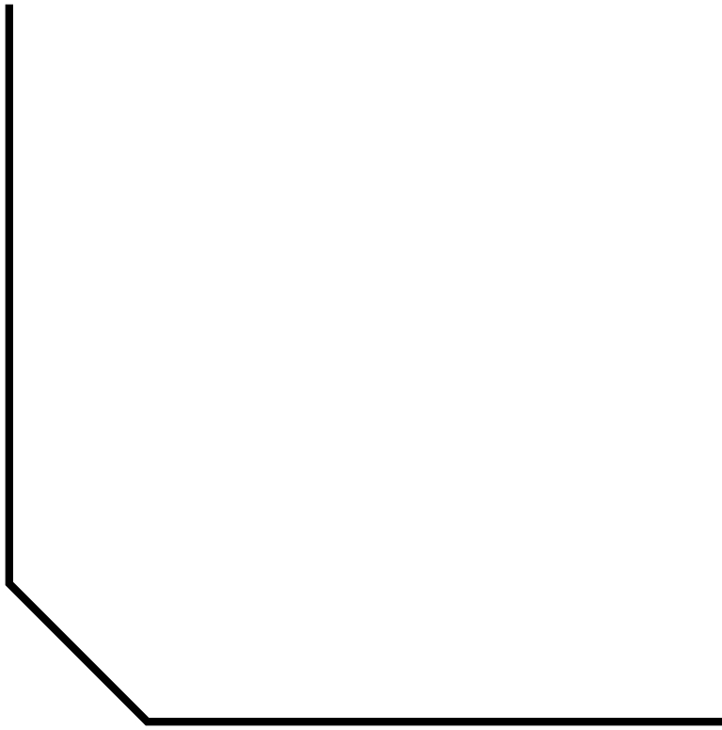

-

FURTHER EXPLORATION
Transparent Rocket Launch I https://youtu.be/su9EVeHqizY
Spacecraft 3D iOS App I https://apps.apple.com/us/app/spacecraft-3d/id541089908
Ares V Launch Animation I https://youtu.be/lpdNFqjfx9I
PURDUE SPACE DAY 2020 I SAIL THE SILVER SKY

DESIGN
- Determine your cargo
  - Below are six types of cargo that you will need to pack into your cargo bay's limited amount of space. Prioritize the importance of each cargo to transport, and write numbers
1 to 6 on the left column (1 being the supplies needed most, 6 being the supplied needed the least).
  - When prioritizing, be sure to consider the resources available at the selected landing site, and what is needed for survival and the construction of a lunar base.

SAFETY TIPS I
- Be careful •
inflating the balloon!
- Stay out of the path of the rocket launch!

1
2

- The 8 inch by 10 inch grid represents the cargo bay of your rocket. Using the shapes on the cargo worksheets (see Mission Logistics activity), pack your cargo bay following your list of priorities. For example, if food is your top priority, there should be a greater percentage of food packed in the cargo bay
  - Try to pack the cargo so there are no empty spaces. Use only the shapes given. Do not cut them to fit inside the cargo bay.

BUILD
- Inflate your balloon rocket and hold the end closed
  - You may want to use a binder clip, clothes pin, or chip clip to hold the end closed while you load your cargo.
- Load your cargo (paperclips) onto your rocket using the available materials according to the table

TEST
- Set up the launch
  - Cut a piece of straw and thread the fishing line through it.
  - Use the fishing line to create a launch path between two surfaces about 12 feet apart. For instance, you can connect one end of the line to a chair or door handle and the other end to another chair.

- Attach the rocket to the straw using a small piece of tape
- Slide the rocket to the end of the launch path and release the end of the balloon to
/1\

launch the rocket into orbit.

TIPS
- If your rocket goes slow, make sure the straw is attached to the center of the balloon.
- If your rocket does not reach orbit (the other end of the line), try reducing the payload. •
I
- You may want to take a slow-motion video to observe what happens as the rocket launches.
- For an additional challenge, attach one end of the fishing line to the ceiling and the other end to the floor.

DISCUSS
- What was the maximum payload your rocket could carry?
- Which types of cargo did you determine to be more valuable and how did you determine the amount of each type of cargo?
- What is one change you would make to improve your design?



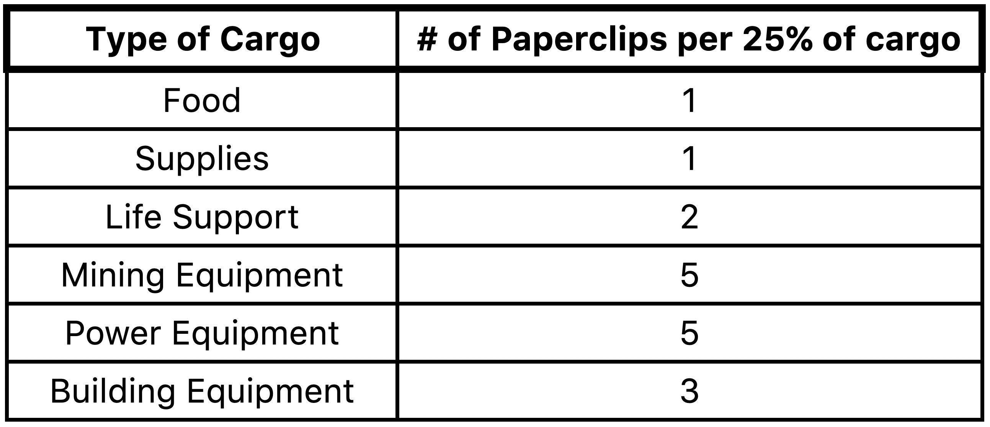
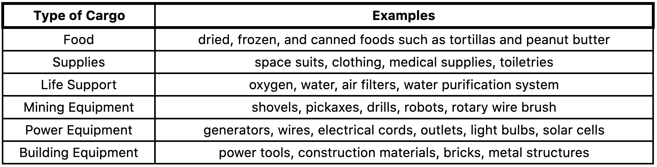
PURDUE SPACE DAY 2020 I SAIL THE SILVER SKY

