Lunar lander

NASA has identified some safe landing sites at the south pole of the Moon. Now they need you to design and build a lander that can safely land at one of these sites without injuring the astronauts or damaging the lander. Since the Moon doesn•t have an atmosphere, the lander has to use propulsion to slow down and have a soft landing. As the lander approaches the surface of the Moon, the engines shutoff a few feet above the surface. This prevents dust and rocks from being blown into the spacecraft.
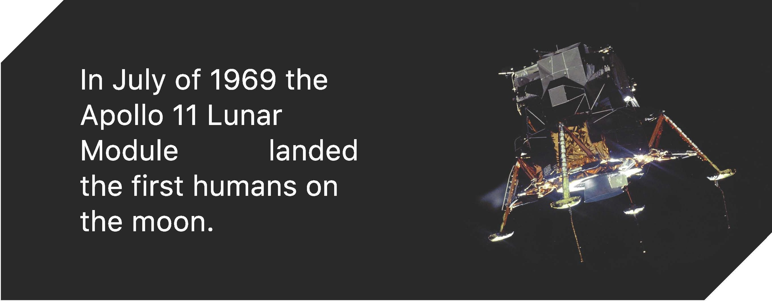

WE CHALLENGE YOU TO
Design, build, and test a shock-absorbing system tp safely lander a lander on the Moon

AND LEARN ABOUT
- Gravity
- Shock-absorbing systems
- Forces acting on a Moon lander

FURTHER EXPLORATION

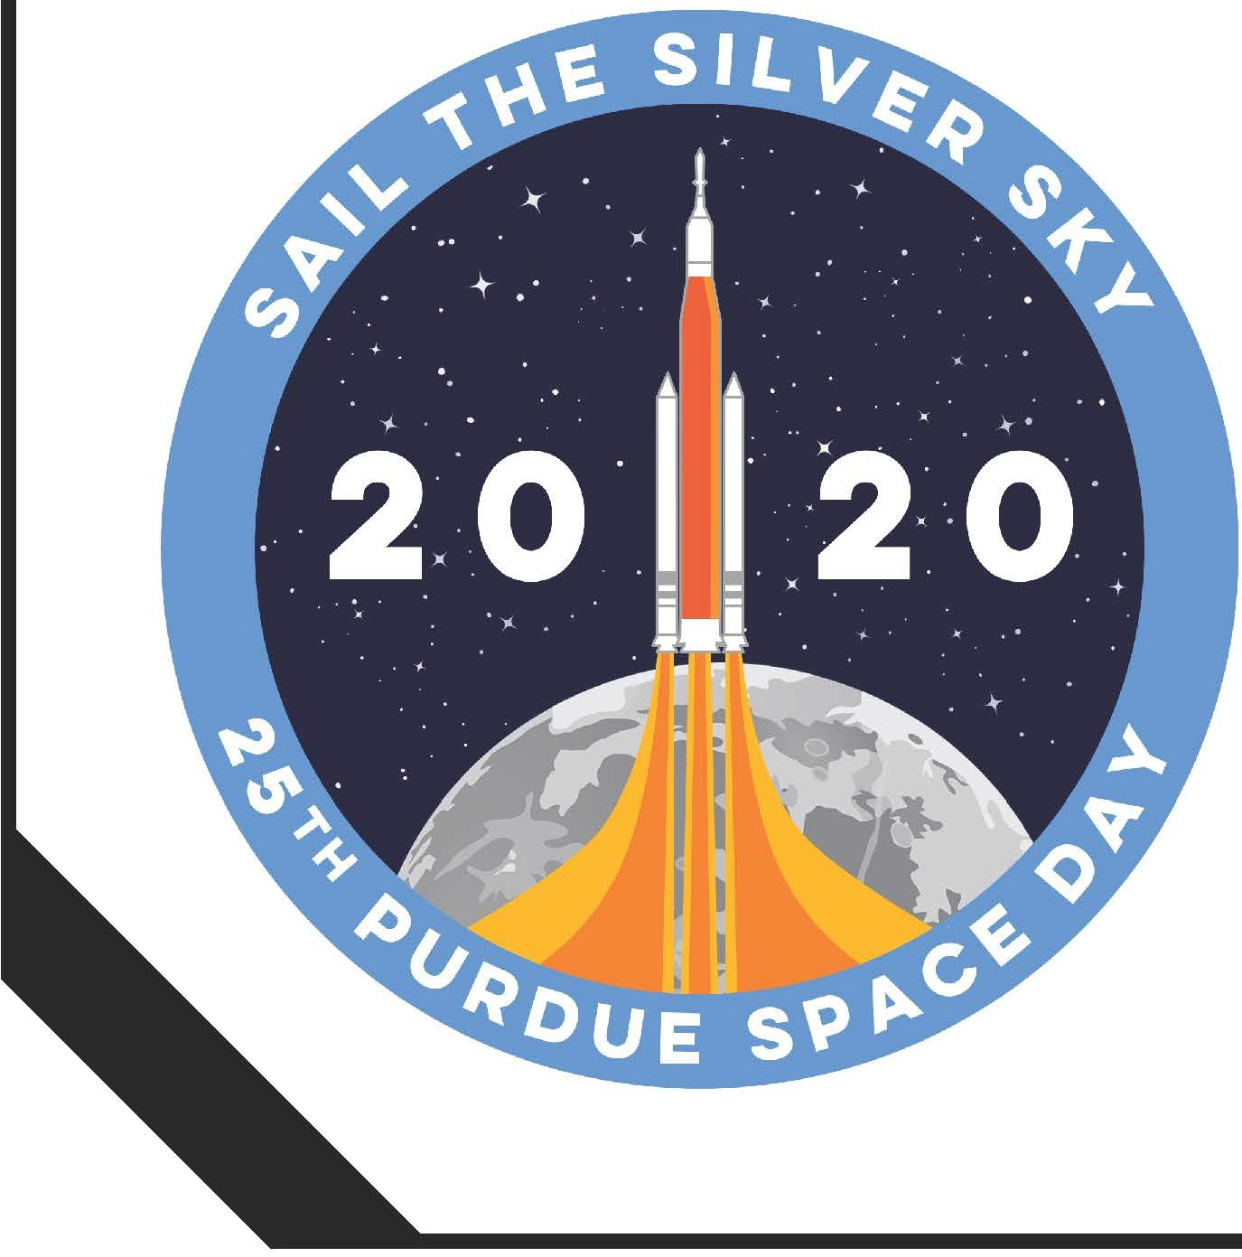

MATERIALS
  - Scissors ***
•Tape***
  - Cardboard or stiff paper ***
  - Index cards
  - 5 oz. paper cup
  - Craft sticks
  - Straws
  - Cotton balls
  - Mini-marshmallows
  - Regular marshmallows

*** Materials found at home
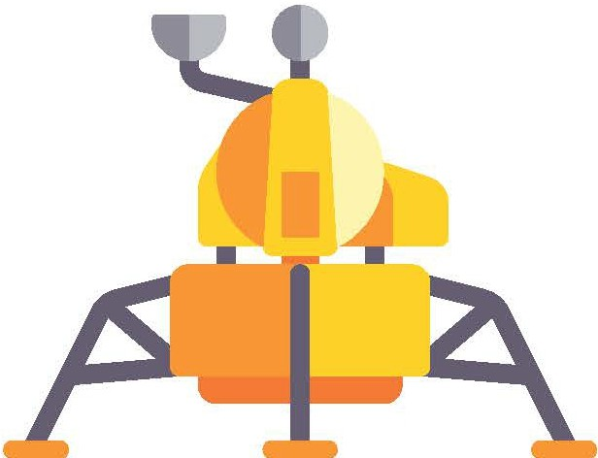
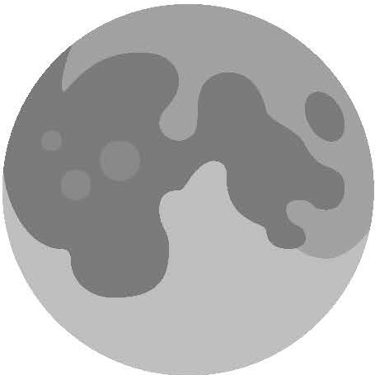



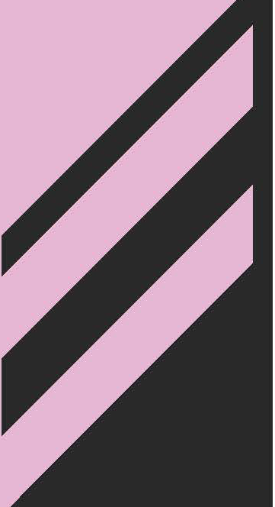
Apollo Moon Landing Animation I https://youtu.be/XsV1sMEzm-l
NASA JPL Lander Activity I https://www.jpl.nasa.gov/edu/learn/project/make-an-astronaut-lander/
PURDUE SPACE DAY 2020 I SAIL THE SILVER SKY

DESIGN & BUILD
- Think about how you can build a spacecraft that can absorb the shock of a landing
  - What kinds of shock absorbers can you from the materials that can help soften the lander when it lands?
  - How will you make sure the lander doesn't flip over as it falls through the air?
- Sketch your design
- Build your shock absorbing lander using the materials provided or using other materials available at home. Remember to include your cabin for your astronaut

TEST
- Drop your lander from a height of about 3 feet
- Evaluate your design, and if necessary, change one thing on your lander and test again to see if the change improved the performance of your lunar lander

SAFETY TIPS



- Be careful with scissors!

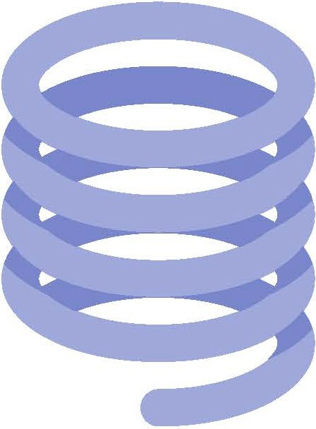



TIPS

- If you lander tips over, make sure it is level when you release it, the cup is centered on the platform, and the weight is evenly distributed
-v
-v
- If your lander bounces rather than lands softly, try adding soft pads, changing the position of the shock absorbers, or modifying any springs
- You may want to take a slow-motion video to observe what happens as the lander touches down

DISCUSS
- What forces were acting on your lander as it fell?
- Did your shock absorption system keep your astronaut safely in the cabin?
- What is one change you would make to improve your lander design?
PURDUE SPACE DAY 2020 I SAIL THE SILVER SKY



