Re-Entry System

One of the most critical parts of a human space mission is also one of the most obvious - coming home! When a Space Shuttle was re-entering Earth's atmosphere, the Shuttle's surface temperature could reach up to 2700 degrees Fahrenheit! Safely slowing a speeding spacecraft enough that it can make a gentle landing on Earth is one of the hardest jobs in engineering - now it's your turn to see if you've got what it takes! Using household materials, your task will be to construct a heatshield to protect your model spacecraft from the fiery heat of the atmosphere.
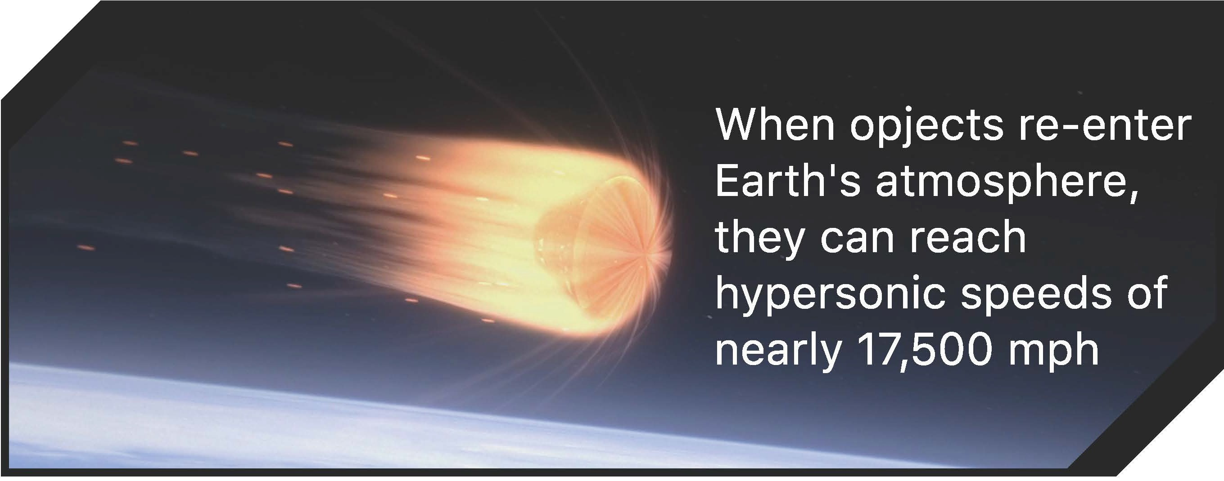


WE CHALLENGE YOU TO
Design, build, and test a heat shield to keep your astronaut safe as their spacecraft re-enters Earth's atmosphere

AND LEARN ABOUT

- Heat transfer

- Temperature
- Hypersonic speeds
- Insulators
- Heat shields

FURTHER EXPLORATION
Orion: Heat Shield I https://youtu.be/XH4VVpfr9Bs
NASA Heat Shield Engineer I https://youtu.be/qmDlp6FW2eE

MATERIALS
- Tongs or oven mitts ***
- Scissors ***
- Tape***
- Ice cube (or other easily melting item) ***
- Hair dryer (optional) ***
- Newspaper (optional) ***
- Other insulating material ***
- Timer or stopwatch ***
- Styrofoam cup
- Aluminum foil
- Felt

*** Materials found at home



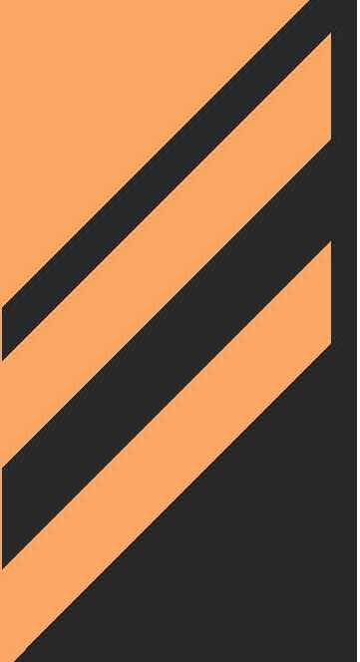
Orion Spacecraft Testing I https://www.nasa.gov/feature/glenn/2019/orion-to-face-simulated-rigors-of-space-in-last-major-testing-before-artemis-i
PURDUE SPACE DAY 2020 I SAIL THE SILVER SKY

DESIGN
- Brainstorm ideas for your heat shield that will protect your astronaut (ice cube) as their spacecraft (styrofoam cup) re-enters the atmosphere
  - Which materials act as insulators?
  - How many layers should your heat shield have to protect your astronaut?
  - In which order should your materials be added to protect your astronaut?
- Sketch your design

BUILD
- Using the materials you collected around your home, build a heat shield to cover the open end of the styrofoam cup

SAFETY TIPS


- Use caution ----when operating
a hair dryer
- The heat shield will be hot! Do not touch with bare hands!
- Use tongs or oven mitts to touch your heat shield
- Be careful with scissors!

TEST
- Place an ice cube into an uncovered cup and set it aside
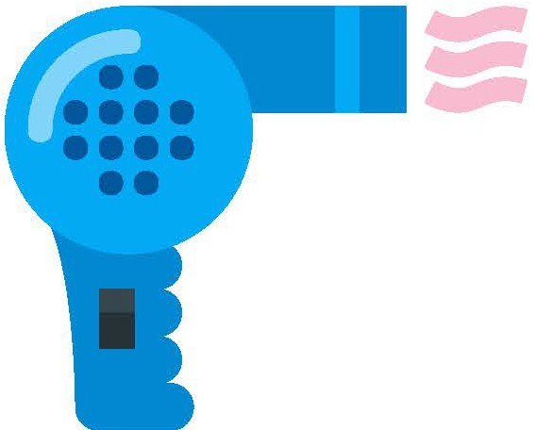
- Place a second ice cube into your spacecraft (Styrofoam cup) and cover with your heat shield
- Hold the hair dryer approximately 12 inches away from the heat shield and turn it on for 60 seconds
- Using oven mitts or tongs, carefully lift the heat shield
and observe the ice cube. Compare with the uncovered ice cube
- Replace your heat shield and apply heat for another 60 seconds. Compare the ice cubes

TIPS
  - An alternative testing method is to apply heat to the
ice cube and time how long it takes to melt. Apply heat to your heat shield for the same amount of time to it took to melt the uncovered ice cube, remove the heat shield, and
observe how much ice remains
  - Instead of a hair dryer, you may place your spacecraft and heat shield in a window and observe the time it takes for the ice cube to melt

DISCUSS

- Which materials were better insulators?
- How would you redesign your heat shield?
- Would you add additional layers or change the order of the layers you already have?


PURDUE SPACE DAY 2020 I SAIL THE SILVER SKY

