**How Does Land Usage Affect Your Watershed?**

**Experience the impact of point and non-point source pollution using the EnviroScape watershed model**

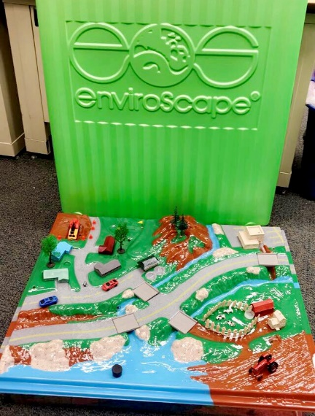

# Objectives:

At the end of this activity, youth should be able to:

* Explain what a watershed is
* Identify point and non-point source pollution
* Apply how land usage impact a watershed
* Apply practices to reduce impact on watersheds

Prep time: 10 minutes

Time to complete activity: 30 minutes per demonstration (2)

Skill level: Grades 3-8 and higher

# Background:

# The facilitator guide contains two demonstrations: 1) How Water Pollution Occurs- understanding how a watershed works and sources of point and nonpoint source pollution. 2) How You Can Prevent Water Pollution- identifying and implementing best management practices. The facilitator guides directs you step-by-step through both demonstrations to be able to preparing the model, check audience awareness, discussion and demonstration of activities, and provide a summary review. In addition, a Location Key Diagram is included that identifies where all the figurines goes, what different structures are on the model, and where to identify pollution sources.

# The begging of the guide gives safety, quick set-up, clean-up instruction, and a description of the facilitator’s role. Please read those sections carefully before facilitating the demonstration. The guide also provides suggested related activities and guest speakers to enhance the learning experience. This demonstration gives you the freedom to present as much information as you deem appropriate, and to adapt the information you present to different audience levels. The demonstration can last a minimum of 15 minutes (reviewing demonstration 1 only) or up to an hour or more including both demonstrations and in-depth content. For beginner audiences, grades 3-8, a brief overview of demonstration 1 is appropriate. For more intermediate to advance audiences, grades 8-12, both demonstration and in-depth content is appropriate.

# Materials:

# EnviroScape watershed model (available at the state office) Includes:

# EnviroScape facilitator guide

# 1 packet of red Kool-Aid

# 1 packet of greed Kool-Aid

# 1 packet of hot coco

# Squirt bottle

# Paper towels

# Figurines

# Clay

# Sponge

# Travel case

# Water

# Table (greater than 25” x 30”)

# Methods

# See facilitator guide pages 9-31 for demonstration 1 and page 33-50 for demonstration 2

# Reflection Questions (Journal or Discussion):

* What is a watershed?
* How does land usage affect a watershed?
* What can be done to reduce the impacts of land usage on a watershed?
* Why is it important to protect a watershed?

# Supplemental Information:

Indiana 4-H Soil and Water Science manuals: <https://www.edustore.purdue.edu/item.asp?Item_Number=4-H-1027-W>

How to become a citizen scientist and monitor your local watershed: <http://www.hoosierriverwatch.com/>

The Nature Conservancy, Nature Works Everywhere: <https://www.natureworkseverywhere.org/resources/>

United States EPA, Surf Four Watershed: <https://www.epa.gov/waterdata/surf-your-watershed>

United States EPA, Watershed Academy: <https://www.epa.gov/watershedacademy>

# Vocabulary:

# See facilitator guide’s glossary pages 53-56