H₂Officers: Groundwater Detectives
Summary
Students will complete a two part activity to explore the work that environmental engineers do. First they will analyze the pH of ten groundwater samples collected around a chemical spill in order to determine the extent and direction of contamination. Second, they will design a filtration treatment system to remove the sediment particles from the water which the water-soluble chemical has become bound to. By measuring the turbidity of the sample before and after treatment, students will determine the effectiveness of the filtration system.
Learning Objectives
- Students will learn how environmental engineers collect and analyze field data to identify polluted water and determine direction of contaminant flow.
- Students will learn how contaminants adsorb to sediment.
- Students will learn various methods environmental engineers use to clean contaminated water.
Materials
List of materials for class to use:

- 7 small plastic cups for “groundwater samples”
- low pH solution (Vinegar or lemon juice)
- coffee filters (2/group)
- bag of cotton balls
- plastic spoons
- straws
- sand and/or gravel
- wire mesh
- rubber bands
- cheesecloth
- masking tape
- scissors
- “Dirty” water
- Turbidity meter or conductivity meter
- Graduated cylinder

List of materials that each group (~4 people) should have:
- two pH strips
- 1 short/wide 9 oz clear plastic cup with holes in the bottom to contain the filtering materials (Or plastic bottle with bottom cut off and cap removed)
- 1 tall 12-16 oz clear plastic cup that will hold filtering materials cup (or bottle) and collect filtered water
- Cost handout (see below)

Procedures
Part I: Identify location and direction of groundwater contaminant
Before: teacher should make the pH of samples 2, 3, and 5 approximately 5. All others should be a close to neutral pH.
- On a slide, show the location of the spill (barrel) and describe the parts of the surrounding community using Figure 1.
- Explain that the students are all environmental engineers hired by the City of Pawnee, Indiana. The City of Pawnee is very concerned because the chemical, igedomium, was spilled by Eagleton Factory this weekend. The City of Pawnee wants your firm to first identify what areas have already been contaminated and which direction the chemical is moving.
- Compared to local groundwater, igedomium, has a low pH (5). You can use this property to identify the extent of the contamination.
- Give each group 1-2 “samples” to test the pH using pH strips.
- Have each group record their sample’s pH on the slide so everyone can see the results.
- Discuss as a group which way the contaminant is moving, and what some consequences of future movement may be. [Should be moving southeast and could possibly impact farm/school; warning should be giving to houses and they should not be allowed to consume any well water]
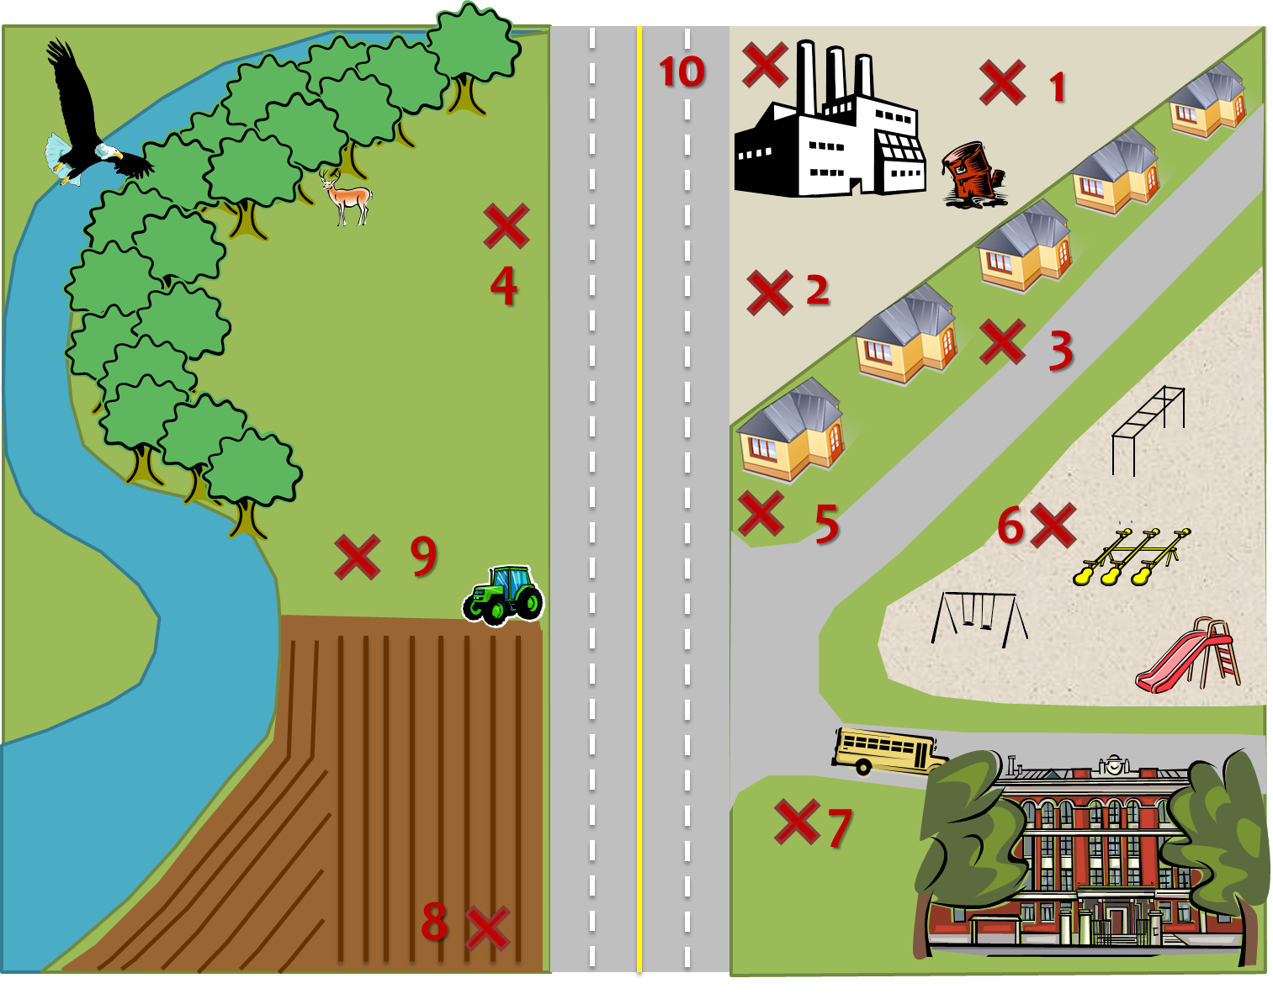
Figure 1. Site layout and location of samples.
Part II: Contamination remediation
- The City of Pawnee is operating on a small budget. They need you to clean the contaminated water using a pump and treat method. You already have a usable pump, and City Councilwoman Leslie Knope finds $100 in the budget for the rest of your expenses.
- The igedomium chemical has a very high affinity for sediment. This means that the chemical prefers to stay adsorbed to the soil/particles that are in the water. Therefore, you will want to design a method for treating the contaminated water which can remove the most sediment.
- We will determine the effectiveness of your treatment by measuring the turbidity before and after treatment.
- The group that has the highest percentage removal will win a lifetime contract with City of Pawnee to work on environmental concerns.
- Use your $100 with your group to design a treatment system to remove the igedomium-covered soil particles.
Material (Qty) | Cost ($)
coffee filters (1) | $25
cotton balls (4) | $10
plastic spoon (1) | $10
straws (4) | $25
sand and/or gravel (1 table spoon) | $10
wire mesh (1 square) | $20
cheesecloth (1 square) | $25
rubber bands (1) | $10

After Activity Reflection Questions:
- What methods/systems worked the best for removing sediment? What didn’t work?
- Do spills happen in the real world?
- When contaminants move in groundwater, what are some things that might cause them to move in one direction versus another?
- What is your filtering system actually modeling that occurs in the real worlds?

Cost Handout
Material (Qty) | Cost ($) | Qty Requested | Qty Requested x Price
coffee filters (1) | $35
cotton balls (4) | $10
plastic spoon (1) | $10
straws (4) | $25
sand (1 table spoon) | $10
gravel (1 table spoon) | $10
cheesecloth (1 square) | $25
rubber bands (1) | $10
Total Cost: $________._____

Modified version of the “Groundwater Detectives” teachengineering.com activity

