GLOBE Educator PD

April 26, 2023

***Intro to*** [***GLOBE***](http://www.globe.gov) ***for the 4-H Educator***

* What has everyone done so far?
  + Made the account and did the [Introduction to GLOBE](https://www.globe.gov/get-trained/protocol-etraining) training?
    - No School? Use Purdue V-School
    - **STEP 1:** Complete [Introduction to GLOBE](https://www.globe.gov/get-trained/protocol-etraining); Download the module and complete the Assessment Test.
    - **STEP 2:** Complete [Introduction to Atmosphere](https://www.globe.gov/get-trained/protocol-etraining/etraining-modules/16867642/12267) (or any of the Intro to “Sphere”)
    - **STEP 3:** Complete ONE additional module for that sphere listed under the Intro to Sphere (Clouds, Precipitation, Aerosols, etc)



* + Downloaded the GLOBE Observer app?
    - [GLOBE Observer on the App Store](http://itunes.apple.com/us/app/globe-observer/id1090456751?mt=8)
    - [GLOBE Observer - Apps on Google Play](https://play.google.com/store/apps/details?id=gov.nasa.globe.observer&hl=en&pcampaignid=MKT-Other-global-all-co-prtnr-py-PartBadge-Mar2515-1)
* GLOBE Science Investigation Areas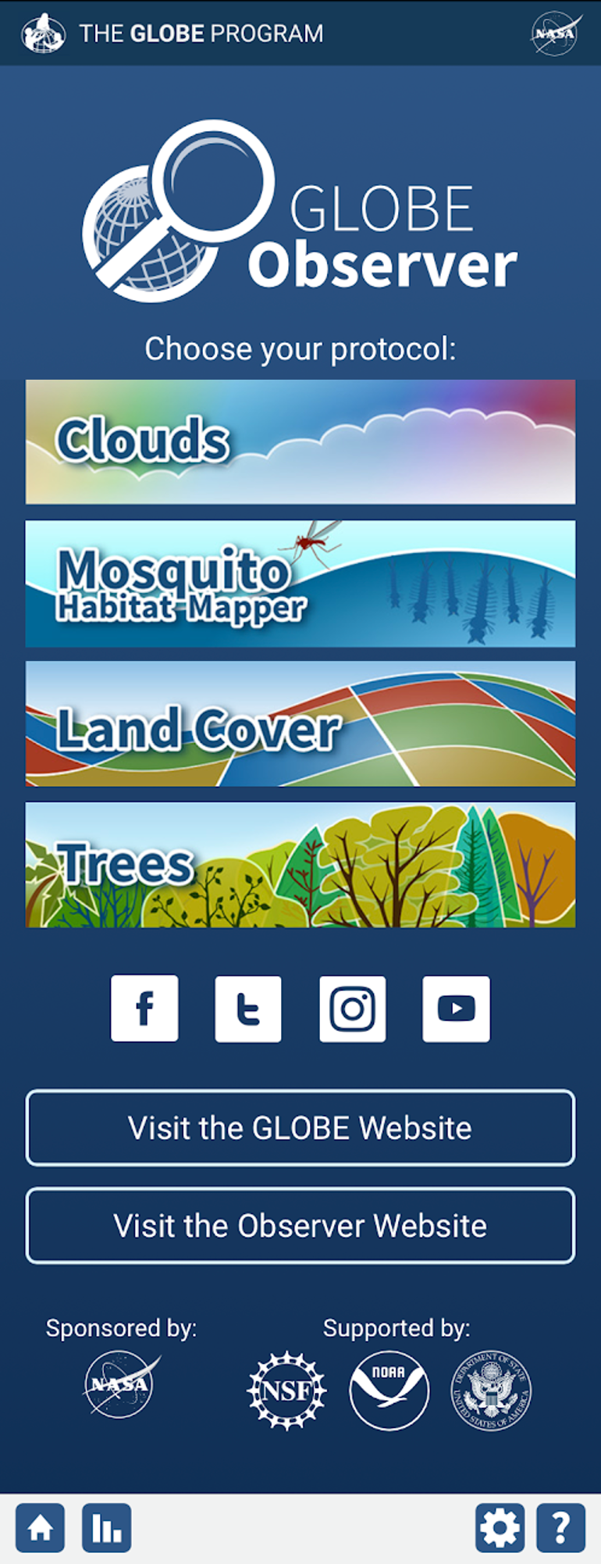
  + Biosphere- Life
    - Tree height activity
      * [Constructing a Clinometer](https://bit.ly/SOS_clinometer)
      * [Measuring Tree Height](https://youtu.be/K64bszvuLOg)
        + [Google Folder with Biometry lesson and article](https://drive.google.com/drive/folders/1GUkomgTUllPiirDT05oEtgLpRe-isofl?usp=sharing) - related to 4-H Weather and Climate Science Level 2 manual section on carbon footprints
  + Atmosphere- Air
    - GLOBE cloud data collection
      * All data collection is in the GLOBE Observer app
      * They can submit and view data throughout the year.
      * If several groups submit data in an area, you can begin building a more robust dataset.
      * Calibrating your eye: [paper activity](https://www.globe.gov/documents/348614/d58984c8-381c-4783-ad30-221fc381d619) or an [online version](https://assets.globe.gov/Cloud_Cover/select.html).
      * For air temperature, use a calibrated thermometer ([instructions for calibrating a thermometer](https://www.globe.gov/documents/348614/351813/Thermometer+Calibration+Lab+Guide/ff1147e1-6ae3-4eb1-b38c-20021910c0a8)).
    - Globe Observer data collection can be used like the CoCoRaHS activities in the Weather and Climate Science manual.
    - [Weather and Climate Lockbox Activity from the College of Science](https://www.purdue.edu/science/K12/lockbox.html)
    - Other corrections and supporting activities for the Weather and Climate Science manuals:
      * [The relentless rise of carbon dioxide – Climate Change: Vital Signs of the Planet](https://climate.nasa.gov/climate_resources/24/graphic-the-relentless-rise-of-carbon-dioxide/) [correction to Level 3 manual]
      * [Radiometer](https://youtu.be/0NJ-9cX2Xbs?_ga=2.180944932.2001331616.1682520969-124578783.1616432902)
      * [Laser demo](https://youtu.be/rmGuSTWqwuU) - albedo
      * [Kids STEM degree – sunlight warms the Earth](https://youtu.be/tSQs-PcsftA)
      * [Cloud in a bottle demo](https://youtu.be/lqTYVpWXldc)
      * [Convection tank demo](https://youtu.be/PNz4drFlhVU)
      * [Introduction to Air Pollution](https://www.purdue.edu/science/K12/LabPages/Atmosphere.html) - high school virtual lab
  + Hydrosphere- Water
    - Introduction to hydrosphere science: [Hydrosphere learning activities](https://www.globe.gov/documents/11865/c7f7a288-d1b9-48b5-8b6b-6298ff97459b)
    - Data collection: [Hydrosphere protocols](https://www.globe.gov/documents/11865/354449/Hydrosphere+Protocols/dd1c3dc4-cafa-42d9-af7c-31058e602482)
    - Date entry: GLOBE Observer app ► Data Entry ►Hydrosphere
  + Pedosphere- Soil
    - Introduction to soil science: [Pedosphere learning activities](https://www.globe.gov/do-globe/classroom-ready-activities/learning-activities)
    - Data collection: [Pedosphere protocols](https://www.globe.gov/documents/352961/8de1fc2a-dc4e-41c5-a5d9-985865b0d67f)
    - Data entry: Not yet on the GLOBE Observer app. Pedosphere data can only be input on the GLOBE website
* [Elementary GLOBE – picture books and related activities](https://www.globe.gov/web/elementary-globe)
  + [Air Quality](https://www.globe.gov/web/elementary-globe/overview/air-quality)
  + [Climate](https://www.globe.gov/web/elementary-globe/overview/climate)
  + [Clouds](https://www.globe.gov/web/elementary-globe/overview/clouds)
  + [Earth System](https://www.globe.gov/web/elementary-globe/overview/earth-system)
  + [Seasons](https://www.globe.gov/web/elementary-globe/overview/seasons)
  + [Soils](https://www.globe.gov/web/elementary-globe/overview/soils)
  + [Water](https://www.globe.gov/web/elementary-globe/overview/water)
* **GLOBE Data Visualization:** [A step-by-step guide to select and graph data points](https://docs.google.com/presentation/d/19xOMenQPGJdxLeu1s4OLWilleXdQuUdiTuWFdKgawW0/edit?usp=sharing)

**Additional Resources from the College of Science Outreach Team:**

* [K-12 Students - College of Science - Purdue University](https://www.purdue.edu/science/K12/students.html)
  + Virtual programs for students
* [Science Demonstrations](https://www.purdue.edu/science/K12/LabPages/Demos.php)
  + A collection of science demonstrations that can be done in the classroom or viewed online. This repository includes a short video of each demonstration. A separate video includes an explanation of the science behind each demo and set-up tips for doing them on your own.
* [Superheroes of Science - YouTube](https://www.youtube.com/c/SuperheroesofScience)
  + Our YouTube channel has hundreds of education STEM related videos.
* **Summer 2023 Eclipse PD:**
  + Elementary on-campus PD (June 15-16, 2023): <https://cvent.me/mPR7Am?_ga=2.71879824.2001331616.1682520969-124578783.1616432902>
  + Middle School virtual PD (June 27):

<https://www.purdue.edu/science/K12/teacher-professional-development-programs/index.html>

**College of Science K-12 Outreach Team Contact Information**

Bill Bayley, Sarah Nern, & Steven Smith

[**k12science@purdue.edu**](mailto:k12science@purdue.edu)