Mock Stream Habitat Assessment:

Bringing the outside in!

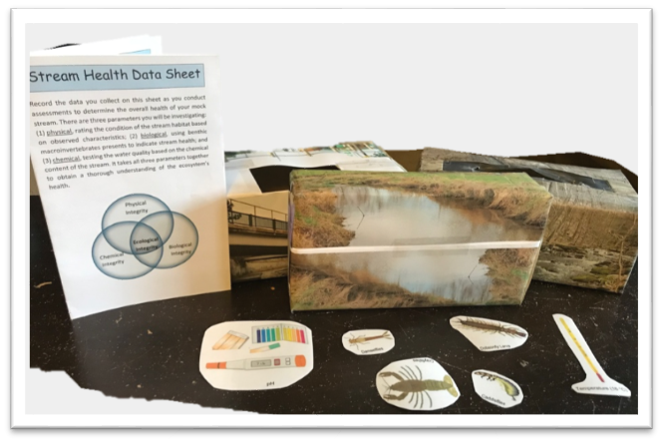

# Objectives:

At the end of this activity, youth should be able to:

* Assess the overall health of a stream habitat
* Apply the terms abiotic and biotic
* Explain how abiotic and biotic factors relates in stream ecosystem

Time to prep: 30 minutes

Time to complete activity: 15-20 minutes

Skill level: Intermediate (grades 6-8)

# Background:

Why monitor streams?

All life depends on water and we all contribute to the quality of our local watershed. Our activities and usage of water and land affects the quality of our drinking water and the health of aquatic plants and animals.

How do you determine the health of a stream?

An ecosystem is a fine balance of interactions between the living (biotic) and non-living (abiotic) factors. To fully understand the health of a stream ecosystem, we must collect data on all of these factors. Abiotic factors can be measured by recording the water chemistry and the physical characteristics of the stream. Biotic factors can be measured by collecting and identifying pollution indicator organisms such as benthic macroinvertebrates, fish, and algae. Certain organisms can help indicate water quality due to how sensitive or tolerant they are to pollution. This level of sensitivity is quantified using what is called the Pollution Tolerant Index (PTI) and is used to calculate the quality of water. The PTI takes into account the level of pollution tolerance of each organisms and the abundance of each organisms found. For instance, if mostly pollution tolerant organisms were found in a body of water, it would indicate the quality of water is mostly poor. However, if highly sensitive organisms were found along with pollution tolerant it would indicate good water quality.

# Materials:

# Building your mock streams

# 3 boxes (tissues boxes or other)

# 3 pictures of different streams environments (rural, agricultural, urban)

# Laminated cut-outs of macroinvertebrates and chemical parameters *(See resources)*

# Stream Health Data Sheets *(See resources)*

# Tape

# Optional: WaterQuality app and iPads

# Build your mock stream by taping or wrapping the picture of a stream around the outside of each box. Place the corresponding macroinvertebrates and chemical parameters (as labeled) inside each box.

# Methods:

1. Participants will be placed into groups of 2 to 4
2. Each group will receive a mock stream box and a stream health data sheet
3. Individuals will work together to collect data for the three parameters (as indicated on the Stream Health Data Sheet) and record their data on the data sheet
   1. Optional: Data can also be recorded in the water quality app for chemical and biological parameters. Physical observations can be recorded in the notes section of the app. Each parameter in the app can be clicked on to learn more about what it is, how it is measure, and how it relates to water quality. Each parameter displays this information in written form along with a graphic to aid all learners.
4. Groups will then analyze their collected data to determine their streams overall health
5. Each group will share their stream assessment and support their claim with data that was collected

# Reflection Questions:

Why do you think we need to collect data on all three of the parameters (Physical, chemical, biological)?

1. An ecosystem is a balance of abiotic (non-living) and biotic (living) factors. Like any investigation, if we only look at one or two sides we may not get the full story.

What if one or more of the parameters indicated an unhealthy environment? Think of your own example from this activity and explain what could have caused this? Then, what do you think could be done to correct it?

1. E.g. Agriculture stream- Chemical parameters indicated poor water quality, very high levels of nitrates and high pH. Animal waste or fertilizer running off into the stream could have cause this. To correct this, animal waste could be picked up or less fertilizer could be applied. Since the physical parameters also indicated poor water quality due to a lack of vegetation, more plants could be planted along the sides of the stream to filter land runoff.

Can you think of another type of environment this type of assessment can be applied to? Why might it be important to know this environment’s “full story”?

1. E.g. Soil- for agriculture, it is important to know and understand soil health when growing crops. Physical properties- soil texture, drainage, Chemical properties- pH, nutrients, Biological- microorganism and other invertebrates presents. All of these parameters determine what type of plants can grow and how well can they grow in the soil.

# Supplemental Information:

Learn more about how water quality data is collected throughout the state of Indiana: <http://www.hoosierriverwatch.com/>

Indiana watersheds:

<https://www.in.gov/idem/nps/2369.htm>

Water Science and Education:

<http://www.waterontheweb.org/index.html>

<https://www.nwf.org/Educational-Resources/Educator-Tools/Lesson-Plans-and-Webinars>

# <https://www.enviroscapes.com> (Available to use from the State Office)

# Vocabulary:

# Abiotic- the physical (non-living) parts within an environment

# Biotic- The living organisms within an environment

# Ecosystem- a community of organisms interacting with their physical environment

# Pollution- the introduction or presence of a potentially harmful substance in an environment

# Watershed- Where water present on land drains and collects into a river system or other body of water

# Resources:

# *Macroinvertebrate cut-outs (Biological parameters)*

# 

# 

# 

Source of macroinvertebrate images:

Kentucky River Water Watch

Administered by the Kentucky Water Resources Research Institute, University of Kentucky

# <http://www.uky.edu/krww/content/watershed-watch-materials>

# *Chemical parameters cut-outs*

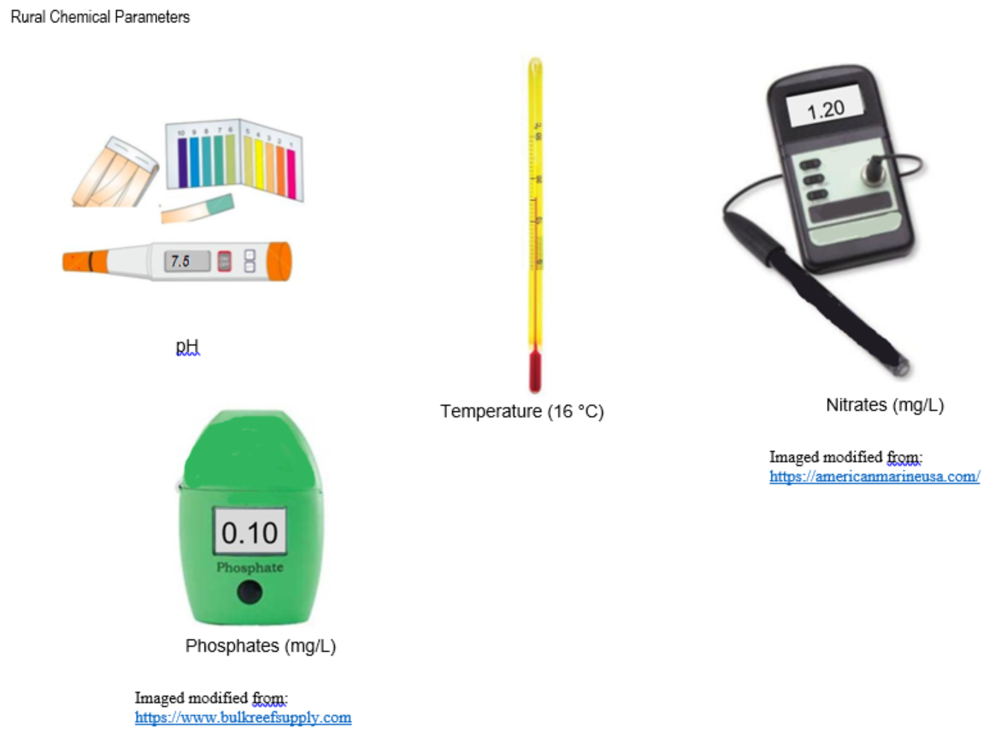

# 

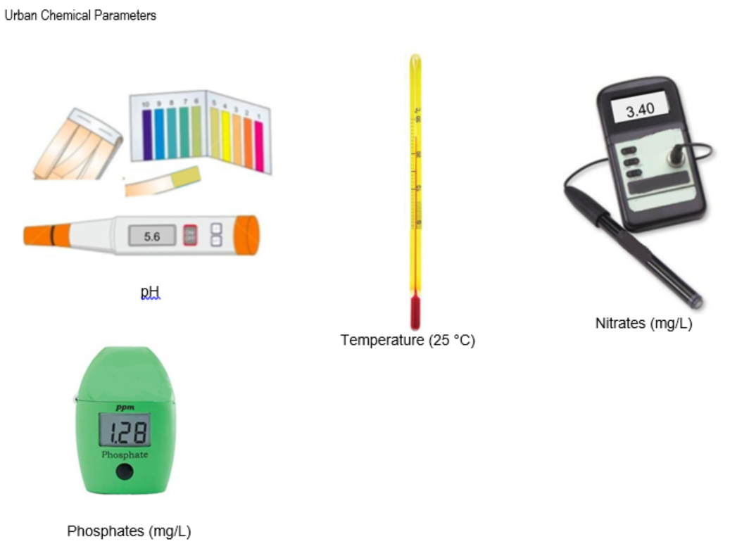

# *Stream Pictures (Physical parameters)*

# Rural stream

# 

Source:

<http://rockandriffle.blogspot.com/2015/04/uodome-and-new-stream.html>

**Agricultural stream**

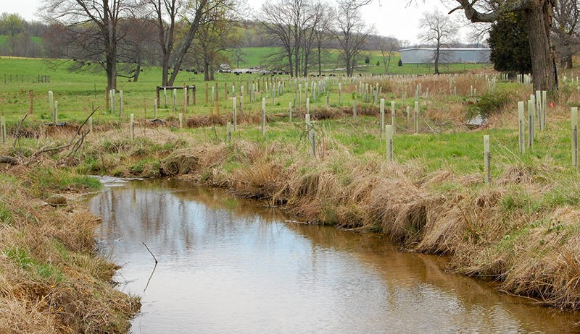

Source:

<https://www.hobbyfarms.com/promote-healthy-waterways-on-your-farm/>

# Urban stream

# 

Source:

<https://www.blogto.com/city/2016/05/the_weird_and_wonderful_concrete_river_in_toronto/>