

**Modeling Wetlands as Sponges**

**Learning Objectives:** 1) To recognize how wetlands prevent excess runoff and associated pollutants from entering waterways 2) To use a model to represent ecosystem functions and interactions 3) To design an experiment to assess the impact of landscape properties on ecosystem processes [Part 4]

*Related Indiana Academic Standards (2022):*

* Develop a model using an example to describe ways the geosphere, biosphere, hydrosphere, and/or atmosphere interact [5-ESS2-1]
* Evaluate competing design solutions for maintaining biodiversity and ecosystem services [MS-LS2-5]

**Time to complete activity:** 1-2 hour

**Skill level:** Grades 5-7

**Setting:** 4-H Club Meetings, School and After-School Classroom Visits

**Potential Careers:** Ecological engineer, water resources engineer, environmental scientist, natural resource manager, environmental engineer, city planner

**Potential Majors:** Environmental and natural resource engineering, environmental and ecological engineering, natural resource and environmental science, sustainable food and farming systems, landscape architecture

**Materials:**

* Long, rectangular pan (e.g. paint trays already have a slope and pool; disposable aluminum pans also work)
* Modeling clay or play dough
* Sponges
* Clean water
* Watering can, spray bottle, or plastic jug/bottle with pin holes to simulate rainfall (Figure 1)
* Potting soil or cocoa powder to represent topsoil
* Container to measure volumes (e.g. graduated cylinder, kitchen measuring cups)

Potential materials for Part 4:

* Tin foil or plastic wrap
* Play sand
* Leaves, grass clippings, twigs to represent vegetation
* Moss or green felt

**Background:**

* Wetlands are ecosystems where there is standing water or where groundwater is near the soil surface for all or part of the year (e.g. your feet will usually sink into the ground where groundwater is shallow).
* Wetlands also contain *hydrophytic* plants, which are plants that tolerate wet soil or flooding better than most plants. Examples of hydrophytic plants in Indiana include broad leaf cattails, duck potato, and rice cutgrass.
* Marshes, bogs, fens, and swamps are examples of different types of wetlands.
* Wetlands are often found between upland areas, which include farms, cities, and forest, and bodies of water, such as lakes, rivers, and streams. These transitional might be referred to as ecotones.
* Wetlands provide critical ecosystem services for societies, including reducing damaging floods and improving water quality. Wetlands must be preserved to maintain these ecosystem benefits.
* In some cases, wetlands have been destroyed or damaged by human activities, such as being drained to develop land or to farm. Wetland restoration involved rehabilitating degraded wetlands or reconstructing wetlands where they were present historically. Created/constructed wetlands are wetlands that are built in areas where wetlands did not historically exist or are a different type of wetland than present in the past at a site.

**Method:**

***Preparation ahead of the activity:***

1. Create a hill with the modeling clay on one side of the pan to represent a watershed that drains to a water body. The hill should grade downward from the edge of the pan toward the center of the pan.
2. Add a shallow layer of clean water to the other side of the pan to represent a water body, such as lake, river, or ocean.

***Activity:***

***Part 1: Wetlands Capture Water to Prevent Floods***

* Introduce the concept of runoff - Runoff is water that flows across the land, because the capacity of the soil to store water is exceeded by the amount or intensity (i.e. rate of rainfall) of rainfall. We want to reduce runoff, because runoff carries pollutants to rivers and streams. Reducing runoff also helps prevent flooding and protects streambanks.
* Start a discussion – What is a wetland? What do wetlands provide for the environment and society?
* Introduce sponges as a model for wetlands: Wetlands soils are porous like sponges, which allows wetland to store water in spaces between soil particles. Large pollutants can get trapped in these pores, which prevents these pollutants from entering waterways.
* Explain how the modeling clay represents an upland landscape, which may include farms, cities/towns, construction zone, forests, prairies, etc.
* Add sponges at the transition between the water body and clay landscape. Try to prevent bypassing of flow from the landscape around the sponges.
* Sprinkle/spray clean water on the clay landscape to simulate a rainstorm. Make sure to pour enough that water runs down the hill, rather than being fully absorbed by the clay. The sponge should capture and store some of the runoff, limiting the volume that reaches the water body.
* To make the activity more quantitative, you can measure the water level (i.e. stage) in the lake before and after the rainstorm with a ruler or tape measure.
* Ask students what they observe. The students should notice that sponges swell with the stored water.

***Part 2: Removal of Wetlands from the Landscape***

* Ask students to predict what will happen if the sponges are removed.
* Repeat the simulated storm with clean water but without the wetland sponges in place. Try to pour the same amount of water at the same rate. Runoff should flow more quickly into the water body. The water level in the lake should rise higher for the same volume of rainfall as compared with the simulation with the sponges in place.
* Ask students to explain the differences between the simulation with and without the sponge.

***Part 3: Wetlands Filter Pollutants\****

* Squeeze out or replace the sponges. Add sponges back to the landscape model.
* Ask students what pollutants might be transported from the landscape by runoff. (Examples: road salt, sediment from farms and construction sites, fertilizer, oil from roads)
* Spread a thin layer of loose soil/cocoa powder over the clay landscape model. The modeling clay is similar to soil layers that are found deeper below the surface. Ask students to predict what will happen to the added soil when it rains.
* Repeat the simulated storm with the clean water. The sponge should catch some of the soil particles.
* Remove the sponges. Refresh topsoil. Replace the water in your model lake/river/stream with clean water.
* Repeat the rainfall simulation. Almost all of soil should end up in the model lake/stream/river.
* Asks students about what happens when the wetlands are present versus removed. How do wetlands improve water quality?

*You can combine Part 3 with Parts 1 & 2 by adding topsoil to each simulation. The separation of pollutants in Part 3 helps to highlight water quality treatment functions of wetlands.

***Part 4: Experimenting with Landscape Features (Optional Extension)***

* Have students brainstorm how engineers and scientists might reduce runoff and prevent pollution from reaching waterways (Example: conservation practices and reduction of impermeable surfaces) or what landscape properties might influence runoff (Examples: slope, soil type, land use) in small groups or as a class
* Ask each group to students to formulate a hypothesis about the relationship between different watershed properties and runoff (Example: We predict that there will be more runoff from a landscape with 50% impermeable surface than a landscape with no impermeable surface).
* Provide students will materials to build different watershed models and then have students test their hypotheses.
* Assess the differences between models by measuring the change in water level on the other side of the pan before and after the simulated storm of a fixed volume with a ruler or tape measure.
  + **Impact of different land use on runoff:** 
    - Permeable landscapes: Forests and prairies support more infiltration and less runoff – represent this with a layer of moss or green felt over the modeling clay
    - Impermeable landscapes: Pavement, concrete, and roofs increase runoff volume due to impeded infiltration – represent with tin foil or plastic wrap over modeling clay, which will prevent infiltration into modeling clay
  + **Impact of soil type on runoff:** 
    - Coarse-textured soils: Sand has higher infiltration rates – replace modeling clay with play sand
    - Fine-textured soils: Fine-textured soils, such as those with high clay content, will have slower infiltration rates – represent with the original model
  + **Impact of slope on runoff:** 
    - Steep slopes limit infiltration and increase the likelihood of severe erosion – create a steep slope with the modeling clay
    - Shallow slopes provide more time for infiltration – create a shallow slope with the modeling clay (extra step: add shallow depressions in the modeling clay where water can be temporarily stored)
  + **Impact of vegetation:** 
    - Vegetated slope: Vegetation reduces runoff velocity, which promotes infiltration and limits erosion – use leaves, grass clippings, twigs, etc to model the presence of vegetation on the slope
    - Unvegetated slope: Bare soil is more susceptible to erosion – Clay is very cohesive, so you can add a thin layer of potting soil or cocoa powder on top of your watershed model to better demonstrate erosion

***Modification for Use with EnviroScape® Ecological Restoration Model***

* Instead of using a paint tray or aluminum pan, you can use the *EnviroScape® Ecological Restoration Model*, which should include all the materials needed for this activity (check if consumables in the kit need to be replenished). EnviroScape® Ecological Restoration Model is also available for check-out from the State Office.
  + Set-up the model based on guidance and photos in the primary manual that is included with the kit, but do not include the wetlands yet (Figure 2). If scheduling permits, you will want to do this before students arrive.
  + Before each precipitation event, you can add cocoa powder or potting soil to zones of the model where there is bare soil (dark brown zones and construction zone) to highlight how wetlands capture sediment.
  + Place empty plastics cups in the water tray beneath the main plug and other holes in the model to capture water.
  + Simulate a precipitation event with the spray bottles. Once the water has drained, show the captured water to students. Ask students what they observe and to predict what will happen when wetlands are added to the landscapes.
  + The EnviroScape kit includes sponges of different sizes. Add sponges to wetland zones on the model, except for the floodplain under the marina.
  + Repeat the simulation of precipitation with the wetlands in place. Less water volume and cleaner water should end up in the cups. Asks students about what happens when the wetlands are present versus removed from the landscape. How do wetlands improve environmental quality?
* Modifying Part 4 for the EnviroScape®
  + To test the impact of vegetation, use the green felt strips to represent restoration of ecosystems with native vegetation (i.e. replacing a gray impermeable pieces on parking lot/buildings or marina with prairie or wetlands).
  + To test the impact of slope, modeling clay could be added to landscape model. Some modeling clay is included in the EnviroScape® kit.

**Reflection Questions:**

* If wetlands are destroyed and replaced with pavement, what might happen when there is a severe storm?
* Why do we want to limit erosion and transport of soil into our waterways?

**Supplemental Information:**

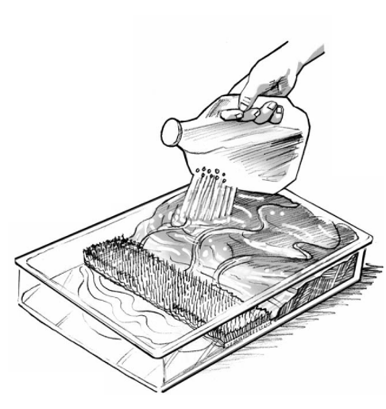

Figure 1: Example of wetland in a pan (Source: California Coastal Commission)

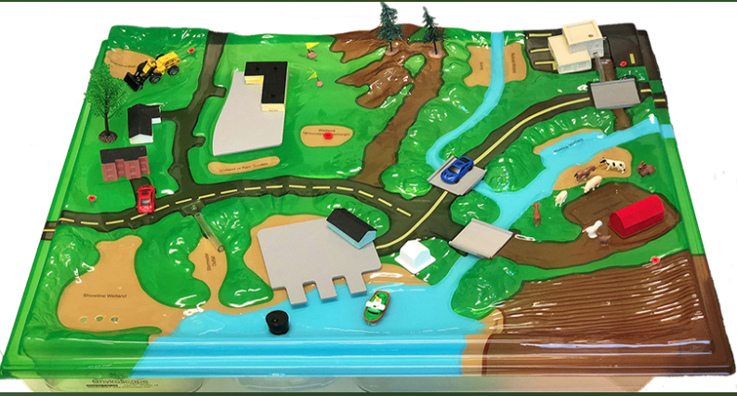

Figure 2: EnviroScape® set-up before wetland addition (Source: JT&A, Inc.)

**Vocabulary:**

Wetlands – ecosystems with ponded water or water just below the ground surface that

Runoff – water that flows across the land, rather than being absorbed into soil

Sediment – soil that ends up in runoff or body of water

**References:**

Adapted from Mykut, J. (n.d.). *Wetlands in a Pan*. Penn State College of Agricultural Sciences. <https://ecosystems.psu.edu/outreach/youth/sftrc/lesson-plans/water/6-8/wetland>

Environmental Concern Inc. and The Watercourse (1995). Wow! The Wonders of Wetlands. St. Michaels, Md., & Bozeman, Mont.: Environmental Concerns Inc. and The Watercourse.