|  |
| --- |
| Chemical Parameters |

|  |
| --- |
| Stream Health Data Sheet |

Circle the corresponding value for the chemical parameters collected from your stream in the data table below

|  |  |  |  |  |
| --- | --- | --- | --- | --- |
| **Chemical Parameter** | **Good (4)** | **Fair (3)** | **Marginal (2)** | **Poor (1)** |
| **pH** | 6.8-7.7 | 6.5-6.7  7.8-8.2 | 6.2-6.4  8.3-8.5 | <6.2  >8.5 |
| **Temperature* (°C)** | 14-20 | 21-24 | 25-27 | >27 |
| **Nitrates (mg/L)** | <1.5 | 1.6-3.5 | 3.6-8.4 | >8.4 |
| **Phosphates (mg/L)** | <0.1 | 0.2-0.4 | 0.5-0.9 | >1.0 |

*Range for cool-water species   
**Average chemical quality rating: ____________________**

**Analysis: 16-13 Good, 12-9 Fair, 8-6 Marginal, 4-5 Poor**

|  |  |  |  |  |
| --- | --- | --- | --- | --- |
| Overall Stream Health Assessment | | | | |
|  | **Good** | **Fair** | **Marginal** | **Poor** |
| **Physical** |  |  |  |  |
| **Biological** |  |  |  |  |
| **Chemical** |  |  |  |  |
| **Overall Average Stream Health: ___________________** | | | | |

Developed by: Alexus Maschinot,   
Modified resources from: Maryland, Indiana,  
 and Kentucky’s Department of Natural Resource

Record the data you collect on this sheet as you conduct assessments to determine the overall health of your mock stream. There are three types of parameters you will be investigating: (1) Biological- using macroinvertebrates presents to indicate stream health. (2) Physical- rating the condition of the stream habitat based on observed characteristics. and (3) Chemical- testing the water quality based on the chemical content of the stream. It takes a combination of all three parameter types to obtain a thorough understanding the health of an ecosystem.

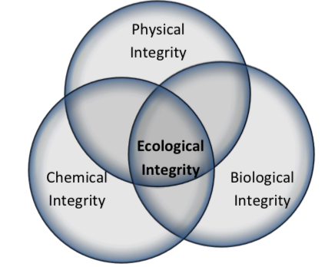

Name: _____________________________________

|  |
| --- |
| Biological Parameters |

Check all of the macroinvertebrates that you find in your stream and calculate the stream’s water quality rating

|  |  |  |  |  |  |  |  |
| --- | --- | --- | --- | --- | --- | --- | --- |
| **Sensitivity to Pollution** | | | | | | | |
|  | **Very Sensitive** |  | **Sensitive** |  | **Somewhat Tolerant** |  | **Tolerant** |
|  | Stoneflies |  | Damselflies |  | Midges |  | Aquatic worms |
|  | Mayflies |  | Dragonflies |  | Black flies |  | Blood Midges |
|  | Dobsonflies |  | Crayfishes |  | Flatworms |  | Rat-tailed maggots |
|  | Water pennies |  | Sowbugs |  | Leeches |  | Left snails |
|  | Caddisflies |  | Scuds |  | Clams |  |  |
| # of checks _______ X 4=  __________ | | # of checks _______ X 3=  __________ | | # of checks _______ X 2=  __________ | | # of checks _______ X 1 =  __________ | |

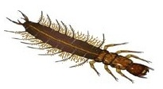 **Sum total_____________**

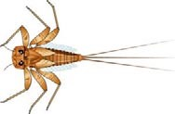**Analysis: 23> Good, 22-17 Fair, 16-11 Marginal, <10 Poor**

|  |
| --- |
| Physical Parameters |

Circle the corresponding description for the physical characteristics seen in your stream

|  |  |  |  |  |
| --- | --- | --- | --- | --- |
| **Characteristic** | **Good (4)** | **Fair (3)** | **Marginal (2)** | **Poor (1)** |
| **Channel alteration** | Channel formed naturally and has many bends | Channel straightened in some places but some natural bends still present | Channel mostly straightened | Channel straightened and flowing along a paved channel |
| **Erosion** | Banks only slightly above the level of the water | Banks somewhat higher above the level of the water | Banks significantly above the level of the water | Banks extremely high compared to water level |
| **Attachment sites for Macro-invertebrates** | Lots of different sized rocks, wood, and plenty of leaf litter | Only small, gravel sized rocks, some wood and leaf litter present | No rocks or wood but some leaf litter present | No rocks, wood, or leaf litter present |
| **Riparian Buffer Width (estimation)** | More than 50 feet of trees and vegetation from each bank | 20 - 50 feet of trees and vegetation | 5-20 feet of trees and vegetation | 0-5 feet of trees and vegetation |

**Total score** _________________   
 **Analysis: 16-13 Good, 12-9 Fair, 8-6 Marginal, 4-5 Poor**