# Snap Circuits Environmental Sensors Activities

### Background

Expected Duration: 1 hour

Learning Objectives:

* To recognize how sensors can measure environmental properties and processes indirectly through relationships electrical properties
* To understand that electrical resistance is opposition to flow of current
* To explain how voltage, current, and resistance relate

### Materials

* Minimum of 2 Snap Circuits kits
* AA batteries
* Table salt
* Clear plastic cups/beakers
* Flash light
* Cocoa powder or soil

### Discussion of Lesson

Many environmental properties and processes are difficult or expensive to measure directly. Scientists and engineer may use sensors to characterize these properties and processes indirectly based on different electrical properties. Calibrations are mathematical relationships that represent how environmental properties relate to electrical measurements from sensors. Calibrations are built from a subset of samples with properties that are characterized with more direct methods, such as in a laboratory.

### Station 1: Conductivity/Salinity Sensors

Scientists and engineers measure differences in resistance to characterize certain environmental properties. Resistance is the opposition to flow of charge through a material. Conductivity is the inverse of resistance. Dissolved salts and other inorganic chemicals conduct electrical current, so measuring conductivity of a water sample provides insight into concentrations of salts and other inorganic chemicals.

### Before the activity, create water samples with different salinity with table salt (no added salt, some added salt, considerable added salt).

* Student teams of 2-4 should:

1. Work through Project 494 to understand how resistance is measured
2. Work through Project 197 to build a conductivity sensor
3. Test the conductivity sensor with water samples and order the samples from least to most salt content (tone/volume changes with conductivity levels)
4. Additional challenge: modify your circuit from Project 197 to provide a more quantitative output for conductivity by using the analog meter

### Station 2: Turbidity Sensors

Suspended solids, which include sediment, algae, and other particulate pollutants, can impact the clarity of water bodies. Engineers and scientist use turbidity, which is a measure of the amount of light that is scattered by particulate pollutants, to gauge concentrations of suspended solids. Resistance in photoresistors depends the intensity of light, so resistance should change with turbidity if a light source is present.

### Before the activity, create water samples with different turbidity with soil or cocoa powder (clear water, moderate clarity, low clarity).

* Student teams of 2-4 should:

1. Work through Project 326 to build a light intensity sensor
2. Hold the water sample over the photoresistor. Shine a flashlight through the water sample toward the photoresistor. The meter should move based on the amount of light that is transmitted through the water sample.
3. Work through Project 486 to investigate if the circuit can be optimized to provide higher resolution measurements (i.e. great movement in meter for smaller changes in light intensity).

### Supplemental Information

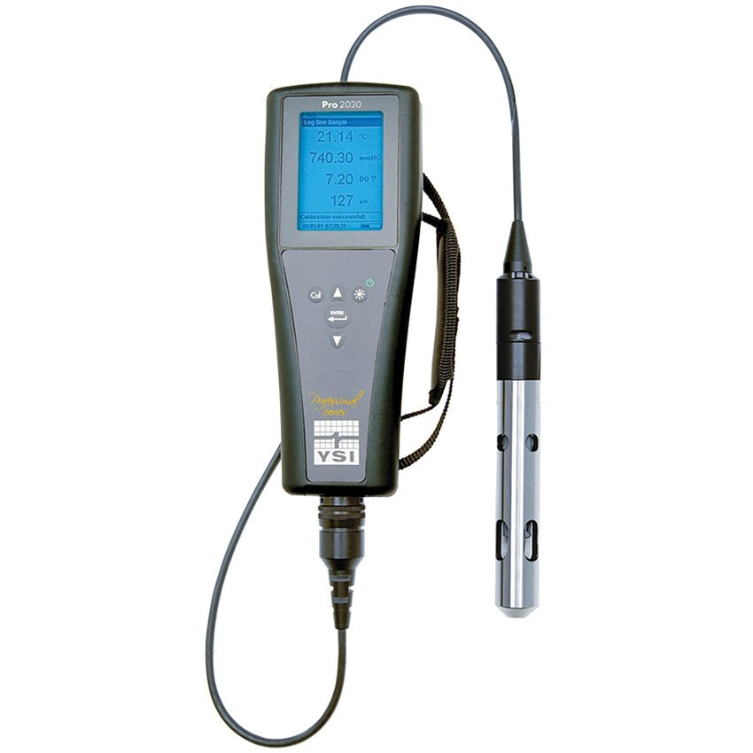

Figure 1: Multiparameter water quality sonde, which can measure conductivity (Image Credit: YSI)

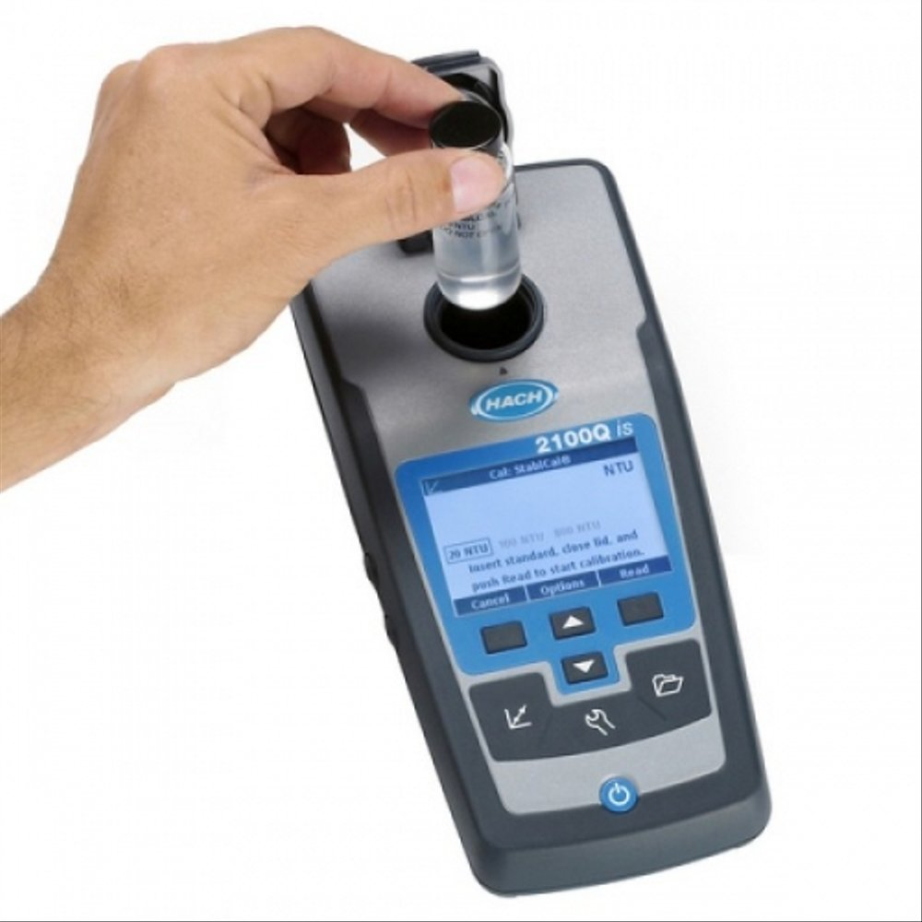

Figure 2: Portable turbidity meter, which measures light that passes through a water sample (Image Credit: Hach Company)

### References

1. Elenco Electronics, Inc. Electronic Snap Circuits (Experiments 1- 101) Manual
2. Elenco Electronics, Inc. Electronic Snap Circuits (Experiments 102-305) Manual
3. Elenco Electronics, Inc. Electronic Snap Circuits (Experiments 306-511) Manual