



INDIANA 4-H & INDIANA FFA

Career Development Events

Soil Judging

Purpose
The purpose of the Soil Judging CDE is designed to teach youth skills necessary in soil science and make land use recommendations for production agriculture and home site development.

Objectives
Students will be able to:
- To identify and evaluate key soil characteristics like texture, slope, drainage, and structure.
- Based on these properties, indicating its suitability for various uses (e.g., agriculture, urban development).
- Use the knowledge to make informed decisions about land management, including appropriate agricultural practices, conservation strategies, and even home site selection.
- By understanding the limitations and potential of different soils, students develop a sense of stewardship towards natural resources and learn how to manage them sustainably.

Event Format

Regional Contest Components (All Individual Activities)
    - Homesite- 2 Pits Evaluated
    - Agriculture Use- 2 Pits Evaluated
    - All pits evaluated using scorecards provided by Purdue Extension
      - Ag Site: 4-H-394
      - Home Site: 4-H-255
      - Upon completion of evaluation contestants will transfer their answers over to their official Indiana Soils Evaluation Scantron for official scoring.
    - Teams may bring and use clean copies of the IN Soils Evaluation Scantron in at the holes in place of the scorecards.
    - NO NOTES, WORKSHEETS OR WRITTEN COPIES OF ANY SCORECARD OR SCANTRON WILL BE ALLOWED. CONTESTANTS ARE SUBJECT TO DISQUALIFICATION IF FOUND
IN POSSESSION OF THEM.

Regional Contest Scoring/Advancement
    - Ag Site Pits- 114 points per pit
    - Home Site Pits- 117 points per pit
    - Total Individual Points Possible- 462 Points
    - Total Team Points Possible- 1,386 Points
    - Team Score is composed of top three scores per team

    - Advancement to State
      - Top 8 Senior Teams
      - Top 5 Junior Teams
      - The top 8 “Non-Masters” teams from each region contest, plus any “Master” teams who would be in the top 8 overall at the region contest. An additional team may be added to the number advancing for each team from that region that qualified for the national event the prior year. No entity (FFA Chapter or 4-H group) shall advance more than 2 senior FFA teams, 2 senior 4-H teams, 2 Masters FFA teams, or 2 Masters 4-H teams from the regional to the state contest.

State Contest Components
    - Homesite- 2 Pits Evaluated
    - Agriculture Use- 2 Pits Evaluated
    - All pits evaluated using scorecards provided by Purdue Extension

Tiebreakers
    - 1- Highest team score including fourth score
    - 2- Total score for team without fourth score for Pit #1
    - 3- Total score for team without fourth score for Pit #2, 3, etc until tie is broken

Contest Prep/Equipment Needed
    - Each student needs the following items
      - Clipboard with Slope Finder attached
      - Pencils
      - Spray Bottle
      - Knife, Nail, Small Spade, etc
    - Appropriate Attire for soil pits (Plan for rainy, muddy weather)
    - Soil Texturing/Soil Horizons Identifying
      - Starting in 2025 students will be required to obtain and identify the proper soil layers to determine soil textures.
      - Exceptions to this rule:
        - Soil profiles which are identified by the soil scientists to close to making an obvious decision
        - Timing issues for efficient running of the contest
        - Soil scientists believe putting soil in buckets would allow for a better learning experience for the students

Registration
    - FFA teams must complete their registration on the Indiana FFA portal. All team members must be on the FFA roster and have their online waivers completed.
    - 4-H teams must complete their registration on the Indiana 4-H online website. All members must meet all 4-H membership requirements.
    - All registration must be completed by the deadline set by 4-H and FFA staff.
    - Teams that advance to the state contest may make one substitution per team from the area/region contest to the state contest.

Ag Judging Handbook
  - This CDE is a joint effort of both Indiana 4-H and Indiana FFA Association. It is governed by the Ag Judging Committee and all rules and guidelines in the Ag Judging Committee handbook apply to Soils CDE.

References
  - Scorecards:
    - HOME SITE CARD
    - AG SITE CARD
- Resources
  - Indiana Soil Evaluation Field Book- Summary of Rules
  - https://extension.purdue.edu/4-H/_docs/get-involved/state-programs/CDE/soils-Clarification-of-Rule-3631324.pdf
  - https://edustore.purdue.edu/id-72-w.html
  - https://extension.purdue.edu/4-H/_docs/ay-362-w-coaches-letter-2019.pdf
  - SITE CARD EXAMPLE
  - SLOPE FINDER

Scantron- Front Side
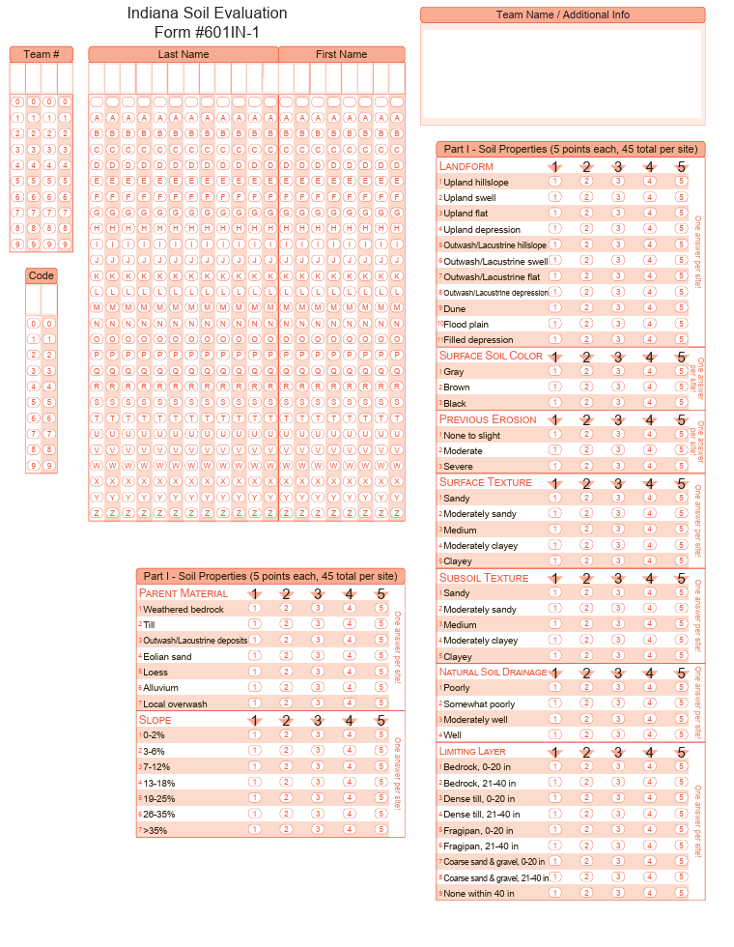

Scantron-Backside
