**Tentative**

**2025 Benton County Pre-Fair & Fair Schedule**

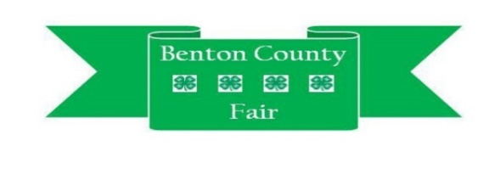**Fair Dates: July 15 - July 20**

**Sunday, June 29**

2:00 pm Food Stand Clean-up

**Tuesday, July 8**

5:00 pm-7:00 pm Fairgrounds Clean-up

**Thursday, July 10**

5:00 pm-7:00 pm Mini 4-H Project Check-in & Judging

**Friday, July 11**

5:00 pm-7:00 pm 4-H Project Check-in

**Saturday, July 12**

8:00-9:00 am 4-H Perishable Check-In (Floriculture, Foods, Garden)

9:00 am 4-H Project Judging

12:00 pm 4-H Consumer Clothing, Fashion Revue, Sewing Project Check-In & Judging

**Sunday, July 13**

4:00 p.m. 4-H Cat & Pet Show

6:00 pm 4-H Dog Obedience Show

**Tuesday, July 15**

6:00 am-noon 4-H Livestock Check-In

1:00 pm 4-H Ag Tractor Contest

1:00 pm 4-H Lawn & Garden Tractor, Zero-Turn Mower Contest

**Wednesday, July 16**

8:00 am 4-H Livestock Weigh-In: Sheep, Goat, & Beef

9:00 am 4-H Rabbit Show

12:00 pm 4-H Poultry Show

8:00 pm   Miss Benton County & Jr. Miss

4-H Fashion Revue

4-H 10 Year Member Recognition

**Thursday, July 17**

9:00 am 4-H Beef Show

1:00 pm 4-H Goat Show

7:00 pm Swine Weigh-in (in Swine Barn)

**Friday, July 18**

7:00-10:00 am Castongia’s Breakfast – 4-H Food Building

9:00 am 4-H Horse & Pony Show

**Saturday, July 19**

9:00 am 4-H Swine Show

3:00 pm 4-H Sheep Show

3:00 pm Mini 4-H Day Activities & Awards

8:00 pm 4-H Auction Sign-up Deadline

**Sunday, July 20**

9:00 am 4-H Horse & Pony Contesting Show

3:00 pm 4-H Supreme Showmanship

3:30 pm Herdsman Awards – Show Arena

4:30 pm 4-H Group Pictures

4:30 pm Battle of the Barns

5:00-7:00 pm 4-H Project Release – Project Building

6:00 pm 4-H Livestock Release (Beef, Goat, Horse & Pony, Poultry, Rabbit, Sheep & Swine)

**Monday, July 21**

9:00 am 4-H Livestock Auction