Overall Goat Industry

- A successful reproductive program in a goat herd requires managers to properly detect estrus. Identify some of the obvious signs of estrus:_______________________________
________________________________________________________________________________________________________________________________________________________________________________________________________________________

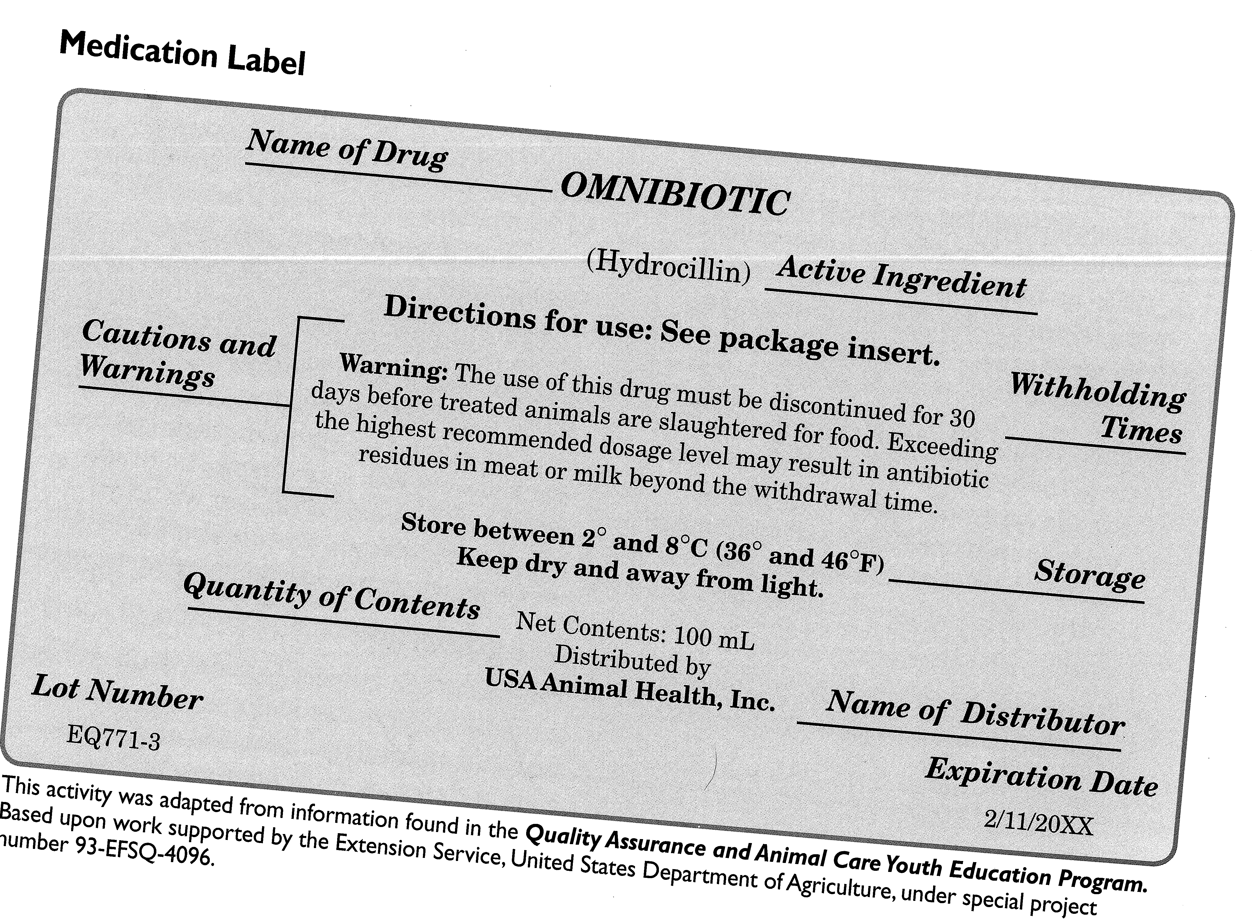
- Label the parts of a Medication Label:

- Identify a potential career in the Animal Sciences industry, explain the career and how your experiences in 4-H could help you be successful in this area. ________________________
________________________________________________________________________________________________________________________________________________________________________________________________________________________

- When giving medication to animals, it is important to follow ______________ times.

- What does “withdrawal time” refer to?
_____________________________________________________________________
_____________________________________________________________________

- Identify 3 characteristics needed to be successful in your search for a career. Identify how 4-H assisted in teaching these characteristics. ___________________________________
________________________________________________________________________________________________________________________________________________________________________________________________________________________


- Most goat breeds entered North American from the ________ to the ________ and were of ________ origin.

- Complete the Following:

Across: Down:
3. The ability of fibers to reflect light. 1. One fiber.
4. Straight, coarse, hollow and brittle 2. Main coat that is usually straight and has
chalky-white fibers that do not accept dye. no commercial value.
6. Curly and has most value. 5. All the hair from one goat.
7. Groups of fibers that cling together.

