Reproductive Management and Genetics

- A successful reproductive program in a goat herd requires managers to properly detect estrus, identify some of the obvious signs of estrus:_______________________________
________________________________________________________________________________________________________________________________________________________________________________________________________________________

- Match the following:
_____ Embryo A. Duct that carries the sperm from the epididymis
_____ Estrus B. Act of giving birth to young
_____ Fetus C. A newly fertilized egg
_____ Cervix D. Muscle that closes off the uterus
_____ Parturition E. Duct through which the sperm and urine travel
_____ Epididymis F. The unborn lamb from embryo to birth
_____ Urethra G. Duct that collects and stores sperm
_____ Vas Deferens H. Period that the female will allow the male to mate

- The birth of an animal where the rear legs are coming first instead of head or front feet first is known as a ____________ birth. Is assistance needed with this type of birth? ________

- Where does an animal get its genes from?
_____% from parents _____% from grandparents _____% great grandparents

- Find the genotype and phenotype of the following: Doe→Rr Buck→rr

Genotype:

Pheotype:

- Does that are healthy and well managed nutritionally can be bred when? ____________

- Identify the correct Reproductive Term:
  - Egg produced by the ovary ___________________
  - Growth period when reproductive system reaches maturity ___________________
  - Release of a mature egg from the follicle ___________________
  - Discharge of semen ___________________
  - Period of time from the end of one heat cycle to the next ___________________
  - Specific chemical messengers secreted by the glands ___________________
  - The length of the period between fertilization and lambing ___________________
  - An external pouch of skin that covers the testicles ___________________

- Identify the Following:

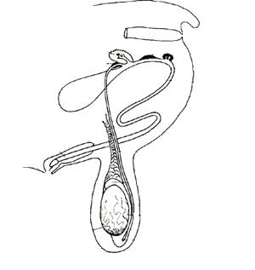

- Use logic to determine the appropriate time to breed a doelings. _____________________
________________________________________________________________________________________________________________________________________________

- Where does an animal get its genes from?
_____% from parents _____% from grandparents _____% great grandparents

- This is a paper showing the goats “family tree”, birth information, and owner. ___________
H
E
T
E
R
O
Z
Y
G
O
U
S
DOMINANT

