Meat Goats

- When does a successful meat goat project experience really begin? _____________________________________________________________________

- What is chevon? _______________________________________________________

- What do consumers want to know about the goat product they purchase? ___________
______________________________________________________________________

- What regulatory agencies play a role in quality assurance of wholesome goat products?
____________________________________ , ______________________________ ,
____________________________________ and ______________________________

- Match the following selection criteria descriptions:
____ Structural Correctness A. Length and depth of the goat.
____ Muscle B. Evaluation of skeletal system/bone structure.
____ Volume C. Ability to grow at the pace best for goals.
____ Style and Balance D. The chest/forearm are best indicators of this.
____ Growth Potential E. How all parts of the goat blend together.

- Meat goats should be long bodied from the top of the _____________ to the ________.

- Where is fat thickness measured? __________________________________________

- What two ethnic/religious groups represent the largest segment of the meat goat market? _________________________ and __________________________________

- Many ethnic and religious groups want meat from goats that have been harvested under specific guidelines:
Products for Islamic consumers much meet ______________ criteria
Products for Jewish consumers much meet ______________ criteria

- Food that does not meet halal standards and is non consumable is called? __________

- What are the four wholesale cuts of goat?
________________ ________________ ________________ ________________

- A 68lb meat goat should be expected to have a carcass weight of __________ lbs and a loin cut of ____________ lbs.

- A 57lb meat goat should be expected to have a carcass weight of __________ lbs and a loin cut of ____________ lbs.

- Identify the following (Cuts of Chevon):
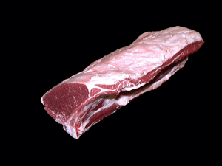
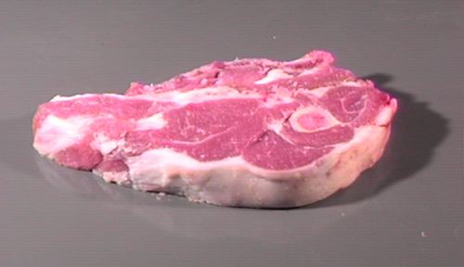

- Shoulder Chop A. Loin Roast
- Arm Chop B. Shower Chop
- Rib Roast C. Fore Shank

- When selecting a meat goat, you should use what criteria? ________________________________________________________________________________________________________________________________________________________________________________________________________________________________________________________________________________________

- Explain a market for your meat goats; include the appropriate specifications desired by that market.____________________________________________________________ __________________________________________________________________________________________________________________________________________________________________________________________________________________

- _________________ is a goat carcass that weighs 15-30lbs and is used in Hispanic populations.

