- Name the Gait
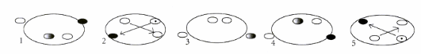

_______________
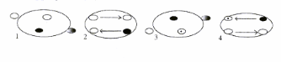

- Nutrition

What is the first step to have a successful feeding program? __________________________
__________________________________________________________________________
__________________________________________________________________________

List the five essential types of nutrition all horses need.
________________________________
________________________________
________________________________
________________________________
________________________________

What factors need to be considered when deciding on the rations for your horse? __________
_________________________________________________________________________________________________________________________________________________________________________________________________________________________________

