- Match the age with the description of a horse’s teeth

Cups worn from lower intermediate incisors 6 years old
Dental stars appears on all incisors 7 years old
Smooth mouth; no cups 8 years old
Cups worn from lower central incisors 9 years old
Cups worn from all lower incisors 10 years old
Cups worn from upper central incisors; dental star 12 years old
appears on lower centrals & intermediate incisors

- Determining a Horse’s Age
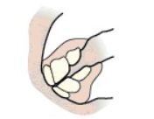
Use the box above the pictures with ages listed to match them with the correct image of the horse’s teeth.
1 Year Old 4 Year Old
7 Year Old 21 Year Old
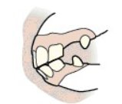

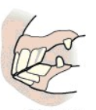
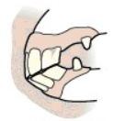

- Know Your Knots
Name the knot shown below.
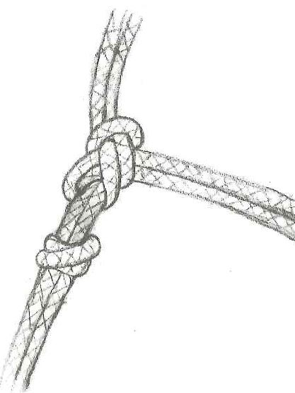

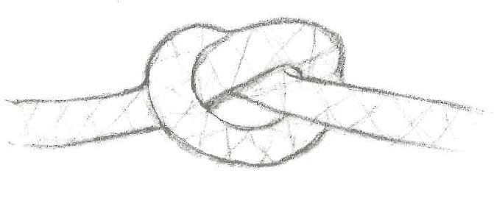
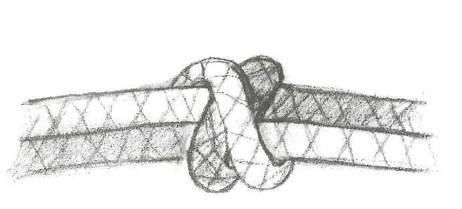

- True or False
T F If you are making your own halter for a large size horse you will need 26 feet of rope.
T F A double overhand knot is also called a blood knot
T F The overhand knot is a durable knot which is extremely difficult to take apart once it haa been used on a horse.
T F Do not leave a rope halter on your horse when you are not using it.

