- World Breeds of Horses
Match the county to the breed of horse that originates from that country

Friesian Scotland
Paso Fino Spain
Connemara United State
Lipizzaner East Prussia
Clydesdale Shetland Isles
Peruvian Paso England
Shetland Pony Ireland
Pinto Horse Netherlands
Trakehner Spain
American Suffolk Peru

- Reproduction True or False
Please circle the T or F. If it is a false statement, explain why it is a false statement.

T or F In the winter months mares usually do not cycle.
___________________________________________________________________________

T or F The average cycle of a mare is 21 days.
___________________________________________________________________________

T or F Normally fillies and colts both reach puberty between 18 and 24 months of age
___________________________________________________________________________

T or F Because fillies and colts reach puberty around the same time it is a good idea to
keep them together until they reach 18 months old.
___________________________________________________________________________

- Mare Reproduction
Define the following words

Anestrous - _________________________________________________________________
Diestrus - ___________________________________________________________________
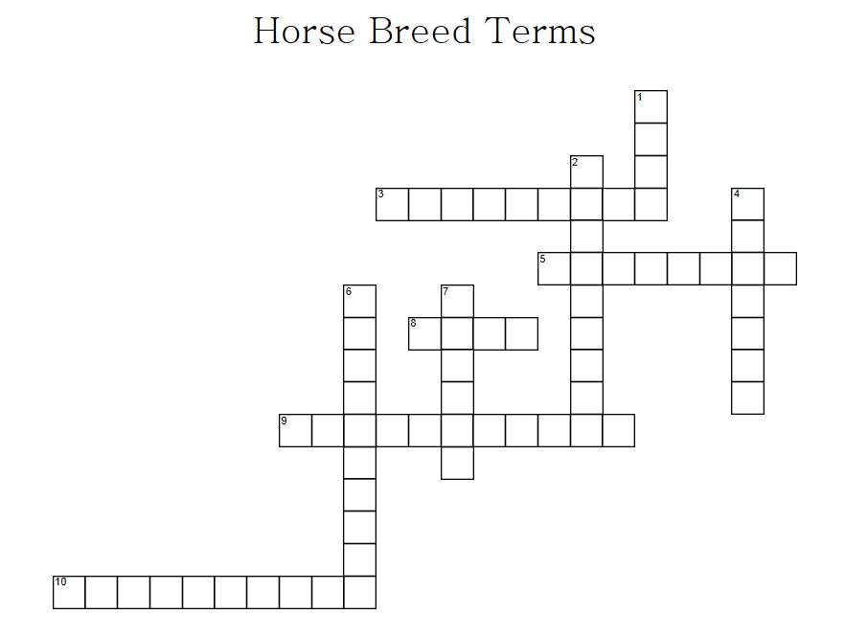
Estrus -_____________________________________________________________________
- Crossword Puzzle
ACROSS
 | 3 |  | A horse with purebred parents of different breeds
 | 5 |  | A written record of the ancestry of an animal
 | 8 |  | This type of horse is a mix of light and draft horse breeding.
 | 9 |  | An animal with draft horse breeding
 | 10 |  | A _______ animal is a horse whose parents are recorded and is itself recorded and the registration certificate has been issued
 | DOWN
 | 1 |  |  | A _____ book is a published record by breed registry associations for purebred horses, ponies or jacks
 | 2 |  |  | Characteristics commonly accepted as ideal for a particular breed
 | 4 |  |  | Owner of the dam at the time of breeding.
 | 6 |  |  | A horse with eastern or oriental blood
 | 7 |  |  | A group of animals within a breed, all of which trace directly to a common ancestor

