- Shoeing True or False

T F Putting shoes on a horse is always best for them.

T F If your horse is stabled then you should have their feet picked out every day.

T F Thrush is the most common hoof disease.

T F Shoeing helps minimize shock to a horse’s ligaments and tendons.

T F When shoeing a horse, the hoof should be shaped to fit the shoe.

- Parts of the Leg and Hoof
Match the number on the hoof structure with the appropriate name of the part.

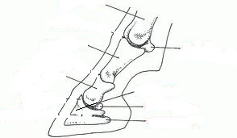

- Horse Behavior- Health or Not Healthy?
Answer the following questions about how to tell if the way your horse is behaving means they might be sick.

What are 10 warning signs that your horse may be sick?

__________________ __________________
__________________ __________________
__________________ __________________
__________________ __________________
__________________ __________________

A mature horse that is sick may have a heart rate as high as _____________ for prolonged periods of time during the illness.

What should you do if your horse looks or sounds like it is having difficulty breathing for no apparent reason? __________________________________________________________
________________________________________________________________________

If your horse is unable to defecate this may be a sign of what two health problems?
_______________ _______________

- What do the ears tell you?
Please put the type of behavior the horse is showing based on the ears of the horse in the pictures below.
 __________ __________  

