PURDUE EXTENSION BOONE COUNTY

4-H Rabbit WORKSHEETS
Grade 11-A
Name: Grade: __________
4-H Club: Date:

Write the correct skeletal part for each number.

1. ___________________
2. ___________________
3. ___________________
4. ___________________
5. ___________________
6. ___________________
7. ___________________
8. ___________________
9. ___________________
10.___________________
11.___________________
12.___________________
13. ___________________
14.___________________
15.___________________
16.___________________
17.___________________
18.___________________
19.___________________
20.___________________
21.___________________
22.___________________
23.___________________

Rabbit Health
Place the letter of the correct description or symptom for each illness.
___Abscesses | A The predisposition may be inherited.
___Coccidiosis | B Microsporum and Trichophyton
___Ear Canker | C Head severely twisted to one side.
___Enterotoxemia | D Staphylococcus aureus or Pasteurella multocida
___Malocclusion | E Common reproductive disease.
___Mange | F Internal parasites found in the cecum.
___Mastitis | G Myxoma virus
___Myxomatosis | H Swollen mammary glands, elevated temperature.
___Pinworms | I Cheyletiella parasitivorax and Listrophorus gibbus
___Pneumonia | J Invades the respiratory or digestive track. Deadly.
___Rabbit Syphilis | K Intestinal disorder caused by protozoan parasites.
___Ringworm | L Matting of the fur on the inside of the front paws.
___Snuffles | M Pasteurella multocida
___Sore Hocks | N A disorder where the teeth continue to grow.
___Viral Hemorrhagic Disease | O Pasteurella multocida
___Weepy Eye | P Often deadly in four- to eight-week-old fryers.
___Wry Neck | Q Psoroptes cuniculi

Fill in the blank.
Rabbit urine commonly has a ____________ pigment, and unless blood is seen, is not cause for alarm. Rabbit ____________ frequently contains large amounts of calcium ____________ or ____________ carbonate. This coloration is especially noticeable when the urine is ____________, usually due to the type of feed eaten.
Molting is the process of growing new ____________. Various molts are associated with the rabbit’s age, and are affected by ____________, ____________, ____________, and ____________. The first molt occurs at about ____________months of age and lasts until the rabbit is four to six ____________ old. ____________is extremely important in the diet at this time as the incidence of ____________ become greater.
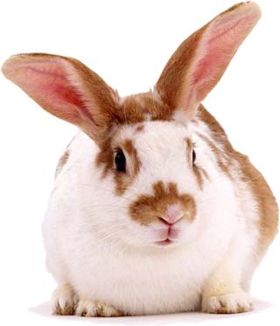
The rabbit’s nails should be trimmed with a pair of ____________clippers designed for use on ____________. Before you trim the toenails, first find the ____________. Do not panic if you accidentally cut into the quick. Put some ____________powder on the end of a ____________cotton swab and press it firmly against the____________. You can also use ____________ or powdered ____________.

