PURDUE EXTENSION BOONE COUNTY

4-H Rabbit WORKSHEETS
Grade 3-A
Name: Grade: __________
4-H Club: Date:

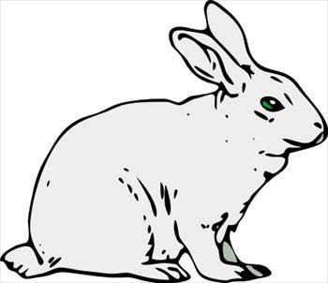
- Fill in the blanks with the correct body part.

- Fur Types: Put the correct letter of fur type in the description blank .
A Rollback B Flyback C Standing D Normal
___ This type of fur simply stands erect and has no return as it is stroked.
___ This fur is the most common. It exists as rollback, flyback, or standing in the breed standards.
___ This fur returns gently to its original position when the fur is stroked from tail to head.
___ This fur snaps back quickly into its original position when stroked forward.
- Tell us about your rabbit? How many rabbits do you have? _____
What are the breeds of your rabbits? ______________________________
____________________________________________________________
Handling Your Rabbit –True or False.

________ You should wear short sleeves when handling your rabbit so
the toe nails won’t get caught.

________ You can lift or carry your rabbit by the ears.

________ Do not hold the rabbit firmly against your body. It will get too
hot.

________ Put the rabbit back into the hutch head first.
________ You can injure your rabbit if you take it from the cage wrong.

________ Don’t tuck their head under your arm. They like to see
where they are going.

________ Remove a rabbit head first from the hutch.

________ You need to watch to make sure you do not catch the rabbit’s
toe or toenails on the wire.

________ You do not have to be gentle with your rabbit. They like a
rough time.

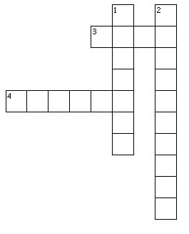
Do the crossword puzzle using the following words: feeder, nestingbox, waterer, cage.
Down
1. You will give your rabbit water in this.
2. You will put your rabbit in this to
nest.

Across
3. You will keep your rabbit in this.

4. You will give your rabbit food in this.

