PURDUE EXTENSION BOONE COUNTY

4-H Rabbit WORKSHEETS
Grade 4-A
Name: Grade: __________
4-H Club: Date:

Match the vocabulary word to the definition:

Wry Tail | A pet name for a rabbit.
Nest Box | The permanent identification mark of a rabbit which is placed in the left ear. The A.R.B.A. number goes in the right ear.
Bunny | An abnormally bent, curled, or twisted tail. Permanently held to one side. A disqualification for a rabbit.
Tattoo | A box inside or attached outside the hutch or cage where the kits are born. Normally placed with the doe 28 days after she is bred.

Circle the nutrients that are good for rabbits from the list below:

Carbohydrates | Fats | Hamburger
Minerals | Pizza | Protein
Soda Pop | Vitamins | Water

Questions to answer about your project. If you have more than one rabbit choose one of them to answer the questions about.

1. How old is your rabbit?

2. What sex is your rabbit?

3. What variety is your rabbit?

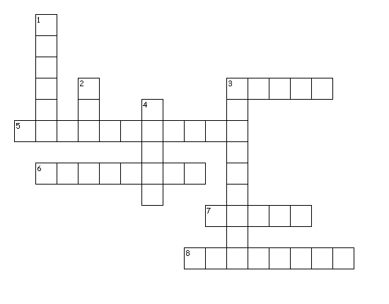
Rabbit Breeds

Word Bank
TAN
SATIN
RHINELANDER POLISH PALOMINO HOTOT HARLEQUIN
DUTCH CINNAMON

Across
3. Large breed with frosty white fur with the exception of the eyebands which are deep black.
5. This medium breed originated in Germany. The white coat has black and bright golden-orange markings.
6. Large breed with good meat and fur qualities. The varieties are golden and lynx.
7. Small breed from Holland is used for exhibition, pets, and in the laboratory.
8. Its coat color is cinnamon or rust with a uniform gray thickening across the back.

Down
1. This small breed has an unknown origin although the name would let you think they are from Poland.
2. This small breed has a full-arch profile. The tan color is uniform and unbroken from the chin, over the chest and belly, and to the tail.
3. Medium breed that originated in France. Japanese varieties are orange or golden fawn.
4. This large breed originated in the United States. The fur should be fine, silky and very dense to the touch.

