PURDUE EXTENSION BOONE COUNTY

4-H Rabbit WORKSHEETS
Grade 6-A
Name: Grade: __________
4-H Club: Date:

Rabbit Tattoos
True or False?
_____ Wrap the rabbit in a towel with the ears showing to do the tattoo.
_____ You can use any kind of needles to do a tattoo.
_____ Disinfect the pliers, letters and numbers before tattooing another animal.
_____ Tattoo a piece of cardboard or paper first to make sure it says what you want it to.
_____ Clean the rabbit’s ear with a cotton swab soaked in soap and water.
_____ Rub tattoo ink into the puncture holes with your finger.
_____ Carefully tattoo the right ear with the tattoo pliers.

Fill in the blanks with the breed type that best fits the description. Choose breeds from the list provided.

1. ___________________ This small breed, originating in Holland, is very popular for its fur and for exhibition. The ears are rather short, carried erect, close together, and firm at the base.
WORD BANK
Havana
Himalayan
Silver Fox
New Zealand
Lilac
2. ___________________ This medium breed originated in Cambridge, England. It is named for the color of its fur.

3. ___________________ The name would not make you think it originated in the United States. It is a large breed and is an excellent meat rabbit.

4. ___________________ This breed would make you think of a different kind of animal. It is a large breed with good meat and fur qualities. It has a dark slate undercoat.

5. __________________ This small breed originated in the Far East and is one of the oldest breeds of rabbits. It is very docile and used for exhibition, laboratory work and as pets.

Rabbit Nutrition
Complete the crossword puzzle.
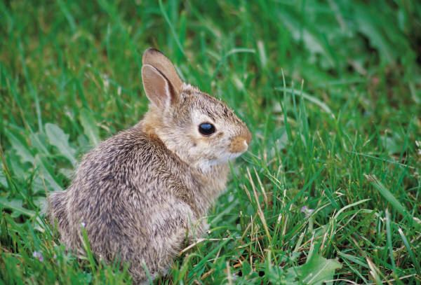
Across
5. There are macro and micro types of these.

6. A major component of animal tissue.

Down
1. Most are contained in commercial rabbit feed and go by names such as A, D and K.

2. They should have as much of this as they would like.

3. A source of energy that helps promotes a shiny coat.

4. Starch and cellulose are two types of this.

Reproduction
Fill in the blanks.
1. Rabbit gestation (pregnancy period) is _____ to _____ days.

2. The nest box should be put in the doe’s hutch about _____ days after the doe has
mated.

3. Baby rabbits are called ___________.

4. Female adult rabbits are called __________.

5. During ___________a doe may be thirstier than usual. She should be given all the
water she wants.

6. The birthing process in rabbits is called _________________.

7. Kits are born __________________ fur.

8. The doe will pull out her ________ to keep the kits warm.

