PURDUE EXTENSION BOONE COUNTY

4-H Rabbit WORKSHEETS
Grade 7-A
Name: Grade: __________
4-H Club: Date:

Processing of Rabbits
True or False
1. __________Selling fryers already processed rather than by live weight may be more profitable.
2. __________The USDA has jurisdiction over the shipment of rabbit meat in interstate commerce.
3. __________You need two buckets of water to dress a rabbit: one with soapy water, the other with cold rinse
water.
4. __________To dislocate the neck, in one quick motion press down with your thumb and raise the animal’s
head.
5. __________Don’t eat the heart, liver or kidney of a rabbit.
6. __________Refrigerate the carcass for 24 hours prior to cutting into usable cuts.

Disease Prevention
Check the tips to prevent diseases in your rabbits.
1. _____ Buy stock that appears healthy from breeders with good reputations and healthy herds.
2. _____ Let your rabbit out of the pen to feed on lawn grass often.
3. _____ Provide plenty of clean, fresh water.
4. _____ Check your rabbits each day. Check closely for ear canker.
5. _____ Give your rabbit special treats of lettuce and nuts.
6. _____ Immediately isolate any animal that appears abnormal and keep it isolated until you identify the
problem and correct it.
7. _____ Wash up thoroughly after completing your rabbit chores.
8. _____ Invite your friends to come and play with the rabbits.

Mineral Functions
______________________ | Assists with transfer of nutrient to the cells and removal of waste materials. Important in making bile.
______________________ | Component of several enzyme systems.
______________________ | Constituent of Vitamin B-12.
______________________ | Enables blood to carry oxygen.
______________________ | Essential for development of normal bones and teeth.
______________________ | Essential for nerve function, and appetite.
______________________ | For proper function of mammary glands and normal reproduction.
______________________ | Necessary for enzyme activation.
______________________ | Necessary for functioning of the nervous system.
______________________ | Necessary for hemoglobin formation.
______________________ | Needed for thyroxin production.
Select the word from the Word Bank that matches the definition.
WORD BANK
Calcium
Colbalt
Copper
Iodine
Iron
Magnesium
Manganese
Phoshorus
Potassium
Salt
Zinc

BITS AND PIECES
Complete the crossword puzzle.
Across
3. Fur mites live in the fur causing hair loss.
6. Intestinal disorder resulting in diarrhea.
7. Occurs when certain intestinal bacteria grow and produce a toxin.
8. turn or bend inward, causing the toes to turn outward.

Down
1. Disqualification if it is twisted more than one turn.
2. Advanced form of this disease can cause blocked tear ducks.
4. A hard swelling or isolated collection of pus or purulent matter occurring in the rabbit's skin.
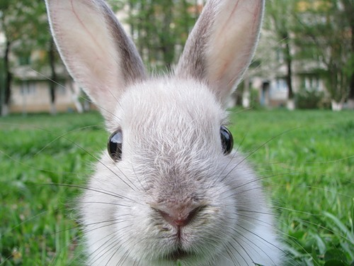
5. This condition prevents normal eating.

