Cass County

4-H Lama Project Record Book
Advanced (Grades 9-12)

General Guidelines:
Each 4-her should complete two (2) of the activities included in this record book. You may not repeat activities. In addition, for each year you are enrolled in the Lama project, complete the feed and financial report included in this record book. Use your 4-H Lama Manual as a resource.

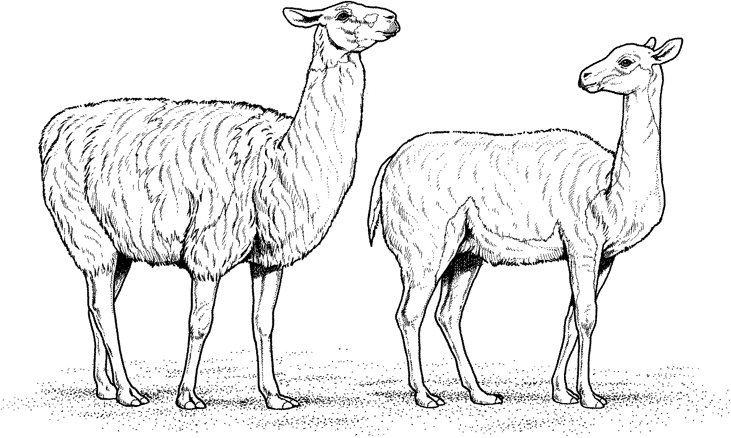

Name:

Club:

Grade 9: Leader Signature Date

Grade 10: Leader Signature Date
Grade 11: Leader Signature Date

Grade 12: Leader Signature Date

Purdue University is an equal access/equal opportunity institution.

Adopted January 2012
Updated August 2025

ACTIVITY 1 – GENERAL HEALTH AND MAINTENANCE
What is the best way to detect if a lama is or is not healthy?

Define the word stoic.

How might stoicism apply to a lama?

List four (4) types of preventative medicines a lama owner should use to help keep a lama healthy.

1.
2.

3.

4.

With good care, a lama may live _____years.
A lama may have crias for years.
What are three (3) things llamas and alpacas need to be vaccinated for?

ACTIVITY 2 – BODY PARTS AND THEIR FUNCTION
Define the function of the following parts of a lama.

- lungs
- heart

- cud/stomach
How can a lama owner tell if a lama needs its toenails trimmed?

How old are lamas when they grow their fighting teeth?

How many fighting teeth do male lamas grow, and where are they?

What is the best way to get rid of fighting teeth?

ACTIVITY 3 – STRESS
What is the normal temperature of an adult lama, and how do you check it?

How does a lama trainer prevent heat stress?

What are three (3) signs of heat stress?

List three (3) ways to help a lama experiencing heat stress.

List six (6) ways to decrease stress on a lama while showing the animal.

ACTIVITY 4 – EXTERNAL LAMA DIAGRAM
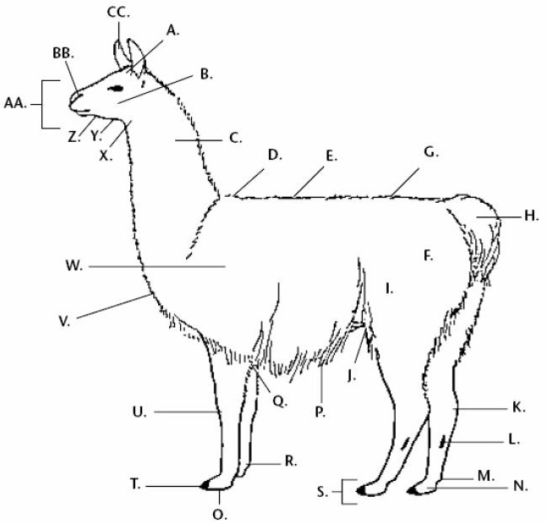
Identify the following body parts on the above external lama diagram.

Pastern Joint | Chin | Toenail
Poll | Throat | Ear
Tail | Chest | Muzzle
Withers | Thigh | Pad
Fetlock Joint | Cannon Bone | Stifle Joint
Neck | Abdomen (Belly) | Jaw
Chestnut (Scent Gland) | Back | Hip
Croup | Knees (Carpus) | Shoulder
Nostril | Cheek | Foot
Hock Joint | Elbow Joint

ACTIVITY 5 – CONFORMATION AND STRUCTURE
- What is conformation?

- What is meant by a “structurally sound” animal?

- If you plan on using your lama for packing, what might you consider when selecting and buying your lama?

- Describe what a lama looks like if it is:

Sickle-hocked:

Cow-hocked:

Knock-kneed:

ACTIVITY 6 – BODY PARTS DIAGRAM PUZZLE

Across Down
6. A 1.
7. B 2.
10. C 3.
12. D 4.
14. E 5.
16. F 8.
19. G 9. X
20. H 11.
21. I 13.
22. 14.
23. 24.
25. 26.
27. 28.
29.
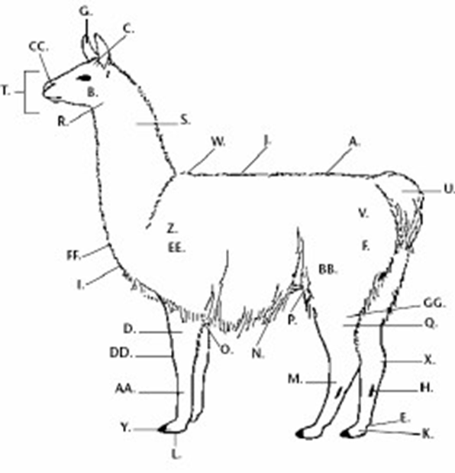
30.
Word List

Abdomen Knee
Back Pad
Cheek Pastern
Chest Pelvis
Croup Poll
Ear Radius
Elbow Scapula
Femur Scent Gland
Shoulder Stifle
Fetlock Tail
Sternum Thigh
Front Cannon Throat
Gaskin Tibia
Hind Cannon Toe
Hock

31.
32.

ACTIVITY 7 – PACKING

How does a trainer know how much weight a lama can pack?

What is a good first step when getting ready to train your lama to pack?

How can a trainer help a lama keep its balance while packing?

List the benefits of using lamas as packers.


ACTIVITY 8 – CROSSWORD PUZZLE

WORD LIST:
ALPACA PERU
ANDES
PREHENSILE
CAMELID RUMINANT
CLOVEN SCENT
GLAND
CONFORMATION SOUTH AMERICA DESENSITIZE SPIT DOMESTIC STIFLE
FEMALE STOIC
FIGHTING STOMACH
GELDING TWO
GUANACO UNDERCOAT GUARD HAIR
VACCINATION

ACROSS CLUES
2. The way a llama says “Bug Off”.
4. Animals that chew cud.
- The word that describes what a llama does when it
carries a load.
- A word that describes animals that do not show signs if they are not feeling well.
- Any animal that has been developed to help man.
- The camelid from which llamas originated.
- A person you should know and who you can call if a llama is sick.
- The of a llama tears off the grass with the lower teeth and is called prehensile.
- Looking at a llama, the way a llama is put together.
14. Kind of teeth that should be removed from a male llama.
- Approximately, how long is a llama’s gestation?
- Stiffer, more course part of llama wool.
- Mountain region where llamas originate.
- Continent from which llamas originate.
- Llamas are members of this family.
- Word that describes helping a llama to be comfortable with being touched on legs, head, etc.
- Dry spot on lower leg that is non-functioning.
- On the back legs, a joint area that gets dirty easily and is often worn.
29. A boy llama.
LIP

VETERINARIAN

DOWN CLUES
1. Smaller South American camelid.
3. Number of toes on each foot.
5. Part of wool that is fine and primarily used for spinning.
7. A llama has three compartments in this.
- Name of a male llama that has been neutered.
- Shots given to animals to prevent sickness.
- Base of neck near the back.
- Name the country in South America where llamas have been domesticated.
- Kind of upper lip that a llama has.
- The bottom of a llama’s foot.
20. Animal from the camelid family that is short and used primarily for wool.
22. The kind of foot that has two toes.
23. A girl llama.

ACTIVITY 9 – DIET

A lama consumes % of its total body weight of food per day. How much feed does your lama require per day?
What are the three (3) main parts of a lama’s diet?
1.

2.
3.

What mineral should be provided for all lamas at all times?

What is the term for an animal with many compartments in its stomach?

What should be done to prevent problems when changing a lama’s diet?

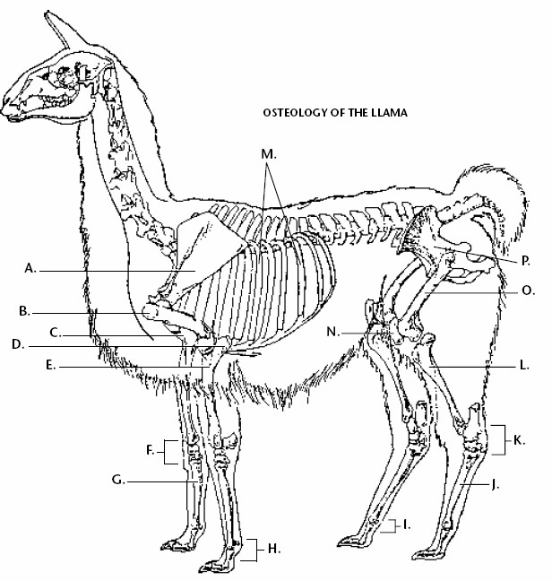
ACTIVITY 10 – INTERNAL LAMA DIAGRAM
Osteology of the Lama

Identify the following bones on the above internal lama diagram.

Carpus Scapula Knee
Ribs Hock Joint Cannon
Humerus Tibia Elbow Joint
Pelvis Stifle Joint
Radius Sternum
Front Fetlock Femur
Joint Back Fetlock Joint

ACTIVITY 11 – REPRODUCTION

- What type of ovulators are lamas?

- How long does a female lama carry the cria (gestation period)?
- Name three (3) ways to test for pregnancy.
a.

b.
c.

- Why is it important to keep detailed record on your lamas?

- Briefly describe the three (3) stages of labor.
Stage One

Stage Two

Stage Three

- What is a baby lama called?

ACTIVITY 12 – FACILITIES AND EQUIPMENT

- What type of housing is best for a lama in Indiana?

- Explain the importance of each type of equipment.
Chute

Scales

Toenail Clippers

Blower

Shears

ACTIVITY 13 – SHOWING

- How would you properly give a lama a bath?

- What are ethics?

- How do you square a lama in the show ring?

- What is the phrase you should remember about quartering when showing?

- In showmanship and halter classes you should stand at a degree angle with your toes facing the lama’s .
- What does a ring steward do?

RECORD SUMMARY
Grade 12

EXPENSES OF 4-H LAMA PROJECT | COSTS
Cost of Animal(s) or Lease expense
Feed Costs
Vet/Medical Fees
Bedding Fees
Manure Handling
Transportation Fees
Show Equipment Costs
Fencing & Housing/Building Costs
Interest on Money to buy lama (if any)
Other
TOTAL EXPENSES
FEED RECORD
Number of days animals were fed
Total Pounds of feed fed to animals
Total Costs of feed
LABOR
Number of hours per week spent on 4-H Lama
project. (This includes feeding, grooming, general care, exercising and getting ready for fair.)
Total hours spent on 4-H Lama project from
beginning of project until the fair.

RECORD SUMMARY
Grade 11

EXPENSES OF 4-H LAMA PROJECT COSTS
Cost of Animal(s) or Lease expense Feed Costs
Vet/Medical Fees
Bedding Fees
Manure Handling
Transportation Fees
Show Equipment Costs Fencing & Housing/Building Costs Interest on Money to buy lama (if any) Other

TOTAL EXPENSES

FEED RECORD
Number of days animals were fed Total Pounds of feed fed to animals Total Costs of feed

LABOR

Number of hours per week spent on 4-H Lama project. (This includes feeding, grooming, general care, exercising and getting ready for fair.)
Total hours spent on 4-H Lama project from beginning of project until the fair.

RECORD SUMMARY
Grade 10

EXPENSES OF 4-H LAMA PROJECT COSTS
Cost of Animal(s) or Lease expense Feed Costs
Vet/Medical Fees
Bedding Fees
Manure Handling
Transportation Fees
Show Equipment Costs Fencing & Housing/Building Costs Interest on Money to buy lama (if any) Other

TOTAL EXPENSES

FEED RECORD
Number of days animals were fed Total Pounds of feed fed to animals Total Costs of feed

LABOR

Number of hours per week spent on 4-H Lama project. (This includes feeding, grooming, general care, exercising and getting ready for fair.)
Total hours spent on 4-H Lama project from beginning of project until the fair.

RECORD SUMMARY
Grade 9

EXPENSES OF 4-H LAMA PROJECT COSTS
Cost of Animal(s) or Lease expense Feed Costs
Vet/Medical Fees
Bedding Fees
Manure Handling
Transportation Fees
Show Equipment Costs Fencing & Housing/Building Costs Interest on Money to buy lama (if any) Other

TOTAL EXPENSES

FEED RECORD
Number of days animals were fed Total Pounds of feed fed to animals Total Costs of feed

LABOR

Number of hours per week spent on 4-H Lama project. (This includes feeding, grooming, general care, exercising and getting ready for fair.)
Total hours spent on 4-H Lama project from beginning of project until the fair.

