Cass County

4-H Lama Project Record Book
Intermediate (Grades 6-8)

Each 4-her should complete two (2) of the activities included in this record book. You may not repeat activities. In addition, for each year you are enrolled in the Lama project, complete the feed and financial report included in this record book. Use your 4-H Lama Manual as a resource.


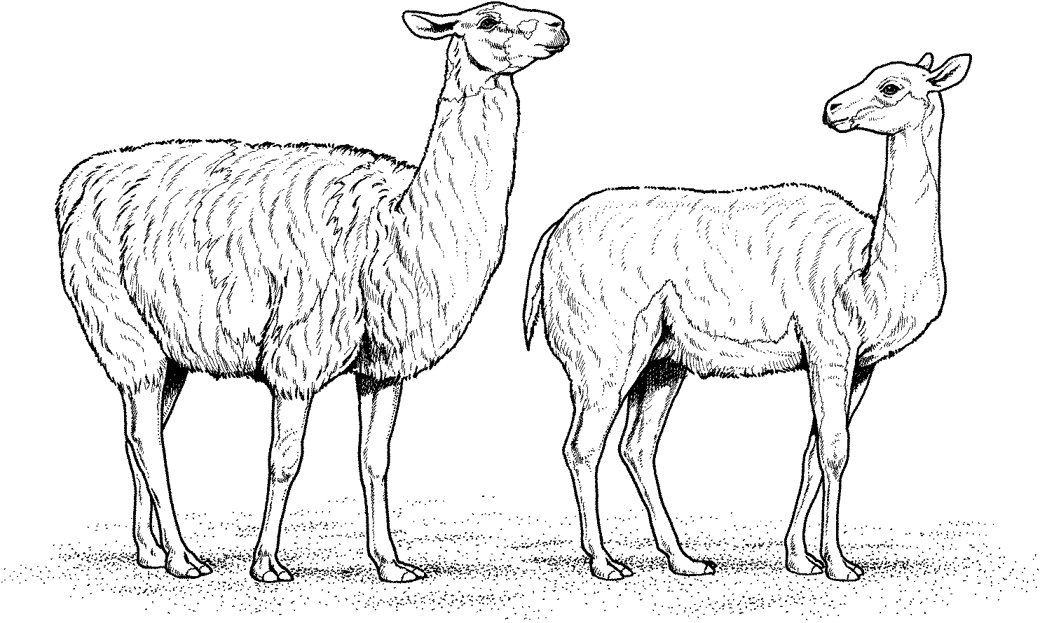

Name:

Club:

Grade 6: Leader Signature Date

Grade 7: Leader Signature Date
Grade 8: Leader Signature Date

Purdue University is an equal access/equal opportunity institution.

Adopted January 2012
Updated August 2025

ACTIVITY 1 – HISTORY AND BACKGROUND
Name four (4) members of the South American Camelid family in order, smallest to largest.

1.

2.

3.

4.

State four (4) reasons why lamas have become popular in the United States.
1.

2.

3.

4.

Baby lamas are called
Which of the South American camelids are domestic?

Which of the South American camelids are wild?

What group of people is given credit for domesticating the llama and alpaca?

ACTIVITY 2 – EQUIPMENT
Why is it not acceptable for the trainer to wrap a lama’s lead rope around his / her hand? Explain your answer -

Name two (2) styles of halters and the differences in each style.

1.

2.

Explain why you should not hold onto the snap when your lama is on lead.

ACTIVITY 3 – PARTS OF A LAMA
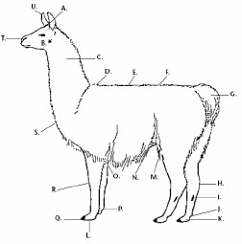
Elbow Joint
U
A
T
B
G
S
O
H
R
I
Q
L
D
C
J
K
P
N M
F
E
Poll
Cheek
Ear
Stifle joint
Back
Tail
Pad
Pastern joint
Back fetlock joint
Hock joint
Croup
Abdomen (belly)
Nostril
Front fetlock joint
Toenail
Chestnut (scent gland)
Knees (carpus)
Withers
Sternum (breastbone)
Neck

ACTIVITY 4 – GENERAL HEALTH AND MAINTENANCE
List two (2) types of preventative medicine a lama owner should use to help keep a lama healthy.

1.
2.

VACCINATIONS
What are two (2) things lamas and alpacas should be vaccinated for?
1.

2.

PARASITES
List three (3) ways internal parasites can affect a lama.

1.
2.
3.

List two (2) types of external parasites.

1.

2.

TEETH AND FEET
When is a lama more likely to need its toenails trimmed?

What is the purpose of fighting fangs, and who gets them?

ACTIVITY 5 – CROSSWORD PUZZLE

Word List

Alpaca
Andes
Camelid
Cria
Domestic
Female
Fighting
Gelding
Guanaco
Guard Hair
Hum
Male
Pack
Practice
Ruminant
South America
Spit
Stomach
Two
Undercoat
Veterinarian
Vicuna
Year

Across Clues

4. A baby lama
5. A neutered lama
6. A girl lama
7. A camelid that is short and primarily used for its wool.
9. Lamas are members of this family
11. How many toes on each foot does a lama have?
14. A person you should know to call if a lama is sick
16. Stiffer, more coarse part of the wool.
17. Animals that chew cud.
18. How long is a lama’s average gestation period?
19. What sound does a lama make?
20. These kinds of teeth should be cut out of a male lama.
21. The mountain range where llamas originated in South America

22. Much of this will help a lama feel comfortable in the show ring. “________ makes perfect.”

Down Clues
- A word to describe what a lama is doing when it carries a load.
- A smaller South American wild camelid.
- A boy lama.
5. The camelid from which the llama was domesticated.
8. The continent from which the lama originated.
10. Any animal that has been developed to help man.
12. The part of the wool that is fine and primarily used for spinning.
13. A lama has three compartments in it’s _______.
15. The way a lama says, “Bug Off”.

ACTIVITY 6 – PROCEDURE
What should you tell your llama to get it to stand still?

Should you move fast or slow around the llama to gain the trust of the llama?

Where should the noseband of the halter lie on the llama’s face?

What are two (2) main things to remember when training your lama?
1.

2.
How far away from the halter should you hold the lead rope? Name two (2) different ways to get a lama to move when it doesn’t want to.
1.
2.
What is desensitizing?

ACTIVITY 7 – WOOL
In halter classes, lamas are grouped by the length of their .

Describe each wool type.
Heavy

Medium
Light

What two (2) basic types of fiber comprise of a lama’s coat?
1.

2.
Name four (4) colors of lama wool.

1.

2.

3.
4.

RECORD SUMMARY
Grade 8

EXPENSES OF 4-H LAMA PROJECT | COSTS
Cost of Animal(s) or Lease expense
Feed Costs
Vet/Medical Fees
Bedding Fees
Manure Handling
Transportation Fees
Show Equipment Costs
Fencing & Housing/Building Costs
Interest on the money to buy a lama (if any)
Other
TOTAL EXPENSES
FEED RECORD
Number of days animals were fed.

Total Pounds of feed fed to animals.

Total Costs of feed
LABOR
The number of hours per week spent on the
4-H Lama project.
(This includes feeding, grooming, and general care,
exercising and getting ready for the fair.)

Total hours spent on the 4-H Lama project from the beginning of the project until the fair.

RECORD SUMMARY
Grade 7

EXPENSES OF 4-H LAMA PROJECT COSTS
Cost of Animal(s) or Lease expense Feed Costs
Vet/Medical Fees
Bedding Fees
Manure Handling
Transportation Fees
Show Equipment Costs Fencing & Housing/Building Costs Interest on the money to buy lama (if any) Other

TOTAL EXPENSES

FEED RECORD
Number of days animals were fed Total Pounds of feed fed to animals Total Costs of feed.

LABOR
Number of hours per week spent on the 4-H Lama project. (This includes feeding, grooming, and general care, exercising, and getting ready for the fair.)

Total hours spent on the 4-H Lama project from the beginning of the project until the fair.

RECORD SUMMARY
Grade 6

EXPENSES OF 4-H LAMA PROJECT COSTS
Cost of Animal(s) or Lease expense Feed Costs
Vet/Medical Fees
Bedding Fees
Manure Handling
Transportation Fees
Show Equipment Costs Fencing & Housing/Building Costs Interest on Money to buy lama (if any) Other

TOTAL EXPENSES

FEED RECORD
Number of days animals were fed Total Pounds of feed fed to animals Total Costs of feed.

LABOR
Number of hours per week spent on the 4-H Lama project. (This includes feeding, grooming, and general care, exercising and getting ready for the fair.)

Total hours spent on the 4-H Lama project from the beginning of the project until the fair.

