CASS COUNTY
BEEF
MINI 4-H

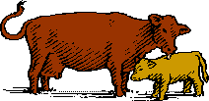

Name _________________________________ Year 20_______
Club _________________________________________________

It is the policy of the Purdue University Cooperative Extension Service that all persons have equal opportunity and access to its educational programs, services, activities, and facilities without regard to race, religion, color, sex, age, national origin or ancestry, marital status, parental status, sexual orientation, disability or status as a veteran. Purdue University is an Affirmative Action institution. This material may be available in alternative formats.

Revised 1-2024

MINI 4-H BEEF
GENERAL MINI 4-H RULES:
- You must be in the 1st or 2nd grade at the time you sign up for this project.

- You must enroll in the Mini 4-H Beef project.

- Complete the Mini 4-H Beef enrollment form by May 15th. (This will be sent to each member who enrolls in Mini 4-H Beef in April.)

- As you exhibit a Mini 4-H beef animal (that belongs to a regular 4-H member), you will receive a Mini 4-H ribbon.

- You are encouraged to attend 4-H club meetings and/or project workshops.

ACTIVITIES TO COMPLETE:

- You will need to work with an older 4-H Beef member who will be exhibiting 4-H Beef at the fair. You should help with the project at least three times before the fair.
- When talking to a 4-H’er enrolled in the 4-H Beef project, find out what is involved in caring for and showing Beef.
- Watch the 4-H Beef show at the fair this year.
COMPLETION GUIDELINES:

To complete your Mini 4-H Beef Project you must:

- Complete the attached record sheet and turn it in to the 4-H Beef Committee when the beef is checked in at the 4-H Fair.

- Exhibit a regular Cass County 4-H Club member's steer or heifer at the county 4-H Fair. (Optional)

- If you decide to make a poster (14” X 22”) in addition to or instead of showing an animal, it will be entered in the Mini 4-H Farm Animal project in the Community Center. This poster will need to be turned in on the Saturday designated in the 4-H Handbook from 7:30 - 9 a.m.
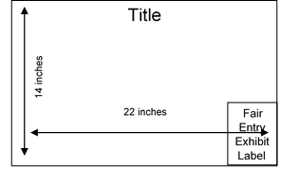
UMINI PROJECTS INVOLVING POSTERSU - 14" X 22" POSTERS SHOULD BE DISPLAYED HORIZONTALLY. IT IS A GOOD IDEA TO MOUNT YOUR POSTER ON PLYWOOD, FOAMBOARD, CARDBOARD, OR OTHER STURDY MATERIALS TO STIFFEN IT. POSTERS SHOULD ALSO BE COVERED WITH CLEAR PLASTIC TO PROTECT THEM. APROPRIDE-SIZED SLEEVES ARE AVAILABLE FROM THE EXTENSION OFFICE. LEAVE A 5” X 6” SPACE IN THE LOWER RIGHT-HAND CORNER FOR THE EXHIBIT CARD THE PURDUE EXTENSION STAFF WILL PROVIDE AT FAIR CHECK-IN.

PARTS OF THE BEEF ANIMAL
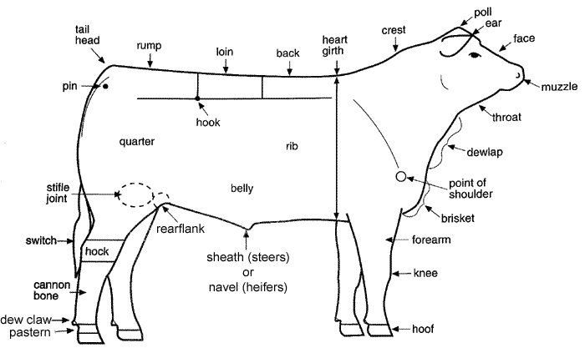

Cuts of Beef
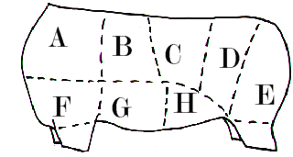

A. Chuck: Chuck Roast, Arm Roast, Ground Beef | E. Round: Round Steak
B. Rib: Rib Roast, Rib Eye Steak | F. Fore Shank & Brisket
C. Short Loin: T-bone, Tenderloin | G. Short Plate: Short Steak
D. Sirloin: Sirloin Steak | H. Flank: Flank Steak
Cattle Breeds

ANGUS – This breed originated in Scotland. These animals are polled with a black, smooth coat. They are known for their carcass quality and milking, mothering, and reproductive abilities.

CHAROLAIS – This breed was developed in France. They are mostly white to cream, or light white with reddish undertones on their skin, especially around the facial features, and on the belly. They are noted for their fast growth and lean meat.

CHIANINA – This breed was developed in Italy. These animals are white with black skin pigmentation. They are noted for their working, mothering, and beef producing abilities.

HEREFORD – This breed was developed in England. The coat of Herefords is primarily red with white on the face, throat, brisket, flanks and switch, and below the knee and hock. They are known for their foraging ability, vigor, hardiness, and quiet dispositions.

LIMOUSIN – This breed originated in the west-central part of France. They are solid-to golden-red in color with lighter circles around the eyes and muzzle.

MAINE-ANJOU – This breed originated in the northwestern part of France. The coloring is a very dark red with white markings on the head, belly, and rear legs and tail. The Maine-Anjou evolved as a dual-purpose breed, with the cows used for milk production and the bull calves fed for market.

POLLED HEREFORDS – This breed was developed in the United States from the Hereford breed. Except for the polled trait, these animals exhibit the same characteristics as the Hereford breed.

RED ANGUS – They possess the same qualities as the black angus. The only difference is that they are red in color.

SHORTHORN – This breed was brought to the United States from England. These animals can be red, white, or roan in color. They are used for their good disposition, mothering, and milking abilities.

SIMMENTAL – This breed was imported into the United States from Switzerland, France, and Germany. These animals have red to dark red, spotted bodies with white to lite straw faces. They are noted for their fast growth and milking abilities.

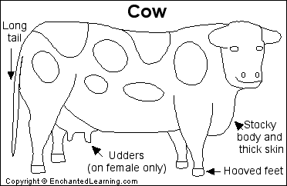

Names: Cows are often called cattle. The adult female is called a cow. The adult male is called a bull. A baby is called a calf.
Cattle are farm animals with thick skin and hoofed feet. Cattle were domesticated (tamed from wild animals) thousands of years ago. They are farmed for their milk, meat, hides (leather), and many other products, like cheese, cream, gelatin, glue, soap, and many other products. In some parts of the world, cattle are still used to pull plows and carts. There are still some wild cattle (like the Gaur and Banteng) living in Asia.
Anatomy: Cattle vary in color from white, black, brown to tan. Milk is produced in the female's udders. Cattle use their long tail to keep insects off their back. Some cattle have horns, others do not.
Diet: Cattle are herbivores (plant-eater) that graze on grass and leaves. They are ruminants, animals that have a four-part stomach. Cattle swallow their food without chewing it very much. They later regurgitate a cud and chew it well, later swallowing it.

MINI 4-H BEEF QUESTIONS

Name five breeds of Beef Cattle:
- _______________________________________________________
- _______________________________________________________
- _______________________________________________________
- _______________________________________________________
- _______________________________________________________
Name five wholesale cuts of Beef:
- _______________________________________________________
- _______________________________________________________
- _______________________________________________________
- _______________________________________________________
- _______________________________________________________
Label with correct parts.
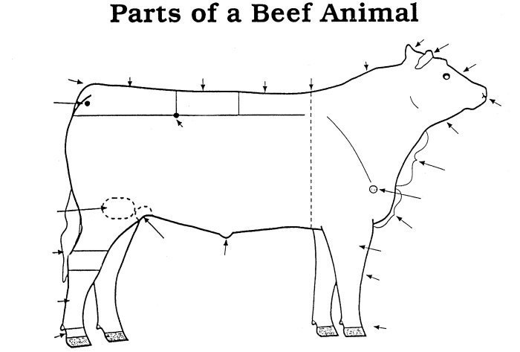

MINI 4-H BEEF RECORD SHEET

NAME________________________________________AGE______________

ADDRESS_______________________________________________________

SCHOOL______________________________________GRADE___________

TOWNSHIP__________________________PHONE_____________________

4-H MEMBER YOU WORKED WITH__________________________________

YOUR CALF'S NAME______________________________________________

YOUR CALF'S AGE AND WEIGHT___________________________________

WHAT DO YOU FEED YOUR CALF? _________________________________

_______________________________________________________________

WHAT DO YOU LIKE MOST ABOUT YOUR CALF? _____________________

_______________________________________________________________

_______________________________________________________________

DRAW A PICTURE OR ATTACH A PHOTO OF YOU AND YOUR CALF BELOW:

