CASS COUNTY
LLAMA and ALPACAS
MINI 4-H

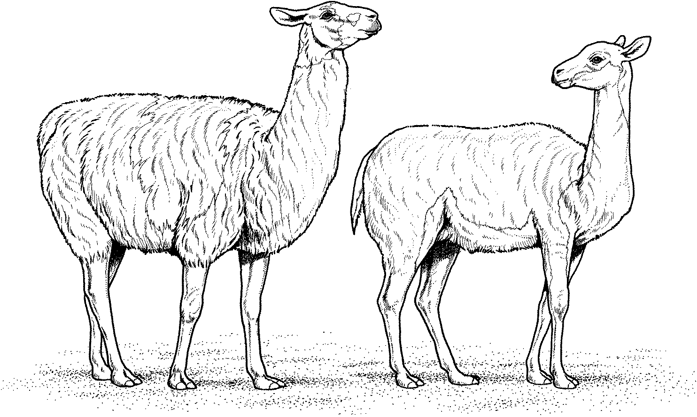

Name _________________________________ Year 20_______
Club _________________________________________________
It is the policy of the Purdue University Cooperative Extension Service that all persons have equal opportunity and access to its educational programs, services, activities, and facilities without regard to race, religion, color, sex, age, national origin or ancestry, marital status, parental status, sexual orientation, disability or status as a veteran. Purdue University is an Affirmative Action institution. This material may be available in alternative formats.

Adapted from Clinton County 4-H Llama Manual March 2008

Revised 01-2023
01-2024


4-H PLEDGE

I Pledge
My HEAD to clear thinking
(right hand point to forehead)



My HEART to greater loyalty
(right hand over heart)

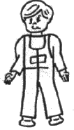

My HANDS to larger service
(arms slightly bent, palms up)



My HEALTH to better living
(arms at sides)

For My Club, My Community, My Country, and My World.
4-H MOTTO
"To Make the Best Better"

Welcome to the Mini 4-H Llama Project. This project is designed to introduce you to the world of llamas. You do not need to own llamas or live on a farm to take this project.
Suggested Activities
- Visit a llama farm.
- Talk to a 4-H’er enrolled in the llama project and find out what is involved in caring for and showing llamas.
- Watch the llama show at the fair this year.
- It is suggested to wear black pants and a white shirt for the show like 4-H members do in the Llama Showmanship Class.
General Mini 4-H Rules
- You must be in the 1st or 2nd grade at the time you sign up for this project.
- You must enroll in the Mini 4-H Llama project.
- Complete the Mini 4-H Llama enrollment form by May 15th. (This will be sent to each member who enrolls in Mini 4-H Llama in April.)
- As you exhibit a Mini 4-H llama animal (that belongs to a regular 4-H member), you will receive a Mini 4-H ribbon.
- You are encouraged to attend 4-H Club meetings and/or project workshops.
Completion Guidelines
- Complete the attached record sheets and turn them into the 4-H Llama Committee when the llamas are checked in at the 4-H Fair.
- Exhibit a regular Cass County 4-H Club member's llama at the county 4-H Fair. (Optional)
- If you decide to make a notebook and/or poster in addition to or instead of showing an animal, it will be entered in the Community Center. This notebook/poster will need to be turned in on the Saturday designated in the 4-H Handbook from 7:30-9 a.m. and contain the following:
- Pictures of equipment used with llamas
- Your completed record sheet signed by your leader. Attach to the back of a poster project.
- You may include any other things you would like if they relate to this project, i.e., pictures of you working with a llama.
- Title the notebook with “Mini 4-H Llamas” and have fun decorating the cover.
- Attend at least 2 workshops. (Optional, but highly recommended.)
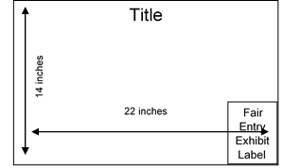
MINI PROJECTS INVOLVING POSTERS - 14"X 22" POSTERS SHOULD BE DISPLAYED HORIZONTALLY. IT IS A GOOD IDEA TO MOUNT YOUR POSTER ON PLYWOOD, FOAMBOARD, CARDBOARD, OR OTHER STURDY MATERIALS TO STIFFEN IT. POSTERS SHOULD ALSO BE COVERED WITH CLEAR PLASTIC TO PROTECT THEM. APROPRIDE-SIZED SLEEVES ARE AVAILABLE FROM THE EXTENSION OFFICE. LEAVE A 5” X 6” SPACE IN THE LOWER RIGHT-HAND CORNER FOR THE EXHIBIT CARD THE PURDUE EXTENSION STAFF WILL PROVIDE AT FAIR CHECK-IN.

U

Llamas

Llamas are South American members of the Camelid family. Llamas are used for pets, pack animals, sheep guards, entertainers, race companions, fiber producers, and cart pullers. Llamas are very intelligent and their calm disposition makes them a favorite with many people.
Llamas are usually three to four feet tall at the shoulder and weigh 250-400 pounds as adults. Llamas may live as long as 25 years. Most llamas are curious and very willing to work with people when it means they can enjoy doing new and different things.
Generally, spitting is used to communicate between llamas, to prove their importance in the herd or when they are hurt or upset. If a llama spits at a human, this may show that it doesn't like what is being done to it (for example, a shot). Although spitting is disgusting, it doesn't hurt and can easily be washed off. A herd-raised llama that has been treated with respect should do very little spitting at humans.
There are three types of llamas. These are "heavy-wooled," "medium-wooled," "light-wooled". All three come in a wide variety of colors.
Llamas need at least a three-sided shelter. They are clean, essentially odor-free (except for occasional bad breath), and tend to use a few select potty areas.
Llamas need fresh water to drink. They have three-compartment stomachs. Llama feed consists of hay and some straw. A com or com/oat mixture may be fed. A 300-pound llama will only eat three to six pounds of hay a day.
Llamas need shots against Clostridium C and D and Tetanus. They also need wormer. They occasionally have skin problems. You need to trim llama’s toenails. Hot weather can cause serious problems for llamas so they should be sheared.
A llama is pregnant about 11½ months. A baby llama is called a cria and will weigh between 18 and 35 pounds. Usually, it takes 10 or 15 minutes after birth before the baby can stand.
Llamas have to get used to being caught and wearing a halter. Then they learn to lead. You should never tie the lead rope around any part of your body or loop it around your hand or wrist. You should talk to your llama and tell it what to do with commands like "walk", "stand", or "stop". You also have to teach your llama to let you brush it. Llamas are sensitive on their backs, legs, stomachs, and hips.

Name the Llama Parts

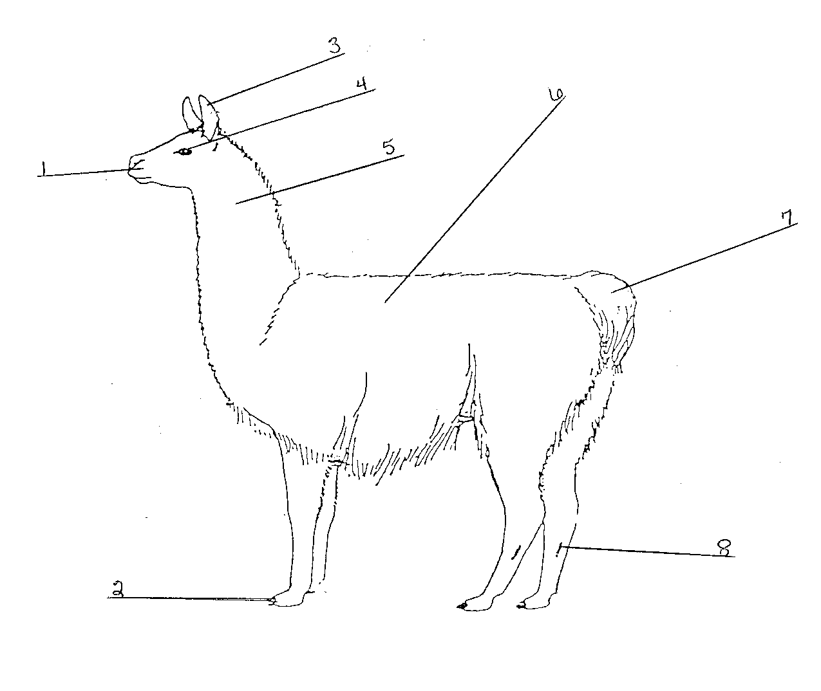

Neck Toenails Back
Ears Eye Tail
Scent Gland Muzzle

Color A Llama

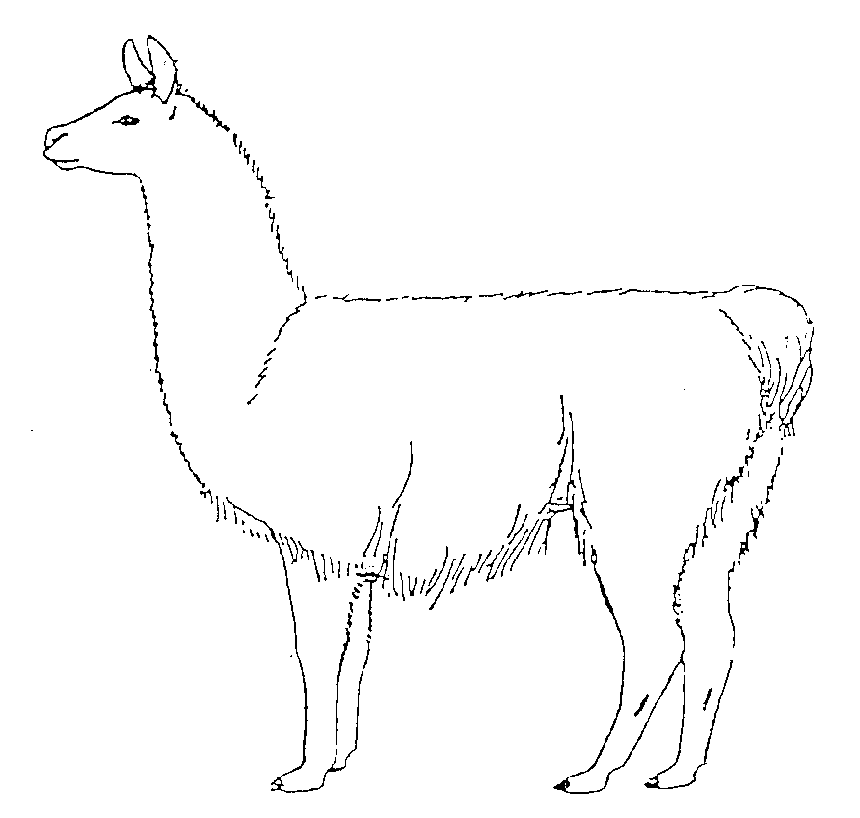
Color this llama like one you saw at your farm visit or in a book or magazine.
2. How long can a lllama live? _

3. Why does a lllama spit? _

4. Name the three types of lllamas.

5. What does a lllama eat?
--------------------~----

6. How long is a lllama pregnant? _

7. What is a baby lllama called? _

8. How much does a baby lllama weigh? _

9. How much does an adult lllama weigh? _

10. How much hay does a grown lllama eat a day? _ I have received this record sheet and found it to be correct.

Mini 4-H Llama Record Sheet

Name _____________________________________________________ Grade___________

Club ______________________________________________________ Year 20__________
Answer the following questions about your Mini llama project:
- Name two things a llama is used for.
              - ________________________________________________________________
              - ________________________________________________________________
- How long can a llama live? __________________________________________________
- Why does a llama spit? _____________________________________________________
- Name the three types of llamas.
              - ________________________________________________________________
              - ________________________________________________________________
              - ________________________________________________________________
- What does a llama eat? _____________________________________________________
- How long is a llama pregnant? _______________________________________________
- What is a baby llama called? _________________________________________________
- How much does a baby llama weigh? __________________________________________
- How much does an adult llama weigh? _________________________________________
- How much hay does a grown llama eat a day? ___________________________________
I have received this record sheet and found it to be correct.

Leaders Signature _________________________________________ Date ______________

Mini 4-H Llama Record Sheet

Name _____________________________________________________ Grade___________

Club ______________________________________________________ Year 20__________
Answer the following questions about your Mini llama project:
- Name two things a llama is used for.
              - ________________________________________________________________
              - ________________________________________________________________
- How long can a llama live? ________________________________________________
- Why does a llama spit? ___________________________________________________
- Name the three types of llamas.
              - ________________________________________________________________
              - ________________________________________________________________
              - ________________________________________________________________
- What does a llama eat? __________________________________________________
- How long is a llama pregnant? _____________________________________________
- What is a baby llama called? ______________________________________________
- How much does a baby llama weigh? _______________________________________
- How much does an adult llama weigh? ______________________________________
- How much hay does a grown llama eat a day? ________________________________
I have received this record sheet and found it to be correct.

Leaders Signature _________________________________________ Date ______________

