CASS COUNTY
POULTRY
MINI 4-H

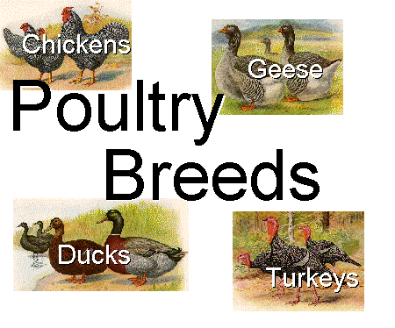
Exhibits

Name ______________________________ Year 20_______
Club ______________________________________________

It is the policy of the Purdue University Cooperative Extension Service that all persons have equal opportunity and access to its educational programs, services, activities, and facilities without regard to race, religion, color, sex, age, national origin or ancestry, marital status, parental status, sexual orientation, disability or status as a veteran. Purdue University is an Affirmative Action institution. This material may be available in alternative formats.

Revised 1-2023
01-2024

MINI 4-H POULTRY

GENERAL MINI 4-H RULES:
1. You must be in the 1st OR 2nd grade at the time you sign up for this project.
2. You must enroll in the Mini 4-H Poultry project.
3. Complete the Mini 4-H Poultry enrollment form by May 15th. (This will be sent to each member who enrolls in Mini 4-H Poultry in April.)
4. As you exhibit a Mini 4-H beef animal (that belongs to a regular 4-H member), you will receive a Mini 4-H ribbon.
5. You are encouraged to attend 4-H club meetings and/or project workshops.

ACTIVITIES TO COMPLETE:
- You will need to work with an older 4-H Poultry member who will be exhibiting 4-H Poultry at the fair. You should help with the project at least three times before the fair.
- When talking to a 4-H’er enrolled in the 4-H Poultry project, find out what is involved in caring for and showing poultry.
- Watch the 4-H Poultry show at the fair this year.

COMPLETION GUIDELINES:
To complete your Mini 4-H Poultry Project you must:
1. Complete the attached record sheets and turn them in with the
4-H Poultry Committee when poultry are checked in at the 4-H Fair.
2. Exhibit a regular Cass County 4-H Club member's bird at the county 4-H Fair
(Optional)
3. If you decide to make a poster (14” X 22”) in addition to or instead of showing an animal, it will be entered in the Mini 4-H Farm Animal project in the Community Center. This poster must be turned in on the Saturday designated in the 4-H Handbook from 7:30-9 a.m.
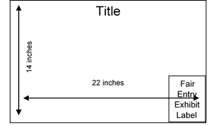
MINI PROJECTS INVOLVING POSTERS - 14"X 22" POSTERS SHOULD BE DISPLAYED HORIZONTALLY. IT IS A GOOD IDEA TO MOUNT YOUR POSTER ON PLYWOOD, FOAMBOARD, CARDBOARD, OR OTHER STURDY MATERIALS TO STIFFEN IT. POSTERS SHOULD ALSO BE COVERED WITH CLEAR PLASTIC TO PROTECT THEM. APROPRIDE-SIZED SLEEVES ARE AVAILABLE FROM THE EXTENSION OFFICE. LEAVE A 5” X 6” SPACE IN THE LOWER RIGHT-HAND CORNER FOR THE EXHIBIT CARD THE PURDUE EXTENSION STAFF WILL PROVIDE AT FAIR CHECK-IN.

PARTS OF THE HEN CHICKEN

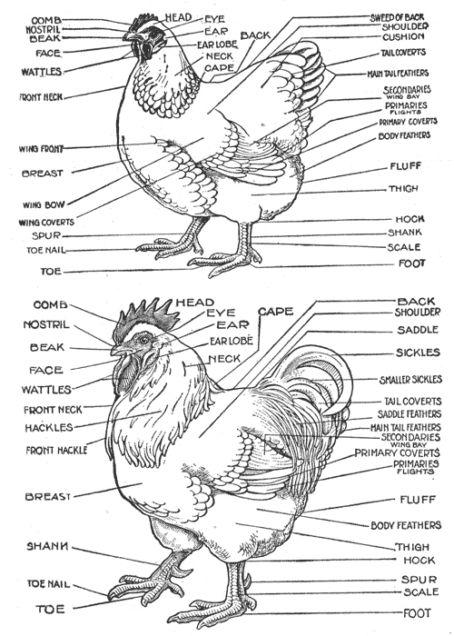

PARTS OF THE ROOSTER

PARTS OF THE HEN CHICKEN (FEMALE)

Label the parts of the hen chicken.

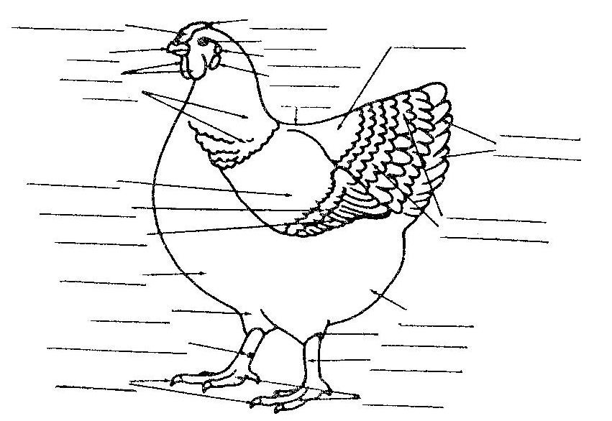

MINI 4-H POULTRY RECORD SHEET

NAME_________________________________ GRADE_______________
ADDRESS___________________________________________________
4-H CLUB___________________________________________________
YEAR IN MINI 4-H (circle) 1st or 2nd
4-H MEMBER YOU WORKED WITH ______________________________
YOUR BIRD’S NAME__________________________________________
YOUR BIRD'S AGE ___________________________________________
WHAT DO YOU FEED YOUR BIRD? _____________________________
____________________________________________________________
WHAT DO YOU LIKE MOST ABOUT YOUR BIRD? __________________
____________________________________________________________
____________________________________________________________
DRAW A PICTURE OR ATTACH A PHOTO OF YOU AND YOUR BIRD BELOW:

MINI 4-H POULTRY RECORD SHEET

NAME_________________________________ GRADE_______________
ADDRESS___________________________________________________
4-H CLUB___________________________________________________
YEAR IN MINI 4-H (circle) 1st or 2nd
4-H MEMBER YOU WORKED WITH ______________________________
YOUR BIRD’S NAME__________________________________________
YOUR BIRD'S AGE ___________________________________________
WHAT DO YOU FEED YOUR BIRD? _____________________________
____________________________________________________________
WHAT DO YOU LIKE MOST ABOUT YOUR BIRD? ____________________________________________________________
____________________________________________________________
____________________________________________________________
DRAW A PICTURE OR ATTACH A PHOTO OF YOU AND YOUR BIRD BELOW:

