CASS COUNTY
SHEEP
MINI 4-H

Name ______________________________ Year 20_______
Club ______________________________________________

It is the policy of the Purdue University Cooperative Extension Service that all persons have equal opportunity and access to its educational programs, services, activities, and facilities without regard to race, religion, color, sex, age, national origin or ancestry, marital status, parental status, sexual orientation, disability or status as a veteran. Purdue University is an Affirmative Action institution. This material may be available in alternative formats.

Revised 01-2023
01-2024

MINI 4-H SHEEP

GENERAL MINI 4-H RULES:
- You must be in the 1st or 2nd grade at the time you sign up for this project.

- You must enroll in the Mini 4-H Sheep project.

- Complete the Mini 4-H Sheep enrollment form by May 15th. (This will be sent to each member who enrolls in Mini 4-H Sheep in April.)

- As you exhibit a Mini 4-H Sheep project (that belongs to a regular 4-H member), you will receive a Mini 4-H ribbon.

- You are encouraged to attend club meetings and/or project workshops.

ACTIVITIES TO COMPLETE:
1. You will need to work with an older 4-H Sheep member who will be exhibiting 4-H Sheep at the fair. You should help with the project at least three times before the fair.
2. When talking to a 4-H’er enrolled in the 4-H Sheep project, find out what is involved in caring for and showing Sheep.
3. Watch the 4-H Sheep show at the fair this year.
COMPLETION GUIDELINES:
To complete your Mini 4-H Sheep Project you must:

- Complete the attached record sheet and turn it in to the 4-H Sheep Committee when the sheep are checked in at the 4-H Fair.

- Exhibit a regular Cass County 4-H Club member's animal at the county 4-H Fair. (Optional)

- If you decide to make a poster (14” X 22”) in addition to or instead of showing an animal, it will be entered in the Mini 4-H Farm Animal project in the Community Center. This poster will need to be turned in on the Saturday designated in the 4-H Handbook from 7:30-9 a.m.

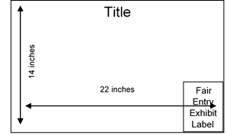
UMINI PROJECTS INVOLVING POSTERS - 14"X 22" POSTERS SHOULD BE DISPLAYED HORIZONTALLY. IT IS A GOOD IDEA TO MOUNT YOUR POSTER ON PLYWOOD, FOAMBOARD, CARDBOARD, OR OTHER STURDY MATERIALS TO STIFFEN IT. POSTERS SHOULD ALSO BE COVERED WITH CLEAR PLASTIC TO PROTECT THEM. APROPRIDE-SIZED SLEEVES ARE AVAILABLE FROM THE EXTENSION OFFICE. LEAVE A 5” X 6” SPACE IN THE LOWER RIGHT-HAND CORNER FOR THE EXHIBIT CARD THE PURDUE EXTENSION STAFF WILL PROVIDE AT FAIR CHECK-IN.

PARTS OF A LAMB
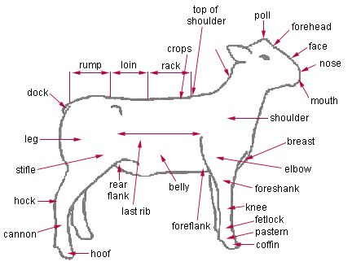

Sheep are mammals with thick, woolly fur, and hoofed feet. Sheep were domesticated (bred to be tame) about 10,000 years ago. Domestic (tame) sheep are farmed for their wool, meat, and milk. There are also many types of wild sheep; they are closely related to wild goats. In 1997, a sheep named "Dolly" was the first animal cloned (grown from a cell from another adult animal, making a genetically exact copy of the original animal).
Names: An adult female sheep is called an ewe; an adult male is called a ram. Babies are called lambs. Male lambs that are castrated to become market animals only are called wethers.
Anatomy: Sheep range from about 2 to 4 ft (0.6 to 1.3 m) tall at the shoulder. Some types of sheep have horns, which are often curved. The horns grow throughout the life of the sheep.
Diet: Sheep are herbivores (plant-eaters) that graze on grass, leaves, twigs, and young plants.

MINI 4-H SHEEP QUESTIONS

Complete the questions below. Refer to the information in this manual to help you. Check your answers from the list.

1. A lamb less than two weeks old depends mainly on its _________________ for its nutritive requirements.
2. A _____________________ is a castrated male sheep.

3. A __________________ is a male sheep (uncastrated).

4. A __________________ is a female sheep.

List of answers

wether mother's milk ewe ram

LABEL THE PARTS OF THE SHEEP

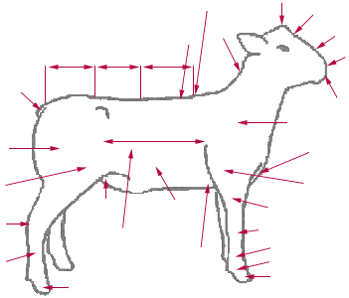

MINI 4-H SHEEP RECORD SHEET

NAME_________________________________ GRADE ___________

ADDRESS___________________________________________________

SCHOOL____________________________________________________

TOWNSHIP_____________________________PHONE_______________

4-H MEMBER YOU WORKED WITH ______________________________

YOUR SHEEP'S NAME_________________________________________

YOUR SHEEP'S AGE AND WEIGHT______________________________

WHAT DO YOU FEED YOUR SHEEP? ____________________________

____________________________________________________________

WHAT DO YOU LIKE MOST ABOUT YOUR SHEEP? ________________

____________________________________________________________

____________________________________________________________

DRAW A PICTURE OR ATTACH A PHOTO OF YOU AND YOUR SHEEP
BELOW:

MINI 4-H SHEEP RECORD SHEET

NAME_________________________________ GRADE ___________

ADDRESS___________________________________________________

SCHOOL____________________________________________________

TOWNSHIP_____________________________PHONE_______________

4-H MEMBER YOU WORKED WITH ______________________________

YOUR SHEEP'S NAME_________________________________________

YOUR SHEEP'S AGE AND WEIGHT______________________________

WHAT DO YOU FEED YOUR SHEEP? ____________________________

____________________________________________________________

WHAT DO YOU LIKE MOST ABOUT YOUR SHEEP? ________________

____________________________________________________________

____________________________________________________________

DRAW A PICTURE OR ATTACH A PHOTO OF YOU AND YOUR SHEEP
BELOW:

