CASS COUNTY
SWINE
MINI 4-H

Name ______________________________ Year 20______
Club ______________________________________________

It is the policy of the Purdue University Cooperative Extension Service that all persons have equal opportunity and access to its educational programs, services, activities, and facilities without regard to race, religion, color, sex, age, national origin or ancestry, marital status, parental status, sexual orientation, disability or status as a veteran. Purdue University is an Affirmative Action institution. This material may be available in alternative formats.

Revised 01-2023
01-2024

MINI 4-H SWINE
GENERAL MINI 4-H RULES:
- You must be in the 1st or 2nd grade at the time you sign up for this project.

- You must enroll in the Mini 4-H Swine project.

- Complete the Mini 4-H Swine enrollment form by May 15th. (This will be sent to each member who enrolls in Mini 4-H Swine in April)

- As you exhibit a Mini 4-H swine animal (that belongs to a regular 4-H member), you will receive a Mini 4-H ribbon.

- You are encouraged to attend 4-H club meetings and/or project workshops.
ACTIVITIES TO COMPLETE:
You will need to work with an older 4-H Swine member who will be exhibiting 4-H Swine at the fair. You should help with the project at least three times before the fair.
- When talking to a 4-H’er enrolled in the 4-H Swine project, find out what is involved in caring for and showing Swine.
- Watch the 4-H Swine show at the fair this year.

COMPLETION GUIDELINES:
To complete your Mini 4-H Swine Project you must:

- Complete the attached record sheet and turn it into the 4-H Swine Committee when the swine are checked in at the 4-H Fair.

- Exhibit a regular Cass County 4-H Club member's pig at the county 4-H Fair. (Optional)

- If you decide to make a poster (14” X 22”) in addition to or instead of showing an animal, it will be entered in the Mini 4-H Farm Animal project in the Community Center. This poster will need to be turned in on the Saturday designated in the 4-H Handbook from 7:30-9 a.m.
U

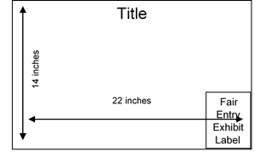
MINI PROJECTS INVOLVING POSTERS - 14"X 22" POSTERS SHOULD BE DISPLAYED HORIZONTALLY. IT IS A GOOD IDEA TO MOUNT YOUR POSTER ON PLYWOOD, FOAMBOARD, CARDBOARD, OR OTHER STURDY MATERIALS TO STIFFEN IT. POSTERS SHOULD ALSO BE COVERED WITH CLEAR PLASTIC TO PROTECT THEM. APROPRIDE-SIZED SLEEVES ARE AVAILABLE FROM THE EXTENSION OFFICE. LEAVE A 5” X 6” SPACE IN THE LOWER RIGHT-HAND CORNER FOR THE EXHIBIT CARD THE PURDUE EXTENSION STAFF WILL PROVIDE AT FAIR CHECK-IN.

PARTS OF THE PIG

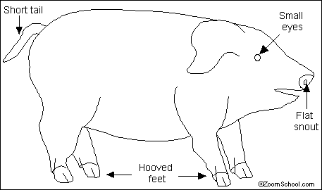

Pigs are very adaptable animals that eat many different foods and live in a variety of environments. Pigs were domesticated (tamed from wild animals) thousands of years ago. They are farmed for their meat and hides (leather). There are still many wild pigs, like the wild boar, the warthog, and the bushpig. Pigs are found on every continent on Earth except Antarctica.

Names: Pigs are also called hogs or swine. The adult female is called a sow. The adult male is called a boar. A baby is called a piglet.

Anatomy: Pigs vary in color from brown, black, and white, to pinkish. Some wild pigs have large tusks, and overgrown teeth used for fighting and digging for food.

Diet: Pigs are omnivores (eating plants and meat). They eat a variety of plants and small animals (like worms and snakes).

Classification: Class Mammalia, Order Artiodactyla (even-toed hoofed mammals), Family Suidae (8 species of pigs).

MINI 4-H SWINE PROJECT

1. Notching the ear
A V-shaped notch can be cut out of the edge of the ear using a pair of clean scissors. Make the notch a few centimeters deep so in future you will be able to read it from a distance.
Litter Mark – The pig’s right ear (R) is used for litter mark. All pigs from the same litter must have the same markings in this ear.
Individual Pig Marks – The pig’s left ear (L) is used to show an individual pig number in the litter. Each pig in the litter will have a different set of notches in this ear. The exact location of the notches determines the pig number.

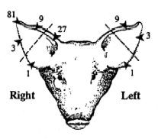
Draw Your Pig’s Ear Notches
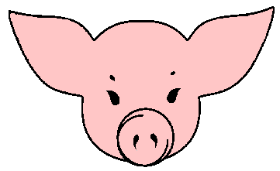

2. What was your favorite thing to do with this project?
__________________________________________________________________________________________________________________________________________
3. Two other names for pigs are? __________________ and __________________
4. An adult female pig is called a _______________________.
5. A baby pig is called a _____________________.
6. An adult male pig is called a ________________________.

MINI 4-H SWINE RECORD

NAME________________________________ Grade____________

ADDRESS___________________________________________________

SCHOOL____________________________________________________

TOWNSHIP____________________________PHONE________________

4-H MEMBER YOU WORKED WITH______________________________

YOUR PIG'S NAME____________________________________________

YOUR PIG'S AGE AND WEIGHT_________________________________

WHAT DO YOU FEED YOUR PIG? _______________________________

____________________________________________________________

WHAT DO LIKE MOST ABOUT YOUR PIG? ________________________

____________________________________________________________

____________________________________________________________

DRAW A PICTURE OR ATTACH A PHOTO OF YOU AND YOUR PIG BELOW:

MINI 4-H SWINE RECORD

NAME_________________________________ GRADE____________

ADDRESS___________________________________________________

SCHOOL____________________________________________________

TOWNSHIP____________________________PHONE________________

4-H MEMBER YOU WORKED WITH______________________________

YOUR PIG'S NAME____________________________________________

YOUR PIG'S AGE AND WEIGHT_________________________________

WHAT DO YOU FEED YOUR PIG? _______________________________

____________________________________________________________

WHAT DO LIKE MOST ABOUT YOUR PIG? ________________________

____________________________________________________________

____________________________________________________________

DRAW A PICTURE OR ATTACH A PHOTO OF YOU AND YOUR PIG BELOW:

