4-H Holiday Craft Manual

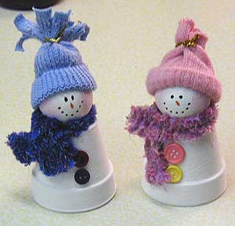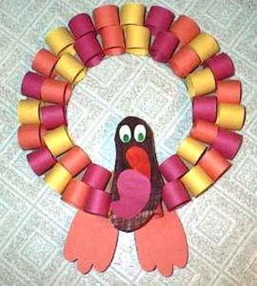



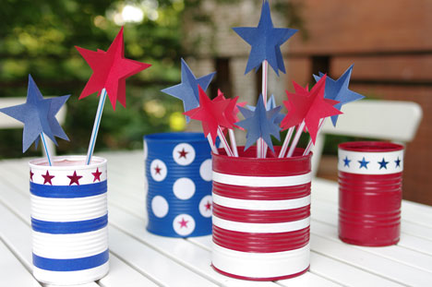

Cass County

Cass County Holiday Craft manual created December 2008.

Magazines with Ideas:

*Pack-of-Fun *Family Circle

*Woman’s Day *Better Homes & Gardens

Reference Books:

Party & Holiday Decorations You Can Make, by Karen McCann

Festive Decorating the Year Round, by Dorothy Waugh

The House and Crafts Book, by Annelike

The Complete Book of Handicrafts, by Linda Olsheim

Purdue University is an equal access/equal opportunity institution.

HOLIDAY CRAFT

Holiday craft is a way of using your creative talents and imagination to make something for any possible occasion or holiday you can think of. Examples of holidays or occasions include but not limited to: New Years, Christmas, Easter, Halloween, Thanksgiving/Fall, Fourth of July, Valentines, Memorial Day, St. Patrick’s Day, Public Occasions such as Festivals, Religious Celebrations, Patriotic Days, Bridal Showers, Weddings, Anniversaries, etc.

A variety of decorations can be made including but not limited to:

* Centerpieces
* Scrolls, Wall Hangings, Wreaths
* Ornaments
* Wall Plaque or Displays
* Table Arrangements
* Other, (use your imagination)

Each decoration will be judged on its own merit, taking into consideration: neatness and construction.

Each article must be accompanied by the Holiday Craft Record sheet.

Judging categories are the same for all crafts:

Level 1 – Grades 3-5

Level 2 – Grades 6-8

Level 3 – Grades 9-12

Difficulty and creativity should increase each year the 4-H member participates in the project.

Exhibit

1. One completed article that can be used for any holiday or special occasion.
2. Turn in completed Holiday Craft record sheet.
3. Attach a craft card to the exhibit describing the project.

Holiday Craft Record Sheet

Name ________________________________________________________________________

Club _________________________________________ Grade (as of Jan. 1) ________________

What occasion will you use your decoration for (i.e., a wedding, a certain holiday, etc.)?

______________________________________________________________________________

Why did you pick this occasion/holiday? _____________________________________________

______________________________________________________________________________

Materials used in the construction of the decoration:

______________________________________________________________________________

______________________________________________________________________________

______________________________________________________________________________

What difficulties (if any) did you have in making this project? ___________________________

______________________________________________________________________________

______________________________________________________________________________

Did you learn some new skills while creating this craft? (i.e., painting, sanding, etc.) If so, what new skills were learned? _______________________________________________________

_____________________________________________________________________________

______________________________________________________________________________

Cost of Decoration materials: _____________________________________________________

4-H Member signature: __________________________________________________________

4-H Leader signature: ___________________________________________________________

Date: ______________________________