Toy Farm Scene/
Miniature Dollhouse
4-H Project
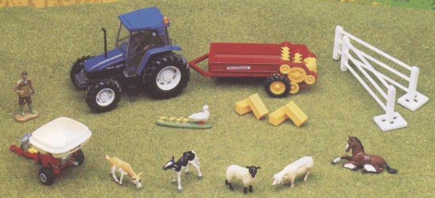

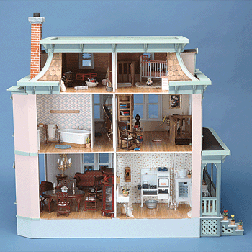

Cass County

Purdue University is an equal access/equal opportunity institution.

Materials for this manual were adopted from Jasper and Fulton County’s manuals.

Revised 2-2008

Toy Farm Scene/Miniature Dollhouse

This project and exhibit is designed to motivate and interest young people in modeling a custom built farm toy display or miniature dollhouse. The 4-H member will create a realistic setting around manufactured or custom built farm or construction toys or designing realistic rooms in a house. Modeling is very personal and involves much imagination; members are encouraged to display their many artistic abilities in this project.

GENERAL RULES:
- Projects will be judged by Beginner, Intermediate, or Advanced divisions.
- Exhibit your display according to the guidelines listed below.
- Complete the attached record sheet, have your leader sign it, and turn it in with your exhibit.
- Exhibits will be judged according to the following criteria: artistic arrangement of exhibit; detail of exhibit; and realistic setting around toys, furniture and decorations.
- Toys used in your display can be scale desired; the preferred size is 1/64 or 1/16.
- Farm toys can be obtained at farm equipment dealers, department stores, farm stores and farm toy shows. Farm toy shows probably offer the widest selection of toys.
- Landscape supplies and dollhouse miniatures can be obtained at hobby shops, craft supply stores, and even in your own back yard.
- Every effort will be made to keep your exhibit safe, but the Cass County 4-H Club Association is not responsible for lost or damaged items from your exhibit.
- Fencing, land and roadways are not included in the maximum number of items that may be included in each division. (for toy farm scenes)
- It is suggested that projects be secured by enclosing your exhibit with Plexiglas or other material. If the dollhouse has an open side, a clear protective shield of some type could be added for security.
PROJECT REQUIREMENTS:

BEGINNER: (Grades 3 – 5)

(Toy Farm Scene Guidelines)
- Prepare a farm scene layout that is no larger than: 3’ wide X 2’ deep X 2’ high (outside dimensions). This includes any and all “protection” in the total measurements, i.e. plexiglass case.
- Any scale of toys may be used.
- Include NOT MORE THAN 20 items (pieces). Fencing, land and roadways are not included in the 20 items.
- Any combination of items may be used but you may have:
  - Not more than 1 structure (barn, building, tool shed, grain bin, silo, house, etc.)
  - Not more than 8 animals
  - Not more than 8 Wheel toys (tractors, trucks, cars, implements, equipment, etc.)
  - Not more than 8 Extras (feeders, people, bales of hay, etc.)
- Display must be built on rigid wood (i.e.: plywood)

(Miniature Dollhouse Guidelines)
- Decorate and accessorize to complete 3 rooms for your dollhouse.
- Items in your display can be scale desired; the preferred size is 1:12.
- Display must be supported on rigid wood (i.e. plywood) for transportation and display purposes.
- Dollhouse must be no larger than 45” wide X 48” high X 24” deep (outside dimensions).

(The same farm toys, layout or dollhouse miniatures may be used in more than one year but exhibits need to be changed, altered or modified so as not to repeat the same exact exhibit.)

INTERMEDIATE: (Grades 6 – 8)

(Toy Farm Scene Guidelines)
- Prepare a farm scene layout that is no larger than: 3’ wide X 2’ deep X 2’ high (outside dimensions). This includes any and all “protection” in the total measurements, i.e. plexiglass case.
- Any scale of toys may be used.
- Include NOT MORE THAN 40 items (pieces). Fencing, land and roadways are not included in the 40 items.
- Any combination of items may be used but you may have:
  - Not more than 3 structures (barns, buildings, tool sheds, grain bins, silos, houses, etc.)
  - Not more than 15 animals
  - Not more than 15 Wheel toys (tractors, trucks, cars, implements, equipment, etc.)
  - Not more than 15 Extras (feeders, people, bales of hay, etc.)
- Display must be built on rigid wood (i.e.: plywood)

(Miniature Dollhouse Guidelines)
- Decorate and accessorize to complete 4-5 rooms for your dollhouse.
- Items in your display can be scale desired; the preferred size is 1:12.
- Display must be supported on rigid wood (i.e. plywood) for transportation and display purposes.
- Dollhouse must be no larger than 45” wide X 48” high X 24” deep (outside dimensions).

(The same farm toys, layout or dollhouse miniatures may be used in more than one year but exhibits need to be changed, altered or modified so as not to repeat the same exact exhibit.)

ADVANCED: (Grades 9 – 12)

(Toy Farm Scene)
- Prepare a farm scene layout that is no larger than: 3’ wide X 2’ deep X 2’ high (outside dimensions). This includes any and all “protection” in the total measurements, i.e. plexiglass case.
- Any scale of toys may be used.
- Display must be built on rigid wood (i.e.: plywood)
- This division is open to create any type of farm. Example: Farmstead (buildings, grain handling equipment, field work, harvesting, or crops and animals); Farm Equipment Stores; Historical Layout; Farm Business Layout; or Specialty Agriculture Area Layout.
- Also, include not more than a page about “Why you chose this layout” and what is your favorite piece and why.
(Miniature Dollhouse Guidelines)
- Decorate and accessorize to complete 5 or more rooms for your dollhouse.
- Items in your display can be scale desired; the preferred size is 1:12.
- Display must be supported on rigid wood (i.e. plywood) for transportation and display purposes.
- Dollhouse must be no larger than 45” wide X 48” high X 24” deep (outside dimensions).
- This division is open to adding creativity to your rooms beyond the normal look (i.e. Christmas decorations, other holiday ideas or seasonal ideas.

(The same farm toys, layout or dollhouse miniatures may be used in more than one year but exhibits need to be changed, altered or modified so as not to repeat the same exact exhibit.)

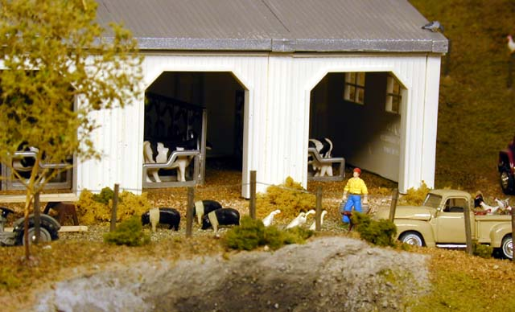

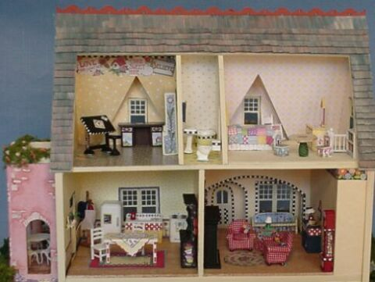

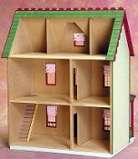

TOY FARM SCENE/
MINIATURE DOLLHOUSE SCORE CARD

 | Very Good | Good | Needs  Improvement
1. Creativity:
Eye catching, educational
2. Size:
Has followed county rules
3. Neatness:
Use of materials, fields,
Buildings, furniture,
accessories, etc.
4. Use of Toys:
(toy farm scene)
Scene appropriate for toys
used
5. Room Layout:
(miniature dollhouse)
Realistic and appropriate for
room size

Comments: ____________________________________________

______________________________________________________

______________________________________________________

______________________________________________________

Ribbon Grade: _____________________

TOY FARM SCENE/ MINIATURE DOLLHOUSE

Name _________________________________________________ Grade ______________

Club ____________________________________________ Year in 4-H ________________

Year in Project _______________ Project Division: Beginner Intermediate Advanced

Leader’s Signature _____________________________________ Date ________________

1. What scale(s) of farm toys/dollhouse miniatures do you collect? ____________________________________________________________________________
2. Describe your layout/house design. _____________________________________________
____________________________________________________________________________
________________________________________________________________________________________________________________________________________________________
3. Of the many items in your collection, which is your favorite and explain why? ____________
________________________________________________________________________________________________________________________________________________________
4. Where do you purchase items for your farm scene/dollhouse, or did you receive items as gifts? _______________________________________________________________________
____________________________________________________________________________
5. What new items would you like to add to your display/house? ________________________
____________________________________________________________________________
6. Did you attend any Toy Shows or Miniature Collection Shows to learn more about your hobby? _____________________________________________________________________
If yes, when and where? _____________________________________________________
7. Have you read any books or articles about collecting farm toys/dollhouse minitatures and/or about making your scene or house? _______________________________________________
____________________________________________________________________________
If yes, list title and author. _______________________________________________________
____________________________________________________________________________
8. Do you know of an interesting web site about collecting miniatures? ___________________
If yes, please list the address ____________________________________________________

