Must be submitted to Extension Office by July 19th. YEAR
Due September 4, 2026 to the Extension Office

My Record of Achievement
Please list your 4-H projects, activities, and achievements for this year. Attach additional pages as needed.

Name
Address

Club
Date of Birth
Telephone( ,
Grade (completed) Years Completed in 4-H

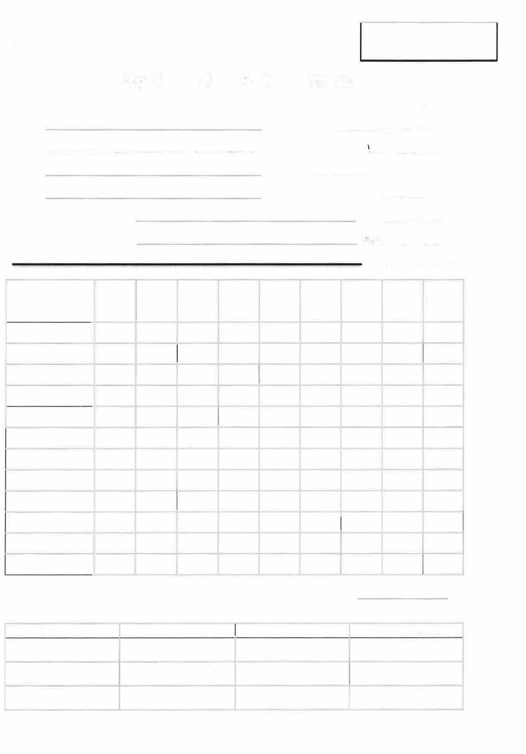
Signature of Member Date
Signature of Parent/Guardian Date

4-H Projects Completed |  | #of Years  Project Taken | # Blues | # Reds | #Whites | #  Champs | #Res. Champs | #  Grand Champ | #  Reserve  Grand Champs | # State Fair Entries

- County Projects: What was your total number of completed projects for this year?
- Complete this section if you had exhibits at the State Fair:
State Fair Project | Div./Level Exhibit |  | Placing (Results)
Continued on Back

- Number of local club meetings attended from October 1 to September 30 meetings Number of county club meetings attended from October 1 to September 30 meetings Number of Junior Leader meetings attended from October 1 September 30 meetings Number of county-level workshops/practices (list which and how many) meetings

- Did you serve on any committees in your club or Jr. Leaders? If so, which? _

Were you a chairperson for a committee? If so, which? _

- Did you serve as an officer in your local club, county club or Junior Leaders? If so, what club and what office?

- Did you give any demonstrations for a club? List date, who to, and topics/titles.

- Did you attend any of the following trips?

_4-H Camp, camper
_4-H Round-Up
_ Jr Leader Conference
_4-H Camp, counselor
_State 4-H Chorus or Band
_Club Completion Trip
_Purdue 4-H Academy
_Indiana 4-H Congress
_Other 4-H Trip: _

Did you participate in any of the following activities/competitions (Mark with a C for county, A for area, or S for state?)

Fashion Revue
_Horse Bowl/Hippology
_ATV Contest
_Performing Arts
_COE/Judging Contest
_Tractor Operator Contest
_ Demonstration/Public Speaking
_Beef grooming
_Bicycle Rodeo

_Showmanship (indicate which):

_ Other 4-H activity/competition:

- Did you receive any 4-H awards/scholarships? Please List

- Do you do any community service? Please list activities and the number of hours.

Signature of Leader/Extension Educator Date _

4-H Record of Achievement Supplement Page

Name: Date:

What have you learned from your 4-H experience?

What skills have you gained or learned from participating in 4-H projects and activities?

