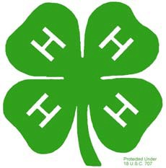
MINI 4-H PROGRAM

ARTS & CRAFTS PROJECT MANUAL

Clay County Cooperative Extension
Mini 4-H Program
6656 N State Road 59
Service

Brazil, IN 47834
(812) 448-9041

PROJECT EXHIBIT TAG
Mini 4-H Arts & Crafts
Name: Age:

Welcome to "MINI 4-H". If you're reading this, you've probably signed up for the Arts Crafts project. We're glad to have

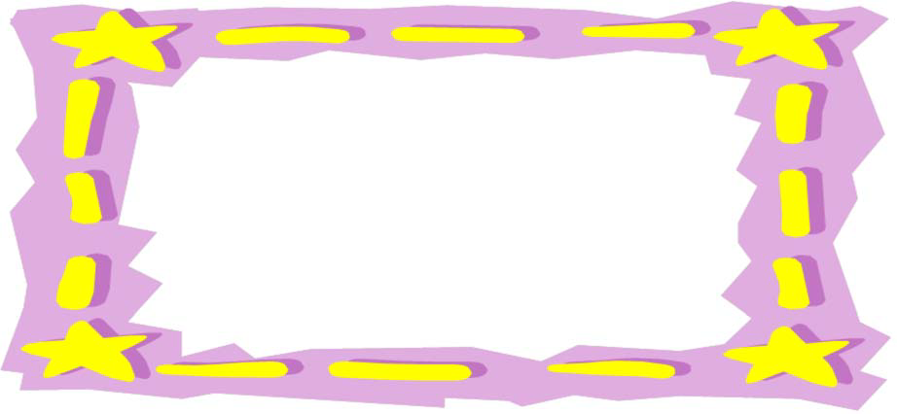

Exploring 4-H Arts & Crafts is
...the fun you have in learning a new
...the fun of showing others your
completed
...the fun of choosing it
...the fun of exploring and
new textures and art forms

What you will exhibit at the County 4-H 

Choose one Arts and Crafts poster project listed below to exhibit at Clay County 4-H Fair.
Geometric 
Collage Drawing
Finger Painting

Try your own way of doing any of the above projects. Try as many fun things as can so you have a wider selection to choose from when making your final choice. Feel to add extra materials and personal touches of your

Most of all.....have 


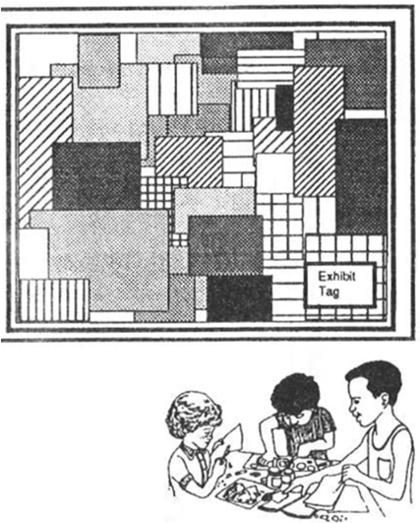
MATERIALS

one large piece of white paper
11" 14"
a black crayon
piece of construction paper
a set of color paints and brush container of water
paper towels old newspapers

Cover your work area with old newspaper to protect
- Select one geometric shape, such as a square, circle or triangle. Using the black crayon, draw that shape on the paper. Repeat it all over the paper in various sizes. Press heavily so the lines are thick and dark.

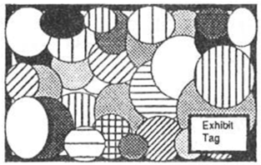
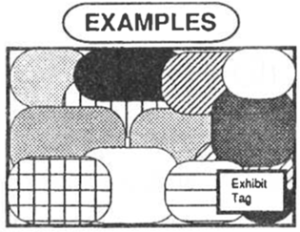
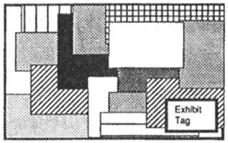
- Using the paint the shapes. Try to use many colors. sure to rinse your brush each time you change colors.
- When completed, let it dry thoroughly and mount on construction paper of a pleasing color. Mount your project on poster board for a stiff backing.
- Rinse your brush well in clean water and dry with a paper towel.
- Clean up your work area

THIS GIVES YOU MANY WAYS TO DO THE SAME SHAPE. SO...HAVE

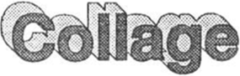


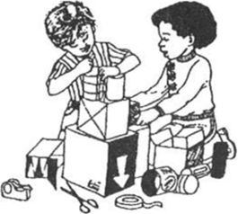
A collage is a picture made of different pieces of paper or pictures from They are pasted together to tell a story or make a

MATERIALS YOU NEED:

cardboard or posterboard 11" x 14" in size glue, paste or rubber cement
scissors

COLLAGE MATERIALS -- IDEAS or SUGGESTIONS:
Catalogs, magazines, old newspapers, candy or gum wrappers, small twigs, small stones, colored paper, tissue paper, scraps of felt, yarn or
- Decide on a subject or idea to make your collage. Then collect the materials will need.
- Cover your work area with old newspapers to protect
- Before you start to glue, arrange your design on the cardboard the way you want your collage to The pieces can be spaced apart, touching or overlapping. Look at the example
- Now glue or paste all the pieces in place.
- Keep you collage flat until it is
- Clean up your work area.


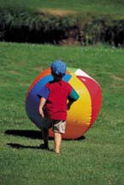
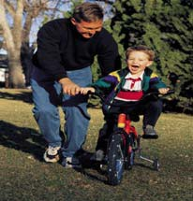
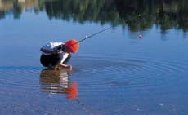
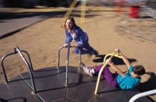
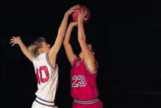
GREAT

Look at these other ideas.

OTHER IDEAS for
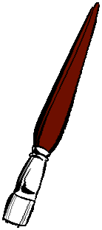
YOUR PRACTICE, ENTERTAINMENT or to EXHIBIT.

Finger painting
Drawing -with crayons, felt tip pen,

pen, pencil, chalk, ink, etc.

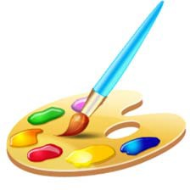
Watercolors

But remember your 4-H Fair Exhibit must

be one of the
A

following:

DESIGN

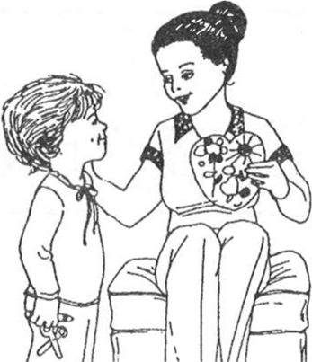
A COLLAGE
A DRAWING
or A FINGER PAINTING

ALSO, your poster must be
mounted on a stiff backing
and be covered with
clear plastic.

MINI  CHECK 













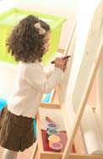
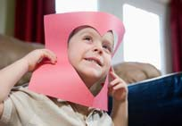


Is your exhibit tag on
(lower right hand corner of your poster

 Are your records 
(must attach to the back of your poster

Is your work neat, clean, and your 

 Are you pleased with what you 


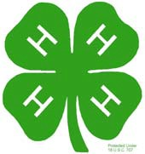
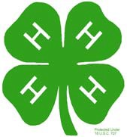
"ARTS & CRAFTS" RECORD  MINI 4-H PROGRAM

Name 

Please answer the following questions. Attach this  record sheet to your project. See you at the fair!!!

 s did 

- What type of materials did you use?

- What is your favorite form of art?

- Did you enjoy this project?

 Date:

