
ount



MINI 4-H

PROGRAM

BICYCLE PROJECT MANUAL

Clay County Cooperative Extension Service
Mini 4·H Program Courthouse 2nd
Floor Brazil, IN 47834



PROJECT EXHIBIT TAG
Mini 4-H Bicycle

Name:

Age:

Welcome to the "Mini project.
We hope you learn as you  through this  Good 

You

•Bicycle DO's and 
•How to use your bicycle safely
•How to care for your bicycle

What you 
 will exhibit one of the  at the Clay  4-H
Fair:

11” x 14"  poster  cut  from  and catalogs. Must be  on a stiff backing and  in clear plastic.

A short story about you and   a  of
you and your bicycle on an  x 14”  poster  a  backing and   clear plastic.

•Attach the completed "RECORD SHEET" to the back of your 

A BICYCLE.

Takes you
places.

Helps you keep physically
fit.

Helps you have fun with your friends.

Helps you earn money.

Can be used for many fun and safe games.

TAKE GOOD CARE OF
YOUR BICYCLE!

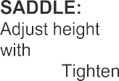
CHECK THESE IMPORTANT
so leg ball of foot on
stroke. secu

slightly
at of
rely.

COASTER BRAKE, HAND BRAKES:
Have brakes adjusted by a reliable service dealer.

SPOKES:

ones promptly.
HANDLE BARS:
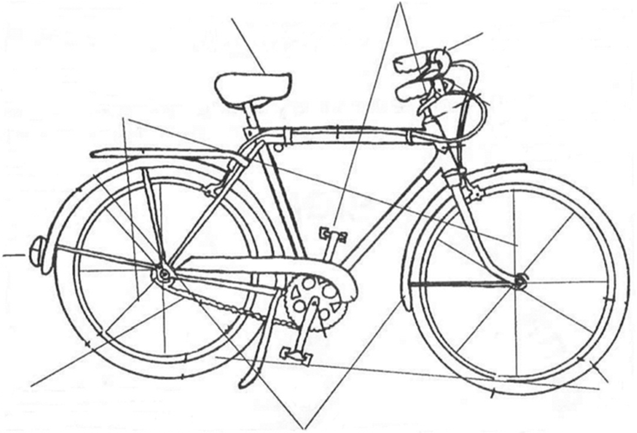
Adjust for your comfort.

them light.

REFLECTOR:
Must be visible for 300
feet and be state
for night

CHAIN:
Check for damaged links and a snug (but not too tight) fit. Clean frequently and lubricate with light oil.

FRONT & BACK WHEELS:
Should be lined up so they don’t wobble.

TIRES:
Inflate to correct pressure. Check tires frequently.

KNOW THE PARTS OF YOUR
BICYCLE!!!!!


Bicycling can be aSAFE
ACTIVITY
if you take care!

Know these signals and use them every time you are bicycling. Look see if
other Bicyclists are also using these signals when needed. Make all these signals a regular

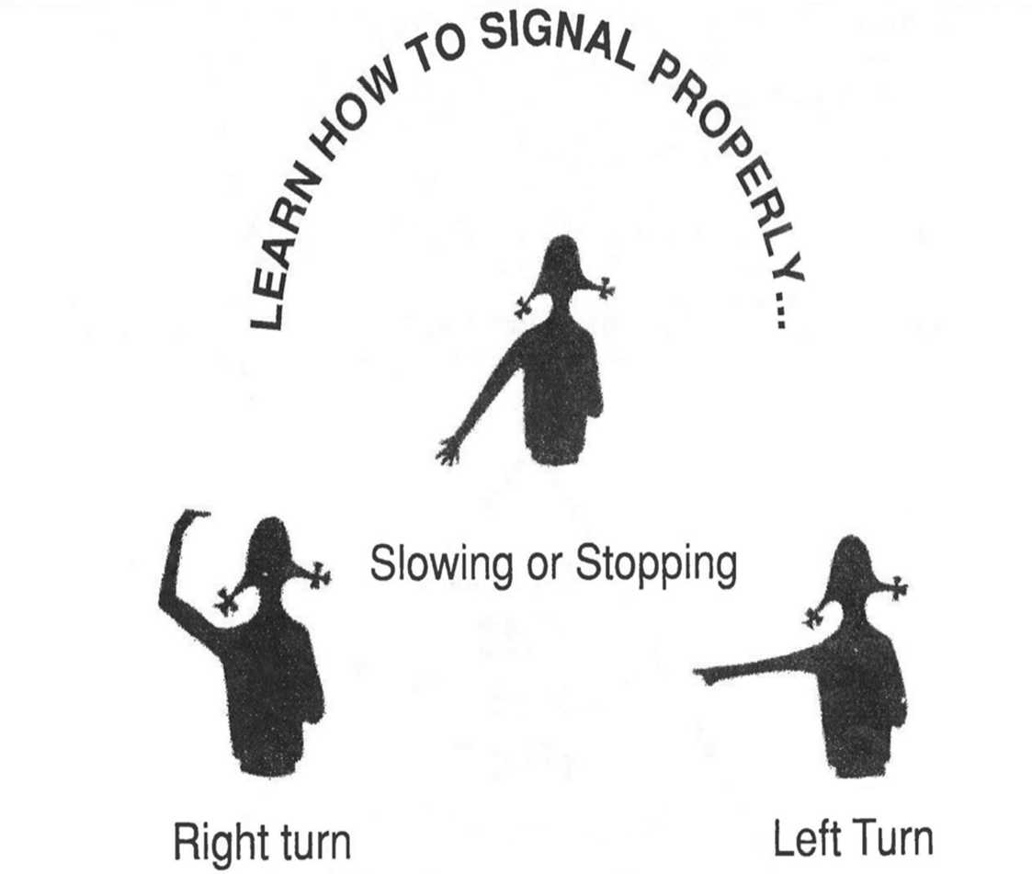

Know these signs of Life" and use them daily.
Where have

you seen these signs when you bike? Write your
answers below.

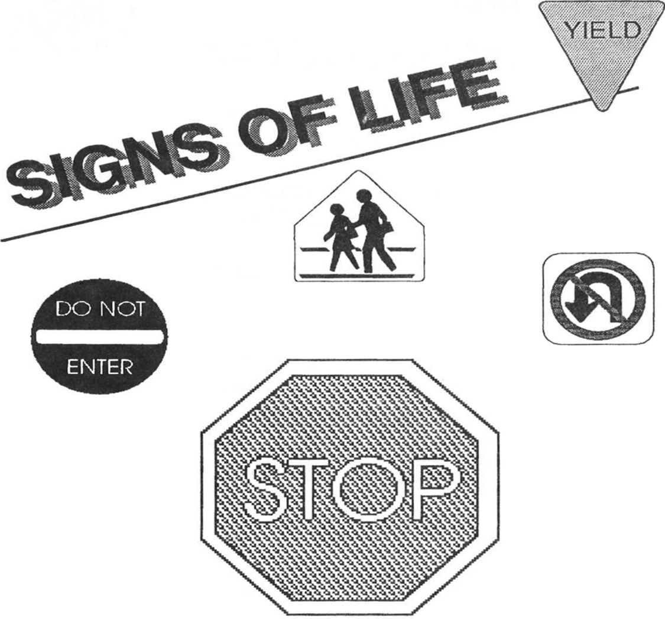

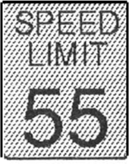
"PEDESTRIAN CROSSING"

"NO Uturn”

"DO NOT ENTER"

"STOP"

"RAILROAD CROSSING"

"SPEED LIMIT"


OTHER WAYS TO AN ACCIDENT.
WATCH OUT 
sudden opening of door of a parked

your speed,  going 

Uneven gravel in  or slippery 

cars pulling out  driveways and 

OBEY SAFETY
BE COURTEOUS and LIVE LONGER!!!!

ride on a bicycle that's TOO BIG for 

ride 

perform STUNTS on 

be TOWED by another 

LEARN THESE "RULES OF THE ROAD”

OBEY ALL TRAFFIC
Red and green lights, stop signs, highway

KEEP TO THE RIGHT ... FOLLOW 
Always ride in a straight line, never weave in and

YIELD THE RIGHT OF WAY TO
Avoid the sidewalks and use care at

WATCH OUT FOR 
Beware of cars pulling out and doors opening unexpectedly.

ALWAYS RIDE 
Bikes made for one rider should never carry two

WATCH THE
Slow down and look to the right and left before 

7. HAVE PROPER LIGHTS ON FRONT AND 
Never ride at night unless you have a white headlamp in front, state approved red reflector in the rear.

HAVE A PROPER SIGNALING 
Warn others of your approach with a horn or

NEVER HITCH 
Hanging on a moving vehicle while riding is extremely 

CHECK YOUR 
Be sure they work efficiently and safely without squeak or

USE HAND 
Let the other driver know your intent, use hand 

NEVER WEAVE OR SWERVE.
Unexpected moves cause accidents. Ride safely and watch out for the other rider.


ACTIVITY

Share the "RULES OF THE ROAD" with friends, classmates your family. Put this on your "Record Sheet" if you talk about the Do's to



MINI 4-H BICYCLING TITLE

Topics for your poster on Bicycling might (but do not have to) include any of the below

- Rules of the
- Bicycling is Fun
- Care of My
- Signs of
- Ways I Use My 
- Bicycling is the Key to

Your poster should be a 11" x 14" horizontal display. All posters required to have a STIFF BACKING and covered with CLEAR Read the helpful hints on page 9 before starting your exhibit.

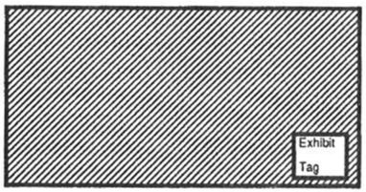
11"

HELPFUL  WHILE DOING

- Every poster should have a
- The poster can be a collage (a group of pictures  your story), magazine cutouts or your own 
- If you use pictures, be sure to label them See Example

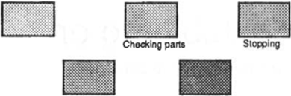

At Stop Sign

- Place the exhibit tag (found on the front cover of manual) on the lower right hand corner of your  and put your "record sheet" on the back of your poster.
- Cover your poster with plastic
- Check your poster before you take it to the fair to exhibited to be sure all of the above has 

HAVE SAFELY...TAKE CARE OF YOUR BIKE...OBEY THE RULES OF THE















CHECK SHEET

Is     correctly?
(lower right hand corner of your

  complete?
(Attach your record sheet to the back of your
Is       very

best?

 have

completed?

 RECORD 
MINI 4-H 

Name Age

Address

Please answer the following questions. Attach this completed record sheet to your project. See you at the fair!!!

- Lis t th e

- List some of the "SIGNS OF LIFE".

- Identify the hand signals
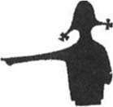
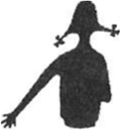
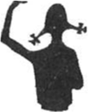

Parent'  Date:

