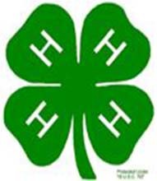
ount

MINI 4-H

PROGRAM

COLLECTIONS PROJECT MANUAL

Clay County Cooperative Extension
Mini 4-H Program
6656 N State Road 59
Service

Brazil, IN 47834
(812) 448-9041

PROJECT EXHIBIT TAG
Mini Collections
Name:
Age:


COLLECTIONS

Collections can be defined as “the gathering of similar articles, objects,  items,  collections can be  on of the ment, while some may take serious consideration before
an be of several different types of materials but to  area. Below is just a short list of the wide variety of you can choose . choose to begin your from the list below or you can use your own idea.

SUGGESTIONS

Arrowheads Baseball Baskets
Bells Books Bottle Caps Bottles
 Stickers Buttons
 Buttons Coffee Mugs

 & Saucers Dishes
Dolls Figurines
Flowers Football Furniture Hats Jewelry Leaves Marbles Matchbooks Miniatures Models Napkins Ornaments Paper Dolls
Pens/Pencils Piggy Banks Pitchers Pocket Knives
Pop Postcards Posters Rocks
Salt &  Shakers Shells
Spoons Stamps
Stuffed Animals Sunglasses

Thimbles Tins Trains

As
can see from the list
can be about
your
For more help with your collection, the public library is a good resource. Books are available on collecting items such as stamps, buttons, coins, rocks and many more. These books have valuable information regarding identification, value and may contain several interesting facts about your collection.

Another important part of your collection is the way it is documented. It is very important to label your collection articles accurately and neatly. Be sure to keep important information such as the date of purchase, cost, and where you purchased the item. Also, it is very important to keep the item in the original container/ package. This will add to the of your in the future.

Displaying your collection is also a  part of this project. Be·sure to arrange your collection n an area where their will be enough space to add to it. A sturdy box, shelves, a notebook, a bulletin board, a display case or drawer would be appropriate. Select where and how you want to display your collection wisely so that members of your family and your friends will be able view your collection that is special to you.
you display and arrange your collection attractively, you will be proud to share it with your family and friends. Sometimes, if they know of your interest,  they will contribute items to your collection.
Also, another important part of a collection is keeping track of the name of the article, date of purchase, cost/value and where you purchased the item. Also, if purchased, you should save your receipt. You should get a notebook to use for purpose. As you add items to your  you should keep this information

 collecting is a hobby. Have fun and be imaginative!

HAPPY
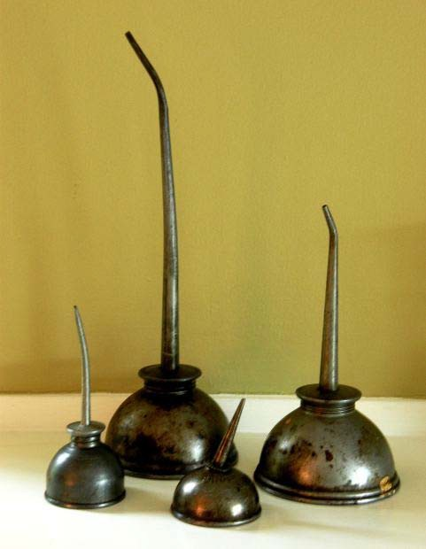
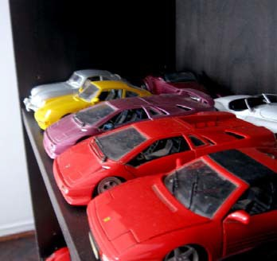
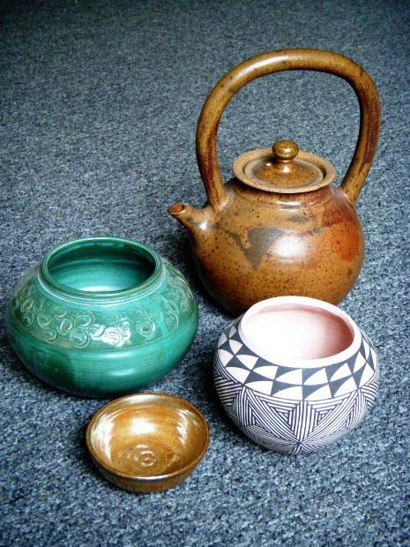

EXHIBIT REQUIREMENTS

NO "LIVE'"

- exhibit:

3 items of your collection

-  your for the  fair in one of the following ways:
  - On a poster, 11'' x 14", covered plastic.
  - In a three-ring notebook
  - take  of the  of items you and  the  in a poster as above in "a

- each item in your  and tell the of the item.

The Clay  4H Council, Inc. will not be responsible for your exhibit at the county fair. We will do everything possible to insure your project’s safety, but if you prefer not to take the risk of theft or damage, you should exhibit your project as described in item “3c” above.



RECORD 
MINI 4-H 

Name Age

  to
project. See at the fair!!!

My is of:

are   chart:

NAME OF ITEM EXHIBITING | WHERE RECEIVED | ESTIMATED VALUE
1.
2.
3.
-  did exhibiting?

e

