
Cupcake Decorating
Clay County Mini 4-H Program


Rules: (There is not a project book for this project.)
- Use your imagination!
- Cupcakes should be individually decorated in a theme.
- Icing must be used but you may also use other items such as candy. Artificial items can also be used.
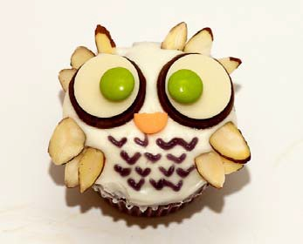
- Cupcakes must be displayed on solid, sturdy base. You may use sturdy, disposable plate, covered cardboard or covered wood.

EXHIBIT

* Exhibit 2 individually decorated cupcakes, decorated in a theme and displayed in single layer, on a solid base with project tag attached.
Project Exhibit Tag
Mini 4-H Cupcakes

Name: Age:

